- Power Transformers Subcommittee
Date April 15, 2015
San Antonio, Texas, USA
Chair: Joe Watson
Vice Chair: Bill Griesacker
Secretary: Kipp Yule

Meeting Attendance
The Power Subcommittee met on Wednesday, April 15, 2015, at 1:30 PM. A show hands indicated more than the needed 47 of the 93 members in attendance, thereby achieving quorum. The list of attendees totaled 202; with 70 members signing the roster, and are shown in Attachment K.1.

Approval of previous meeting minutes, and meeting agenda
The Chair presented the Agenda, Attachment K.2. The Chair asked for questions and discussions, being there were none, the Agenda was approved by unanimous vote.
The Chair requested a motion to approve the Power Transformers Subcommittee Fall 14 meeting minutes; Phil Hopkinson moved for approval and Ed teNyenhuis seconded: and the minutes were subsequently approved by unanimous vote.

Chair’s Remarks
At the Administrative SC meeting it was emphasized that Working Groups and Task Forces should have minutes completed within 30 days to allow subcommittees and overall main minutes to be completed within 60 days or sooner. Please include overall attendance in meeting minutes as it is used by Greg Anderson to plan the next meeting room size selection.

The SC Chair introduced Michael Thompson from the IEEE Relay Committee and Substation Test regarding how we could be working more closely together.

Mr. Thompson expressed appreciation and thanks for the warm welcome and opportunity build on common areas of interest. Relay Committee is similar organization with subcommittees, and an Advisory Subcommittee, then organized by areas of expertise. The common areas are Relaying Practices (I) and Substation Protection (K). The Attachment K. 3, (presentation) shows the scope the subcommittee covers, which is effectively all the equipment and protection of everything inside the substation fence; as well as, the interfaces to the utility, and connections beyond the fence. The goal in the protection is to understand the equipment being protected and listing shows the areas of crossover. The IEEE Relay Group is power user of the transformer standards, therefore take an opportunity to seek input and reach out via the liaison. The relaying committee meets three times a year, with the upcoming dates for 2015 provided.

Working group reports

Development of Standard Requirements for Phase Shifting Transformers - IEEE/IEC 60076-57-12 - Raj Ahuja
See Attachment K.4.1 for the details. The Working Group is continuing through ballot resolutions in preparation for Ballot recirculation. The high points included discussion on shipping impact force, contact life curve to be established for the advance/retard switch (ARS), and possibly 80% level for lightning impulse test (LIMT) as a routine, and 100%as a type test, further actions required.

Revision of PC57.12.10 IEEE Standard Requirements for Liquid-Immersed Power Transformers – Gary Hoffman
This was the first Working Group meeting, and the action plan will consist of the formation of three (3) sub-groups (Task forces) to address each of the three (3) major clauses of the document: Clause 4 (Ratings), Clause 5 (Construction), and Clause 6 (LTC Equipment). The scope of each of these Task Forces will be to review and recommend revisions to the given sections. It was noted that this would likely include review relative to other related documents, such as C57.12.00, in order to confirm consistency with those partner documents. See Attachment K.4.2 for the details.

Revision of C57.93 IEEE Guide for Installation and Maintenance of Liquid-Immersed Power Transformers – Mike Lau
See Attachment K.4.3 for the detailed discussions regarding risk of testing transformers under vacuum, the risk of static electrification when using pumps, and methods for determination of vacuum end points using dew point measurements.

When WG Chair asked if there any questions, Tom Prevost emphasized the overlap in meetings between PC57.93 and the WG Moisture in Insulation PC57.162 (Insulation Life SC) has the expertise and interested attendees split between WG that should benefit if the Schedule was not concurrent. A request to shift meeting schedule to allow attendees to participate in both WG would beneficial to all.

Revision of C57.125 Guide for Failure Investigation, Documentation, Analysis and Reporting for Power Transformers and Shunt Reactors – W. Binder
There was no meeting of the Working Group for Revision of C57.125 at the Spring 2015 San Antonio meeting of the Transformers Committee. The minutes of the Fall meeting were distributed. As you are probably aware, the document being prepared by the Working Group for Revision of C57.125 went to ballot prior to the Fall Meeting and was successful, achieving an 80% return response and a 93% Approved response.
The Ballot Resolution Group that was appointed after the Fall 2014 meeting has been working on resolving comments received from the ballot and expects to issue a recirculation ballot shortly.
The WG Chair expressed his appreciation to all who have contributed to the effort.

TF to Compare C57.131-2012 Standard for Load Tap Changers and IEC 60214-1 ED 2.0 for consideration of recommending adoption of IEC standard for (Also WG 60214-2 Tap-Changer Application Guide) - Craig Colopy
WG Chair explained the task at hand of comparing the two documents, C57.131-2012 and 60214-1in order to make a sound recommendation to the Transformer SC to consider adopting the 60214-1 IEC standard as a dual logo document for IEEE, replacing the existing C57.131. This would start a future joint review process going forward on one document to be used globally.

A review of the Application Guide, Draft 2 WD IEC 60214-2, based on work completed in Washington DC and London, UK was presented to the joint revision Working Group. Comments from the WG as well as ideas for additional information to be included in the draft were discussed.

A link on the Power Transformer SC will be created for access to a website for work being done on the joint revision of the Tap-Changer application guide. This site will also include work created by the Task Force comparing the Part 1 of the IEC 60214 Ed 2.0 Tap Changer standard with the IEEE C57.131-2012 standard.

See Attachments K.4.5.1 and K4.5.2 for details.

Development of PC57.140 WG Evaluation and Reconditioning of Liquid Immersed Power Transformers C57.140 – Paul Boman
Purpose of the meeting was to review unresolved straw ballot comments.

A review of C57-152, C57-143, and the furan article produced by an IEEE Task Force to compare Clause 5 on diagnostic tests are focused on the Guide Scope. This revised draft will be sent out for an electronic vote to Working Group members. The revision distribution date is by the end of May.

Clause 6.1.3 contains examples on re-blocking pressure calculations that edits thought could be miss-interpreted by the general public. The example information will be replaced with formulas.

An informative annex will be submitted by Patrick McShane with supporting information Julio Caldeira on the use of natural and synthetic ester liquids to dry moisture from power transformers.

The WG Chair will submit a PAR extension request as soon as possible for the event the Guide does not make it to a Sponsor Ballot before the last 2015 RevCom deadline.

See Attachment k4.6 for details.

Development of PC 57.143 Guide for Application for Monitoring Equipment to Liquid-Immersed Transformers and Equipment – Donald Chu
There was no meeting of the Working Group for Revision of C57.143 at the Spring 2015 San Antonio meeting of the Transformers Committee and the WG Chair stated no there was nothing to report.

Development of PC 57.148 Standard for Control Cabinets for Power Transformers – Joe Watson
There was no meeting of the Working Group for Revision of C57.148 at the Spring 2015 San Antonio meeting of the Transformers Committee and the SC / WG Chair stated the WG will resume work next year, as the standard was issued in 2011 and will be due again 2021. The SC Chair requested nominations to assume his role of WG Chair for PC 57.148.

Development of PC 57.150 Guide for the Transportation of Large Power Transformers and Reactors – Greg Anderson
WG Chair promoted the Tutorial Presentation scheduled for Thursday.
Transportation HOT BUTTONS to be covered at tutorial.

There was no meeting of the Working Group for Revision of C57.150 at the Spring 2015, San Antonio meeting of the Transformers Committee, and the WG Chair stated the WG PC 57.150 will also resume work soon.

Development of PC 57.153 Guide for Paralleling Transformers - Tom Jauch
The WG Chair report the Guide for Paralleling Transformers successfully completed all balloting and IEEE reviews and was td approved by SASB in March 2015. The WG Chair thanked all 37 Working Group Members, the 182 Balloters (and their-7 to 8 hundred comments), and those involved with creating Guide for Paralleling Transformers.

Development of PC57.156 Guide for Transformer Tank Rupture Mitigation of Liquid-Immersed Power Transformers and Reactors - Peter Zhao
See Attachment K.4.11 for the detailed discussions.
Peter Zhao reported there were 118 balloters, with an 88.0% response rate. Approval rate was 87%, with 2% abstaining. There were 191 comments to be resolved. The Ballot Resolution Group will be composed of 10 selected active contributors to the Guide and the process will move forward towards completion later this year.

Development of PC57.157 Guide for Conducting Functional Life Tests for De-Energized Tap Changer Contacts - Phil Hopkinson
The WG Chairman reported the ballot pool has been formed, the next task will be to resolve MEC/Safety comments, if any; forecast is May 2015. Once MEC/Safety comments are resolved then submit guide for final ballot and expect to be in ballot comments resolution in August 2015.

A PAR extension will be prepared (expires 12/2015) and the balloting process may not be completed before then. The WG Chair thanked everyone for the long term commitment that has been in process since about 1997. With the various combinations of contact material and fluid types it has been a credit to all the companies that have significantly contributed extensive testing to demonstrate the stable and unstable outcomes that were used to create the testing methodology used in the Guide.

See Attachment K.4.12 for the details.

Old Business
None

New Business
See SC Chair remarks regarding visitor member from IEEE Relay Committee.

The Joe Watson announced that there be an opportunity to serve in the role as Chair of the Power Transformers Subcommittee next year, and those that may be interested should identify themselves.

Adjournment
The meeting adjourned as scheduled. The motion to adjourn was by Wally Binder and seconded.

Attachments –Working Group Meeting Minutes and Agenda
Attachment K.1 – S15 PTSC Attendees
Attachment K.2 – S15 PTSC Agenda
Attachment K.3 – Relaying Committee Presentation
Attachment K.4.1 – IEEE / IEC 6076-57-12 Phase Shifting Transformers
Attachment K.4.2 – PC57.12.10 Std Reqts for Liquid-Immersed Power Transformers
Attachment K.4.3 – PC57.93 Installation Guide
Attachment K.4.5.1 – TF IEC60214-1 / IEEE C57.131 Tap Changer harmonization
Attachment K.4.5.2 – WG 60214-2 IEC Tap Changer Part 2 Application Guide
Attachment K.4.6 – PC57.140 Evaluation & Reconditioning Guide
Attachment K.4.11 – PC57.156 Tank Rupture Guide
Attachment K.4.12 – PC57.157 Functional Life DETC Guide
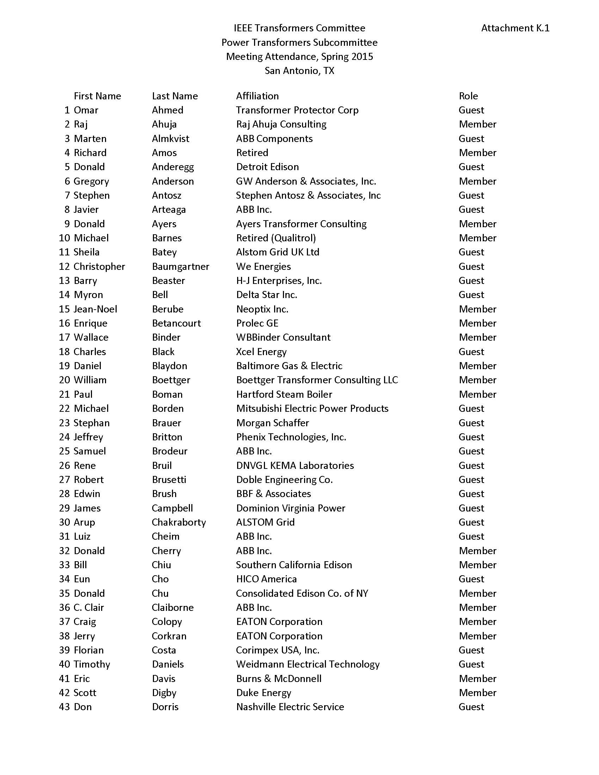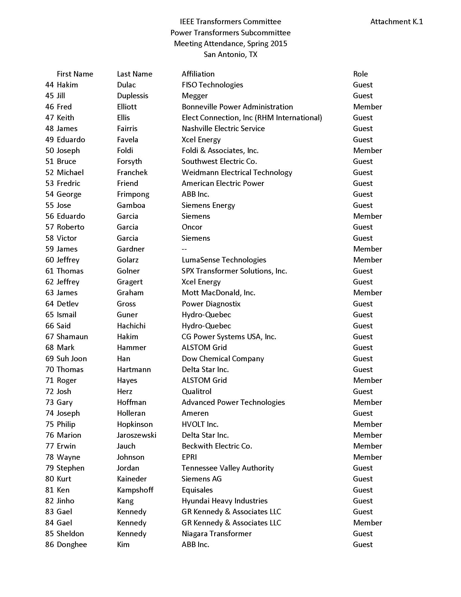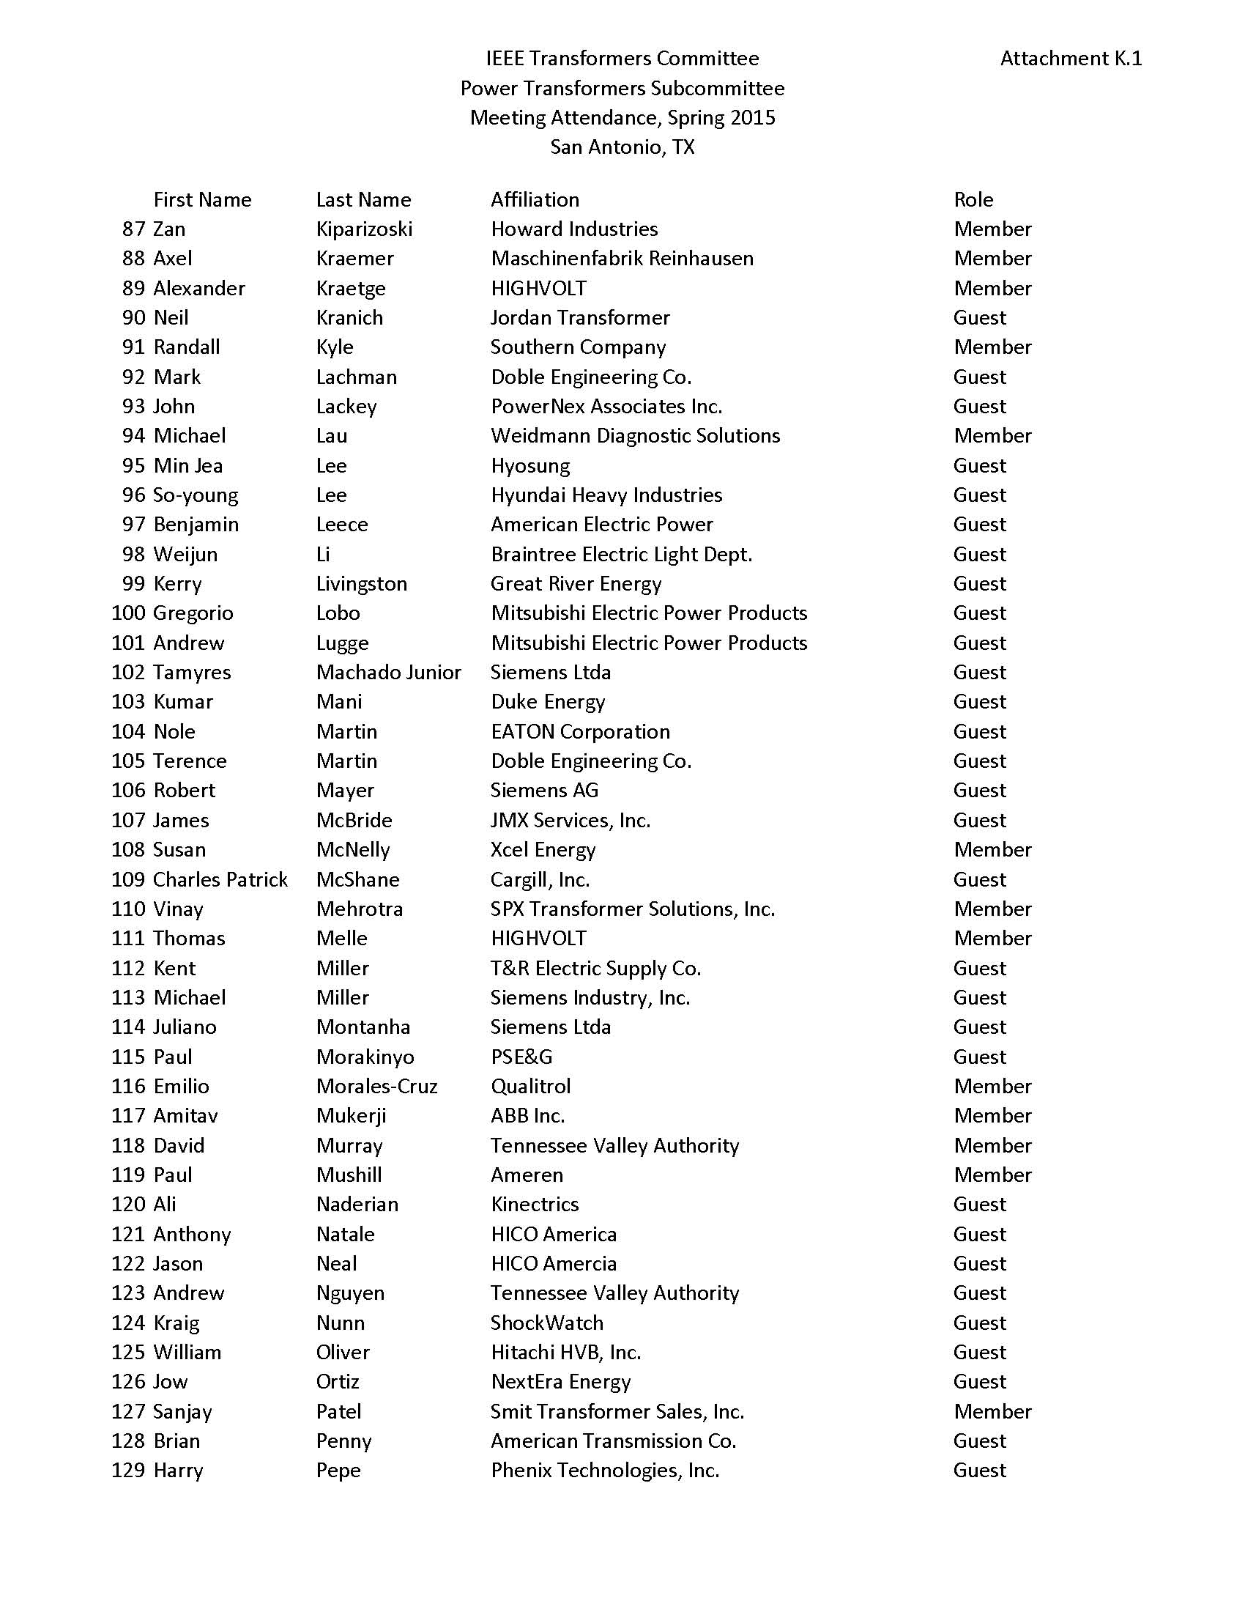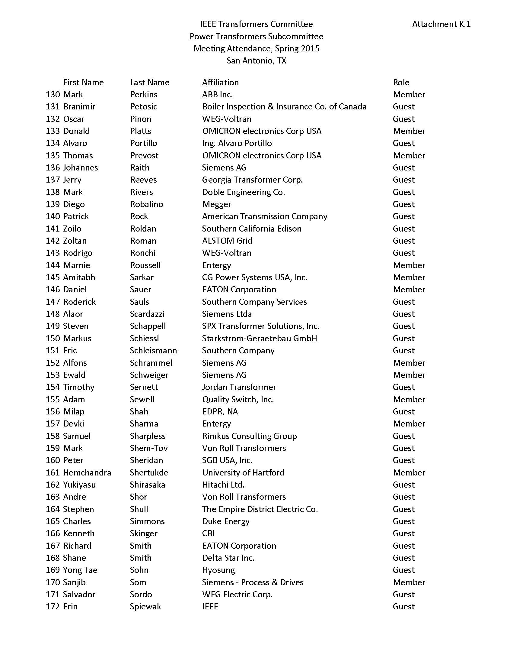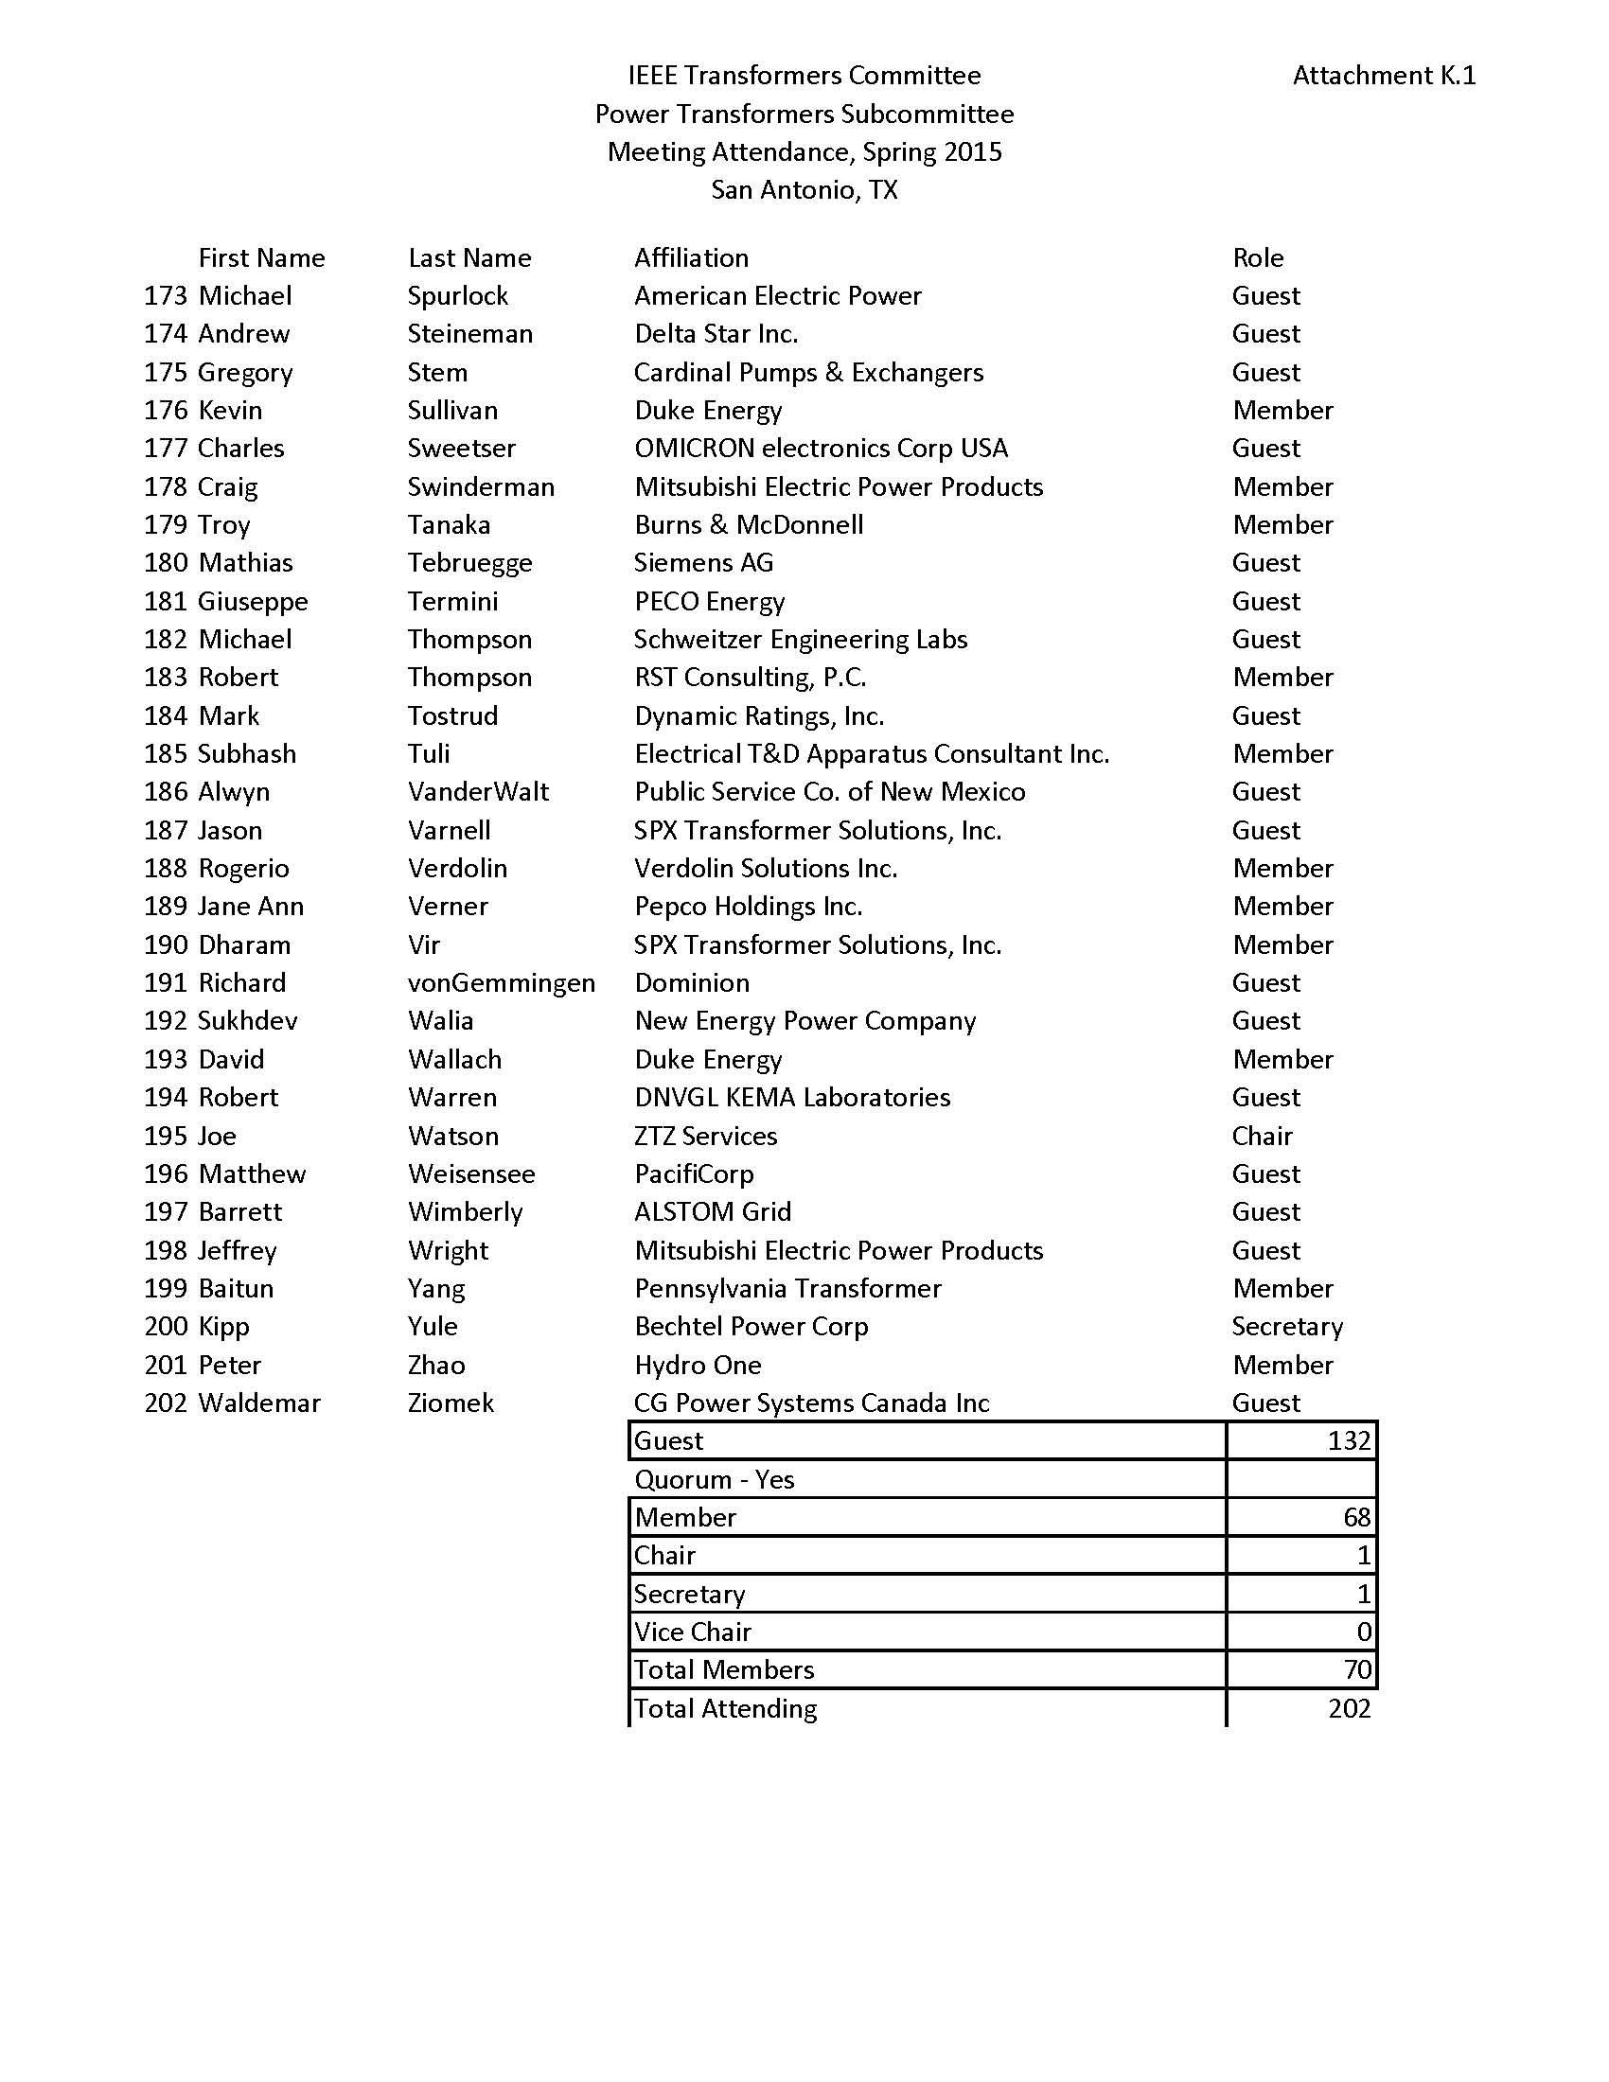
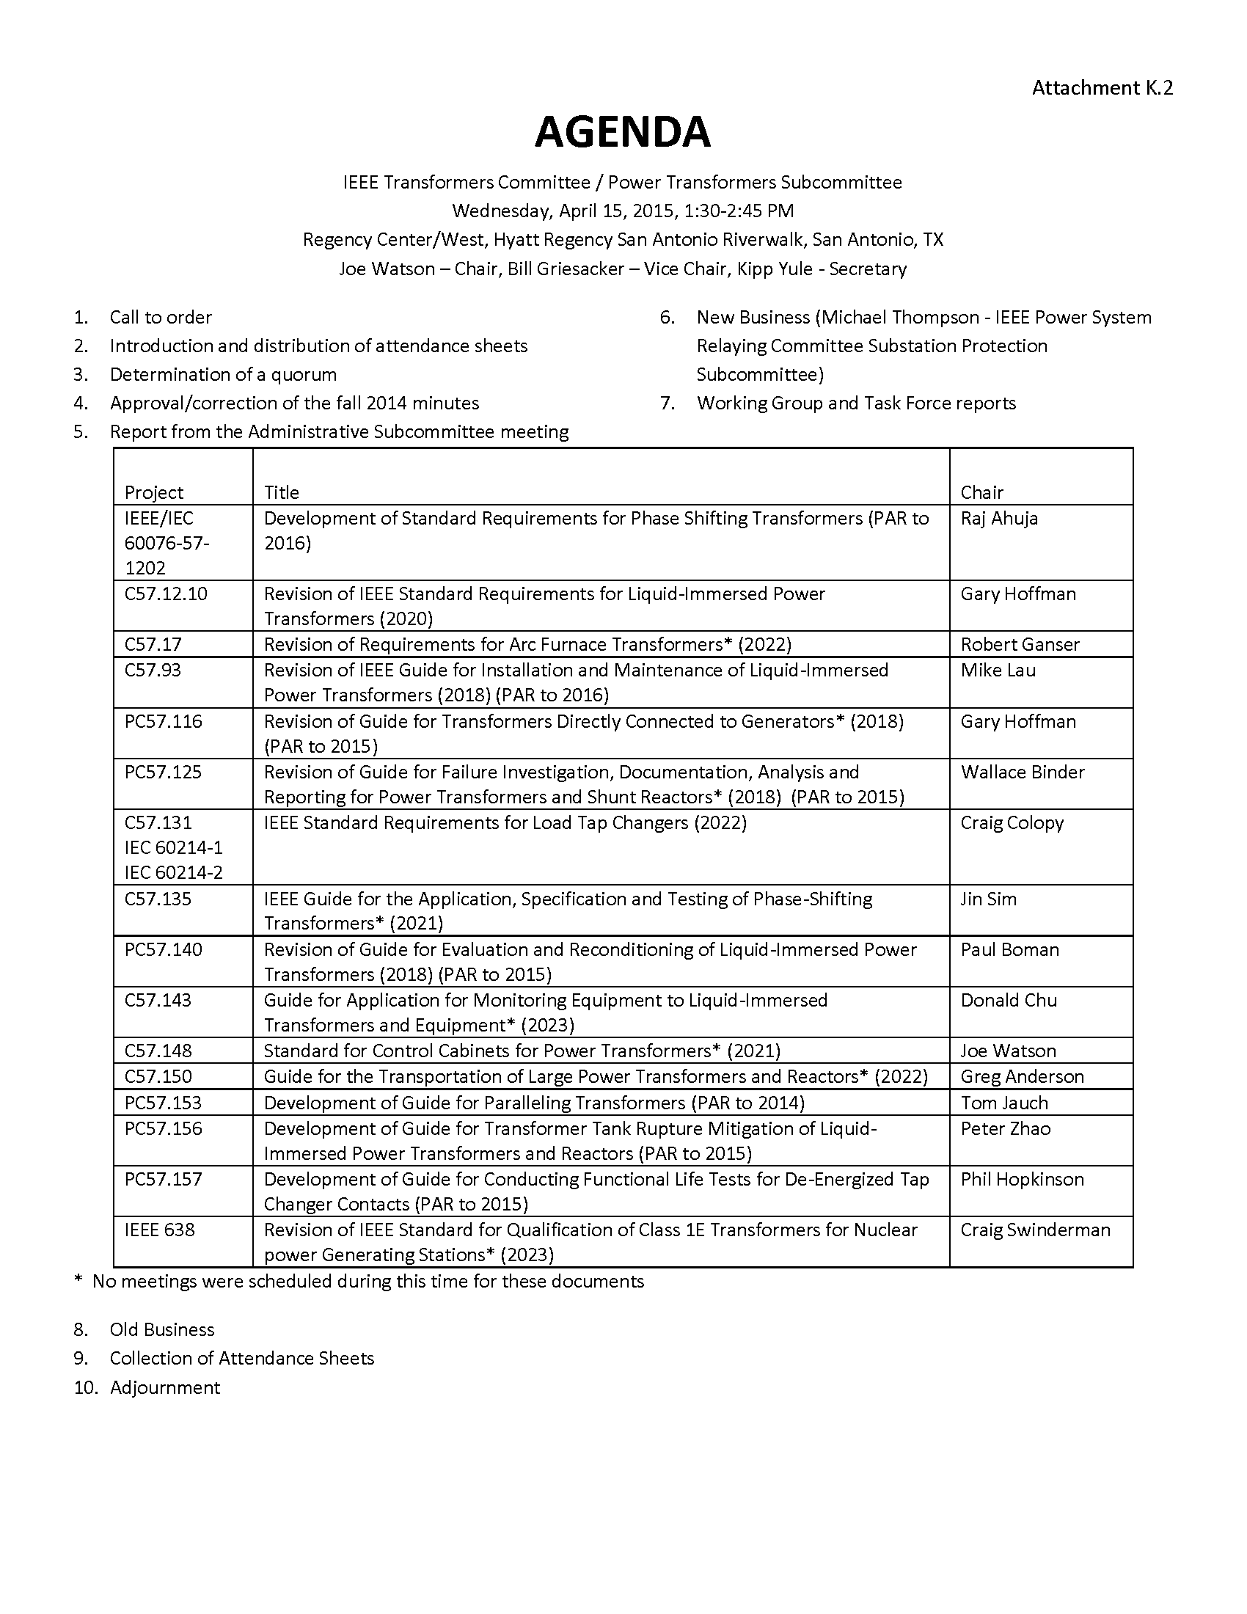
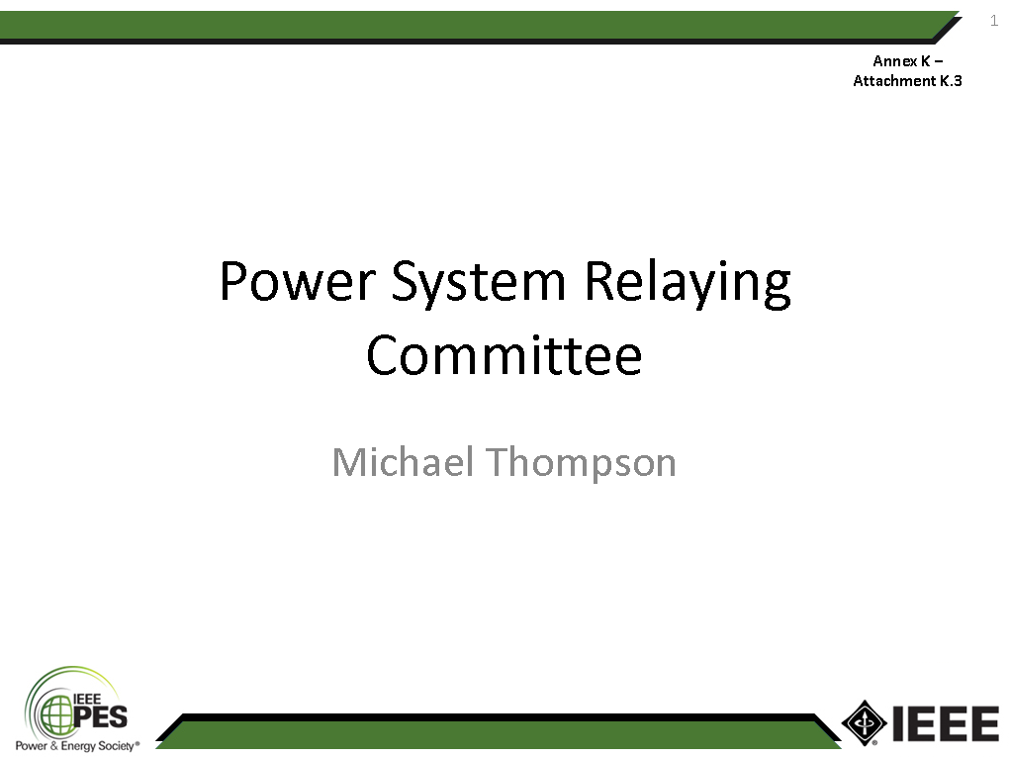
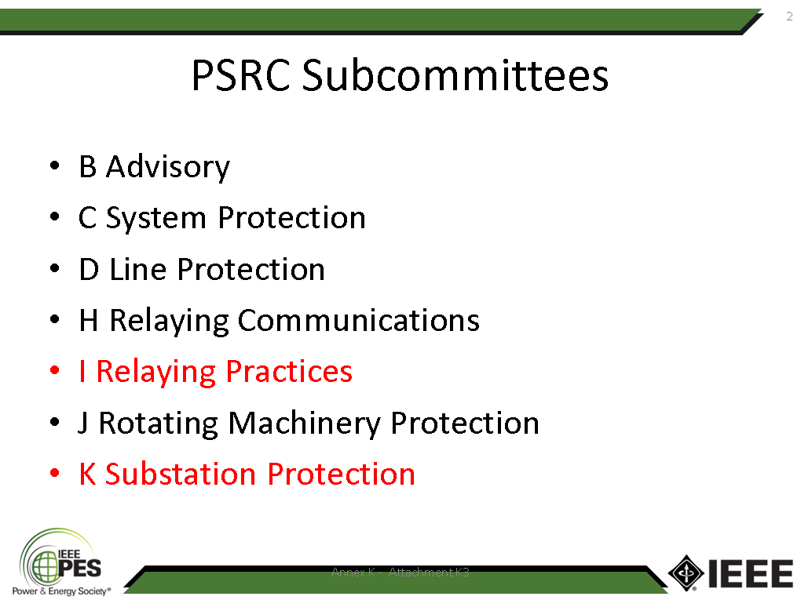
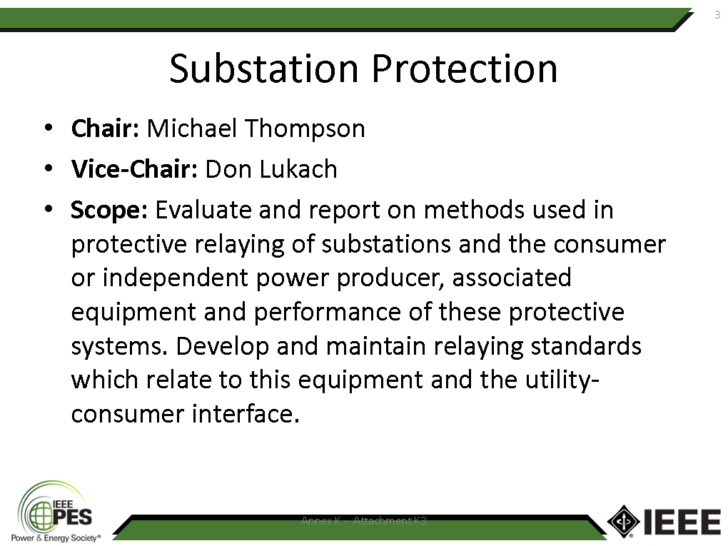
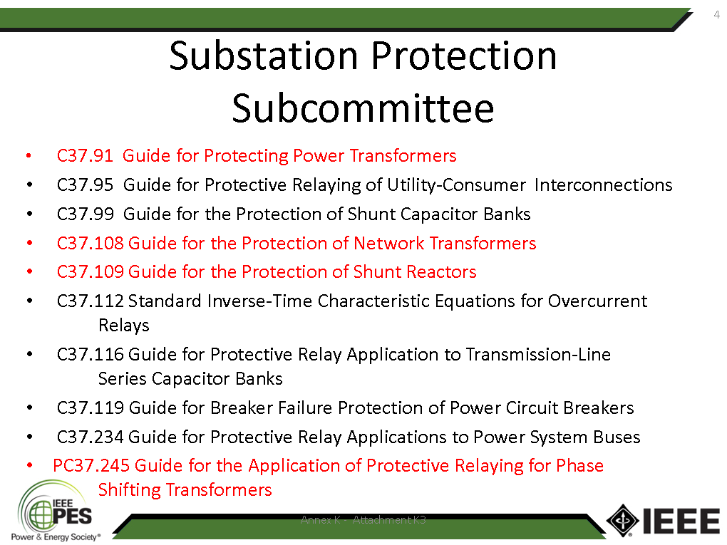
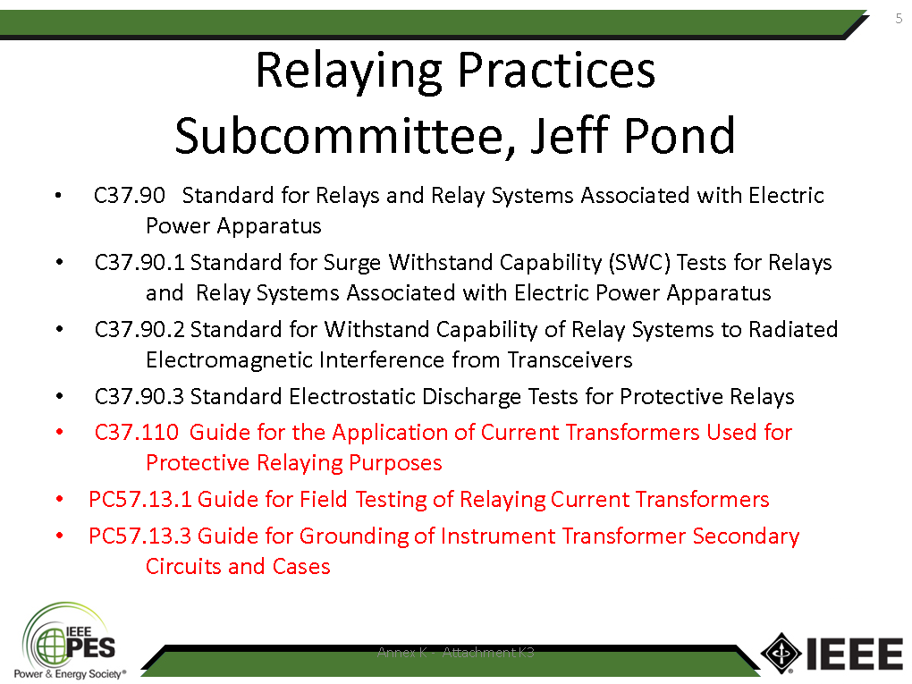
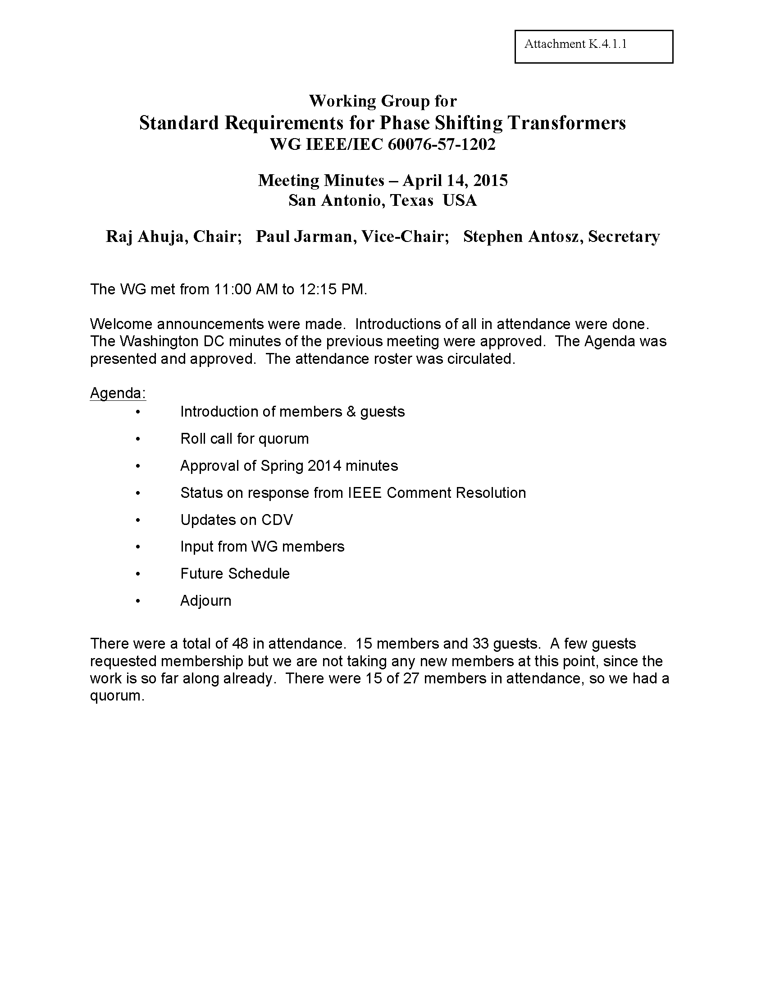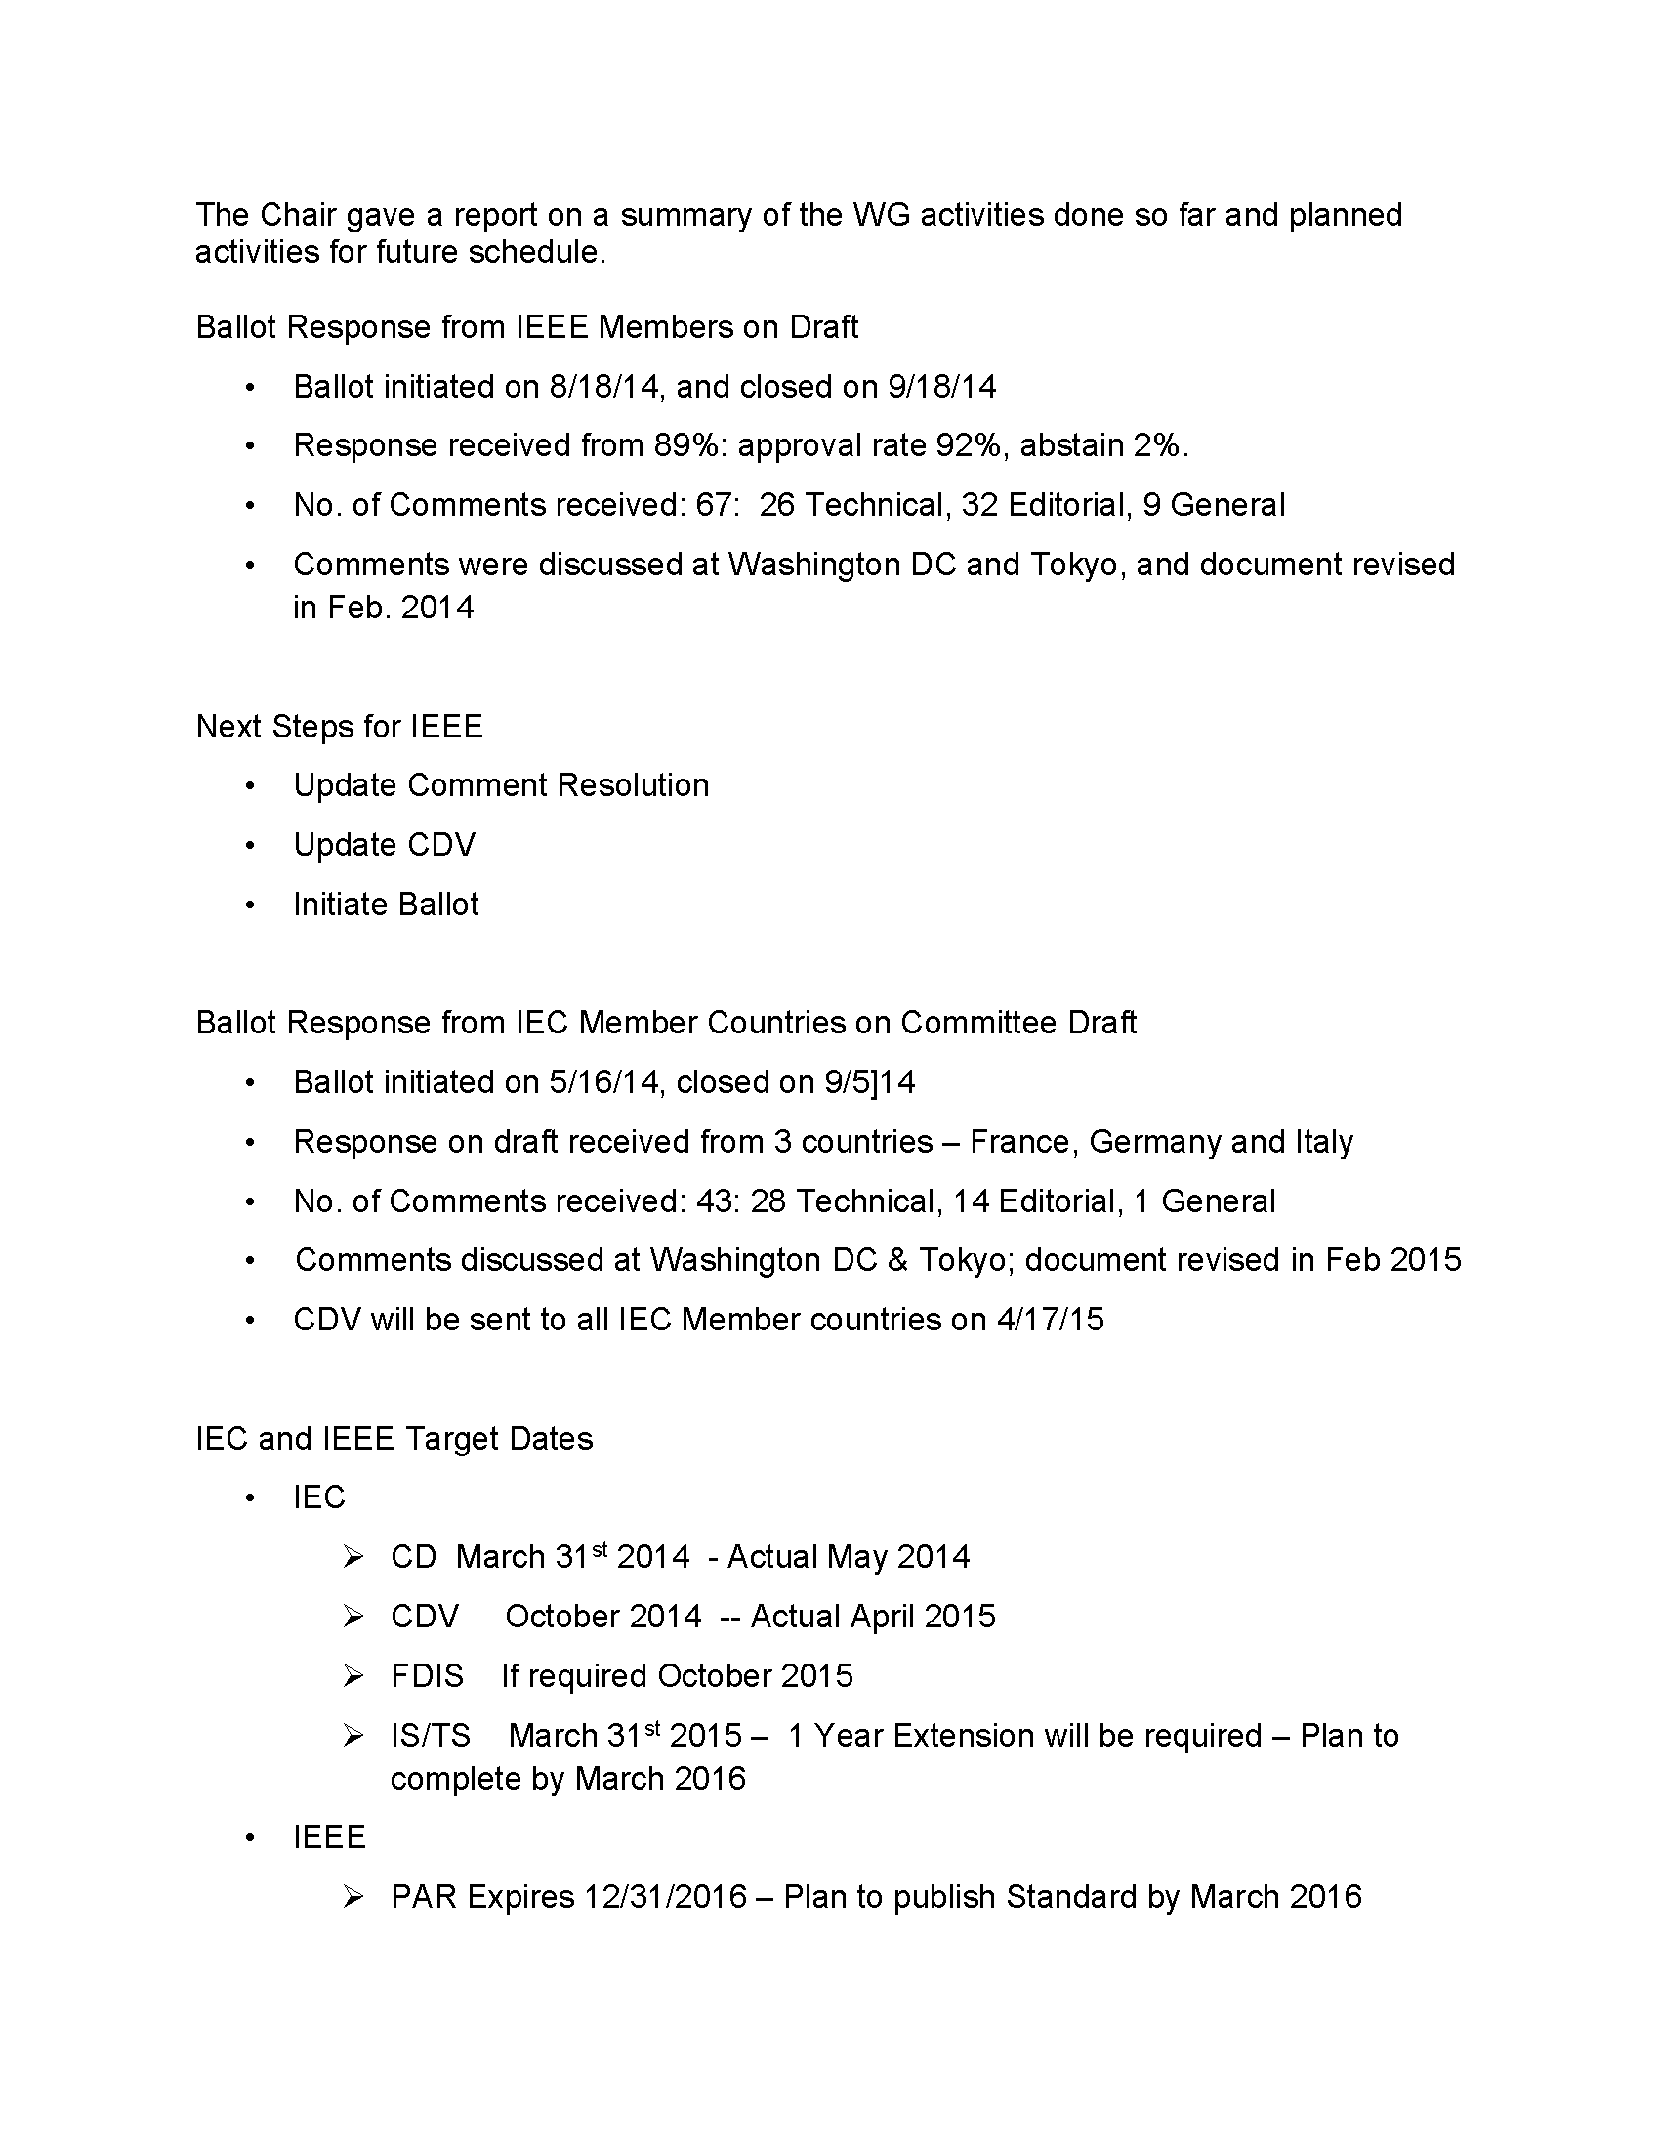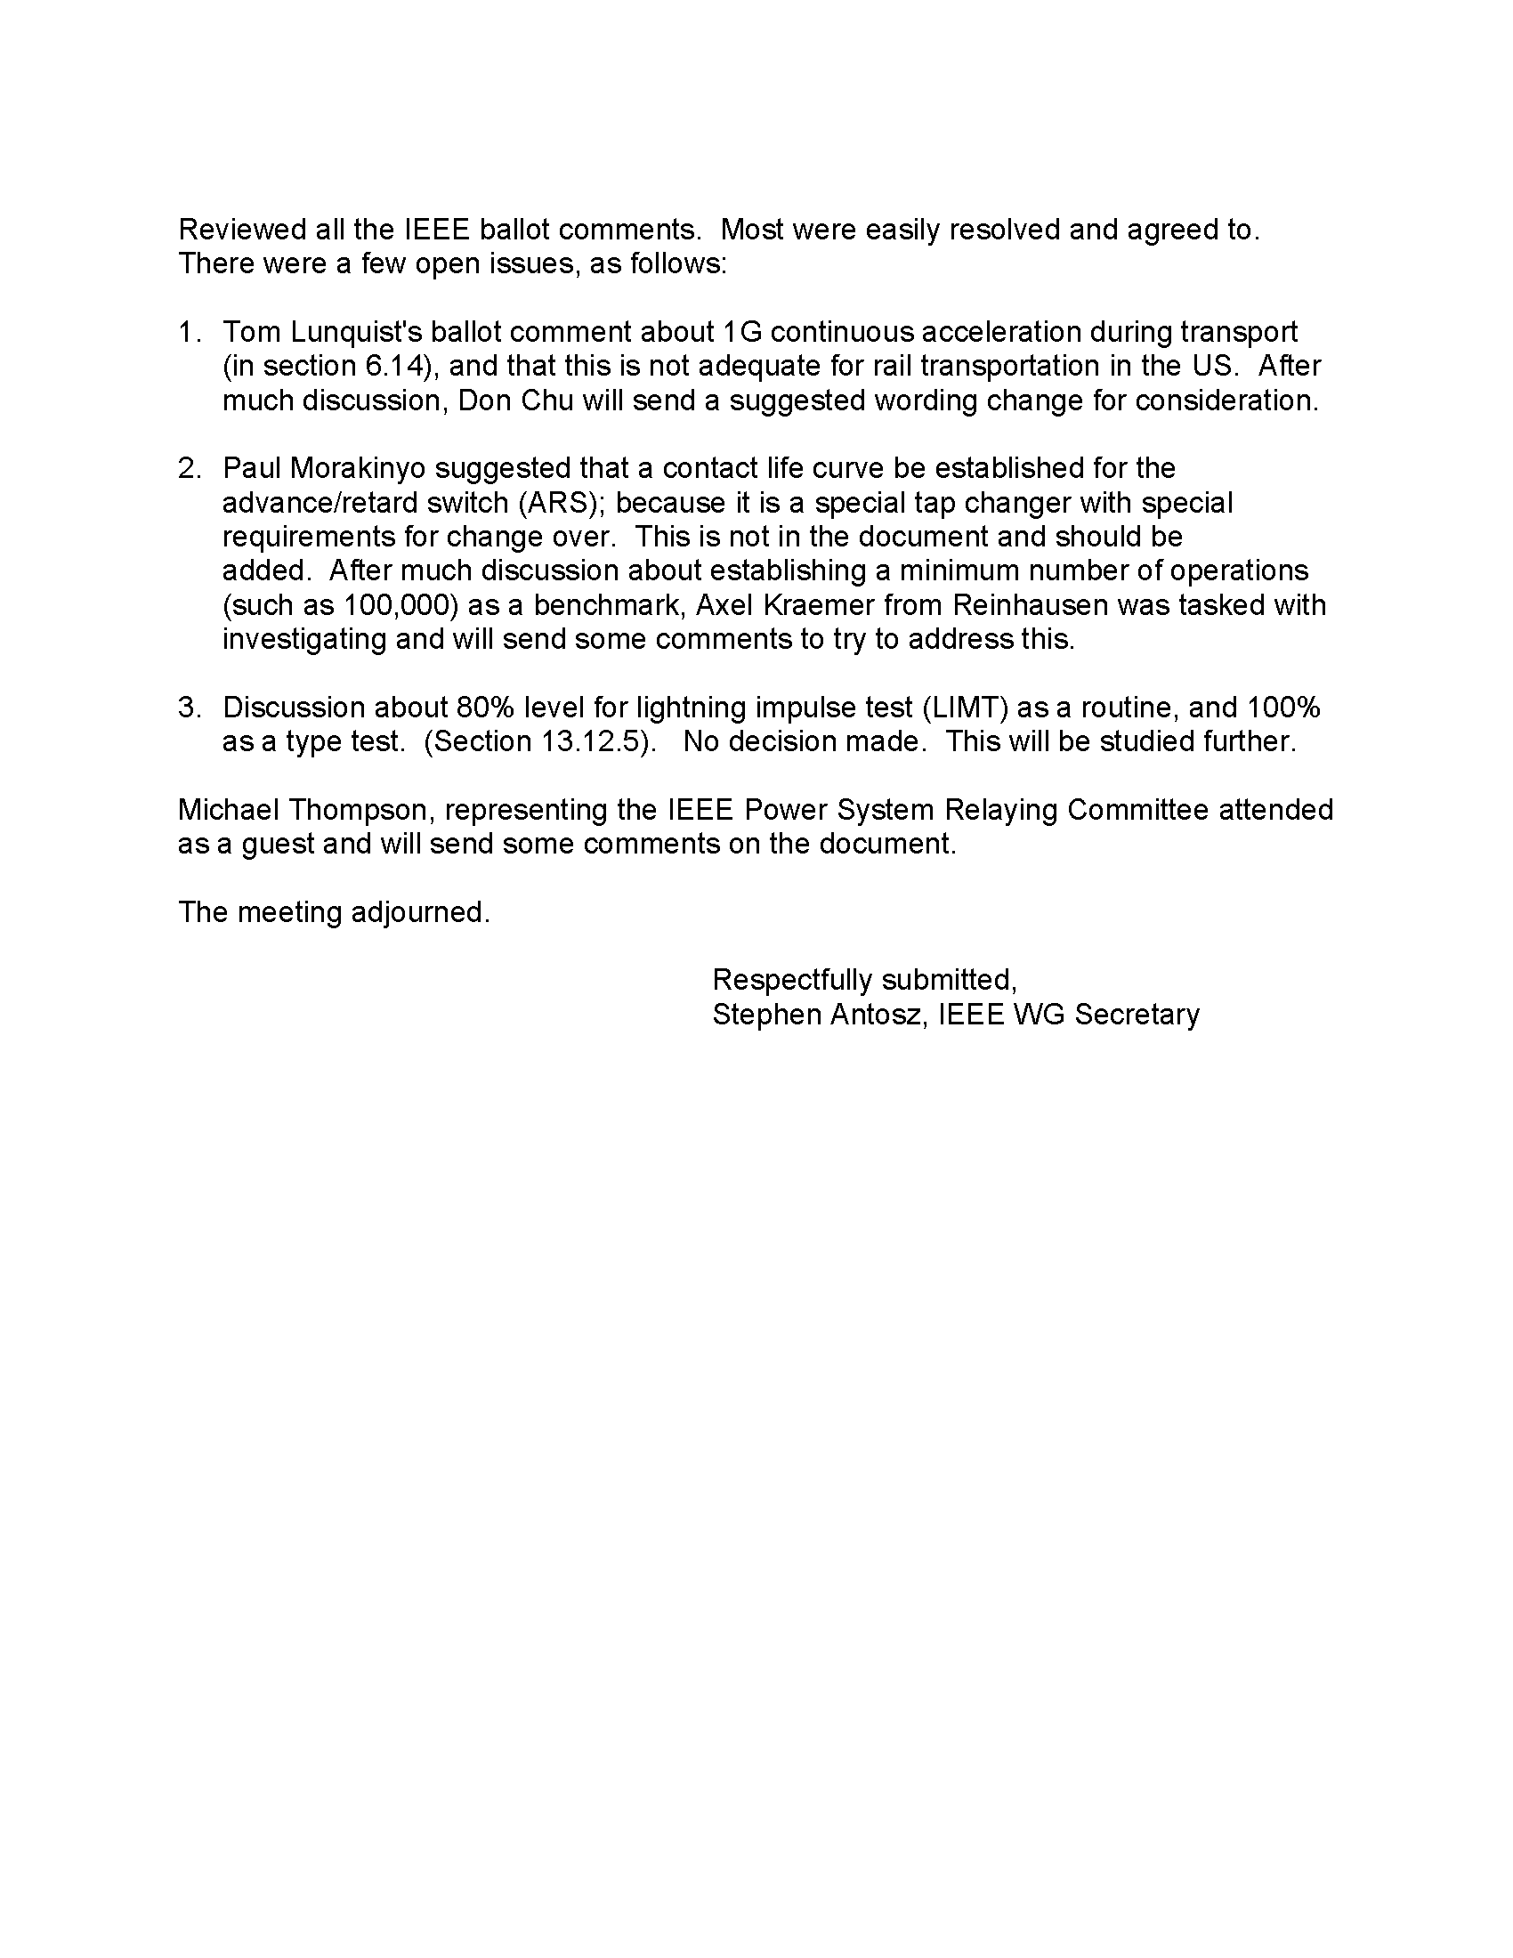

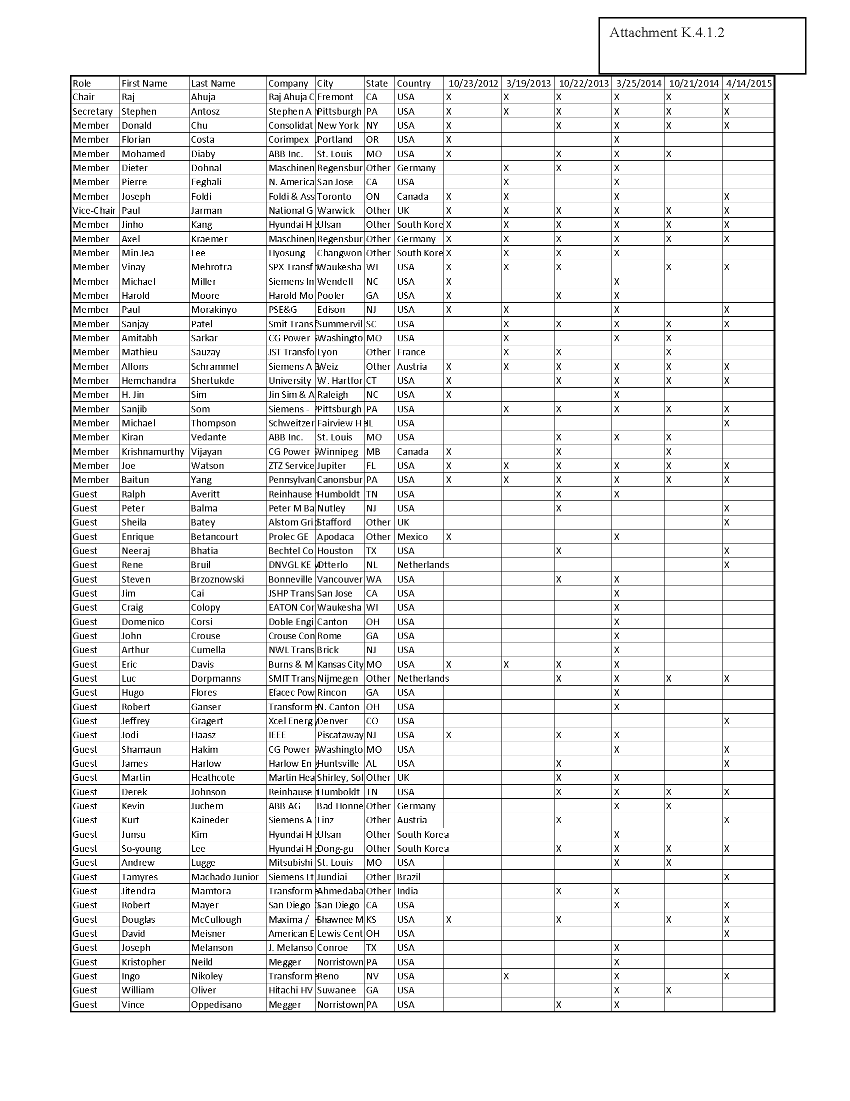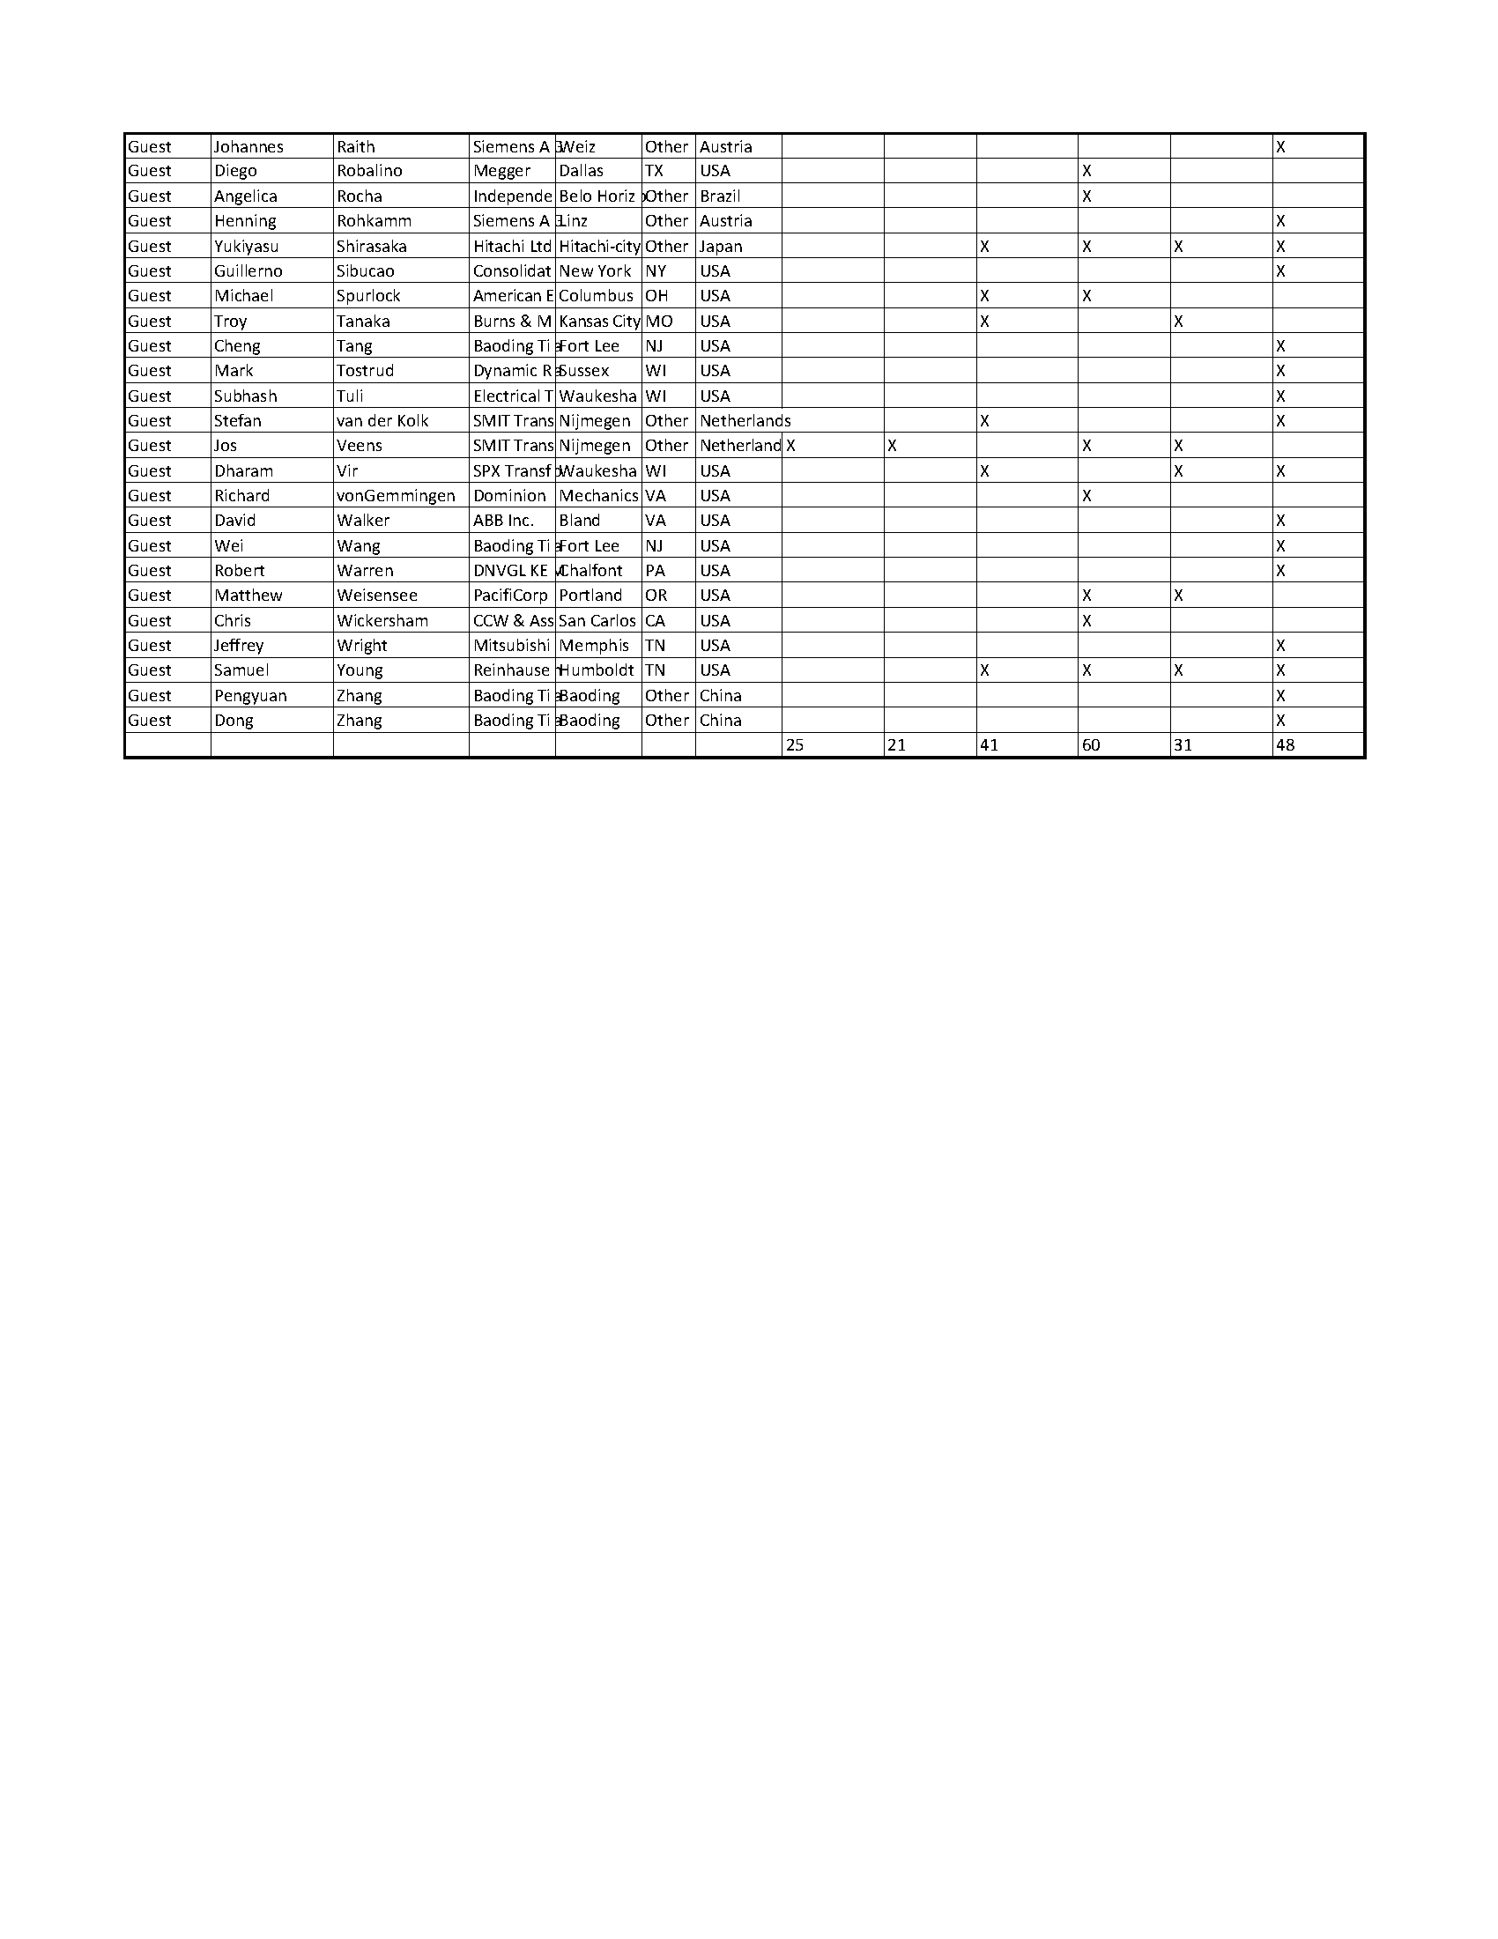
Attachment K.4.2
PC57.12.10 - WG for the Revision of
IEEE Standard Requirements for Liquid-Immersed Power Transformers
April 13, 2015
Regency West, 9:30 to 10:45 AM
San Antonio, TX

Unapproved Meeting Minutes

WG Chair Gary Hoffman called the meeting to order at 9:30 a.m., Monday, April 13, 2015, with WG Vice-Chair Brian Penny and WG Secretary Scott Digby also present. It was noted that this was the first meeting of this WG, and as such all those in attendance were considered guests until the WG membership is established during this meeting.
Introductions were made. The Chair reviewed the WG membership requirements. All attendees requesting membership in this new WG at this meeting will be automatically granted membership. After this meeting, individuals will be required to be present at two (2) consecutive WG meetings in order to be eligible for membership. There were 65 attendees present and of these 35 requested and were granted membership. Including the WG officers this brings the WG membership to a total of 38.
While the rosters were in circulation the Chair gave a general presentation on the Standard Development Process in order to review the path the WG will be taking towards the completion of their work towards revision of this standard document. This presentation is being made available on the WG web page. Special note was made that official WG correspondence is not to include a confidentiality statement or include a clause asserting copyright protection, as is often automatically included in many companies’ standard email transmittal.
The agenda was reviewed and a motion to approve was made by Craig Colopy and seconded by Don Platts, which was approved by unanimous consent.
The Chair advised that the current version of this standard, C57.12.10-2010, and all Corrigenda have been posted onto the WG web page, where they are password protected under a Username and Password specific to this WG. This username and password were shared with those in attendance. As part of the work of this WG, the Corrigenda material will need to be rolled into the main document.
The Chair noted that the scope stated in the PAR remains unchanged from what is currently in the published document.
The next order of business was to review the action plan for the working group, which will consist of the formation of three (3) sub-groups (Task forces) to address each of the three (3) major clauses of the document: Clause 4 (Ratings), Clause 5 (Construction), and Clause 6 (LTC Equipment). The scope of each of these Task Forces will be to review and recommend revisions to the given sections. It was noted that this would likely include review relative to other related documents, such as C57.12.00, in order to confirm consistency with those partner documents. The Chair then solicited volunteers for the three task forces, resulting in the following:
Clause 4 TF (Ratings): Brian Penny (TF Chair), John K. John, Rogerio Verdolin, and Richard VonGemmingen
Clause 5 TF (Construction): Joe Watson (TF Chair), Chris Baumgartner, Eduardo Garcia, David Geibel, Marion Jaroszewski, Kumar Mani, Anthony Natale, Don Platts, Richard VonGemmingen, and Peter Zhao
Clause 6 TF (LTC Equipment): Mark Tostrud (TF Chair), Myron Bell, Alex Boll, David Geibel, Robert Mayer, Emilio Morales-Cruz, Paul Mushill, and Amitabh Sarkar
The Chair plans to schedule an initial meeting of the Task Force Chairs to discuss the project further, then the individual TF Chairs will schedule meetings, teleconferences, etc. to conduct the work associated with their assigned scope. The Chair stressed the need for the Task Forces not to exceed the scope of the PAR.
Peter Zhao commented that Clause 5 of the document includes many requirements that greatly affect maintenance costs to users, including accessories that can have great impact on the useful life of the transformer, and recommended a survey to gather what experiences users are having that might help drive potential improvement or changes within this clause.
Joe Watson noted that telemetry type requirements are missing from the standard, citing LTC position as an example. The Chair stressed the need to preserve the scope that the standard included the minimal requirements only. Peter Zhao commented, and the Chair agreed, that if it becomes necessary to change the PAR, specifically the scope, as a result of the review of the clauses then it was possible but would need to be brought forward as a motion to the WG.
The next agenda item was to discuss Annex A of the current published document with the focus being whether it was still necessary now that C57.153 (IEEE Guide for Paralleling Regulating Transformers) was published. After some discussion, a motion was made by Craig Colopy and seconded by Don Platts to remove Annex A from PC57.12.10 in its entirety. During discussion of the motion it was noted by Joe Watson that there needs to be a review to confirm the content of Annex A is now completely covered elsewhere. Also during discussion of the motion it was noted by Don Platts that section 6.1 of the document that now refers to Annex A should now refer to C57.153. This discussion prompted an amendment to the original motion, so the final motion read:
Amended motion by Craig Colopy and seconded by Don Platts: Remove Annex A from PC57.12.10 in its entirety if after examined it is confirmed that its content is included in C57.153. This motioned passed.
The Clause 6 Task Force Chair, Mark Tostrud, agreed that his TF would perform the review required by this motion.
The Chair stated that the WG members and guests will be enrolled in Listserv, which is planned to be used as a communication tool by this WG, as well as Join.me as a web meeting tool planned to be utilized by this WG.
Under new business, Don Platts posed a question regarding the Corrigendas to the published document, wondering whether they were published in the form they appeared, which included crossed out text. The Chair noted that this was a required format of such Corrigendas and noted that they will be reviewed as part of this revision process.
The motion to adjourn was made by Richard VonGemmingen and seconded by Don Platts. The motion passed and the meeting was adjourned at 10:45 a.m.

Respectfully Submitted
Scott Digby, WG Secretary
Attachment K.4.3
WG Revisions to Installation of Power Transformers C57.93
Monday, April 13, 2015 11:00 AM – 12:15 PM
San Antonio, TX
Minutes of the Working Group Meeting
Chair Mike Lau called the WG meeting to order at 11:00 am on April 13, 2015. 15 of 25 members were present, so a quorum was achieved. 29 guests also attended, for a total attendance of 44. Four guests requested membership.
A motion to approve the Fall 2014 minutes was made by Alan Peterson, seconded by Mike Miller. The minutes were approved unanimously. The agenda was approved by acclimation.
Mike Lau reminded the working group that the PAR expires in 2016.
Mike Lau led a discussion of testing transformers under vacuum. There was unanimous agreement that acceptance testing should not be performed while the transformer is under vacuum. Some users monitor the progress of vacuum processing with power factor testing or winding resistance measurements. Monitor testing may be acceptable if the test voltages are low. Larry Kirchner will research the maximum safe voltage for monitor testing while the transformer is under vacuum.
Joe Watson submitted proposed text covering static electrification when using pumps, including a summary of concerns regarding static electrification for incorporation into the guide. There was consensus the guide should not specify pump running durations, only general guidance.
Derek Baranowski discussed the determination of vacuum end points using dew point measurements. This can be done with an on-line dew point monitor or periodic discreet dew point measurements. Dew point measurements may give false positives if the moisture freezes during vacuum processing.
The last topic discussed was cold start up and operation of ester-filled transformers. There were concerns expressed regarding the use of pumps with ester liquids.
The working group meeting adjourned at 11:55 am.
Respectfully submitted
Mike Lau Saurabh Ghosh Jim Graham
WG Chair Vice Chair Secretary
April 13, 2015

Attachment K.4.5-1

Document #: | 60214-1 and C57.131

Document Title: | Tap-Changers

Chair: | Craig A. Colopy | Vice-Chair | Axel Kraemer
Secretary

Current Draft Being Worked On: | N/A | Dated: | N/A

Meeting Date: | 14 April 2015 | Time: | 13:45 to 15:00

Attendance: | Members | 15
 | Guests | 27
 | Guests Requesting Membership | 3
 | Total | 45

Meeting Minutes / Significant Issues / Comments:

- Meeting was called to order at 1:45 pm, April 14
- Chairman provided the WG a view of a presentation made to the IEC TC14 meeting in Tokyo, Japan, regarding the work being done to harmonize the Tap-Changer standards between IEEE and IEC.
- Chairman reiterated the task at hand of comparing the two documents, C57.131-2012 and 60214-1in order to make a sound recommendation to the Transformer SC to consider adopting the 60214-1 IEC standard as a dual logo document for IEEE, replacing the existing C57.131. This would start a future joint review process going forward on one document to be used globally.
- Chairman provided a review of his comparison of Section 5, On-Load Tap-Changer requirements, between C57.131 and 60214-1. A significant amount of additional technical data was observed with regard to the latest 60214-1 standard which includes information regarding vacuum resistor and reactor type tap-changers as well as tap-changers using SF6 gas.
- Volunteers were secured to review other sections between the IEEE and IEC standards covering: Definitions, Service Conditions, Requirements for motor-drive mechanisms for On-Load Tap-Changers, Requirements for De-Energized Tap-Changers and Requirements for motor-drive mechanisms for de-energized tap-changers.
- A link on the Power Transformer SC will be created for access to a website for work being done by the Task Force comparing the Part 1 of the IEC 60214 Ed 2.0 Tap Changer standard with the IEEE C57.131-2012 standard. This site will also include work created by the WG for the joint revision of the Tap-Changer application guide.
- Next meeting — November 3, 2015 at the Peabody Hotel in Memphis TN
- Meeting closed at 3:00 pm, April 14
Submitted by: Craig A, Colopy
Date: 04/15/2015
Attachment K.4.5-2

Document #: | 60214-2

Document Title: | OLTC Application Guide

Chair: | Craig A. Colopy | Vice-Chair | Axel Kraemer
Secretary

Current Draft Being Worked On: | 3 WD IEC 60214-2 | Dated:

Meeting Date: | 14 April 2015 | Time: | 15:15 to 16:30

Attendance: | Members | 13
 | Guests | 17
 | Guests Requesting Membership | 2
 | Total | 32

Meeting Minutes / Significant Issues / Comments:

1. Meeting was called to order at 3:15 pm, April 14
2. Chairman provided the WG a view of a presentation made to the IEC TC14 meeting in Tokyo, Japan, regarding the work being done to harmonize the Tap-Changer standards between IEEE and IEC.
3. A review of Draft 2 WD IEC 60214-2 based on work completed in Washington DC and London, UK was presented to the joint revision Working Group. Comments from the WG as well as ideas for additional information to be included in the draft were discussed.
4. A link on the Power Transformer SC will be created for access to a website for work being done on the joint revision of the Tap-Changer application guide. This site will also include work created by the Task Force comparing the Part 1 of the IEC 60214 Ed 2.0 Tap Changer standard with the IEEE C57.131-2012 standard.
5. Next Work Sessions scheduled are the following:
Kista (suburb of Stockholm, Sweden) on June 8th and 9th, 2015
After the General IEEE transformer meeting in Memphis TN, on November 5th and 6th, 2015.
6. Next general meeting — November 3, 2015 at the Peabody Hotel in Memphis TN
7. Meeting closed at 4:45 pm, April 14

Submitted by: Craig A, Colopy
Date: 04/15/2015

8. Chairman advised WG of the Work Session which took place Friday and Saturday, April 10 – 11, before the General Meeting. Draft 1.0 had been created between the Washington DC and San Antonio meetings based on the work completed in Washington DC. Draft 1.0 had been sent out to the WG members before the work session in San Antonio. Draft 1.1 was created from work done during this past week’s work session.
9. Approval of Washington DC minutes and San Antonio’s agenda was given.
10. The Chairman reviewed presentation given at the IEC TC14 meeting in Tokyo, Japan last November regarding the work completed in Washington DC.
11. Chairman reviewed Draft 1.1 with Working Group members and Guests
12. Highlights of Draft 1.1
  - Discussion on Design Type B resulted in establishing a standard range of regulation in the Raise and Lower directions for Forward and Reverse Power Flow. Annex C created for additional information on step-voltage regulator construction.
  - Temperature limits in Table 2 enhanced to include differences between IEC and IEEE. Updates also made based on latest changes to C57.12.00.
  - Added corresponding maximum system voltages to rating tables for single and three phase regulators, 50 and 60 Hz.
  - Increased maximum supplementary continuous-current rating from 668 to 875 amps
  - Addressed preferred force-air ratings in a new table.
  - Provided audible sound levels based on kVA
  - Added additional Design Tests; Audible Sound and Tank Integrity.
  - External dielectric clearance table provided for Distribution and Substation regulators
  - Changes to Design Impulse and Temperature tests in C57.12.90 incorporated.
  - Routine and Design On-Load Tap-Changer tests added.
  - Obsoleted referenced control design tests removed and replaced with latest standards
  - Details on Universal Interface (Mil Spec connector) established for juncture between tank and control enclosure. Identification and numbers of terminals were implemented.
  - Design compatibility test for control and tap-changer groupings.
  - Annexes added for Step-Voltage Regulator construction, “Bypass off Neutral” issue and Overloading of Voltage Regulators.
- Work Sessions will continue at the Memphis meeting in the Fall. An attempt will be made to have a meeting in Germany or France with the IEC members and any interested IEEE members before the Memphis meeting.

- Next meeting — October 30 & 31, 2015 at the Peabody Hotel in Memphis TN

Submitted by: Gael R Kennedy
Date: 04/13/2015
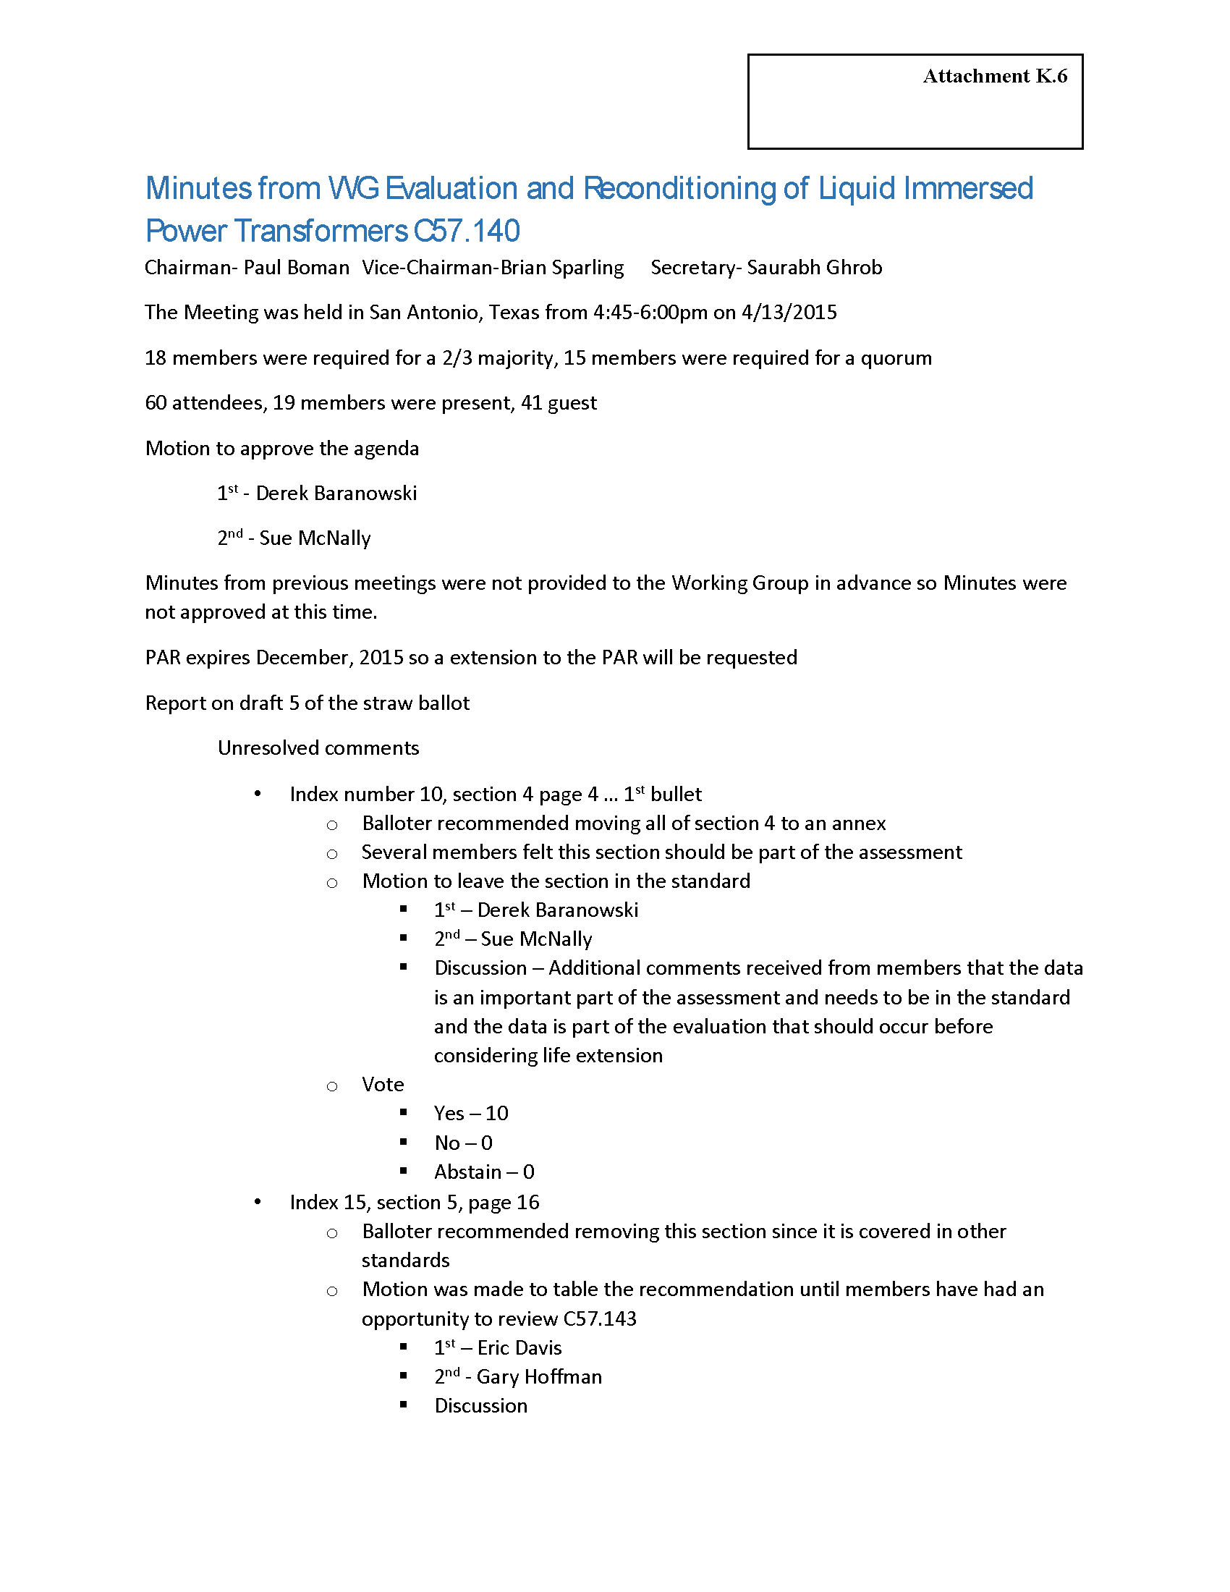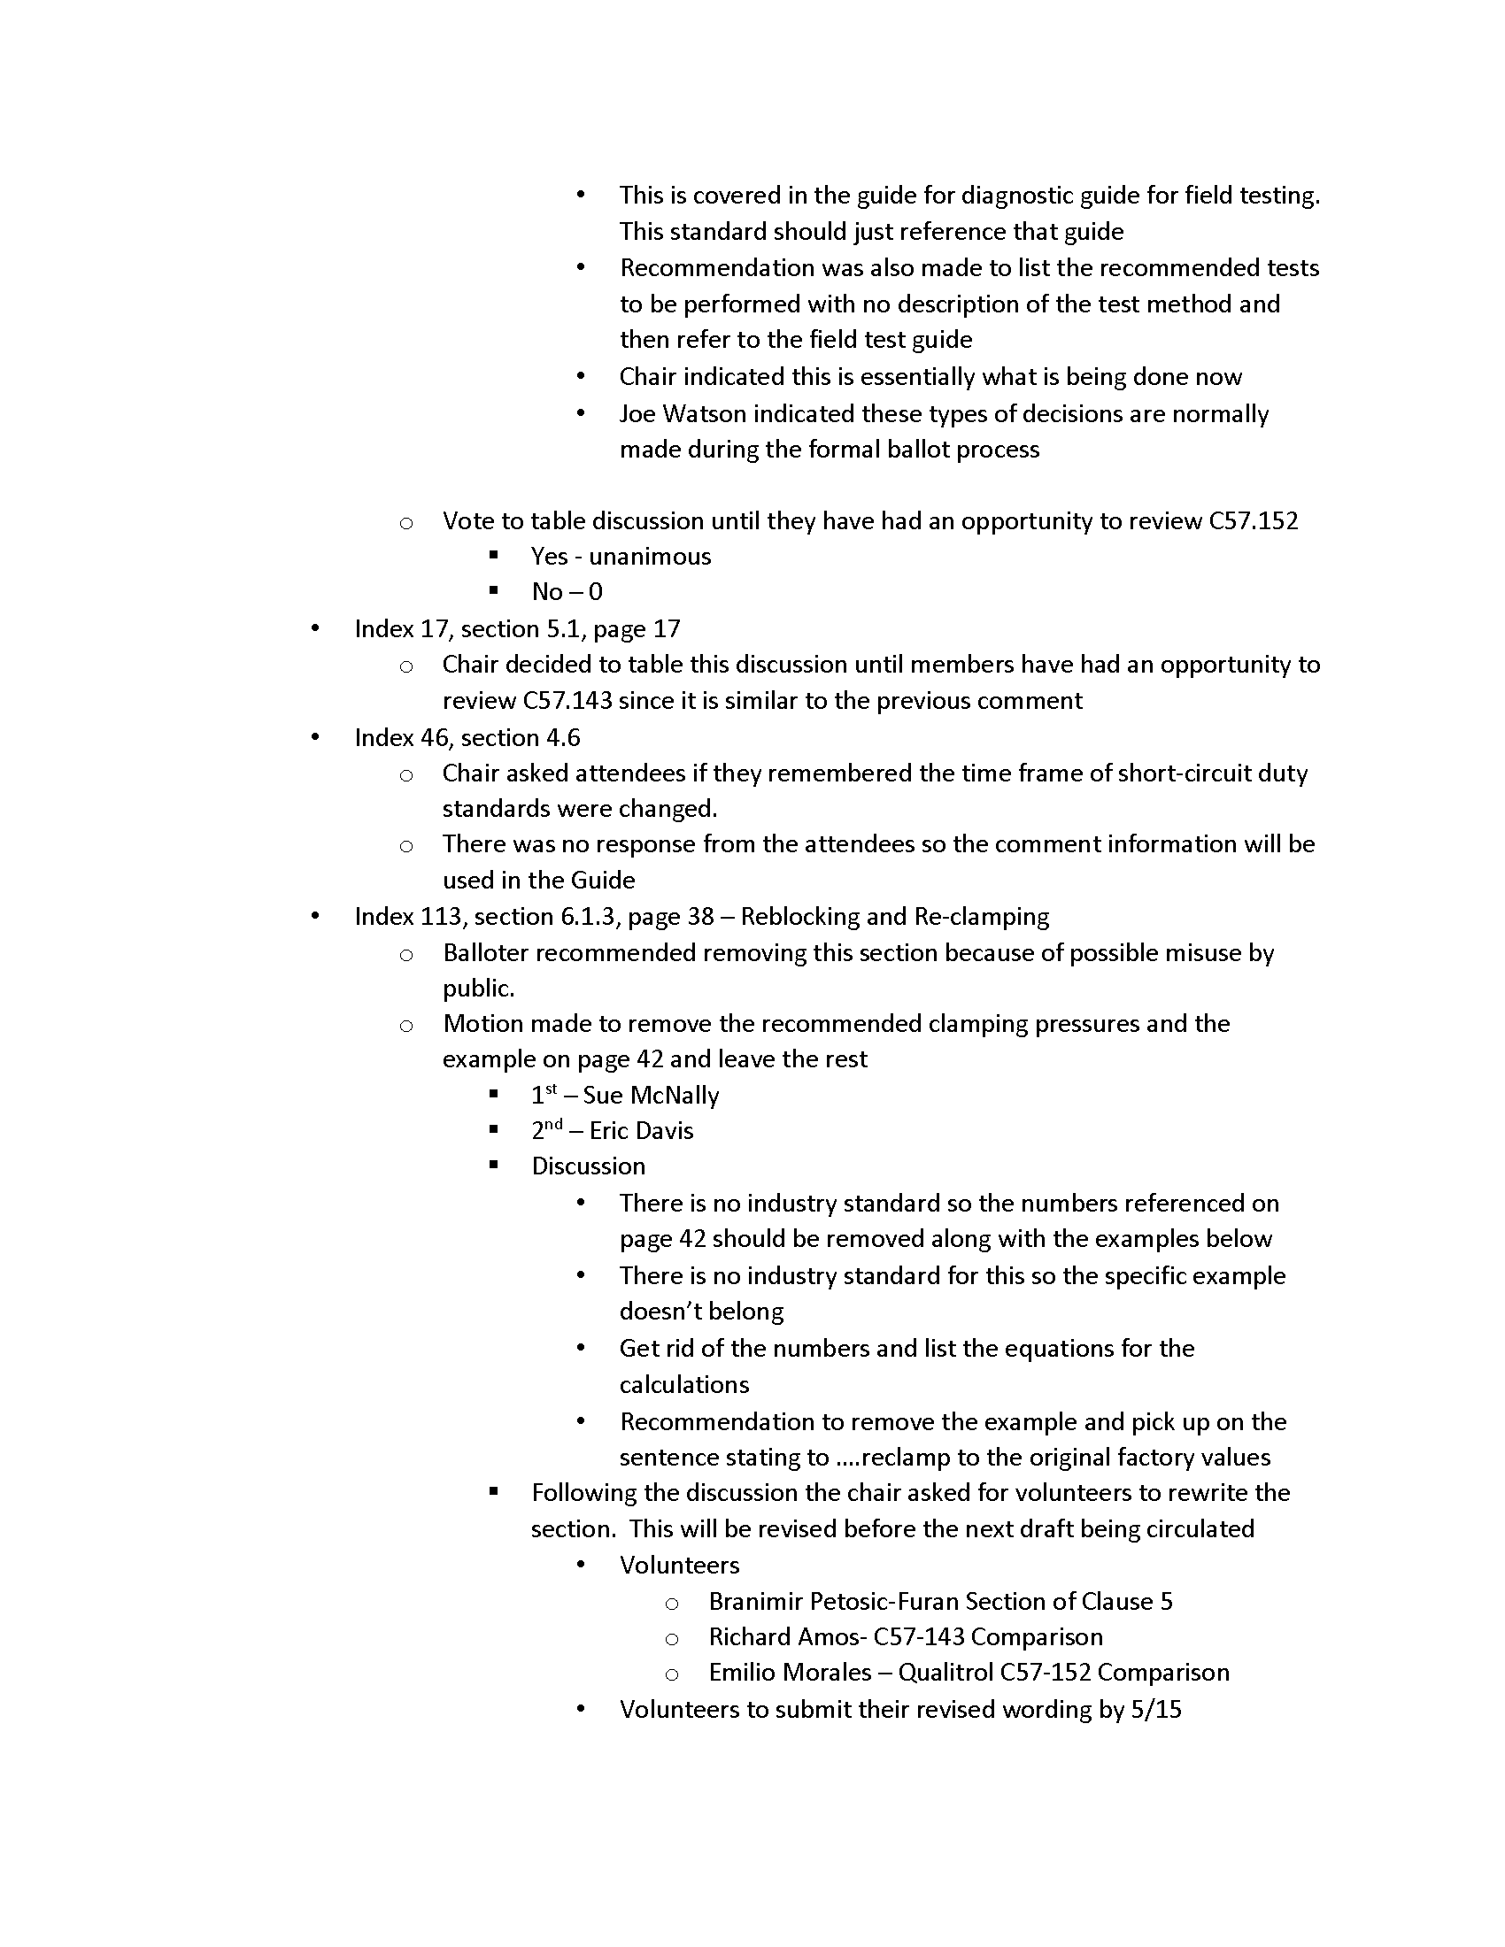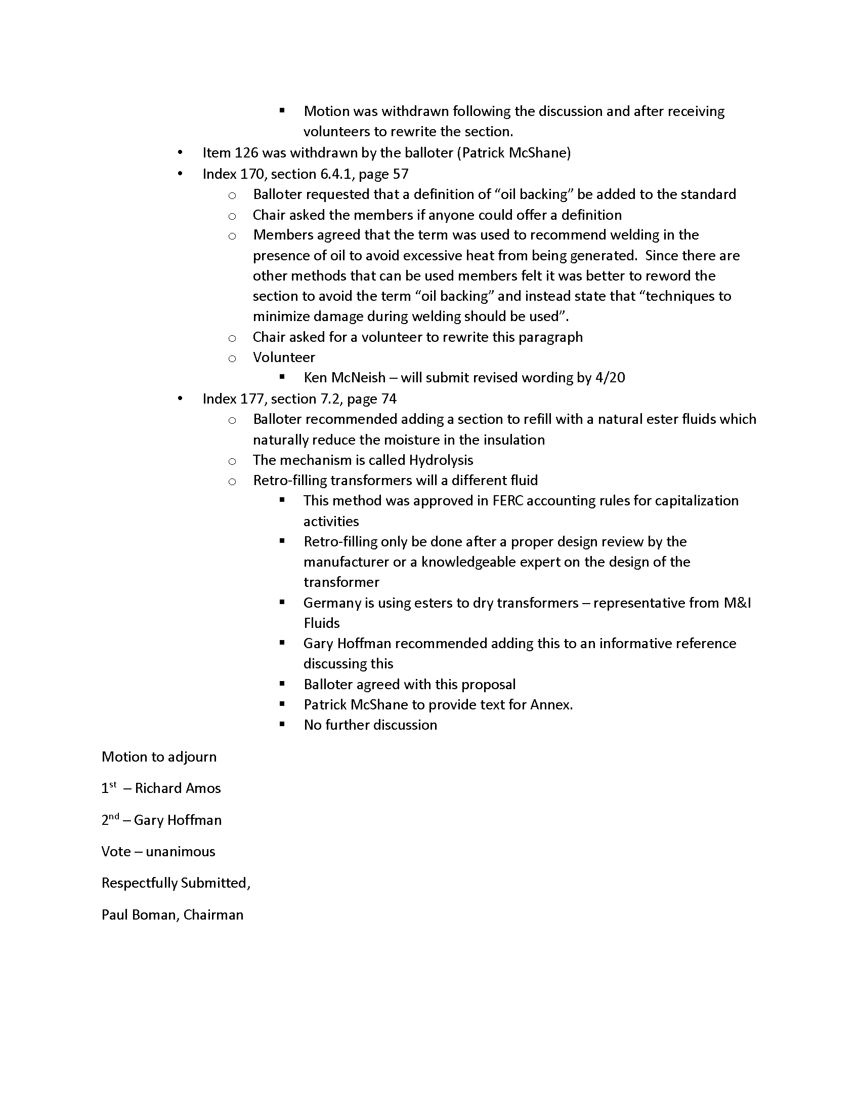

Attachment K.4.11

REPORT OF MEETING

WG PC57.156– GUIDE FOR TANK RUPTURE MITIGATION

1:45pm – 3:00pm Monday 04/13/15

San Antonio, Tx

The meeting of the Working Group for the Guide for Tank Rupture Mitigation convened Monday afternoon at 1:45pm. Chairman Peter Zhao presided.

Introductions were made and attendance rosters were passed around.

Attendance was 62 (15 members, 47 guests). Although we failed to meet a quorum it should be noted that, due to the status of the document (balloting just completed), there was no business to be conducted at this meeting.

Minutes of the 14-02 meeting in Washington were presented for comment. Patrick McShane pointed out that his request to use the term “insulating liquid” instead of “fluid” was stated in the reverse. Minutes will be revised accordingly and forwarded to Joe Watson for the record.

Chairman Zhao provided introductory remarks and previewed the agenda to be covered for the meeting.

The chairman presented a pie chart illustrating the diversity of backgrounds for participating voters.

Results of the balloting were presented by Chairman Zhao: There were 118 balloters, with an 88.0% response rate. Approval rate was 87%, with 2% abstaining. There were 191 comments to be resolved.

The Chairman confirmed that the path forward is for him and the vice chair to establish a Ballot Resolution Group (composed of selected active contributors to the Guide) to resolve comments. Resolution period will be restricted to 10 days from the request going out.

When comments are resolved, the revised guide will again be sent out for votes with comments to be restricted to changes resulting from the ballot resolution process. Once any resulting comments are resolved, the guide will be forwarded to IEEE for review and publishing.

The hope is to publish sometime during the second half of the year. It is anticipated that a full open meeting will not be necessary for our next meetings in the fall (Memphis), although there may be a few selected persons invited to meet during that time.

Joe Watson commented that the important thing at this point is that the process continues to flow toward completion.

The meeting was adjourned at 2:30pm.

Respectfully,
Robert Thompson, V Chair 04/14/15

Attachment K.4.12

IEEE/PES TRANSFORMERS COMMITTEE

WG FUNCTIONAL LIFE TESTS ON SWITCH CONTACTS PC57.157

MINUTES
Document #: | PC57.157 | Current Standard Date: | NA

Document Title: | WG Functional Life Tests on Switch Contacts PC57.157

Chair: | Phil Hopkinson | Vice-Chair | Adam Sewell
Secretary | NA

PAR Date: | 12/07/2011 |  | PAR Expiration Date: |  | 12/31/2015
PAR Status: | NA
Current Draft Being Worked On: |  | 6.1 |  | Dated: |  | Oct 2014

Meeting Date: | April 14, 2015 | Time: | 8:00-9:15 AM

Attendance: | Members | 10(out of 23)
 | Guests | 25
 | Guests requesting Membership | 2
 | Total | 35

The Working Group was called to order at 8:05 AM on April 14, 2015.

- Introductions
  - The chairman welcomed attendees and all attendees announced their name and company affiliations. Attendance sheets were passed out. A count of members was made at this time, and it was determined by the chairman that a quorum was present.

- The agenda for this meeting were approved
  - D.Sauer – motion, J.Sewell – second
  - none opposed, APPROVE

- The minutes were approved from the Fall 2014 meeting in Washington, D.C.
  - D.Sauer – motion, A.Kraemer – second
  - none opposed, APPROVE

- Assignments
  - Approve ballot pool if balanced or send more invites to ballot (see p. 2 of minutes)
    - Ballot pool had no group at 33% or higher so it was determined to be balanced
  - Form a MEC/Safety resolution TF
    - P.Hopkinson, A.Sewell, J.Sewell, & J.Antwiler volunteered to be a part of TF
  - Form a ballot resolution TF (BRG)
    - P.Hopkinson, A.Sewell, J.Sewell, J.Antwiler, & A.Kraemer volunteered to be a part of TF

- Future Work
  - Corresponding Member title eliminated (A. Sewell to update)
    - change to Member if 2 out of last 3 meetings attended
    - change to Guest if less than 2 out of last 3 meetings attended
  - Resolve MEC/Safety comments – May 2015 (MEC/Safety TF)
  - Submit guide for final ballot – May 2015 (Chair/Vice Chair)
  - Resolve ballot comments – August 2015 (BRG)
  - Prepare PAR extension request – A. Sewell
    - our PAR expires 12/2015 and balloting process may not be completed before then
  - Send out ballot process updates to WG – A. Sewell

- Adjournment
  - The meeting was adjourned at 8:25AM

- Time and place of next meeting
- Next in person meeting will be at the Fall IEEE Transformer Committee meeting in Memphis, TN during the week of November 1, 2015.
