IEEE/PES
Transformers
Committee

Spring 2015
Meeting Minutes

San Antonio, Texas, USA
April 12 – 16, 2015

Unapproved
(These minutes are on the agenda to be approved at the next meeting in Fall 2015)
Table of Contents
Monday Opening Session – April 13, 2015
- Agenda
- Attendance
- Approval of Agenda and Previous Minutes – Don Platts
- Meeting Schedule
- Chair’s Remarks & Report – Don Platts
- Vice Chair’s Report – Stephen Antosz
- Secretary’s Report – Susan McNelly
- Treasurer’s Report – Gregory Anderson
- Awards Report – Bill Chiu
- Administrative SC Meeting Report – Susan McNelly
- Standards Report – William Bartley
- Editor’s Report – Sanjib Som
- Liaison Reports
  - Cigre – Raj Ahuja
  - IEC TC14 Technical Advisor to USNC – Paul Jarman
  - Standards Coordinating Committee No. 18 (NFPA/NEC) – Ned Brush
  - Standards Coordinating Committee No. 4 (Electrical Insulation) – Paulette Payne reported by Don Platts
- Unfinished (Old) Business
- New Business
- Monday Opening Session Adjournment
Thursday Closing Session – April 16, 2015
- Chair’s Remarks and Anouncements
- Meetings Planning SC Minutes & Report – Gregory Anderson
- IEC TC14 Technical Advisor to USNC –Phil Hopkinson
- Reports from Technical Subcommittees (decisions made during the week)
- Report from Standards Subcommittee (issues from the week)
- New Business (Continued from Monday General Session)
- Thursday General Session Adjournment
Minutes of Technical Subcommittees
- Bushings SC – Peter Zhao
- Dielectric Tests SC – Michael Franchek
- Distribution Transformers SC – Steve Shull
- Dry Type Transformers SC – Charles Johnson
- HVDC Converter Transformers & Reactors – Mike Sharp
- Instrument Transformers SC – Ross McTaggart
- Insulating Fluids SC – David Wallach
- Insulation Life SC – Bruce Forsyth
- Meetings SC – Greg Anderson
- Performance Characteristics SC – Ed teNyenhuis
- Power Transformers SC – Joe Watson
- Standards SC – Bill Bartley
- Underground Trans & Network Protectors SC – Dan Mulkey

Monday Opening Session

Agenda
Opening Session
Monday, April 13; 8:00 am - 9:15 am
(rosters circulated and attendance recorded as eligibility for Committee membership)
- Welcome and Announcements Don Platts
- Approval of Agenda Don Platts
- Approval of Minutes from Fall 2014 Meeting Don Platts
- Chair’s Report Don Platts
- Vice Chair’s Report Stephen Antosz
- Secretary's Report Sue McNelly
- Treasurer's Report Greg Anderson
- Report from Administrative Subcommittee Meeting Don Platts
- Standards Report Bill Bartley
- Editor’s Report Sanjib Som
- Reports from Liaison Representatives (moved from Monday due to lack of time)
  - CIGRE Raj Ahuja
  - IEC TC-14 Technical Advisor to USNC Phil Hopkinson
  - Standards Coord. Committee, SCC No. 18 (NFPA/NEC) Ned Brush
  - Stds Coord. Committee, SCC No. 4 (Electrical Insulation) Paulette Payne Powell
- Hot Topics for the Upcoming Week Subcommittee Chairs
- New Business & Wrap-up Don Platts
Closing Session
Thursday, April 16, 11:00 am - 12:00 pm
- Chair's Remarks and Announcements Don Platts
- Meetings Planning Subcommittee Greg Anderson
- Reports from Technical Subcommittees (decisions made during the week)
Dielectric Tests Mike Franchek
Distribution Transformers Steve Shull
Dry Type Transformers Chuck Johnson
HVDC Converter Transformers & Reactors Mike Sharp
Instrument Transformers Ross McTaggart
Insulating Fluids David Wallach
Insulation Life Bruce Forsyth
Performance Characteristics Ed teNyenhuis
Power Transformers Joe Watson
Underground Transformers & Network Protectors Dan Mulkey
Bushings Peter Zhao
- Additional Report from Standards Subcommittee (issues from the week) Bill Bartley
- New Business (continued from Monday) and Wrap-up Don Platts

Attendance

Committee Member Attendance
Legend:
CM Committee Member
CM-LM Committee Member-IEEE Life Member
CM-EM Committee Member-Emeritus
Committee Member Attendance (Red designates CM added at present meeting)
Member Type | Name | Company | Mon | Thu
CM | Ahuja, Raj | Raj Ahuja Consulting | X
CM-LM | Amos, Richard | Retired | X | x
CM | Anderson, Gregory | GW Anderson & Associates, Inc. | X | x
CM | Antosz, Stephen | Stephen Antosz & Associates, Inc | X | x
CM | Arteaga, Javier | ABB Inc. | x | x
CM-LM | Ayers, Donald | Ayers Transformer Consulting | x | x
CM | Ballard, Robert | DuPont | x
CM | Balma, Peter | Peter M Balma Engr Consulting | x
CM | Bartley, William | Hartford Steam Boiler | x | x
CM | Beaster, Barry | H-J Enterprises, Inc. | x | x
CM | Beauchemin, Claude | TJH2b Analytical Services | x | x
CM | Betancourt, Enrique | Prolec GE | x | x
CM-LM | Binder, Wallace | WBBinder Consultant | x | x
CM | Blaydon, Daniel | Baltimore Gas & Electric | x | x
CM-LM | Boettger, William | Boettger Transformer Consulting LLC | x | x
CM | Boman, Paul | Hartford Steam Boiler | x
CM | Bromley, Adam | Fort Collins Utilities | x | x
CM | Brush, Edwin | BBF & Associates | x
CM | Buckmaster, David | Transformer Forensics, LLC | x
CM | Bush, Carl | Pemco Corporation | x | x
CM | Callsen, Thomas | Weldy-Lamont Associates |  | x
CM | Castellanos, Juan | Prolec GE | x | x
CM | Cherry, Donald | ABB Inc. | x | x
CM | Chiu, Bill | Southern California Edison | x | x
CM | Chu, Donald | Consolidated Edison Co. of NY | x
CM | Claiborne, C. Clair | ABB Inc. | x
CM | Colopy, Craig | EATON Corporation | x
CM | Damico, Frank | TAMINI Transformers USA | x
CM | Davis, Eric | Burns & McDonnell | x
CM | Del Rio, J. Arturo | Trench Limited | x | x
CM | Dix, Larry | Quality Switch, Inc. | x
CM-LM | Elliott, Fred | Bonneville Power Administration | x
CM | Ellis, Keith | Elect Connection, Inc (RHM International)
CM | Fairris, James | Nashville Electric Service | x | x
CM-LM | Foldi, Joseph | Foldi & Associates, Inc. | x
CM | Forsyth, Bruce | Southwest Electric Co. | x | x
CM | Foster, Derek | Magnetics Design, LLC | x
CM | Franchek, Michael | Weidmann Electrical Technology | x | x
CM | Garcia, Eduardo | Siemens | x | x
CM | Gardner, James | -- |  | x
CM | Gaytan, Carlos | Prolec GE | x | x
CM | Ghafourian, Ali | ERMCO | x
CM-LM | Girgis, Ramsis | ABB Inc. | x | x
CM | Graham, James | Mott MacDonald, Inc. | x | x
CM | Graham, John | Siemens TDL | x | x
CM | Griesacker, Bill | Doble Engineering Co. | x
CM | Haas, Michael | Instrument Transformers, Inc. | x
CM | Hachichi, Said | Hydro-Quebec | x
CM | Hardin, Michael | H-J Enterprises, Inc. | x
CM | Harley, John | FirstPower Group LLC | x | x
CM-LM | Harlow, James | Harlow Engineering Associates | x
CM | Hayes, Roger | ALSTOM Grid | x | x
CM | Herz, Josh | Qualitrol | x
CM | Hochanh, Thang | ALSTOM Grid | x
CM | Hoffman, Gary | Advanced Power Technologies | x
CM | Holdway, Timothy | Intermountain Electronics | x
CM | Holifield, Thomas | Howard Industries | x | x
CM-LM | Hopkinson, Philip | HVOLT Inc. | x | x
CM | Iman, Mike | MGM Tansformer Company | x | x
CM | Johnson, Charles | ABB Inc. | x
CM | Jordan, Stephen | Tennessee Valley Authority | x | x
CM | Kennedy, Gael | GR Kennedy & Associates LLC | x
CM | Kennedy, Sheldon | Niagara Transformer | x | x
CM | Khalin, Vladimir | KV Consulting | x
CM | King, Gary | Howard Industries | x | x
CM | Klaponski, Brian | Carte International Inc. | x
CM | Kraemer, Axel | Maschinenfabrik Reinhausen | x
CM | Kraetge, Alexander | HIGHVOLT | x
CM | Lackey, John | PowerNex Associates Inc. | x | x
CM | Ladroga, Richard | Risk Management International
CM | Lau, Michael | Weidmann Diagnostic Solutions | x | x
CM | Levin, Aleksandr | Weidmann Electrical Technology | x | x
CM | Lopez-Fernandez, Xose | Universidade de Vigo | x | x
CM | Marek, Richard | DuPont | x | x
CM | Matthews, Lee | Howard Industries | x | x
CM | McClure, Phillip | Weschler Instruments | x
CM | McNelly, Susan | Xcel Energy | x | x
CM | McShane, Charles Patrick | Cargill, Inc. | x
CM | McTaggart, Ross | Trench Limited | x | x
CM | Mehrotra, Vinay | SPX Transformer Solutions, Inc. | x | x
CM | Melle, Thomas | HIGHVOLT
CM-LM | Miller, Kent | T&R Electric Supply Co. | x | x
CM | Miller, Michael | We Energies | x
CM | Millward, Paul | ITEC
CM | Molden, Arthur | AMEESCO
CM | Moleski, Hali | S.D. Myers Inc. | x
CM | Mukerji, Amitav | ABB Inc. | x
CM | Mulkey, Daniel | Consultant | x | x
CM | Murphy, Jerry | Reedy Creek Energy Services | x | x
CM | Patel, Poorvi | ABB Inc. | x
CM | Payerle, George | Carte International Inc. | x | x
CM | Penny, Brian | American Transmission Co. | x | x
CM | Perkins, Mark | ABB Inc. | x
CM | Pezzin, Justin | IFD Corporation | x | x
CM | Platts, Donald | OMICRON electronics Corp USA | x | x
CM | Ploetner, Christoph | ABB Inc. | x
CM | Pointner, Klaus | Trench Austria GmbH | x | x
CM | Poulin, Bertrand | ABB Inc. | x | x
CM | Prevost, Thomas | OMICRON electronics Corp USA | x | x
CM | Progar, John | Jordan Transformer
CM | Radbrandt, Ulf | ABB | x | x
CM | Rasor, Robert | S.D. Myers Inc. | x
CM | Rave, Martin | ComEd | x | x
CM | Riffon, Pierre | Hydro-Quebec | x | x
CM | Robalino, Diego | Megger | x | x
CM | Roussell, Marnie | Entergy | x | x
CM | Sampat, Mahesh | EMS Consulting Inc. | x
CM | Sarkar, Subhas | Virginia Transformer Corp. | x
CM | Sauer, Daniel | EATON Corporation | x | x
CM | Schappell, Steven | SPX Transformer Solutions, Inc. | x
CM | Schweiger, Ewald | Siemens AG | x
CM | Sewell, Adam | Quality Switch, Inc. | x
CM | Sewell, Jeremy | Quality Switch, Inc. | x
CM-LM | Sharma, Devki | Entergy | x | x
CM | Sharp, Michael | Trench Limited | x | x
CM | Shertukde, Hemchandra | University of Hartford | x
CM | Shull, Stephen | The Empire District Electric Co. | x | x
CM | Simmons, Charles | Duke Energy |  | x
CM | Sizemore, Thomas | ABB Inc. | x | x
CM | Skinger, Kenneth | CBI | x | x
CM | Smith, Edward | H-J Enterprises, Inc. | x | x
CM | Snyder, Steven | ABB Inc. | x
CM | Solano, William | ABB Inc.
CM | Som, Sanjib | Siemens Industry, Inc. | x | x
CM | Spitzer, Thomas | City Transformer Service Co. | x
CM-LM | Stahara, Ronald | Stahara Consulting | x | x
CM | Stiegemeier, Craig | ABB Inc. | x
CM | Sweetser, Charles | OMICRON electronics Corp USA | x | x
CM | Swinderman, Craig | Mitsubishi Electric Power Products | x
CM | Tanaka, Troy | Burns & McDonnell | x
CM | Tarlapally, Susmitha | ABB Inc.
CM | teNyenhuis, Ed | ABB Inc. | x | x
CM | Termini, Giuseppe | PECO Energy | x
CM | Thompson, James | T&R Service Company | x
CM | Thompson, Robert | RST Consulting, P.C. | x
CM | Traut, Alan | Power Partners | x
CM | Tuli, Subhash | Electrical T&D Apparatus Consultant Inc. | x
CM | Verdolin, Rogerio | Verdolin Solutions Inc. | x | x
CM | Verner, Jane Ann | Pepco Holdings Inc. | x
CM | Vir, Dharam | SPX Transformer Solutions, Inc. | x
CM | Wallace, David | ABB Inc. | x | x
CM | Wallach, David | Duke Energy | x | x
CM | Watson, Joe | ZTZ Services | x | x
CM | Wicks, Roger | DuPont | x | x
CM-LM | Wilks, Alan | Consultant | x | x
CM | Wimmer, William | Dominion | x
CM | Yang, Baitun | Pennsylvania Transformer | x
CM | Yule, Kipp | Bechtel Power Corp | x | x
CM | Zhang, Shibao | PCORE Electric
CM | Zhao, Peter | Hydro One | x | x
CM | Ziomek, Waldemar | CG Power Systems Canada Inc | x | x
 |  | Totals: | 139 | 81
 |  | % of Members Present: | 68% | 40%
In addition to the above totals,

Quorum achieved at Monday Opening Session
Quorum not achieved at Thursday Closing Session

General Attendance
Legend:
AP Active Participant
AP-LM Active Participant-IEEE Life Member
II Interested Individual
II-LM Interested Individual-IEEE Life Member
PCM Past Committee Member
General Attendance
Member Type | Name | Company | Mon | Thu
II | Ahmed, Omar | Transformer Protector Corp | x | x
AP | Allen, Jerry | Metglas Inc.
II | Almkvist, Marten | ABB Components | x | x
II | Alton, Henry | Triacta Power Technologies
II | Anderegg, Donald | Detroit Edison | x | x
AP | Ansari, Tauhid Haque | ABB Inc. | x
AP | Antweiler, James | Schneider Electric/Square D | x
II | Armstrong, Rodney | Mitsubishi Electric Power Products
AP | Atef, Kahveh | San Diego Gas & Electric | x
AP | Averitt, Ralph | Reinhausen | x
II | Ayers, Roy | Nashville Electric Service | x | x
II | Azordegan, Ehsan | Kinectrics | x
II | Bahn, Christy | IEEE | x
AP | Baranowski, Derek | Baron USA, Inc.
AP | Barnes, Abbey | Baron USA, Inc.
AP | Barnes, Michael | Retired (Qualitrol) | x | x
AP | Bartek, Allan | C-K Composites
II | Batey, Sheila | Alstom Grid UK Ltd | x
AP | Baumgartner, Christopher | We Energies | x | x
AP | Becker, Scott | American JST
AP | Behrens, Tammy | SPX Transformer Solutions, Inc.
II | Bell, Myron | Delta Star Inc.
AP | Benach, Jeffrey | Weidmann Diagnostic Solutions
II | Bergmann, Stefan | HIGHVOLT |  | x
AP | Bernesjo, Mats | ABB Inc. | x | x
AP-LM | Bertolini, Edward | Richards Manufacturing Co.
AP | Berube, Jean-Noel | Neoptix Inc. | x | x
II | Bhatia, Neeraj | Bechtel Corp | x
II | Black, Charles | Xcel Energy | x | x
II | Blackwell, Zack | TCI Sales, Inc.
II | Blaszczyk, Piotr | The Specialty Switch Co LLC
II | Boege, Alan | Orto de Mexico | x
II | Boll, Alex | SPX Transformer Solutions, Inc. | x
II | Borden, Michael | Mitsubishi Electric Power Products | x
II | Borowitz, James | Eversource Energy | x
II | Bradford, Ira | Pennsylvania Transformer | x
AP | Brafa, John | ABB Inc. | x | x
II | Brauer, Stephan | Morgan Schaffer | x
AP | Bressan, Natalia | Siemens Energy
II | Brinkman, Steve | Cindus Corp. | x
AP | Britton, Jeffrey | Phenix Technologies, Inc. | x | x
AP | Brodeur, Samuel | ABB Inc. | x
II | Brown, Darren | Howard Industries | x
II | Bruil, Rene | DNVGL KEMA Laboratories | x
II | Brusetti, Robert | Doble Engineering Co. | x
II | Burns, Andrew | Edwards Moving and Rigging
II | Butterfield, Laura | Mitsubishi Electric Power Products
AP | Cai, Jim | JSHP Transformer | x
II | Caldeira, Julio | M&I Materials Ltd | x
AP | Campbell, James | Dominion Virginia Power | x
II | Cantrell, Richard | Doble Engineering Co. |  | x
II | Carpenter, Erin | Delta Star Inc.
AP | Caskey, John | NEMA
II | Catugas, Marcelo | Nuclear Service Organization
II | Chakraborty, Arup | ALSTOM Grid | x
AP | Cheim, Luiz | ABB Inc. | x
II | Chen, Qi | JSHP Transformer | x
II | Chiang, Solomon | The Gund Company | x
AP | Chisholm, John | IFD Corporation | x
II | Cho Eun | HICO | x
II | Cho, Eun | HICO America |  | x
II | Christini, J. Mark | ANSYS Inc.
II | Christodoulou, Larry | Electric Power Systems
II | Chrysler, Rhett | ERMCO | x | x
II | Clonts, Jermaine | Power Partners | x
II | Collin, Jean-Francois | Nomos Systems | x
II | Colosi, Laura | DuPont | x | x
II-LM | Corkran, Jerry | EATON Corporation | x
AP | Costa, Florian | Corimpex USA, Inc.
II | Coulter-Bueide, Deb | AllianceTech
II | Cox, Paul | GE Digital Energy | x
II | Crawford, Christy | Reinhausen Mfg.
AP | Cunningham, Kelcie | Delta Star Inc.
II | Dahlke, Michael | Central Moloney, Inc. | x | x
AP | Daniels, Timothy | Weidmann Electrical Technology
AP | Davydov, Valery | Mr. Valery Davydov | x | x
AP | de la Cruz, Dan | Ocampo-Esta Corp.
II | Dennis, Scott | ABB Inc. | x
II | DeRouen, Craig | ERMCO | x
II | Dhawan, Anil | ComEd | x
AP | Diaby, Mohamed | ABB Inc. | x
AP | Digby, Scott | Duke Energy | x | x
AP | Dorpmanns, Luc | SMIT Transformatoren B.V. | x
AP | Dorris, Don | Nashville Electric Service | x
AP | Drees, Terry | Cindus Corp. | x
AP-LM | Dukarm, James | Delta-X Research | x | x
II | Dulac, Hakim | FISO Technologies | x | x
II | Duplessis, Jill | Megger | x | x
II | Ebbert, Alexander | HICO America
II | Elliott, Andrew | Trench LTD |  | x
II | Elliott, Will | General Electric
II | Ernest, Judith | FirstPower Group LLC | x
II | Euvrard, Eric | RHM International | x
II | Favela, Eduardo | Xcel Energy | x | x
II | Fedor, Ken | Smit Transformer Sales, Inc.
AP | Fernandes, Tania | Efacec Energia, SA
II | Flores, Stephen | GE Digital Energy
II | Foata, Marc | Reinhausen Canada
AP | Forrest, George | Delta-X Research USA, Inc. | x
II | Friend, Fredric | American Electric Power | x
AP | Frimpong, George | ABB Inc. | x
II | Frotscher, Rainer | Maschinenfabrik Reinhausen
II | Gagnon, Jean-Francois | Siemens Transformers Canada
II | Gamba, Renato | Tamini Trasformatori | x
II | Gamboa, Jose | Siemens Energy | x | x
II | Gara, Lorne | Orbis Engineering | x
II | Garcia, Benjamin | Southern California Edison | x
II | Garcia, Roberto | Oncor | x
II | Garcia, Victor | Siemens | x | x
II | Garland, Jimmie | DuPont | x
II | Geibel, David | ABB Inc. | x | x
II | Gilmer, David | TCI Sales, Inc.
AP | Golarz, Jeffrey | LumaSense Technologies | x
II | Golner, Thomas | SPX Transformer Solutions, Inc. | x | x
II | Golubev, Alexander | Dynamic Ratings, Inc. | x
AP | Gomez, Rolando | Arteche
AP | Gonzalez de la Vega, Jorge | Orto de Mexico | x
II | Goydich, Shane | Roechling | x
II | Gragert, Jeffrey | Xcel Energy | x
AP | Gross, Detlev | Power Diagnostix | x
AP | Guilbault, Frank | Cogent Power Inc. | x
II | Guner, Ismail | Hydro-Quebec | x
AP | Hakim, Shamaun | CG Power Systems USA, Inc. | x
II | Hamilton, Kendrick | Power Partners | x
AP | Hammer, Mark | ALSTOM Grid | x
II | Han, Suh Joon | Dow Chemical | x
AP | Hanson, David | TJH2b Analytical Services | x
II | Harder, Steven | Siemens Energy
II | Harrison, Ken | N. American Substation Services
II | Hartmann, Thomas | Delta Star Inc. | x
II | Hernandez, Ronald | Doble Engineering Co. | x
II | Holleran, Joseph | Ameren | x | x
AP | Holmes, Jill | Bureau of Reclamation
II | Humphrey, Eric | Electro Composites ULC
II | Jackson, Jerry | 3M | x | x
AP | Jacob, Nathan | Manitoba Hydro | x
AP | Jakob, Fredi | Consultant
AP | Jarman, Paul | National Grid | x
AP | Jaroszewski, Marion | Delta Star Inc. | x
AP-LM | Jauch, Erwin | Beckwith Electric Co. | x
II | Johel, William | ShockWatch
AP | John, John | Virginia Transformer Corp. | x | x
AP | Johnson, Derek | Reinhausen Mfg. | x
II | Johnson, Jean | NEMA
AP | Johnson, Wayne | EPRI | x
II | Johnstone, Ted | Cogent Power Inc. | x
II | Joshi, Arvin | General Electric | x | x
II | Kaineder, Kurt | Siemens AG | x
II | Kaiserseder, Gerald | Starkstrom-Geraetebau GmbH | x
II | Kampshoff, Ken | Equisales | x | x
AP | Kang, Jinho | Hyundai Heavy Industries | x
II | Kashkari, Umesh | Powerlink Engineering Products Inc. | x
II | Kelley, Robert | N. American Substation Services
II | Kerr, Angela | ShockWatch
II | Kharel, Rudra | Burns & McDonnell | x
II | Kim, Donghee | ABB Inc. | x
AP | Kinner, Robert | FirstPower Group LLC | x
II | Kiparizoski, Zan | Howard Industries | x
AP | Kirchner, Lawrence | Siemens Energy | x
AP | Kornowski, Marek | Polycast International | x | x
AP | Kranich, Neil | Jordan Transformer | x | x
II | Kriska, Jeremy | Tulstar Products, Inc.
AP | Krump, Reiner | HSP Hochspannungsgeraete GmbH
II | Kulasek, Krzysztof | ABB Inc. | x
II | Kuntz, Robert | HICO America | x
AP | Kyle, Randall | Southern Company | x
AP | Lachman, Mark | Doble Engineering Co. | x | x
AP | Larochelle, David | NDB Technologies | x
II | Lawless, Andrew | Siemens Energy
II | Layman, Tim | HV Technologies Inc. | x
II | Leal, Gustavo | Dominion | x | x
II | Lee, Shawn | HICO America | x
II | Lee, So-young | Hyundai Heavy Industries | x
II | Leece, Benjamin | American Electric Power | x | x
II | Li, Weijun | Braintree Electric Light Dept. | x
II | Li, Yi | Xian XD Transformer
AP | Livingston, Kerry | Great River Energy | x | x
II | Lobo, Gregorio | Mitsubishi Electric Power Products | x
AP | Locarno, Mario | Doble Engineering Co.
AP | Lopes, Ana | Efacec Power Transformers
II | Lugge, Andrew | Mitsubishi Electric Power Products
II | Macdonald, Nigel | Trench Limited | x
II | Machado Junior, Tamyres | Siemens Ltda | x
II | Macias, Alejandro | Centerpoint Energy | x
AP | Mamtora, Jitendra | Transformers & Rectifiers (India) | x
II | Mango, Joseph | NextEra Energy Resources
II | Mani, Kumar | Duke Energy | x
II | Mao, Libin | Consolidated Edison Co. of NY
II | Marquardt, Bryan | AK Steel | x
II | Martig, Arnaud | Trench Limited | x
II | Martin, Nole | EATON Corporation | x
AP | Martin, Terence | Doble Engineering Co. | x
II | Martin, Zach | Delta Star Inc.
AP | Mayer, Robert | San Diego Gas & Electric | x
II | Mayer, Robert | Siemens AG | x
AP | McBride, James | JMX Services, Inc. | x | x
II | McCloskey, Scott | Amran Inc.
II | McCullough, Douglas | Maxima / Hyundai | x
II | McKinney, Kenneth | Underwriters Laboratories | x
II | McLaughlin, Richard | KEMA-Powertest LLC | x
II | McNeish, Kenneth | TXTS | x
II | Meisner, David | AEP | x | x
II | Mendoza, Juan | Dynamic Ratings, Inc. | x
AP | Miller, Michael | Siemens Industry, Inc. | x
II | Minhaz, Ronnie | Transformer Consulting Services Inc.
II | Montanha, Juliano | Siemens Ltda | x | x
II | Morakinyo, Paul | PSE&G |  | x
II | Morales-Cruz, Emilio | Qualitrol | x | x
AP | Morgan, Charles | Eversource Energy | x | x
II | Morrison, Richard | Utility Agency & Import (UAI)
II | Morrissey, Desmond | RESA Power Solutions | x | x
II | Mullikin, John | WEG Electric Corp
AP | Mullikin, Randolph | ABB Inc.
AP | Murray, David | Tennessee Valley Authority | x | x
AP | Mushill, Paul | Ameren | x | x
AP | Naderian, Ali | Kinectrics | x
II | Nambi, Shankar | Bechtel Power Corp
AP | Narawane, Aniruddha | ABB Inc. | x | x
II | Natale, Anthony | HICO America | x
AP | Navarro, Martin | Siemens Ltda | x | x
II | Nazarko, Jeffrey | Tempel
II | Ndiaye, Sophie | Consolidated Edison Co. of NY | x
II | Neal, Jason | HICO Amercia
II | Nguyen, Andrew | TVA | x | x
II | Nie, SanYuan | Xian XD Transformer
AP | Nikoley, Ingo | Transformer Business Developement
AP | Nims, Joe | Allen & Hoshall | x
AP | Nordman, Hasse | ABB Oy, Transformers | x
II | Nunn, Kraig | ShockWatch
AP | Oakes, Stephen | Instrument Transformer Equip Corp | x
AP | Ogajanov, Rudolf | ABB Inc. | x
AP | Olafsson, Gylfi | SPX Transformer Solutions, Inc. | x
II | Oliver, William | Hitachi HVB, Inc. | x
II | Ortiz, Jow | NextEra Energy
AP | Ostrander, David | Ameren | x
AP | Panetta, Sergio | I Gard Corporation
AP | Patel, Dhiru | Hammond Power Solutions Inc. | x | x
AP | Patel, Sanjay | Smit Transformer Sales, Inc. | x
II | Patoine, Barbara | Weidmann Electrical Technology | x | x
II | Pellon, Verena | Florida Power & Light | x
II | Pepe, Harry | Phenix Technologies, Inc. | x | x
AP | Perjanik, Nicholas | Weidmann Diagnostic Solutions | x
AP | Peterson, Alan | Utility Service Corporation | x
AP | Petosic, Branimir | Boiler Inspection & Insurance Co. of Canada | x | x
II | Pinon, Oscar | WEG-Voltran | x | x
II | Portillo, Alvaro | WEG | x
II | Prince, Jarrod | ERMCO | x
II | Pruente, John | SPX Transformer Solutions, Inc. | x
II-LM | Rahangdale, Ravi | Pennsylvania Transformer
II | Raith, Johannes | Siemens AG |  | x
II | Rasco, Jimmy | Ergon, Inc | x
AP | Ray, Jeffrey | JLR Consulting, Inc. | x | x
II | Raymond, Mark | UL LLC | x
AP | Razuvayev, Sergiy | Delta Star Inc. | x
II | Reagan, Ashley | ELTEK International Labs
PCM | Reed, Scott | MVA Diagnostics, Inc.
AP | Reeves, Jerry | Efacec Power Transformers | x | x
AP | Reiss, Tony | Custom Materials, Inc. | x
II | Rezai, Hossein | The Transformer Consultant | x
II | Riopel, Sebastien | Electro Composites ULC
II | Rivers, Mark | Doble Engineering Co. | x
II | Robey, Dennis | RL Components | x
II | Robles, Eduardo | EATON Corporation | x
II | Rock, Patrick | ATC | x | x
II | Rohkamm, Henning | Siemens AG | x
II | Roizman, Oleg | IntellPower Pty Ltd |  | x
II | Roldan, Zoilo | Southern California Edison | x
II | Roman, Zoltan | ALSTOM Grid | x | x
II | Ronchi, Rodrigo | WEG-Voltran | x
II | Rottenbacher, Andre | Ritz Insrument Transformers
AP | Runewicz, John | Weschler Instruments
II | Saldivar, Juan | Prolec GE | x
II | Sanders, Brian | ICMI, Inc. | x
AP | Sarkar, Amitabh | CG Power Systems USA, Inc. | x
AP | Sauls, Roderick | Southern Company Services | x
II | Scardazzi, Alaor | Siemens Ltda |  | x
II | Schiessl, Markus | Starkstrom-Geraetebau GmbH | x
AP | Schleismann, Eric | Southern Company | x | x
AP | Schrammel, Alfons | Siemens AG | x
II | Schubert, Juergen | Starkstrom Geraetebau GmbH | x
II | Sernett, Timothy | Jordan Transformer |  | x
II | Sewell, Russell | Quality Switch, Inc. | x
II | Sexton, Aron | Kinectrics
II | Shah, Milap | EDPR, NA
II | Sharpless, Samuel | Rimkus Consulting Group | x | x
AP | Shem-Tov, Mark | Von Roll Transformers | x | x
II | Sheridan, Peter | SGB USA, Inc. | x
II | Shertok, Yitzhak | Duke Energy | x
II | Shirasaka, Yukiyasu | Hitachi Ltd. | x | x
II | Shor, Andre | Von Roll Transformers | x | x
II | Shorts, Geoffrey | Central Moloney, Inc. | x | x
AP | Siebert, Stefan | BROCKHAUS MESSTECHNIK | x
II | Simon, Preston | Electrical Technologies
II | Simonelli, Richard | SPX Transformer Solutions, Inc.
II | Slattery, Christopher | FirstEnergy Corp. | x
II | Smith, Richard | EATON Corporation | x | x
II | Smith, Shane | Delta Star Inc. | x
AP | Sohn, Yong Tae | Hyosung | x
II | Sordo, Salvador | WEG Electric Corp. |  | x
AP | Sparling, Brian | Dynamic Ratings, Inc.
AP | Spiewak, Erin | IEEE | x
AP | Spurlock, Michael | American Electric Power | x | x
AP | Stank, Markus | Maschinenfabrik Reinhausen | x
AP | Stankes, David | 3M IPT | x | x
AP | Steineman, Andrew | Delta Star Inc. | x
II | Steineman, Christopher | Meramec Instrument Transformer Co. | x
AP | Stem, Gregory | Cardinal Pumps & Exchangers | x
AP | Stranko, Jennifer | HPN Global
AP | Sullivan, Christopher | Westmark Parnters
II | Sullivan, Kevin | Duke Energy | x | x
II | Susa, Dejan | Statnett SF |  | x
AP | Tafoya, Mauricio | Siemens Energy
II | Tang, Cheng | Baoding Tianwei Baobian (BTW)
II | Taousakis, Anastasios | Pepco Holdings Inc.
AP-LM | Tendulkar, Vijay | ONYX Power, Inc. | x | x
II | Thompson, Michael | Schweitzer Engineering Labs | x
II | Tikvesa, Taib | KAEC
II | Tong, Lin | SYET
II | Tostrud, Mark | Dynamic Ratings, Inc. | x | x
II | Tozzi, Marco | Camlin Power | x
AP | Trivitt, Donnie | Oklahoma Gas & Electric | x
II | Vailoor, Vasanth | Trantech | x | x
II | Valencia, Jose | EATON Corporation | x
II | Valentin, Reinaldo | Duke Energy | x
II | van den Berg, Peter | Rickmers-Linie
II | van der Kolk, Stefan | SMIT Transformatoren B.V.
II | Van Horn, Jeremy | IFD Corporation | x | x
II | VanderWalt, Alwyn | Public Service Co. of New Mexico | x
II | VanSickel, Greg | Memphis Light, Gas & Water | x | x
AP | Varghese, Ajith | SPX Transformer Solutions, Inc. | x
II | Varnell, Jason | SPX Transformer Solutions, Inc. | x
AP | Vedante, Kiran | ABB Inc. | x | x
II | Verdell, Joshua | ERMCO | x | x
AP | vonGemmingen, Richard | Dominion | x | x
AP-LM | Walia, Sukhdev | New Energy Power Company | x
II | Walker, David | ABB Inc. | x
II | Walls, Albert | Federal Pacific | x
AP | Walters, Shelby | Howard Industries | x
II | Wang, Evanne | DuPont |  | x
II | Wang, Wei | Baoding Tianwei Baobian (BTW)
II | Warren, Robert | DNVGL KEMA Laboratories | x
AP | Weatherbee, Eric | PCORE Electric
AP | Weathington, Larry | N. American Substation Services
II | Weisensee, Matthew | PacifiCorp | x | x
II | Welch, Lee | Georgia Power Co. | x
II | Wheeler, Michael | ABB Inc.
II | White, Leon | Serveron
II | Whitehead, Kip | Kip Whitehead Renewable Energy Consulting | x
AP | Williams, Michael | ABB Inc. | x | x
AP | Williams, Randy | ABB Inc.
AP | Wimberly, Barrett | ALSTOM Grid | x | x
II | Woods, Deanna | Alliant Energy |  | x
II | Wright, Jeffrey | Mitsubishi Electric Power Products | x | x
AP | Young, Samuel | Reinhausen Mfg. | x
II | Zanwar, Anand | Siemens Energy
II | Zhang, Dong | Baoding Tianwei Baobian (BTW)
II | Zhang, Pengyuan | Baoding Tianwei Baobian (BTW)
II | Zhang, Xiaoyu | Xian XD Transformer
II | Ziger, Igor | KONCAR - Instrument Transformers | x | X
Total General Attendance: |  |  | 247 | 91

 |  |  | Mon | Thu
 |  | Total Committee Member Attendance: | 139 | 81
 |  | Total Attendance: | 386 | 172
In addition to the above totals, there were 156 of the total attendees that attended both the Monday and Thursday Sessions and 402 that attended either the Monday or the Thursday Session.

Approval of Agenda and Previous Minutes – Don Platts
The Chair asked if there were any comments or corrections to the Agenda, hearing none, the Agenda was approved.
A motion to approve the minutes was received from the Phil Hopkinson and seconded by Kent Miller. The motion was unanimously approved.

Meeting Schedule
The meeting schedule is provided starting on the next page.

Chair’s Remarks & Report – Don Platts
The Vice Chair’s Report was presented at the Monday General Session.
Highlights:
Don opened welcoming the attendees to San Antonio. He thanked Greg and everyone for their work in making this hostless meeting a success.
Don asked whether there were any additions or corrections to the Agenda. Hearing none, the Agenda was approved.
Don asked for comments or corrections to the meeting minutes from the Fall 2014 Washington DC Meeting. Hearing none, the minutes were approved subject to verification of quorum.
With sincere regret, Don announced that since the fall meeting longstanding Committee Member Jeewan Puri, Past Committee Chair Bill McNutt, as well as Committee Participants David Keithly and Don Kline passed away.

Chair’s Report – Presented at the Monday General Session

IEEE Power & Energy Society Technical Council
The Technical Council of the IEEE Power Energy Society (PES) is presently composed of the Chairpersons of the PES Technical Committees, plus the Chairpersons of Standing Committees reporting to it. The Power Energy Society is Division VII of The Institute of Electrical and Electronics Engineers (IEEE). For operating functions it is responsible to the IEEE Technical Advisory Board and for technical activities to the IEEE Technical Activities Board.
The PES Technical Committees report to the Technical Council on matters concerning membership, technical publications, recognition, scope and the coordination of the Power Energy Society generated standards. For standards relating to their technical scope, the Technical Committees work directly with the IEEE Standards Board and the Power Energy Society Standards Coordinating Committee.
Please see http://www.ieee-pes.org/statement-of-purpose-and-scope-of-activities-for-the-pes-technical-council
for further details on the Statement of Purpose and Scope of Activities for the PES Technical Council.

Technical Council Officers & Membership
The officers and members of the Technical Council are listed below for your reference. Each individual listed here is the chair of that respective committee. Where available, the affiliation of the technical committee chair is also shown in parentheses.
TECHNICAL COUNCIL OFFICERS
Ken Edwards, Chair (BPA)
Miriam Sanders, Vice Chair (SEL University)
Farnoosh Rahmatian, Secretary (Quanta Technology)
Jeffrey H. Nelson, Past Chair (TVA)

STANDING COMMITTEES
Awards Committee | Jeffrey H. Nelson, Chair
Organization & Procedures Committee | Miriam Sanders, Chair
Standards Coordination Committee | Ted Burse, Chair
Technical Sessions Committee | Miriam Sanders, Chair
COORDINATING COMMITTEES
Emerging Technologies Coordinating Committee | Nouredine Hadjsaid, Chair
Intelligent Grid Coordinating Committee | Steve Pullins, Chair
Marine Systems Coordinating Committee | Paul Bishop, Chair
Wind and Solar Power Coordinating Committee | Richard J. Piwko, Chair
TECHNICAL COMMITTEES
Electric Machinery Committee | Kevin Mayor, Chair
Energy Development and Power Generation Committee | Michael J Basler, Chair
Insulated Conductors Committee | Thomas Champion III, Chair
Nuclear Power Engineering Committee | Stephen Fleger, Chair
Power System Analysis, Computing, and Economics Committee | Joydeep Mitra, Chair
Power System Communications Committee | Dan Nordell, Chair
Power System Dynamic Performance Committee | Pouyan Pourbeik, Chair
Power System Instrumentation and Measurements Committee | Farnoosh Rahmatian, Chair
Power System Operations Committee | Hong Chen, Chair
Power System Planning and Implementation Committee | M. L. Chan, Chair
Power System Relaying Committee | Mike McDonald, Chair
Stationary Battery Committee | Rick Tressler, Chair
Substations Committee | Markus Etter, Chair
Surge Protective Devices Committee | Ronald W. Hotchkiss, Chair
Switchgear Committee | Ted Olsen, Chair
Transformers Committee | Don Platts, Chair
Transmission and Distribution Committee | John McDaniel, Chair

PES Technical Council Activities
The Tech Council is undertaking a project to ensure that the activities of each of the technical committees fits within their scope, and that each has an updated O&P manual, and those that write standards also have a current P&P.
It appears that as some new technologies develop, they do not fit into the scope of the present committees, or that they may fit into several possible places due to scope overlaps, or gaps in the scopes. A program is underway to realign the technical committees with the industry today. There will likely be some changes in the standards documents assigned, and the scope of some of the technical committees.
This project was the focus of a planning meeting held in Nov. 2014. The Technical Council has agreed to follow the recommendations of their Committee Structure Task Force. It was formed to identify areas of overlap in the traditional areas of focus for PES technical committees and technology gaps that are not adequately addressed or not covered at all. Several technical areas, such as distributed generation, communications, cyber security, renewables, energy storage and power system planning and operations were identified as areas where significant changes should be made. Also identified was the potential for a new technical committee focused on customer-side systems, covering technical issues in subject areas such as smart load systems, consumer-side and prosumer resource systems, end-use energy efficiency, electric vehicles, and home and energy management networks, to name a few.
To implement this, the present list of 21 Technical Committees and Coordinating Committees will be reduced to 18-19, through combinations and some eliminations.
New committees that have been proposed are: Grid Communications and Cyber Security; and a committee with a scope including Smart Buildings, Loads and Customer Systems.
The proposals that would impact the Transformers Committee would be the possible transfer of optical instrument transformers and CCVTs into our Instrument Transformer Subcommittee, and the possible transfer from the Power Electronics Society of what is commonly called a “Solid State” transformers. As of today, none of these transfers have been confirmed.
More details can be found at the following PES web page: http://sites.ieee.org/pes-enews/2015/02/10/leaders-corner/

Update on Geomagnetic Disturbance (GMD) Taskforce
The Technical Council Taskforce on GMD has made very little progress on the development of the position paper, since the last Chair’s report in October 2013. The task force was able to complete an initial release of an article entitled Geomagnetic Disturbance and Its Impacts on the Power Grid in the PES Power & Energy Magazine in the July, 2013 edition to coincide with the GMD Super Session planned at the PES General Meeting in July, 2013 at Vancouver Canada. This project continues to fall further behind schedule, primarily due to fundamental differences of opinion of some of the contributors. The IEEE PES Technical Council still maintains strong support for the project and has urged the task force to proceed with the completion, even if the report needs to be a Stage 1 report, subject to revision and additions as time passes and knowledge grows. The chair has a plan to try to move the participants toward completion of the project by later this year.

Transformers Committee Activities
Officers Progression for the 2014-2015 Period
In accordance with the rules set forth in the Transformers Committee Policies and Procedures Manual, the Committee Officers (the Chair, the Vice Chair, and the Secretary) are recommended by the incumbent Chair of the Committee with the concurrence of the immediate Past Chair and are approved by the Chair of the Technical Council. Each is expected to serve a two-year term, and to follow the established progression cycle for the next two-year period. The table below shows the progression of officer's assignment for the two years beginning January 2014.

Officer Role | 2014-2015 Term
Committee Chair | Donald W. Platts
Committee Vice-Chair | Stephen Antosz
Committee Secretary | Susan McNelly
Past Chair / Awards Chair | Bill Chiu
Committee Treasurer* | Greg W. Anderson
Standards Coordinator* | William (Bill) H. Bartley
* Treasurer and Standards Coordinator are excluded from the officer progression cycle.
Subcommittee Chairpersons & Technical Editor
. Our current roster of the Subcommittee Chairs and Editor are:
- Bushings Subcommittee Peter Zhao
- Dielectric Test Subcommittee Michael Franchek
- Distribution Transformers Subcommittee Stephen Shull
- Dry-Type Transformers Subcommittee Charles Johnson
- HVDC Converter Transformers & Smoothing Reactors Subcommittee Michael Sharp
- Instrument Transformers Ross McTaggart
- Insulating Fluids Subcommittee Susan McNelly
- Insulation Life Subcommittee Bruce Forsyth
- Meetings Subcommittee Gregory Anderson
- Performance Characteristics Subcommittee Ed teNyenhuis
- Power Transformers Subcommittee Joe Watson
- Standards Subcommittee William Bartley
- Underground Transformers & Network Protectors Subcommittee Dan Mulkey
- Technical Editor Sanjib Som

What You Need to Know About IEEE Standards and the Law [an excerpt]
IEEE standards should be relevant and respond to regulatory and market needs. They should not distort the global or domestic market, have adverse effects on competition, or stifle innovation and technological development. Efforts should be made to avoid duplication or overlap with other standards, especially international standards.
Wherever appropriate, IEEE standards-developing groups should specify standards based on performance or function rather than design or product specifications.
The full brochure can be found at:
https://standards.ieee.org/develop/policies/stdslaw.pdf

The Standards Board Operations Manual
The following text has been approved by The Standards Board and will be implemented into our Operations Manual in January 2015. The accompanying text may provide an opportunity to educate the committee members as a whole.
"5.4.3 Conduct of the standards balloting process
The ballot process may include communication among the Sponsor comment resolution group and Sponsor balloting group members regarding the substantive merits and possible resolution of comments. However, no comment resolution member, Sponsor balloting group member, or standards participant shall intimidate or coerce a specific vote from any Sponsor balloting group member."
IEEE-SA supports communication among participants and members as a part of the technical discourse or comment resolution, and advocating a personal view or opinion can be a part of the discourse. However, the WG or TF should be mindful not to give specific recommendations and proposed text with instructions to other members. This could be seen as a form of coercion for a specific vote, which violates Clause 5.4.3 of the IEEE-SA Standards Board Operations Manual, "Conduct of standards balloting process."
Within our committee we want to operate in a manner that does not give the appearance, or cause anyone to perceive, that our actions would result in collusion or coercion by any members or activity leaders.

IEEE Standards Association (SA) Requirements
IEEE SA’s Role
In the course of developing our standards, we as volunteers while having the best interest of advancing the technical understanding of our industry, are no doubt also influenced by those who sponsored our participation with other interests that potentially could influence our decisions. This is where a good understanding of the IEEE SA’s role and its relevant policy and procedures will help in clarifying some of the dos and don’ts in the process of developing our standards.
IEEE SA is a standards development organization that:
- Develops voluntary standards, recommended practices, and guides
- Uses an accredited process that promotes consensus building among those with material interest in any given technology, and is based on proven imperative principles of openness, consensus, balance, due process, and right of appeal
- Oversees the process by which consensus is reached
- Has standards that are adopted by regulatory agencies and international bodies around the world
- Promotes standards implementation, but does not define laws or regulatory requirements
- Defines technical requirements, not market mechanisms
- Reviews documents based on technical merit, and established scientific findings
IEEE SA does not:
- Test or verify the content of standards
- Assure health or safety
- Make guarantees
- Make warrantees
- Establish law or regulation
- Define essential patents, essential patent holders, or licensing terms
- Define commercial terms or market mechanisms
- Infer that an IEEE standard endorses products, services, or companies
Press Releases Policy Relating to IEEE SA Work & Products
Press releases about IEEE standards by outside entities without approval by IEEE:
- Cannot claim that the IEEE standard endorses a product, service, or company
- Cannot claim that the standard establishes requirements based on information in informative text (including informative annexes)
- Cannot include marketing text about IEEE or IEEE-SA that may infer endorsement by IEEE or IEEE-SA
- Must clearly indicate that all statements are that of the entity and does not necessarily represent a position or opinion of either IEEE or the IEEE Standards Association
IEEE SA Disclaimers
A statement, written or oral, that is not processed in accordance with the IEEE-SA Standards Board Operations Manual shall not be considered the official position of IEEE or any of its committees and shall not be considered to be, nor be relied upon as, a formal position of IEEE. At lectures, symposia, seminars, or educational courses, an individual presenting information on IEEE standards shall make it clear that his or her views should be considered the personal views of that individual rather than the formal position of IEEE.

IEEE Code of Ethics
The IEEE Code of Ethics serves as the guiding light to keep us focused on maintaining and evolving our culture that makes the Transformers Committee one of the best technical committees in the Power & Energy Society’s area. Below is the excerpt from the IEEE Policies, Section 7 – Professional Activities.
Affiliation
Given the core objectives of the standards development process to follow the concept of “openness” and “due process” in that it allows for equity and fair play we need to strive to have a balance of interests and not to be dominated by any single interest category. Moving forward, the disclosure of participants’ affiliation shall include not just who you are, but also who is your financial sponsor.

IEEE Membership – Senior Grade
IEEE membership has several categories, with the senior level being the highest grade which a member can apply. IEEE has developed a streamlined process for members to request elevation of their membership status. The process is simple and can be done entirely online. The Chair strongly encourages everyone that has been an active contributor to the industry for at least five years to apply for this elevation in membership status. The basic qualifications are:
- be engineers, scientists, educators, technical executives, or originators in IEEE-designated fields;
- have experience reflecting professional maturity;
- have been in professional practice for at least ten years;
- show significant performance over a period of at least five of their years in professional practice.
Benefits of becoming a senior member include:
- Recognition: The professional recognition of your peers for technical and professional excellence.
- Senior member plaque: Since January 1999, all newly elevated Senior members have received an engraved Senior Member plaque to be proudly displayed for colleagues, clients and employers. The plaque, an attractive fine wood with bronze engraving, is sent within six to eight weeks after elevation.
- US$25 coupon: IEEE will recognize all newly elevated Senior members with a coupon worth up to US$25. This coupon can be used to join one new IEEE society. The coupon expires on 31 December of the year in which it is received.
- Letter of commendation: A letter of commendation will be sent to your employer on the achievement of Senior member grade (upon the request of the newly elected Senior member).
- Announcements: Announcement of elevation can be made in section/society and/or local newsletters, newspapers and notices.
- Leadership Eligibility: Senior members are eligible to hold executive IEEE volunteer positions.
- Ability to refer other candidates: Senior members can serve as a reference for other applicants for senior membership.
- Review panel: Senior members are invited to be on the panel to review senior member applications.
- US$25 referral coupon: Newly elevated Senior members are encouraged to find the next innovators of tomorrow and invite them to join IEEE. Invite them to join and the new IEEE member will receive $25 off their first year of membership.
IEEE Membership – Fellow Grade
The IEEE membership grade of Fellow recognizes unusual distinction in the profession and shall be conferred only by invitation of the Board of Directors upon a person of outstanding and extraordinary qualifications and experience in IEEE-designated fields, and who has made important individual contributions to one or more of these fields. IEEE Fellow nominees are classified into the following four categories:
- Application Engineer/Practitioner
- Educator
- Research Engineer/Scientist
- Technical Leader
IEEE Fellow is a distinction reserved for select IEEE members whose extraordinary accomplishments in any of the IEEE fields of interest are deemed fitting of this prestigious grade elevation.
According to IEEE Bylaw I-305.5, the total number of Fellow recommendations in any one-year must not exceed one-tenth of one percent of the voting membership on record as of 31 December of the year preceding. At the time the nomination is submitted, a nominee must:
- have accomplishments that have contributed importantly to the advancement or application of engineering, science and technology, bringing the realization of significant value to society;
- hold IEEE Senior Member or IEEE Life Senior Member grade;
- have been a member in good standing in any grade for a period of five years or more preceding 1 January of the year of elevation.
For further details please refer to the website http://www.ieee.org/membership_services/membership/fellows/index.html
Transformers Committee Membership
All are welcome to participate in the work of the Transformers Committee. Membership in the Committee provides recognition of your peers and indication to your co-workers and management of your active role in Committee work. If you are presently not a Main Committee Member, and you have been actively participating in our work for at least two full year – and can secure the acknowledgement and sponsorship of at least 3 activity Chairs (WGs, but must include at least one Subcommittee Chair) affirming that participation, the Committee will look forward to welcoming you as a member. Membership requirements and application forms can be found in the Organization and Procedures Manual posted on the Committee website.
As our organization is a 100% volunteer based organization, we are very much in need of your continued participation and sharing of your expertise towards our world-class standards development efforts. Many of our long-standing committee members have made tremendous contributions towards our standards development effort over the years and their contributions are greatly appreciated.
Respectfully submitted,
Don Platts
Chair, IEEE/PES Transformers Committee

Vice Chair’s Report – Stephen Antosz

IEEE PES Calendar of Upcoming Events
Following are upcoming PES sponsored conferences and committee meetings. Please check the PES website at www.ieee-pes.org for further details, and additional events.
2015 IEEE/PES General Meeting
July 26-30, 2015, Denver, Colorado

Conference Papers Submitted for 2015

IEEE/PES General Meeting July 26-30, 2015, Denver, Colorado
On Oct 24, 2014 the paper submission web site opened to authors for 2015 General Meeting. A total of 22 conference papers were submitted, along with 1 Transactions paper. After peer review, 10 papers were rejected and 11 papers were accepted. 1 was withdrawn due to an author discrepancy. The Transactions paper was automatically accepted since it has already gone through a more rigorous peer review process. These will be presented at the Poster Session in Denver. The papers that were accepted are:

ID | Title
15PESGM0109 | New Electronic Current Transformer with a Self-Contained Power Supply  (PES Transactions Paper TPWRD-01400-2013.R1)
15PESGM0420 | A Novel UV-Vis Spectroscopy Application to Measure Interfacial Tension of Transformer Oil
15PESGM0624 | Sinusoidal Noise Suppression Technique for Partial Discharge Measurement of Transformers
15PESGM0636 | Time Domain Diffusion-Driven Dielectric Response Model for Investigation of Moisture Dynamics in Transformers Insulation
15PESGM0902 | Real-time Transformer Parameter Estimation Using Terminal Measurements
15PESGM1060 | Investigation of Moisture Influence on Dielectric Response of Ester Oil Impregnated Pressboard
15PESGM1216 | Research on homogeneous magnetic field source of cube four-turn coil
15PESGM1218 | Mechanical Fault Diagnosis of On-Load Tap-Changers Based on Chaos Theory & Fuzzy C-Means Algorithm
15PESGM1241 | Establishment of Transformer Turn-to-turn Fault Model Based on Relay Protection Management System
15PESGM1620 | Priority Assessment Model for Transformer On-line Monitoring Devices
15PESGM1959 | Power Voltage Transformers - Expanding Beyond Station Service
15PESGM2495 | U.S. and Thai Utilities Partner to Address Transformer Health

Stephen Antosz
Vice Chair
IEEE PES Transformers Committee
April 9, 2015

Secretary’s Report – Susan McNelly
Voting Committee Members – eight new committee members were approved and added at the Fall 2014 Washington DC Metro Area meeting as shown in the table below:
Name | Affiliation | Sponsor #1 | Sponsor #2 | Sponsor #3 | Membership Category
Axel Kraemer | MR | Joe Watson  Power TR SC  (2 yrs+) | Raj Ahuja  WG PC57.157  (2 yrs) | Phil Hopkinson  WG PC57.131  (10+ yrs) | Producer
Thomas R. Melle | HighVolt (Prev. Siemens) | Wallace Binder  WG C57.125  (3 yrs) | Sheldon Kennedy  WG C57.32  (2 yrs) | Joe Watson  Power TR SC  (3 yrs) | Producer
Poorvi Patel | ABB Inc. | Ali Nadarian  WG PC57.161  (2 yrs) | Tom Prevost  WG Moisture in Inuslation  (---) | Ed teNyenhuis  Performance Char. SC  (2 yrs) | Producer
Leslie D Recksiedler | Manitoba Hydro International | Peter Zhao  Bushing SC  (7 yrs) | Michael Sharp  HVDC Converter & Reactor SC  (3 yrs) | Greg Anderson  WG C57.150  (5 yrs) | User
Adam M. Sewell | Quality Switch | Wallace Binder  WG C57.125  (3 yrs) | Phil Hopkinson  WG PC57.131  (3 yrs) | Joe Watson  Power TR SC  (3 yrs) | Producer
Charles E. Simmons | Duke Energy | Alan Traut  WG C57.12.20  (6+ yrs) | Stephen Shull  Distribution SC  (6+ yrs) | Ali Ghafourian WG C57.12.38  (6 yrs) | User
Kenneth R. Skinger | Chicago Bridge & Iron | Wallace Binder  WG C57.125  (2 yrs) | Michael Franchek  Dielectric Test SC  (3 yrs) | Ed teNyenhuis  Performance Char. SC  (2 yrs) | User
Troy Tanaka | Burns & McDonnell | Michael Franchek  Dielectric Test SC  (2.5 yrs) | Eric Davis  WG External Dielectric Clearances  (3 yrs) | Shibao Zhang  WG C57.19.01  (2 yrs) | User
The Transformers Committee AMS database of people currently has three general categories of participation in our activities. These are: Interested Individual, Active Participant, and Committee Member. Anyone can join the AMS 123 system as the system is designed for self-registration. A new participant will automatically be assigned the role of Interested Individual when they first sign up. Based on the level of participation, the committee administrative staff will upgrade the participation status to “Active Participant” when appropriate. The Committee Member status however, can only be attained through a formal application with the sponsorship of a minimum of three WG or SC chairmanships. Details of the application requirements and approval process by the Administrative Subcommittee are outlined in our O&P manual.
The following table contains a count of the participants grouped by the three general categories.
Membership Status | Oct-12 | Mar-13 | Oct-13 | Mar-14 | Oct-14 | Apr-15
Interested Individual | 1205 | 1277 | 1376 | 1381 | 1386 | 1362
Interested Individual - IEEE Life Member | 7 | 8 | 16 | 12 | 10 | 9
Total Interested Individuals | 1212 | 1285 | 1392 | 1393 | 1396 | 1371
Active Participant | 231 | 173 | 178 | 192 | 201 | 205
Active Participant - IEEE Life Member | 6 | 5 | 5 | 5 | 6 | 6
Total Active Participants | 237 | 178 | 183 | 197 | 207 | 211
Committee Member | 182 | 186 | 170 | 166 | 170 | 173
Committee Member - Emeritus Member | 6 | 6 | 3 | 09 | 10 | 10
Committee Member - IEEE Life Member | 30 | 31 | 25 | 21 | 20 | 22
Total Committee Members | 218 | 223 | 198 | 196 | 200 | 205
Past Committee Member |  |  |  | 15 | 18 | 19
Past Committee Member - IEEE Life Member |  |  |  | 6 | 6 | 7
Total Past Committee Members |  |  |  | 21 | 24 | 26
TOTAL IN AMS DATABASE | 1667 | 1686 | 1773 | 1810 | 1827 | 1813
It is the responsibility of each individual to keep his/her profile updated, (except for the category).

New Member Applications
Three new applications for Committee Membership have been received since the previous meeting in Washington DC Metro Area.
Name | Affiliation | Sponsor #1 | Sponsor #2 | Sponsor #3 | Membership Category
Josh Herz  IEEE/PES/SA status confirmed | Qualitrol LLC | Carlos Gaytan Cavazos  Distr. WG PC57.12.39  (2 yrs) | Peter Zhao  Power WG PC57.156  (5 yrs incl. TF) | Gary Hoffman  WG PC57.12.10  (2 yrs) | Producer
George Payerle  IEEE/PES/SA status confirmed | Carte International Inc. | GiuseppeTermini  UGTNP WG C57.12.24  (3 yrs) | Brian Klaponski  Distr. WG C57.12.40  (3 yrs) | Dan Mulkey  UGTNP SC  (3 yrs) | Producer
Shibao Zhang  IEEE/PES/SA status confirmed | PCORE Electric | Peter Zhao  Bushing SC  (8 yrs) | Tommy Spitzer  WG C57.19.100  (8 yrs) | Scott Digby  WG C57.19.04  (3.5 yrs) | Producer
The Committee welcomes and encourages active participants to become Members of the Committee. Requirements and application forms can be found in the Organization and Procedures (O&P) Manual, accessible on the Committee website. A link to the Membership Application form can be found on the TransformersCommittee.org homepage in the Committee Information Box. Subcommittee Chairs are encouraged to recommend new members and to communicate the process of attaining membership through active participation and contribution at the WG and SC level. WG and SC Chairs are reminded also that signing an application sponsoring a new member signifies their sponsorship that the applicant has met the requirement of membership and active participation for at least one year in the WG or SC they Chair. New member applications may be submitted to the Committee Secretary’s attention at any time. Applications will be collected for review and approval in batches at each Administrative Subcommittee meeting.

Committee, Subcommittees, and Working Group Rosters
In order to provide indemnification to working group and subcommittee members it is crucial that membership lists be maintained. The AM system has these functions built-in to ease these administration tasks. It is important that each subcommittee and working group chair keep the rosters updated so that this information can be provided to the IEEE SA.
A similar main committee roster has also been developed to track attendance for the Main Committee General Session meeting on Monday & Thursday. The data will be used to update participant’s membership profile.

IEEE/PES and IEEE/SA Membership Requirements
As a reminder, all members of the Transformers Committee must also be members in good standing of the Power & Energy Society (IEEE/PES) and the Standards Association (IEEE/SA).
WG Chairs must also be a member of the SC, IEEE, PES, and SA.

Committee Membership Maintenance
The following member was removed: Ernst Hanique for non-attendance and not responding to requests for verification of intent to participate. There are several members who have not attended for several meetings. Notices will be sent notifying them of pending removal if they do not attend.

Essential Patent Claims
The Transformers Committee asks each participant at the time of meeting registration if they are aware of an essential patent claim, and if so to provide details. An Essential Patent Claim is any Patent Claim the use of which was necessary to create a compliant implementation of the IEEE Standard when there was no commercially and technically feasible non-infringing alternative. In other words, if an IEEE Standard REQUIRES the use of a product or process that is already patented, then this could be an essential patent claim. If they did, they would be instructed to have the patent holder’s legal team file a Letter of Assurance (LOA) with the IEEE-SA Standards Board Patent Committee. There is a link to this information on the transformerscommittee.org website under Patent Disclosure Requirements.
For the Spring 2015, San Antonio meeting, most people indicated No to the Patent question. There were 8 people who answered YES that they were aware of an essential patent claim. Of these, 6 provided no details and were therefore not considered any further. The remaining 2 were reviewed: 1 referred to US Patent 6613250 for the application of natural esters, indicating that the Letter of Assurance (LOA) has not to their knowledge been supplied and 1 referred to the LOA related to C57.139, which has been supplied. The next steps that should be taken will be reviewed by IEEE.

Affiliation
According to the IEEE Standards Board Bylaws, there is a requirement that participants of an IEEE meeting must disclose their employer and affiliation. Consultants must state if they are sponsored, or not. One cannot simply announce that "My name is John Smith, and I'm a consultant." If a client is sponsoring an attendees presence, it must be disclosed. If the consultant does not have a sponsor, the proper introduction is something like.”My name is John Smith, I am a consultant, and I represent myself at this meeting.”

Meeting Minutes
The minutes of the Washington DC Metro Area Transformers Committee Fall 2014 meeting were posted to the committee website in February of 2015.
Subcommittee Chairs are requested to submit their SC Minutes for the San Antonio meeting before July 1, 2015. It is important to have timely submittal and review of the minutes while the activities are still fresh in members minds. This helps ensure that accurate minutes are
The minutes should be submitted via e-mail to the Committee Secretary, Susan McNelly [sjmcnelly@ieee.org], who will also make sure that they are posted on the Committee website.
The submittal file should be saved as a Word document formatted Similar to this document. Attendance, indication of quorum, names of members making any motion, seconding any motion, and the result of any votes (affirmative and negative count) for each SC, WG, and TF meeting are to be included in all minutes.
Respectfully submitted,
Susan McNelly
Secretary
IEEE PES Transformers Committee
April 9, 2015

Treasurer’s Report – Gregory Anderson
Greg mentioned that we are looking for strategic ways to spend money that has built up in our account. One item that we are experimenting with is the RFID technology in our nametags. We will be validating check-ins at lunches, tours, and the Wednesday Social event. At the next meeting, we will expand its use.

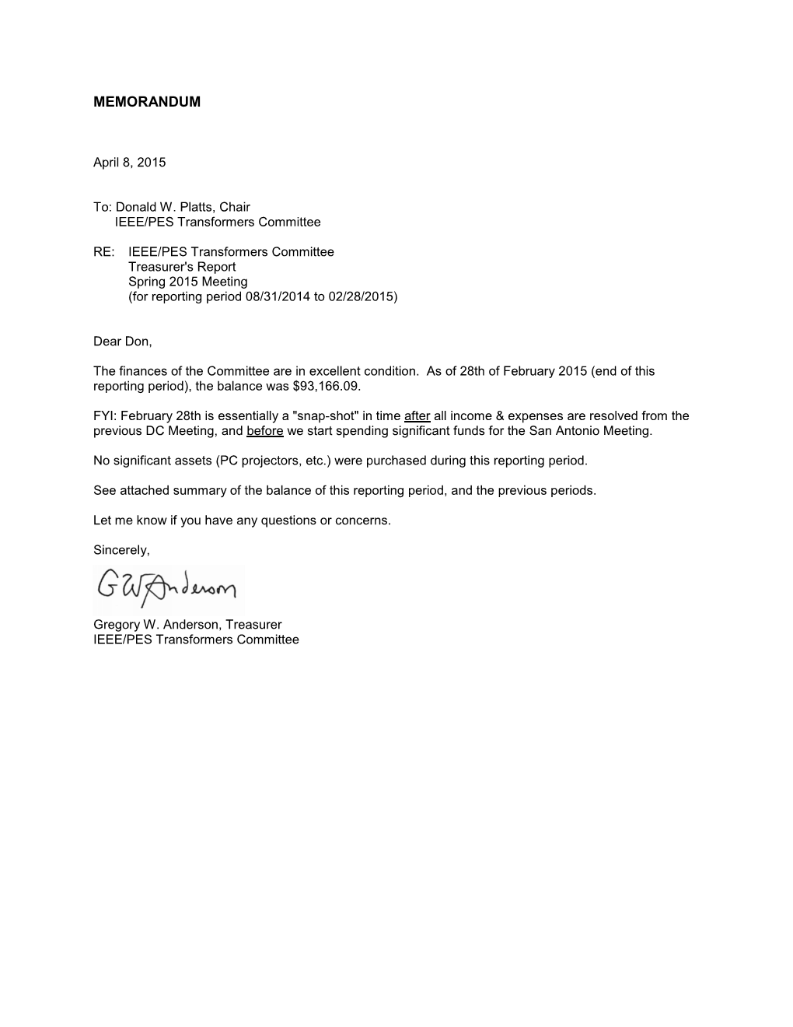
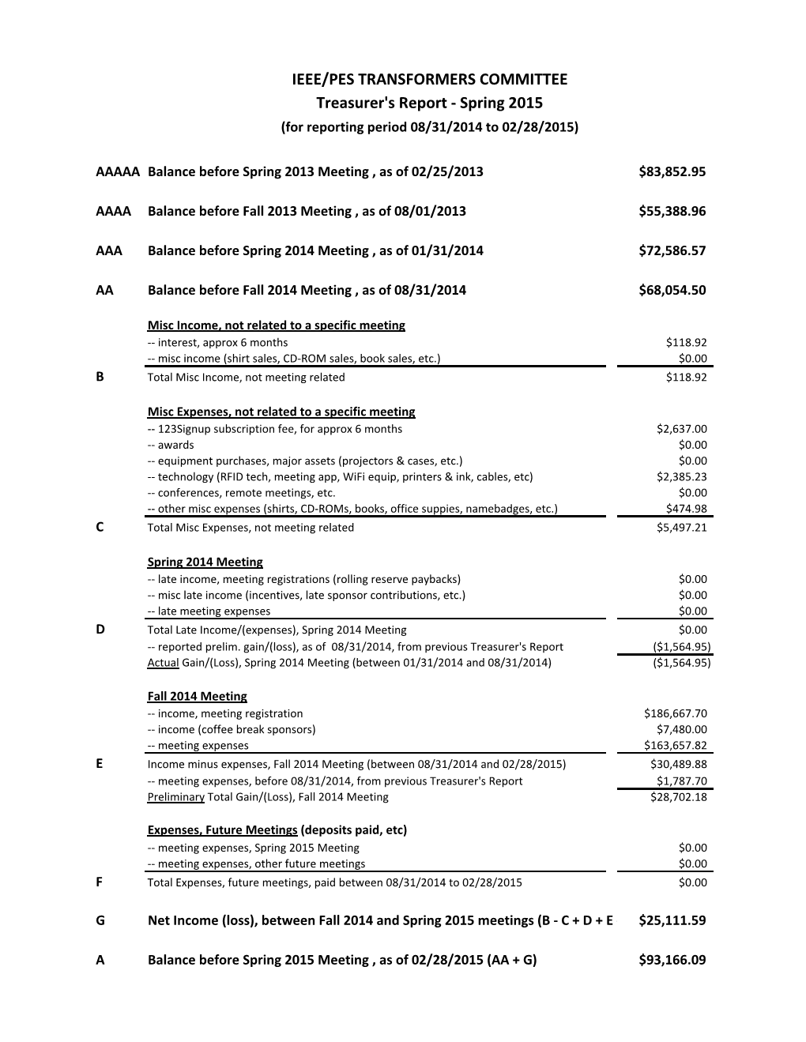
Gregory W. Anderson,
Treasurer IEEE/PES Transformers Committee

Recognition and Awards Report – Bill Chiu
The Awards were presented at the Tuesday Awards Luncheon. No report was made at the Monday General Session.

Special Tributes
Over the course of the past several months since our previous meeting in October 2014 at Washington DC, the Transformers Committee and the industry lost four of our life-long contributors. At our Awards luncheon on Tuesday, the meeting attendees gathered to pay special tributes to the four friends who passed away recently.
David A. Keithly (1942 – 2015)
David passed away on Saturday, March 14, 2015.
David started in 1966 at Allis-Chalmers in West Allis, Wisconsin (of which the electrical division became Siemens-Allis). He then worked 11 years at RTE-ASEA in Waukesha (which later became Magnetek, then Waukesha Electric, and now SPX), before moving to North Carolina to work for Siemens. He retired from Siemens in 2008. Dave was an active participant in the IEEE Transformers Committee, and he and his wife Joanne were regular attendees at those meetings. For those of you who knows Dave and live near Raleigh, you may want to take note of the memorial service that will be held on May 9 (Dave's birthday) at 11 am at Grace Lutheran Church in Raleigh.
A couple of representative remarks shared are include below:
“I knew Dave fairly well. He was a VERY active participant in the Committee, and he and his wife Joanne regularly attended the meetings for many years. He retired from Siemens 6-7 years ago, and the last meeting he attended was in 2006 (Montreal). I know he's been short of breath for many years. I remember in 2009-10, he was in the hospital for several weeks, and in a nursing home / rehab center for 3-4 months after that. Shortly after that, he had an operation to remove some clots in his lungs, and he's been in fairly good health since then. We stayed in occasional contact by email.” - G. W. Anderson
“Echoing Phil Hopkins’s thoughts – another Good Man lost to us. In addition to learning a few things, you did feel good just being in Dave’s company - so we’re all diminished a bit, and saddened, by his passing.” - D. J. Fallon
Alexander D. “Don” Kline (1925 - 2014)
Don passed away on Monday, November 24, 2014
Don was born in Newark, New Jersey in 1925. Don received his Bachelor of Science degree in Mechanical Engineering from Columbia University in 1946. Like many able young men at that time, he served in the military to protect our country in his early years. He was a member of the Navy College Training V-12 Program, and was a Commissioned Officer of the Naval Reserves and again from 1953-1955 as a Junior Grade Lieutenant. He first joined GE in 1946 after having earned his BSME degree from Columbia University and worked in the transformer departments of Pittsfield, Massachusetts from 1946-1953. He worked at Rome Georgia from 1955-1962, and at the Philadelphia Switchgear Department from 1964-1966. During his Rome, GA assignment, Don received the coveted Cordiner Award (named after GE’s Chairman Ralph Cordiner) for his exceptional work on Transformer Design and Value Analysis. He also became an expert in dry-type transformer design. From 1966-1969, Don worked for Ensign Electric & Manufacturing Co. in Huntington, West Virginia, a new plant where Nomex Insulation was introduced for dry-type transformers. Then from 1969-1991, he founded and ran the Southern Transformer Company in East Point, Georgia (near Atlanta), which produced 15-5000 kVA dry-type transformers. Don could not retire; instead he became a consultant in 1991 until his passing. He specialized in dry-type transformers, rectifiers, and transit duty transformers. He was a Registered PE in Georgia and New York. Don was also a Senior Life member of IEEE, and for many years he participated in the Transformers Committee and also in the Rail Transit Committee.
He leaves behind his dear wife, Carolyn, who he married in 1953 while at GE Pittsfield. There is a little known fact that Don’s wife Carolyn designed the power transformers that continue to operate at Hoover Dam.
Jeewan L. Puri (1938 – 2014)
Jeewan passed away suddenly on Monday, November 17, 2014.
Jeewan was born in New Delhi, India in 1938 and received his Bachelor of Science degree from Punjab University. He moved to the United States where he obtained his Master’s Degree in Electrical Engineering from the Illinois Institute of Technology in Chicago. In 1967, Jeewan joined Westinghouse Electric and had numerous assignments in Large Power Transformers in Muncie, Indiana; High Voltage Bushings in Alamo, Tennessee; and Distribution Transformers in Athens, Georgia. He was awarded the "George Westinghouse Signature Award" for Engineering Excellence at Westinghouse Electric Corporation in 1988. Jeewan also held assignments with Cooper Industries in Canonsburg, Pennsylvania and with Square D in Monroe, North Carolina.
While he was with Square D/Schneider Electric, Jeewan earned the "People Who Made a Difference Award" in 1997. In 2001, Jeewan started his own Transformer Consulting firm, called Transformer Solutions, Inc. which he managed until his passing.
Jeewan was a long time member of the IEEE Transformers Committee in which he rose quickly to chair of the Audible Sound & Vibrations Subcommittee. He also actively participated as a member of the US Technical Advisory Group for IEC TC 14 (Power Transformers Section of the International Electro-Technical Commission).
“….. Jeewan was one of a handful of my earlier mentors when I first started attending the Transformer Committee meetings. I know I speak for many in sharing that Jeewan was truly a gentleman, always kind to me despite of my earlier ignorance. He welcomed me to the group and was very patient to have explained some of the unwritten rules of the how the committee functions and some of the dos and don’ts and the professional etiquette of how to get things done……In the earlier years, there was a more stringent requirement to have at least two subcommittee chairs to be willing to be your sponsor, and Jeewan was one of the two subcommittee chairs who sponsored my committee membership…and I can honestly say that I would not have been given the great opportunity to serve the committee if it wasn’t for Jeewan’s sponsorship.” - B. Chiu
William (Bill) J. McNutt (1927 - 2014)
Bill passed away on Friday, November 14, 2014.
Bill was born in Philadelphia, Pennsylvania on Aug. 31, 1927. He was the son of Thomas and Mary V. McNutt. He graduated from high school at Germantown Friends School in Philadelphia in 1945. He served in the Navy from 1945 to 1946, and on his return he earned a BSEE degree from Tufts College, Medford, Mass. in 1950 and an MSEE degree from the Illinois Institute of Technology in 1952. He joined General Electric Company's Large Power Transformer Department from 1952 until its closure in 1986. After that, he continued his career as Berkshire Transformer Consultants and provided worldwide transformer consulting services.
Bill was an active participant in IEEE and CIGRE. He was recognized as an IEEE Fellow in 1976 for contributions to the design of power transformers and standardization of test procedures, and was awarded the Charles Proteus Steinmetz award for sustained contributions and leadership in the development of standards for power transformers. He was chair of the IEEE Transformers Committee from 1981 to 1982, and was recognized twice with the Transformers Committee's Distinguished Individual Service Award. The recognition of his key role to the industry went beyond the Committee when he was elected to the National Academy of Engineering for his contributions to the design and development of large power transformers. Bill was committed to his family and was an active participant in his church and local community. In addition, he found time for recreation, enjoying square dancing, bridge, golf, and tennis.
The Transformer World lost a giant on November 14, 2014. Bill McNutt, who was 87, was a leader, teacher, mentor and friend to all of us in the committee and across the industry.
Below are few thoughts and remembrances for Bill:
"He took time to mentor me as a young engineer, and later worked for me when I returned to Pittsfield, where he continued to mentor me! Bill was the engineer's engineer and fully enjoyed his opportunities to attend IEEE and associate with each of us and those that went before. I remember how he delighted in downplaying shell-form construction and how absolutely sure he was that core-form was the only way to build a transformer!" - P. J. Hopkinson
"What can I say - he was such a good person - such a loss. To me, Bill was always the standard against which you graded your work. In my experience, he was a technical giant but also a very caring person, looking out for the best for his people. There are very few like him." - R. C. Degeneff
"The Transformer Industry lost one of its giants who I believe, probably contributed more to this industry than anyone I know in our lifetime. He is one of the greats of our time. One day in July 1979, I interviewed with Bill, Bob Degeneff, and Joe MacDonald in Pittsfield for a job there; a day after I interviewed with Harold Moore for a job at Westinghouse Muncie. The rest is history.” - R. Girgis
"The summer that Ramsis was interviewing with Bill, I was just starting out on my career at GE. Little did I know how much I would benefit from Bill's mentoring! His advice & personal interest shaped both my career and my way of living. It was truly a lifetime legacy that Bill gave me." - J. McIver
"He was a teacher, mentor, and friend when I was a young engineer just starting to learn about how transformers worked. We are all fortunate to have known Bill." - D. J. Fallon
"As for me personally, I can say that I was one of the privileged few to have been his student in a week-long intensive transformer class that he personally thought back in 1993 in Schenectady, New York. Thinking back, it was really my formal technical indoctrination to the field of power transformers and as some have said before, the rest is history.” - B. Chiu

Committee Membership Certificates
The Transformers Committee welcomes three new full committee members. Each of the following new members was presented with a membership certificate:

New Member | Affiliation
Josh Herz | Qualitrol LLC
George Payerle | Carte International Inc.
Shibao Zhang | Pcore Electric

IEEE Fellow – Class of 2015
IEEE Fellow is a distinction reserved for select IEEE members whose extraordinary accomplishments in any of the IEEE fields of interest are deemed fitting of this prestigious grade elevation. This Fellow’s Nomination Process involves a lengthy nomination documents describing the accomplishments and contributions in details. It requires a number of references, and also a number of endorsers, who each also have to write a separate endorsement that describe why the candidate is deserving of this prestigious recognition.
At this meeting, the Transformers Committee is honored to have one of our very own active member and contributor, Mr. Gary Hoffman, to be selected to the 2015 class of IEEE Fellow for his leadership in the advancement of monitoring systems for power transformers and power line protection.
Gary is Founder, President and CEO of Advanced Power Technologies where he has been for the last 15 years. Previous to starting APT, Gary was General Manager of ALSTOM T&D Protection and Control Division in the US where he spent three years. Prior to ALSTOM, he was with RFL Electronics where he held various executive positions including Senior Vice President of Sales and Marketing, Vice President of Operations, and Vice President of Engineering over an 8-year period. Mr. Hoffman holds 9 U.S. and Foreign Patents.
Gary’s many contributions to the IEEE Transformers Committee include the Chair of Working Groups C57.12.10 and C57.116 as well as Vice Chair of PC57.163. He is also a member of the IEEE SA Standards Board, member AudCom and ICCom past member of RevCom, ProCom, and PatCom. He is the author of Chapter 24 of a book titled On-Line Monitoring of Liquid-Immersed Power Transformers. This book is edited by James H. Harlow. Mr. Hoffman’s chapter deals with economic justification for on-line monitoring and covers the various techniques used to perform on-line monitoring major power transformer components including Power Transformer Core, Coil, and insulation systems; Power Transformer bushings; Load Tap Changers; Instrument Transformers. He is also a contributor to EPRI’s The Copper Book, Chapter 9--Monitoring and Diagnostics. Gary holds a B.S. Engineering and M.S. Electrical Engineering from the State University of New York at Stony Brook.
The Transformers Committee presented a heartfelt congratulatory certificate of merit to recognize and celebrate Mr. Hoffman’s achievement.
The list of IEEE Fellows from the Transformers Committee as included below for reference (in alphabetical order the last name).

Name of IEEE Fellow | Year | Citation
Dennis J. Allan  (Life Fellow) | 1992 | for contributions to the design and development of power transformers
Peter M. Balma | 2013 | for leadership in developing technical guides for electric power equipment
Ray Bartnikas  (Life Fellow) | 1977 | for contributions to the field of dielectric and corona loss mechanisms in electrical insulating systems.
William H. Bartley | 2014 | for contributions to the development of generator and transformer standards for life cycle planning and risk assessment
Robert C. Degeneff  (Life Fellow) | 1993 | for contributions to the modeling and computation of transient voltages in transformer windings
Ramsis S Girgis  (Life Fellow) | 1993 | for contributions to reductions in the losses of large power transformers
James H. Harlow  (Life Fellow) | 2013 | for leadership in IEEE technical and standardization committees on transformer technology
Philip John Hopkinson  (Life Fellow) | 2002 | for contributions to the reliability of distribution transformers and the development of related standards for testing and application
Gary Hoffman | 2015 | for leadership in the advancement of monitoring systems for power transformers and power line protection
William J McNutt  (Life Fellow) | 1976 | for contributions to the design of power transformers ad standardization of test procedures
Harold R. Moore  (Life Fellow) | 1997 | for leadership in the development, design, and application of power transformers and associated equipment
Linden W. Pierce  (Life Fellow) | 2000 | for contributions to the understanding of heat transfer and loading of liquid-immersed and dry type power and distribution transformers
Robert A. Veitch  (Life Fellow) | 1998 | for leadership in the development and design of very large and extra high voltage transformers, shunt reactors and associated equipment
Loren B. Wagenaar  (Life Fellow) | 1996 | for contributions to transformer and bushing test standards and specifications
Dean A. Yannucci  (Life Fellow) | 1990 | for leadership in the development and manufacture of large power transformers
Committee members are encouraged to nominate our fellow contributors for this distinguished recognition of Fellow. Nominations, including references by at least five present IEEE Fellows and optional additional endorsements, must be completed and submitted by March 1 of each year for the following year’s Class of Fellows.

Special Service Awards & Certificate of Appreciation
In any successful organization, there are always a handful of hard working individuals behind the scene that put in the sweat and tears year after year in contributing to our success at each one of our meetings. Often the real contributors are not necessarily those who held the official titles. The Transformers Committee wishes to take a pause and recognize Mr. Sheldon Kennedy for his many years of service to us and also to the industry.
Sheldon graduated with a Bachelor of Science degree in Electrical Engineering from the Pennsylvania State University in 1975. Upon graduation he worked for the Allegheny Power Service Corporation in Greensburg, Pennsylvania as a Transmission Substation Engineer and as a Rate engineer. In 1982 he joined the R. E. Uptegraff Manufacturing Company, a transformer manufacturer, in Scottdale, Pennsylvania as Chief Electrical Engineer. He also served as a part time Electrical Engineering Instructor in Electrical Engineering and for Professional Engineering Exam Review Classes at the Pennsylvania State University Fayette Campus in Uniontown, Pennsylvania from 1981 to 1985. He is the United States industrial convertor transformers representative to IEC from the ANSI National Committee Technical Advisory Group. He was the NEMA Transformer Section Chairman from 2000 to 2003. He was the past Chairman of the Accredited Standards Committee C57 – Transformers, Regulators, and Reactors from 2002 to 2005. In addition, he is also a member of the Industry Applications Society and Chairman of the Electrochemical Subcommittee of the PCIC - Petroleum and Chemical Industry Committee. He is the author of the Rectifier Transformer chapter in the CRC book, “Electric Power Transformer Engineering”.
Sheldon is not only a long time attendee, but most importantly, a steadfast contributor and a technical leader to many of our specialty product standards such as the semiconductor power rectifier transformers, arc furnace transformers, neutral grounding devices, and also the non-ventilated dry type transformers. Sheldon is currently employed by Niagara Transformer Corporation as their Vice President of Engineering.
The Transformers Committee presented a heartfelt congratulatory certificate of appreciation to recognize and celebrate Sheldon’s contributions to the IEEE Transformers Committee and to our industry.

Name of Award Recipients | Affiliation | Contributions
Sheldon P. Kennedy | Niagara Transformer Corporation | “Outstanding Contributor”  to the Transformers Committee

IEEE SA Standards Board Awards
In addition to the Committee Awards above, the IEEE SA SB presents its own Award to the WG Chair upon publication of a new or revised document, and offers the WG Chair the opportunity to nominate significant contributors to the project for an IEEE SA SB Certificate of Appreciation. All Working Group Chairs chose to have their awards sent direct to their residence or place of business. The award recipients were called forward for recognition during our Awards Luncheon on Tuesday.
IEEE SA Award Reccipients:
Revisions to C57.12.01 - Standard for General Requirements for Dry-Type Dist. & Power Transformers
Timothy L. Holdway - Working Group Chair
Casey Ballard – Working Group Vice Chair
Rick Marek - Significant Contributor
Aleksandr Levin - Significant Contributor
Marcel Fortin - Significant Contributor
Roger Wicks - Significant Contributor
C57.153 - Guide for Paralleling Power Transformers
E. Tom Jauch - Working Group Chair
James Graham - Working Group Vice Chair
Stephen Anthony - Significant Contributor
Jim Harlow - Significant Contributor
Dave Harris - Significant Contributor
Mark Tostrud - Significant Contributor
Karsten Viereck - Significant Contributor
C57.155 - Guide for Interpretation of Gases Generated in Natural and Synthetic Esters
Paul Bowman - Working Group Chair
John Luksich - Working Group Secretary
Jim Dukarm - Significant Contributor
Dave Hanson - Significant Contributor

Other IEEE PES Awards
The IEEE PES recognizes important technical, educational and service contributions through the conferral of numerous awards. The listing below highlights the various other awards that are available through the IEEE PES organization.
- IEEE PES Award for Excellence in Power Distribution Engineering
- IEEE PES IAS A.P. Seethapathy Rural Electrification Excellence Award
Nominations due by February 1st
- IEEE PES Charles Concordia Power Systems Engineering Award
Nominations due by January 31st
- IEEE PES Cyril Veinott Electromechanical Energy Conversion Award
Nominations due by February 1st
- IEEE PES Douglas M. Staszesky Distribution Automation Award
Nominations due by January 1st
- IEEE PES Lifetime Achievement Award
Nominations due by February 1st
- IEEE PES Leadership in Power Award
Nominations due by February 1st
- IEEE PES Meritorious Service Award
- IEEE PES Nari Hingorani Custom Power Award
Nominations due by January 31st
- IEEE PES Nari Hingorani FACTS Award
Nominations due by January 31st
- IEEE PES Outstanding Chapter Award
- IEEE PES Outstanding Power Engineering Educator Award
Nominations due by January 31st
- IEEE PES Outstanding Young Engineer Award
Nominations due by Februrary 1st
- IEEE PES Prabha S. Kundur Power System Dynamics and Control Award
Nominations due by January 31st - Call for Nominations
- IEEE PES Prize Paper Award
- IEEE Power & Energy Society Ramakumar Family Renewable Energy Excellence Award
- IEEE PES Robert P. Noberini Distinguished Contributions to Engineeering Professionalism Award Nominations due by February 1st
- IEEE PES G. Ray Ekenstam Memorial Scholarship
Nominations due by June 30th
- IEEE PES Scholarship Plus Initiative
Applications due by June 30th
- IEEE PES Roy Billinton Power System Reliability Award
Nominations due by February 1st
- IEEE PES Student Prize Paper Award in Honor of T. Burke Hayes
Nominations due by December 15th
- IEEE PES Uno Lamm High Voltage Direct Current Award
Nominations due by November 30th
- IEEE PES Wanda Reder Pioneer in Power Award
Nominations due by January 15th
- IEEE PES Working Group Recognition Awards
The PES Working Group Recognition Awards recognize “the most outstanding and timely publications” by a PES Working Group (or Committee or Subcommittee) from among the nominations. The PES Recognition Award is divided into two categories: 1) for technical reports; 2) standards and guides. Each Technical Council Committee may nominate one report from each category, published by IEEE, during the previous three year period.” This award consists of a plaque which will be presented to the Working Group Chair at the PES Summer Meeting Awards Luncheon. A framed certificate will be presented to each Working Group member at a designated meeting of the parent Technical Committee.
- IEEE PES CSEE Yu-Hsiu Ku Electrical Engineering Award

Presentation Slides from the Awards Luncheon
The slides from the presentation used at the Tuesday’s Awards Luncheon are included below for reference.
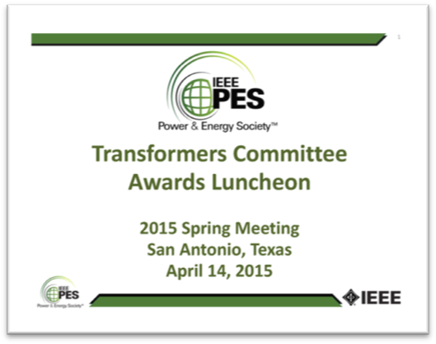

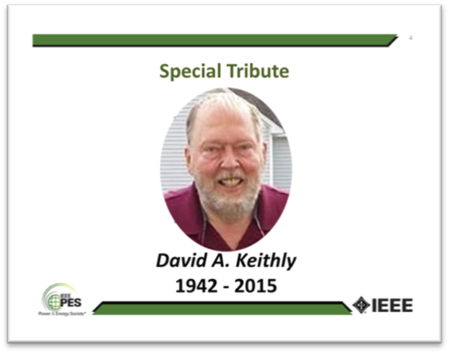
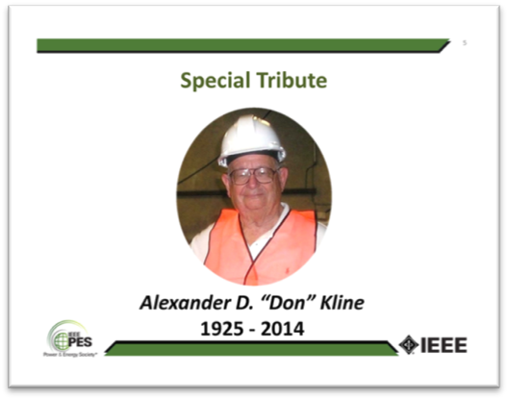
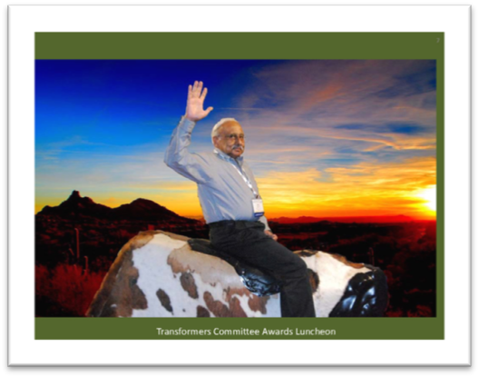
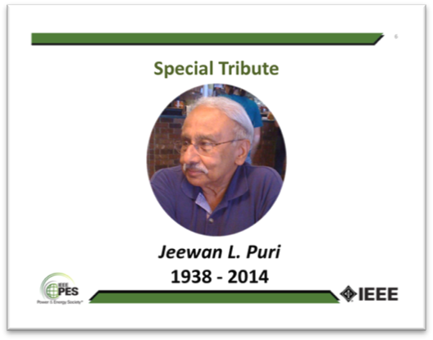
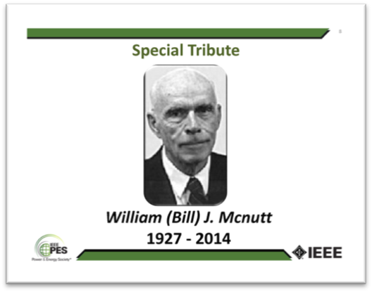
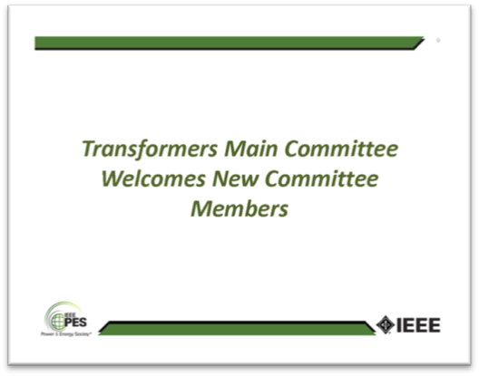
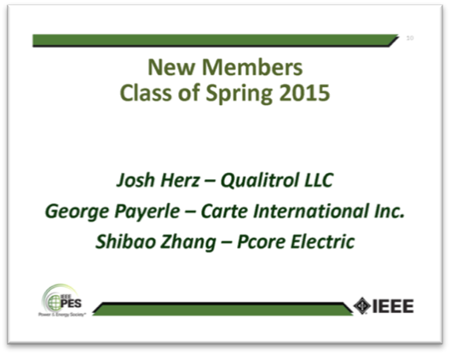
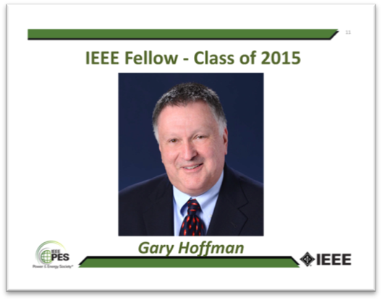
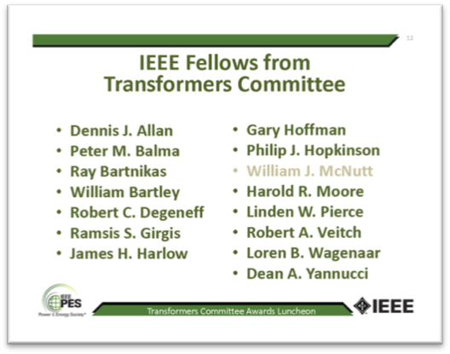
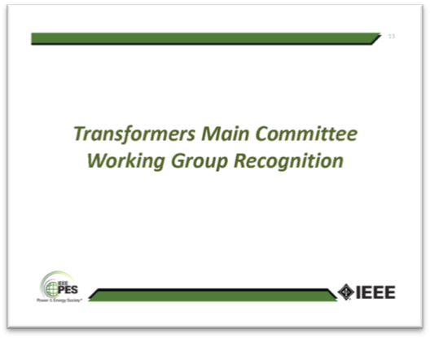
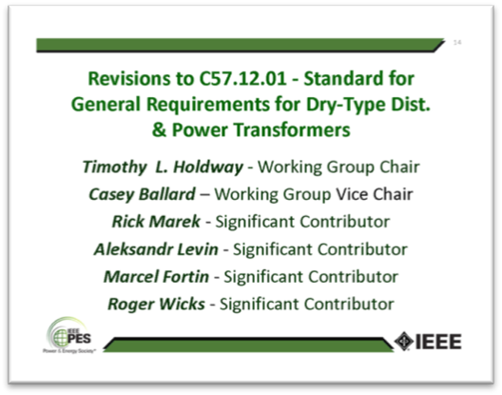
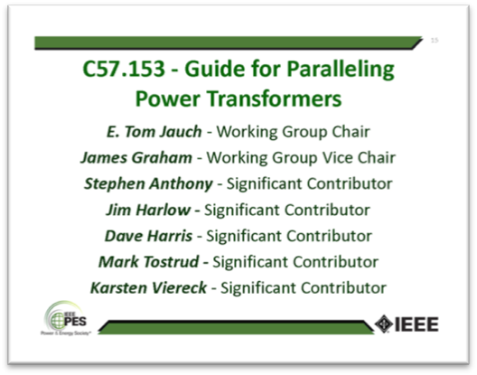
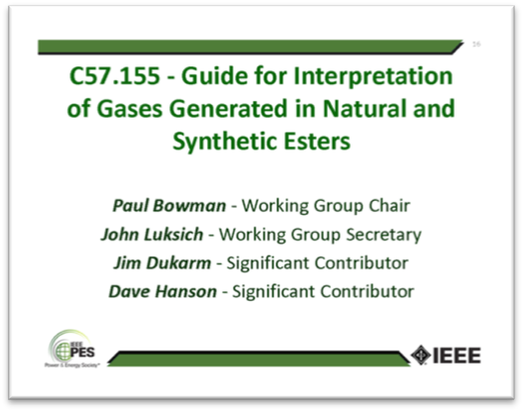
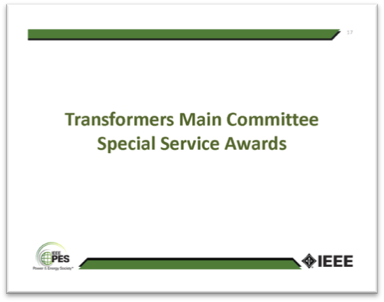
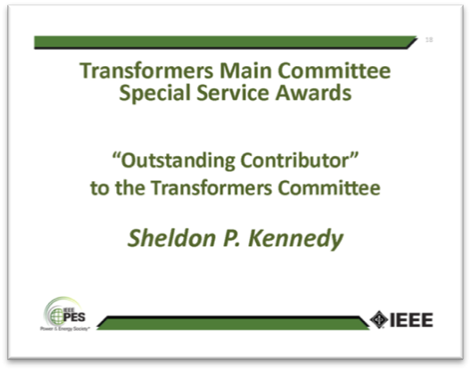
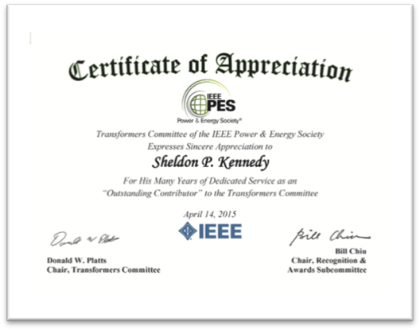

Respectfully submitted,
Bill Chiu
Chair, Awards Subcommittee

Administrative Subcommittee Meeting Report

Don asked if there were any attendees that also attend any of the other PES Technical Committees. A handful of people responded that they did. He then invited them to consider becoming a liaison between the other Committee and our Transformers Committee.

Don recapped the discussions in the report. He invited attendees to come up and introduce themselves to him and any of the officers so that we can better get to know more of our attentees.

Hem asked that if a patent had been previously identified in a document and there was a revision to the document in progress, do we need to pursue this again. Erin indicated that to be safe we should verify that this has been received.

Introductions
Mike Thompson, special guest from the Relay Committee was introduced.
The attendees were asked to introduce themselves. The chair asked each attendee to state his/her affiliation. If the attendee is a consultant, the attendee must state if he is representing a company other than his own consulting interest. Introductions were made by members and guests.

Attendance
Members Present:
Chair Donald Platts
Vice Chair Stephen Antosz
Secretary Susan McNelly
Treasurer Gregory Anderson
Standards Coordinator William Bartley
Awards/Past Chair Bill Chiu
Bushings Peter Zhao
Dielectric Tests Michael Franchek
Distribution Transformers Stephen Shull
Dry Type Transformers Charles Johnson
HVDC Converter Transformers & Reactors Michael Sharp
Instrument Transformers Ross McTaggart
Insulating Fluids David Wallach
Insulation Life Bruce Forsyth
Performance Characteristics Ed teNyenhuis
Power Transformers Joe Watson
Underground Transformers & Network Protectors Dan Mulkey
Guests Peter Balma, Erin Spiewak, Christy Bahn, Mike Thompson

Approval of Previous Meeting Minutes
The Chair asked for comments from the Fall 2014 Washington DC Metro Area Administrative Subcommittee meeting minutes. Hearing no comments or requests to change the draft minutes, the minutes were approved.

Approval of Agenda
The Chair reviewed the draft agenda with the attendees. The Standards Report was moved up in the Agenda for visitor Mike Thompson’s benefit. There were no other changes or additions.
Approved Agenda
- Introduction of Members and Guests (:05) All
- Standards Report (:30) B. Bartley
- Approval of Fall 2014 Minutes from Washington DC Metro Area (:03) D. Platts
- Additions to and/or Approval of the Agenda (:02) D. Platts
- Chair’s Report (:05) D. Platts
- Vice Chair’s Report (:05) S. Antosz
- Secretary’s Report & New Committee Membership Approval (:10) S. McNelly
- Treasurer’s Report (:05) G. Anderson
- Recognition & Awards Report (:05) B. Chiu
- IEEE Staff Update (:10) E. Spiewak
- Meeting Planning (:10) G. Anderson
  - San Antonio Meeting Update
  - Future Meetings
Break & Time Check – 3:30 pm
- Old Business
  - WG Data – Confidentiality, Storage, Access, & Use (:10) S. McNelly/E. Spiewak
- New Business
  - Draft Transformers Committee Operations Manual D. Platts/P. Balma
Time Check – 4:30 PM
- Subcommittee Reports – Roundtable (not intended to indicate order of reporting)
Bushings (:03) P. Zhao
Dielectric Test (:03) M. Franchek
Distribution Transformers (:03) S. Shull
Dry Type Transformers (:03) C. Johnson
HVDC (:03) M. Sharp
Instrument Transformers (:03) R. McTaggart
Insulating Fluids (:03) D. Wallach
Insulation Life (:03) B. Forsyth
Performance Characteristics (:03) E. teNyenhuis
Power Transformers (:03) J. Watson
Underground Transformers & Network Protector (:03) D. Mulkey
- Adjourn

Chair’s Report – Donald Platts
Refer to Section 5.0 for a complete “Chair’s Report.”
- Retreat Items discussed
  - Strengthen PES Awareness
  - Committee Structures
  - External Coordination
  - PES Leader Training
  - IEEE/IEC/CIGRE Interaction
  - PES Presentation to the world – Websites should all look the same
  - Best Practices for Standards Development
- Technical Council:
Technical Committee Structure
  - There were suggestions for eliminating some and combining some. Combination of the individual committees dealing with communications was one example.
  - Transformers – Suggested revising scope to include the following: Energy Routers, Solid State TRs, Submersible TRs, Other TRs as they are identified in the future.
  - There are presently 21 Technical Committees and the proposal is to reduce this to 18 Technical Committees.
A summary of the DOE QER report was provided in the Chairs Report
- Technical Committee Structure
The scope of each technical committee will be reviewed to make sure that all documents assigned to the technical committees belongs in that committee and that new technologies have a place that they can fit into.
- Proposals to add language to standards
What you need to know about IEEE Stds and the law excerpt is provided in the report. Wherever appropriate, IEEE standards-developing groups should specify standards based on performance or function rather than design or product specifications.
The full brochure can be found at:
https://standards.ieee.org/develop/policies/stdslaw.pdf
There will be a mention at the General Meeting regarding conduct of the standards balloting process. We need to make sure that we operate in a manner that does not give the perception of collusion in order to get members to vote in a certain way.

Vice Chair’s Report – Stephen Antosz
Refer to Section 6.0 for a complete “Vice Chair’s Report.”
Highlights:
IEEE/PES General Meeting A total of 22 conference papers were submitted. After review, 10 papers were rejected, 11 papers were accepted and will be presented at the Poster Session. One paper was withdrawn due to an author discrepancy.

Secretary’s Report – Susan McNelly
Refer to Section 7.0 for a complete “Secretary’s Report.”
Highlights:
The Secretary presented a list of membership requests for this meeting. There were three new requests for membership received. One request (Josh Herz) did not include the required SC Chair sponsorship. Joe Watson indicated he would sign the membership application for Josh. With that, all three requests for membership were approved.
The SC Meeting Minutes submittal deadline is July 1, 2015. A plea to the SC Chairs was made to push their WGs for timely submittal of their minutes. Greg Anderson requested that SC Chairs include attendance numbers in their minutes for the, SC, WG, and TF meetings, with breakouts for members and guests. He uses this information for room size planning. It is also a requirement for meeting minutes content.

Treasurer’s Report – Gregory Anderson
Refer to Section 8.0 for a complete “Treasurer’s Report.”
Highlights:
The finances of the Committee are in excellent condition. As of 28th of February 2015 (end of this
reporting period), the balance was $93,166.09.
FYI: February 28th is essentially a "snap-shot" in time after all income & expenses are resolved from the previous DC Meeting, and before we start spending significant funds for the San Antonio Meeting.
No significant assets (PC projectors, etc.) were purchased during this reporting period

Recognition & Award’s Report – Bill Chiu
Refer to Section 9.0 for a complete “Recognition & Award’s Report.”
Highlights:
The Recognition & Awards Chair presented
There will be three standards (C57.12.01, C57.153, C57.155) that will be recognized.
There will also be short tributes to people that passed away since the last meeting: David Keithly, Don Kline, Bill McNutt (former Committee Chair), and Jewan Puri (former Committee Member).

Standard’s Report – William Bartley
Refer to Section 11.0 for a complete “Standards Report.”
Highlights:
The Standard Coordinator presented.
There were 2 new standards approved (C57.155 and C57.152)
There was 1 revisions to Standard (C57.12.01) approved
There were 2 PARs approved for revisions (C57.119 and C57.129) in the last 6 months.
PAR modifications – No longer have to change the PAR for changes to wording that do not change the intent of the original PAR.
There were 4 PAR extensions approved (C57.13, C57.13.7, C57.104, C57.153-already approved)
The deadline for submittal to REVCOM for year end is October 23 of this year.

IEEE Staff Update – Erin Spiewak
Erin introduced Christy Bahn with IEEE-SA who will be attending the meeting this week and observing WG interactions etc.
Public Review
–Monday Standards Luncheon presentation
–Go live: July 6th
Public Review process will be reviewed at the Monday Standards lunch meeting. Ballots in progress prior to July 6 will not need to comply with the public review process.
2016 Call for Candidates
–IEEE-SA Standards Board & Standing Committees
–May 5, 2015
2015 Awards
–Questions on nomination process: sa-arcom@ieee.org
–Deadline July 31, 2015
–http://standards.ieee.org/develop/awards/nominate/index.html
IEEE/IEC Update – Transformers Committee (report submitted by Jodi Haaz, presented by Erin Spiewak)
This report is an update on the activities taking place under the IEC/IEEE Dual Logo Agreement
Adoption of IEEE Transformer Committee Standards under the IEC/IEEE Dual Logo Agreement
- IEEE C57.15™-2009 (IEC 60076-16:2011-12) – Guide for the Application, Specification and Testing of Phase-Shifting Transformers
- IEEE C57.135™-2011 (IEC 62032 Ed.2:2012-06) – Guide for the Application, Specification and Testing of Phase-Shifting Transformers
Maintenance of IEEE Transformer Committee Standards adopted under the IEC/IEEE Dual Logo Agreement
- IEEE PC57.15/IEC 60076-21, Guide for the Application, Specification and Testing of Phase-Shifting Transformers
Status – The PAR to revise the standard was approved on 27 March 2014. Currently undergoing draft development.
Joint Development of standards with IEC
Published Standards
- IEC/IEEE 65700-19-03:2014, Standard Requirements, Terminology, and Test Code for Bushings for DC Applications Rated 110 kV BIL and Above
Standards Under Development
- IEC/IEEE 60076-16, Standard Requirements for Wind Turbine Generator Transformers
Status – The IEEE sponsor ballot completed on 27 February 2015. The IEC Committee Draft opened on 27 March 2015 and closes on 3 July 2015.
- IEC/IEEE 60076-57-1202, Standard Requirements for Liquid Immersed Phase-Shifting Transformers
Status – The IEEE sponsor ballot completed on 18 September 2014 and the IEC Committee Draft closed on 5 September. Currently undergoing comment resolution.
- IEC/IEEE 60214-2, Tap-Changers - Part 2: Application Guide
Status – The IEEE PAR was approved on 12 June 2014. The document is undergoing draft development.
- IEC/IEEE 61378-2, Convertor transformers - Part 2: Transformers for HVDC applications
Status – The IEEE PAR was approved on 10 December 2014. The document is undergoing draft development.
SA will be working on helping PES with interaction with other standards groups. No timing on this effort is available yet.
Don Platts raised the issue of email confidentiality statements. Erin indicated that emails to balloters that contain confidentiality statements will not be accepted. Don indicated that there is a question on when in the process this will be an issue. Better clarification on this and a formal procedure will need to be developed.
Don Platts also raised the issue of the joint standards documents don’t match the style guides (no front matter, etc) that are typically seen on IEEE Standards. It would be helpful to have information/guidance on what is required. Erin indicated that when we signed the agreement with IEC, we agreed to follow their template.

Meeting Planning Report – Gregory Anderson
No written report provided.
Highlights:
There is no host for the San Antonio meeting.
The Spring 2016 meeting will be either the week of March 13 or March 20. The Fall 2016 meeting will be either the week of October 16 or October 23. No meeting locations have yet been determined.
Greg discussed the new RFID technology that will be tested at the San Antonio to allow electronic check in at events and eventually track attendance.

Old Business

WG Data Confidentiality – E. Spiewak
A concern was raised at the last meeting that the plan was not secure enough. The use of a third party was brought up. IEEE would be the middle man and have a third party manipulate the data. Timeline – this will require some additional discussions, as there will be a cost impact to the Committee. Erin indicated that there should be more information available by April 24. A final business case for the service should be available and approved by the end of May. An estimated timeframe to have manipulated data back to the WG would be sometime in July.
Peter Balma asked if there are any other Committees indicating an interest in this service.
Dave Wallach asked if the data would still own the data. Erin indicated that IEEE would own the data.
Don Platts indicated that originally the process discussed was that a third party would analyze the data and provide the report and then destroy the data. There would need to be some more information provided on whether this is still the case. There will need to be another round of review by the interested parties once a final process is ready for presentation.

Revision of WG P&P
There were three major items raised.
      - Recommend that the Chair of the WG transition Corresponding Members to Members at his discretion. The remainder of the individuals would be moved to Active Participants.
Discussion by Administrative SC: Steve Antosz indicated that this applies not only meeting notices, but content (actionable items) that is sent for review. The agenda should identify any actionable items. Steve Shull indicated that the WG P&P, Clause has new wording indicating an agenda is to be provided 10 calendar days prior to a face-to-face meeting and at least 5 days prior to an electronic meeting.
      - The meeting notice clause was reviewed and a recommendation that a 30 day notice be given on any face-to-face meeting and 14 days for any web meeting.
Discussion by Administrative SC: Peter Balma will take this back to find out if the 14 day notice conflicts with the requirements.
      - A recommendation of how to determine a quorum in the WG was not resolved. It was discussed that the WG would be hard pressed to obtain a quorum if it was based on total membership. This is due to meeting conflicts at the bi-annual meetings, which has prevented many from attending every meeting and travel restrictions that have been impressed on many of the members by their sponsors. It is recommended that this issue be determined by a vote of the Administrative SC.
Discussion by Administrative SC: The question is really, is the 2/3 based on the quorum present or of the total membership. Erin verified that the 2/3 requirement for moving forward to ballot is of the attendance at the meeting, IF this attendance represents a quorum.

New Business

Draft Transformers Committee Operation Manual – Peter Balma
Peter indicated that periodically IEEE-SA reviews by-laws and Operations Manual updates. The Sponsor is responsible for ensuring that participants are notified of their obligation to disclose their affiliations, which includes employer(s) and any other affiliations(s). More discussion on what
Budgeted income or expenses of $250,000 or more require audit.
Vice Chairs or IEEE Stds WGs shall be members of IEEE-SA and and IEEE member.
Trial-Use standard process has been updated and clarified. Trial-Use Standards will now have a three year life.
Commercial terms and conditions…
IEEE-SA Bylaws & Operations Manual updates
- Affiliation
  - The Sponsor is responsible for ensuring that participants are notified of their obligation to disclose their affiliation(s), which includes employer(s) and any other affiliation(s). Each participant's affiliation(s) shall be disclosed during any standards development activity (e.g., during meetings and Sponsor balloting).
During standards development meetings, the Working Group Chair or the Chair's delegate shall inform participants of the definition of, and requirement for, disclosure of affiliation(s) and possible penalties for non-compliance (see 5.2.1.5 of the IEEE-SA Standards Board Bylaws). This disclosure of affiliation shall be via a sign-in (e.g., sign-in sheet, electronic sign-in, verbal disclosure, or electronic communication) that provides for disclosure of affiliation(s). The minutes of each Working Group or other subgroup meeting shall record a list of attendees, and the disclosed affiliation(s) of each attendee.
  - A participant who fails to disclose all affiliation(s) shall not accrue any participant rights, including rights of or towards voting membership or ballot participation, until such disclosures have been made.
  - Affiliation during Sponsor balloting – Misleading disclosures.
- Annual Financial report must now be submitted by February 15 each year.
  - IEEE Standard Sponsor committees with actual or budgeted income or expenses of $250,000 or more shall be audited by a fully qualified, independent professional (external or IEEE Internal Audit Department). Less than $250,000 & greater than $25,000 will be periodically audited by IEEE Audit department
- Ballot Process
  - The ballot process may include communication among the Sponsor comment resolution group and Sponsor balloting group members regarding the substantive merits and possible resolution of comments. However, no comment resolution member, Sponsor balloting group member, or standards participant shall intimidate or coerce a specific vote from any Sponsor balloting group member.
- Vice chairs of IEEE Standards working groups shall be members of IEEE-SA and an IEEE member
- Trial-Use standard process has been updated and clarified
  - Trial-Use standards now have three year life
  - The process for moving a standard project to or from Trial-Use status has been defined.
  - What actions require a re-start to the balloting process
- Commercial terms & conditions
  - In connection with standards that relate to the determination of whether products or services conform to one or more standards, the process or criteria for determining conformity can be standardized as long as the description of the process or criteria (a) is limited to technical or engineering concerns and does not include what would otherwise be a commercial term, and (b) does not provide for testing conformance with any commercial terms.
Operations Manual:
- Asked all SubCommittee Chairs to review their scope
- PAR Study Groups
- Present topic of interest with a brief summary and outline to the appropriate subcommittee (see subcommittees scopes in this manual) as part of new business at their meeting and or contact subcommittee chair to be placed on the agenda.
- A motion, and a second, followed by discussion; and then a vote of the Subcommittee follows and requires majority approval of the Subcommittee to move the potential project forward and form a Standards Study Group to do so. The motion shall clearly state the following:
  - Scope of standards study group
  - Task to be completed, e.g. to determine need or viability for a standard, or to outline the potential project, or to prepare a draft PAR (do we need AdCom review prior to developing PARs to coordinate alignment of efforts of subcommittees and to avoid scope overlap?)
  - Due date for task completion.
  - Chair/leader of standards study group.
  - Standards Study group recommendation for project or for draft PAR to be returned to the Subcommittee for consideration and vote.
  - The Coordinator then reviews the project request with the prospective WG chair, and the cognizant Subcommittee chair, to consider if it is appropriate to proceed. They will resolve any technical clarifications, grammatical corrections, etc. When the Coordinator is satisfied, he/she recommends approval to the Administrative Subcommittee.
  - AdCom then has 30 days to respond. The project must be approved by a 2/3 majority of AdCom members. This is normally an electronic ballot. The Coordinator is responsible for resolving any conflicts that are identified by AdCom.
Discussion:
The Operations Manual covers the more general items that are no longer part of the P&P Manual. It documents our processes and procedures (cannot conflict with P&P).
All SC Chairs were asked to review their scopes. The next step if there are no more comments from the Administrative Committee would be to forward it on to the Main Committee.
There was a comment that there will be a Chair, Vice-Chair, and a Secretary. There are many groups (SCs and WGs) that do not have all three. Steve Shull indicated that in past discussions, we had agreed that we could combine Vice-Chair and Secretary positions into one. Peter indicated that he thought there was also previous discussion that it would be preferred to have all three positions.
There was a comment by Dan Mulkey regarding the Awards and Recognition SC. Peter will review this.
There are additional comments. Peter will collect the comments and another review will be performed (by April 20). A revised document will be sent out. If no further comments, an electronic vote by the Administrative SC will be held and then if approved, will go forward to the Main Committee with recommendation for approval by the Administrative SC.

Succession Planning
Don requested that the SC Chairs submit recommended replacements if they are looking at stepping down. We are looking for recommendations from everyone, including the Treasurer and Webmaster roles.

Subcommittee Reports

Subcommittee | Report/Hot Topic
Bushings – P. Zhao | Two new TFs have been established.  - Distr. TR Bushing  - Composite bushings.
Dielectric Test – M. Franchek | A new TF will be created to look at feasibility for establishing limits for winding PF and insulation resistance.
Distribution Transformers – S. Shull | Bob Olen recently retired and will no longer be participating. Dan Mulkey will chair the enclosure integrity working groups.
Dry Type Transformers – C. Johnson | A TF for C57.12.60 Insulation Test guide for Dry Type TRs will be started this week.  C57.94 O&M Guide is finished.
HVDC – M. Sharp | HVDC converter TR WG PAR was approved and they are making great progress.
Instrument Transformers – R. McTaggart | C57.13 is about to be recirculated. It had 95% approval. They are working on resolving comments. The last hour of the meeting for C57.13 will be turned over to the station service transformer WG.  The Low mA CT WG has some difference of opinion on burdens
Insulating Fluids – D. Wallach | There are a number of documents in Ballot resolution.  The content in C57.106 that is in C57.162 will be removed prior to ballot.
Insulation Life – B. Forsyth | There are 4 WGs and 1 TF meeting  Two WGs are in ballot resolution process.  C57.162 for Moisture Related Parameters is in progress.  TF on Winding Temp Indicators that has been active for approximately 15 years is close to being completed. They will be preparing a TF report which is nearing completion.
Performance Characteristics – E. teNyenhuis | One PAR, C57.32 will be expiring this year.  Working with new WG/TF Chairs to make sure that they understand their roles.  There are 14 active WGs  A presentation on Core Gassing will be given on Thursday
Power Transformers – J. Watson | Three PARs expire at the end of the year and are in ballot resolution. They all expect to be complete by the end of the year. Bill Bartley indicated that C57.140 has indicated a need for a PAR extension.
Standards SC – W. Bartley | The C57.12.00 and C57.12.90 are in Ballot Resolution and the GMD WG is working towards going out for ballot soon.  Steve Antosz plans to document the process and look for improvements on the continuous revision documents. He is waiting until the document gets through its present cycle to work on a documentation/improvement of the process
Underground Transformers & Network Protector – D. Mulkey | There are 4 WGs in progress, one that is going to ballot and the PAR is due to expire at the end of this year.

Dave Wallach indicated that he was asked to bring up whether there was a way to make it possible for remote participation during the face-to-face meetings. There was discussion that this was looked at and the logistics would be extremely difficult.

Adjournment

The meeting was adjourned at 5:35pm.

Standards Report – William Bartley
The semi-annual Standards Report follows on the next page.
In the last six months:
- Two new Standards were approved (C57.155 and C57.153).
- There was one revision to C57.12.01 for Dry Type Transformers.
- There were no PARs for new standards. There were seven PARS for revisions to standards. For details see the report.
- There were four PAR modifications approved
PARs have a 4 year life and Standards and Guides now have a 10 year life.
The deadline for the December REVCOM meeting is October 23, 2015. Any documents expiring at the end of this year need to be in BY October 23.
Bill provided a practical, but aggressive example timeline for ballot, comment resolution, recirculation ballot, etc.
.

Editor’s Report
Between Fall 2014 meeting and this meeting a total of 45 new & resubmitted papers in the transformer area was under review of IEEE Transactions on Power Delivery for possible publication. For all of these papers the recommendations were as follows:
Accept: 11
Revise and Resubmit: 19
Reject: 9
Under review 6
The above numbers include reviews managed by all editors.
The papers which were accepted for publication are shown below:
Number | Paper ID | Title
1 | TPWRD-00399-2014.R2 | Winding Condition Assessment of Power Transformers Based on Vibration Correlation
2 | TPWRD-01136-2013.R4 - | Comparison of Mechanically and Electrically Excited Vibration Frequency Responses of a Small Distribution Transformer
3 | TPWRD-00083-2014.R3 | The influence of geomagnetic storms on  thermal processes in the tank of a power transformer
4 | TPWRD-00721-2014.R2 | An Investigation of Winding Curvature Effect  on the Mechanical Strength of Transformers Windings
5 | TPWRD-00879-2014.R2 | Thermodynamic Estimation of Transformer Fault Severity
6 | TPWRD-01207-2014.R3 | Inter-laminar Insulation Faults Detection and Quality Assessment of Magnetic Cores Using Flux Injection Probe
7 | TPWRD-01006-2014.R2 | An Improved Transformer Winding Deformation Monitoring Method Based on Lissajous Graphical Analysis
8 | TPWRD-01034-2014.R2 | Novel Technique to Compute the Leakage Reactance of Three Phase Power Transformers
9 | TPWRD-01246-2014.R2 | Implementation of Inverse Hysteresis Model into EMTP – Part I: Static Model
10 | TPWRD-01247-2014.R2 | Implementation of Inverse Hysteresis Model into EMTP – Part II: Dynamic Model
11 | TPWRD-01144-2014.R1 | Submersible Dry Type Transformer
Two significant changes have taken place in favor of paper submitters during last 12 months.
Firstly, on first submission three reviewers are required compared to earlier practice of four.
Secondly, IEEE overall has changed its policy to allow for up to 40% commonality in comparison to earlier publication.
The first step has made the process faster while the second step allows authors to convert their ideas faster into papers.
I would like to thank all of the reviewers who volunteered for this effort and donated their time, and would like to encourage everyone associated with IEEE Transformers Committee activities to consider becoming a Reviewer. I would like to encourage those Reviewers that already have an account on IEEE Manuscript Central to keep their profile information updated and complete the areas for key words and areas of interest. We need more reviewers and I encourage any of you that have not signed up as reviewers to sign up per the instructions at the end of this document.
It is important for all interested individuals to follow the norm for writing papers as provided in IEEE; the link is http://www.ieee.org/publications_standards/publications/authors/authors_journals.html and the link to upload the paper is http://mchelp.manuscriptcentral.com/gethelpnow/training/author/.
Please inform me at sanjib.som@siemens.com as soon as you do sign up so that we are able to utilize your efforts as reviewer.
- I would also like to take this opportunity to personally acknowledge the reviewers involved in the transformer committee who have been regularly and consistently reviewing papers. This is an important contribution since it maintains the high standards for our papers and it gives back to the industry their expert knowledge.
Special mention must also go out to the editors who have worked hard to make this possible; they are Dr Kulkarni, Dr. Francisco De Leon, and Dr. Wilsun Xu.
All members and attendees of the IEEE Transformer Committee are invited to review technical papers. Please sign up at: http://tpwrd-ieee.manuscriptcentral.com/
INSTRUCTIONS FOR SIGNING UP TO REVIEW IEEE TRANSACTIONS PAPERS
- Before you create a new account, please check for an existing account by clicking on: "Check for Existing Account"
- Assuming that you do not get an existing account notification email, click on "Create New Account" and enter in your information.
- Please specify any “Specialty / Area of Expertise” according to the 5 numerical codes below:
13a: Power and Instrument Transformers
13b: Insulating fluids category
13c: Dielectric Testing
13d: Audible Noise and Vibration
13e: Transformer Modeling Techniques
- Please specify any “Key Words” such as: distribution transformers, core losses, oil DGA, or thermal, for example.
- Submit your information.
- Click on "Request Reviewer Status" to be enabled as a reviewer.
Respectfully Submitted,
Sanjib Som
Editor, IEEE Transactions on Power Delivery from Transformer Committee

Liaison Reports

Cigre Report – Raj Ahuja
SC A2 Working Groups-Transformers
WG A2-37 Transformer Reliability Survey - S. Tenbohlen (DE)
WG A2-38 Transformer Thermal Modelling - J. Lapworth (UK)
WG A2.40 Copper sulphide long-term mitigation and risk assessment J. Lukic (RS)
JWG A2/D1.41 Oil conductivity under DC condition – A. Küchler (DE)
WG A2.42 Guide on transformer Transportation - A. Mjelve (NO)
WG A2.43 Transformer bushings reliability - A. Mikulecky (HR)
WG A2.44 Transformer Intelligent Condition Monitoring C. Dupont (BR)
WG A2.45 Transformer Failure Invest. & post-mortem Analysis M.C. Lessard (CA)
JWG A2/D1.46 Field experience with trans. solid insulating ageing markers R. Mertens (BE)
JWG D1/A2.47 New frontiers of Dissolved Gas Analysis (DGA) interpretation for power transformers and their accessories M. Duval (CA)
WG A2.48 Technology and utili. of Oil Insulated HV Shunt Reactors S. Ryder (UK)
WG A2.49 Condition Assessment of Power Transformers P. Cole (AU)
WG A2.50 Effect of the distributed energy sources and consequent induced reverse power flow (step up) on T&D transformers J. C. Riboud (FR)
JWG A2/D1.51 Improvement to Partial Discharge Measurements for Factory and Site Acceptance Tests of Power Transformers - S. Coenen (DE)
JWG A2/C4.52 HF transformer models for non-standard waveforms Bjorn Gustavsen (No)
Recent CIGRE BROCHURES
Scope Ref Year
Transient Interac-Transformers & Power System 577 2014
Guide for Specifications 528 2013
Guide for Design Review 529 2013
Guide for Factory Capability Assessment 530 2013
Guide for Fire Safety 537 2013
Guide on Transformer Maintenance 445 2011
HVDC Tr. – Test, ageing, reliability in service 406 2010
HVDC Tr. – Guidelines for design review 407 2010
Experience in service with new insulating liquids 436 2010
Copper Sulphide in Transformer Insulation 378 2009
2015 SC A2 Colloquium
2015 Colloquium in Shanghai September 20-15 (with SC B3 and C3)
Preferential Subjects:
  - EHV/UHV and EHVDC/UHVDC Transformers and its components
    - Specification, design, manufacturing and testing
    - Transportation constraints, installation and commissioning
    - Reliability, operation and maintenance
  - Equipment technologies for substations of the future and Smart Grid
    - HV equipment using innovative efficient and environmentally friendly interrupting media and dielectric materials
    - Optimization of substation design, O&M and equipment in efficiency, compactness, noise, costs, low maintenance, etc.
    - Improved control of switching devices and means to reduce network stresses
    - Increased application of semi conductor technologies and superconductivity
  - Making the Best use of the Existing transformer fleet
    - Life Management techniques, criticality evaluation, fleet ranking
    - Improvements to condition monitoring, diagnostic techniques and on-site testing
    - Influence of more severe weather and new environmental considerations
    - Mitigation techniques to cope with higher stresses applied on aged transformers
Future WG activities
Possible future WG - under discussions
  - FRA Interpretations
  - Phase Shifting Transformers
  - Effects of GIC
  - Life Extension
  - Typical and Minimum Sound Level
  - Efficient and eco-design transformers

IEC TC14 – Paul Jarman
Meetings and website
  - Last TC14 Meeting Tokyo November 10-11 2014
  - Next meeting planned Boras, Nr Gothenburg Sweden, 15-16th October 2015
  - See Website WWW.IEC.CH/TC14 for a summary of projects and publications
  - See www.electropedia.org – for a comprehensive IEC electrotechnical vocabulary reference
Recently published
  - IEC 61378-3 Converter transformers – Application Guide
  - Published Feb 2015
  - IEC 60214-1 Tap-changers
  - Published May 2014
New documents in development
  - IEC 60076-20 Energy efficiency
  - 2nd CD published January 2015
  - Comments return date 17th April 2015
  - IEC 60076-57-1202 Phase Shifting Transformers
  - Joint with IEEE – new standard
  - Comments on first draft completed
  - CDV sent to IEC expect to be circulated 17th April
  - IEC 60076-22 Transformer and Reactor Fittings
  - -1 Protective devices (alarms and trips)
  - -2 Cooling equipment
  - -3 Accessories and fittings
  - Working on CD – decided to add gas relays, fans, bags, terminal boxes and valves. Electronic monitoring will be separate proposal.
Revisions in progress
  - IEC 60076-10 Determination of Sound Levels
  - Final draft FDIS complete, but held pending guide completion
  - IEC 60076-10-1 Sound Level Application Guide
  - CDV positive vote
  - Final draft for vote FDIS to be issued May
  - IEC 60076-16 Transformers for wind turbines
  - CD first draft for comments circulated
  - Comments close on 3rd July 2015
  - IEC 60214-2 Tap-changers application guide
  - Work has started on revising this to be a dual logo document
  - IEC 60076-15 Gas Filled Transformers
  - Voting on FDIS closed 10th April,
  - Approved, so will be published soon
  - IEC 60076-7 Loading guide for liquid immersed transformers
  - CD First draft circulated and comments received
  - IEC 61378-2 (60076-57-129) HVDC converter transformers
  - Work continuing on joint revision, met Friday and Saturday
  - Expect CD following next meeting in September
  - IEC 60076-21 (60076-57-15) Step voltage regulators
  - Joint revision in progress met Friday and Saturday
  - IEC 60076-11 Dry type transformers
  - revision in progress first meetings held
  - IEC 60076-4 Impulse test guide
  - Revision agreed, work not yet started
Proposals for new work
  - DC current blocking devices
  - New work proposal from China has been approved
  - IEEE C57.142 Guide to Describe the Occurrence and Mitigation of Switching Transients Induced by Transformers, Switching Device, and System Interaction
  - Proposal to adopt as a dual logo in IEC to be considered by National committees
  - Subsea transformers
  - Interest shown in Tokyo, need to discuss with IEEE and other IEC TCs
Proposals for new revisions
  - IEC 60076-5 Short Circuit tests
  - Agreed to start new revision
  - IEC 60076-19 Uncertainties in Loss Measurement
  - Agreed to revise jointly with CENELEC

Standards Coordinating Committee, SCC No. 18 (NFPA/NEC) – Ned Brush No report provided

Standards Coordinating Committee, SCC No. 4 (Electrical Insulation) – Don Platts for Paulette Payne Powell
14.4.1. Scope:
  - To formulate guiding principles for the evaluation of insulation materials and systems for electrical and electronic applications.
  - To formulate principles for the identification of insulation materials and systems based on functional tests and/or experience.
  - To coordinate the preparation of standards for functional test programs and diagnostic methods for the evaluation of insulation materials and systems.
14.4.2. Standards:
  - IEEE 1-2000 (R2011) Recommended Practice – General Temperature Limits in the Rating of Electrical Equipment and for the Evaluation of Electrical Insulation
  - IEEE 98-2002 (R2007) Standard for the Preparation of Test Procedures for the Thermal Evaluation of Solid Electrical Insulating Materials
  - IEEE 99-2008 Recommended Practice for the Preparation of Test Procedures for the Thermal Evaluation of Insulation Systems for Electrical Equipment
14.3.3. Current Activities:
  - PC 98 – Resolution of ballot comments is in process; the PAR expires December 2015.
  - IEEE 99 – The SC will proceed with revision pending completion of PC98.
Anyone interested in joining the SC or WG activities even as a corresponding member should contact:
Paulette Payne Powell
Chairperson SCC 04
papayne@ieee.org
Respectfully submitted,
Paulette Payne Powell

Unfinished (Old) Business
No old business was discussed.

New Business
No new business was discussed.

Monday General Session Adjournment
The meeting adjourned at 9:15am.

Thursday General Session

Chair’s Remarks and Announcements
Don mentioned briefly that the status of Corresponding Member is no longer an option. He recognized that this may make it difficult for some participants and that the individual chairs will need to make decisions on whether to move someone from Corresponding Member status to Member or to Guest status depending on their ability to achieve quorums.

Meetings Planning SC Minutes & Report – Gregory Anderson
Greg provided some meeting logistics.
Future Meetings: Greg reminded everyone that all of this information is on the website. The next meeting (November 1-5, 2015) will hosted by Mistubishi in Memphis, Tennessee at the Peabody Hotel. The Spring and Fall meetings in 2016 have not yet been finalized. Greg indicated that we are looking for hosts. He did indicated that some cities may not work due to the groups growth in size.
The Memphis webpage is now available and he urged attendees to look at making their hotel reservations early.
Don thanked Greg and the staff he has put together for a well run meeting.

IEC TC14 Technical Advisor to USNC –Phil Hopkinson
PLACE OF MEETING: Hyatt Regency San Antonio Riverwalk
123 Losoya Street
San Antonio, Texas 78205
Room: Chula Vista.
DATE AND TIME: Wednesday April 15, 2015
7:00-8:30AM
PRESIDING OFFICER: P. Hopkinson, HVOLT, Technical Advisor
SECRETARY: J. Johnson, NEMA
TC14 USTAG Members
Raj Ahuja Consulting, Raj Ahuja
Burns & McDonnell, Eric Davis
Cargill, Kevin Rapp
Cooper Power Systems, Jerry Corkran
Cooper Power Systems, Dan Sauer
Doble, Mario Locarno
DuPont, Robert (Casey) Ballard
Dupont, Rick Marek
Eaton, Craig Colopy
EMS, Mahesh Sampat
Foldi & Assoc., Joseph Foldi
Niagara Transformer, Sheldon Kennedy
Qualitrol, Emilio Morales Cruz
Onyx, Vijay Tendulkar
Phoenix, Jeff Britton
GUESTS
ABB/IEC, Christopher Ploetner
ABB, Ed Tenyenhuics
ABB, Marten Almkvist
Bechtel, Kipp Yale
Cargill, Charles Patrick McShane
Hitachi, Yukiyasu Shirasaka
Hydro-Enerec, Ismail Guner
MR Reinhausen/IEC, Axel Kraemer
National Grid/IEC, Paul Jarman
Siemens, James Keith Armstrong
Siemens, Johannes Raith
SPX, Dharam Vir
STATNETT (Norway), Dejan Susa
Virginia Transformer, John John
1 Call to Order (Hopkinson)
Technical Advisor Hopkinson called the meeting to order at 7:25 am CDT. Meeting guidelines were reviewed. Those present introduced themselves. Fourteen TC112 TAG members were present, and Technical Advisor Hopkinson declared a quorum present.
2 Approval of the Agenda (Hopkinson)
DECISION: It was moved, seconded and agreed to approve the agenda, as distributed.
Concerning invoices for USTAG dues, there following were noted: Mahesh hasn’t received an invoice; Rick Marek paid on-line, but hasn’t received an invoice; Vijay hasn’t received an invoice; Jeff Britton hasn’t received one (he replaced Johannes Rickman) on TC14 USTAG.
Action Item 1: Email Kevin Sullivan, ANSI, and identify the status of invoice distribution and payment for TC14 USTAG.
3 Approval of Previous Minutes
DECISION: It was moved, seconded, and agreed to approve the October 23 minutes.
4 Identify Potential New Participants in TC14 USTAG
The TC14 USTAG roster was provided to TC14 USTAG in advance (for review/correction). It was noted that there are 24 members of TC14 USTAG, a significant increase since the days when there were three members of the TC14 USTAG.
It was noted that TC14 USTAG members receive access to working group documents. It was asked how IEEE WG members may gain access to the documents, and this was discussed.
5 2015 Plenary Meetings
The Next TC14 plenary meeting is scheduled circa October 2015 in Boras, near Gothenburg, Sweden, although an official invitation has not yet been received. It was noted that a recent TC14 meeting had 90 attendees (in conjunction with an IEC General meeting), although attendance around 50 people is likely at the TC14 meeting in October 2015.
6 Update on TC14 Standards Activities
The following Items are included on the IEC TC14 work program. The status of a particular document reflects the latest indication on the IEC TC14 working documents listing, as well as other information. .
6.1 IEC 60076-4: Power transformers- Part 4: Guide to the lightning impulse and switching impulse testing (MT 60076-4)
No doc in working docs listing. No US expert listed. It was noted that a document, explaining the issues associated with the document was sent to the TC14 Chair by Mr. Huang (CN). A call for experts is anticipated in the next few weeks. Testing is digital now.
6.2 IEC 60076-7 Ed 2.0: Power transformers - Part 7: Loading guide for oil-immersed power transformers (Loading Guide) (MT-60076-7) 14/807/CD circulated 2015-01-16. USTAG provided comment via USNC (due to IEC 2015-0327).
Previously, 14/806/RR circulated 20150116 indicates “publication to be revised and in work program as Ed. 2. Corkran and Marek are listed as US experts. It was noted that the convenor is present, and that an MT meeting is scheduled on the following day.
6.3 MT 60076-10 Determination of sound levels
[No US expert listed on MT; however, Ramsis Girgis is the US expert that will provide opinions as needed.]
6.3.1 IEC 60076-10 Ed. 2.0 - Power transformers - Part 10: Determination of sound levels (MT 60076-10)
14/796/RVC circulated 20140815 indicates “CDV will be registered as an FDIS by 2015-08.” It was reported that documents are ready to be published (ready for FDIS), and comments on the Guide are generally minor. It is hoped that both documents will be submitted for editing next month.
6.3.2 IEC 60076-10-1 Determination of sound levels – Application guide
14/815/RVC circulated 20150220: CDV will be registered as an FDIS by 2015-04. US voted yes. See Agenda Item 6.3.1 for status. Sound curves are under development in IEC, with parallel development in IEEE. It was noted that NEMA TR 1 remains. Because of the number of crossreferences, it is desired to publish both 60076-10 and 60076-10-1 simultaneously.
6.4 IEC 60076-11: Power transformers- Part 11: Dry-type transformers (MT 60076-11)
14/786/INF circulated 20140404 reported US provided comments on proposed revision. Tendulkar and Ballard are US experts on MT. It was reported that the last meeting was March 19, and Rick Marek attended. Issues include: Transformer rating in an enclosure; provider of enclosure provides nameplate, as well; initial proposal discussed adding a procedure to address insulation life. Rick Marek offered joint WG to develop common standard, as an alternative. Seismic qualification issues and picocoulomb limits were discussed.
6.5 IEC 60076-15 Ed 2.0: Power transformers - Part 15: Gas-filled power transformers (MT 60076-15)
14/811/FDIS replies due 2015-04-10 to IEC. (On 14/782/CDV closed 2014-07-11, US abstained. No US expert on MT.) Yuki Yasu spoke to the issue of corrections identified at FDIS, noting that one proposed correction will be held to the next revision.
6.6 IEC 60076-16 Ed. 1.0 - Power transformers - Part 16: Transformers for wind turbines applications (MT 600076-16)
No update from 2014-Oct: 14/776/RR indicates IEC 60076-16 is to be revised (joint with IEEE) 2013-12-06. Casey Ballard is US expert. Casey Ballard reported that a CD was distributed in March, and comments are due in July.
6.7 IEC 60076-20 Power Transformers Part 20: Energy Efficiency (PT 60076-20)
14/805/CD replies due 2015-04-17 to IEC. [Previously, 14/778/CD US provided comments 2014-03-21. Sampat is US expert. Combining 60076-20 and 60076-20-2 into one standard based on the CENELEC work done for TC14 on transformers above 36kV. Energy efficiency to be determined via three relevant methods: load/no-load losses, efficiency @ 50% rated power, and the PEI index.] Sampat reported the second CD was issued, with comments due at the end of this week. Table corrections have been noted. Level 1 and Level 2 are now defined. It was noted that Japan may propose addition of an Annex reflecting another example of regulatory practice.
6.8 IEC 60076-21 Standard requirements, terminology, and test code for step-voltage regulators (Breckenridge—IEEE) (MT 60076-21) (Colopy)
No update from 2014-Oct. 14/794/RR reported the publication is to be revised (joint with IEEE) 2014-09-05. Sauer is US expert. Craig Colopy reported that 60076-21 is becoming 60076 57.15, in anticipation of a joint IEEE/IEC numbering scheme. A second work session was held earlier in this week. The group is anticipating a CD later this year.
6.9 WG 32 Power Transformers and reactor fittings (Adoption of EN 50216)
Emilio Morales is US expert. Mr. Morales reported that WG 32 is working on three documents. A CD was anticipated earlier this year, but did not materialize. WG may be renamed to 60076-22.
6.9.1 IEC 60076-22-1 Power transformer and reactor fittings – Protective devices
No update from 2014-Oct when 14/768/RVN proposal approved as new work item 2013-11-15.
6.9.2 IEC 60076-22-2 Power transformer and reactor cooling equipment
No update from 2014-Oct when 14/769/RVN proposal approved as new work item 2013-11-15.
6.9.3 IEC 60076-22-3 Power transformer and reactor fittings – Power transformer and reactor fittings – fittings
No update from 2014-Oct when 14/770/RVN proposal approved as new work item 2013-11-15.
6.10 IEC 60076-57-1202 Ed 1.0 Dual Logo IEEE/IEC standard for “Liquid Immersed Phase Shifting Transformers” (PT 60076-57-1202)
14/795A/CC circulated 20150220 revises compilation of comments. 14/795/CC compiles comments on 14/787/CD. US provided no comments 2014-09-03. Raj Ahuja and Sanjay Patel are US experts. Raj Ahuja reported that the CD was circulated 6 months ago, with comments addressed. CDV is ready for publication (this weekend). This is a new standard, with the Guide as the basis.
6.11 IEC 60214-2 Tap changers - Part 1: Performance requirements and test methods – Application Guide (MT 60214-1) (Kramer)
No update from 2014-Oct when 14/784/INF provided results of 14/777/DC. US provided comments 2014-02-14. IEC 60214-1 Ed.2 published 2014. Kramer/DE is convenor. Larry Dix and Craig Colopy are US experts. An oral report was provided, noting that a CD, reflecting ideas to be incorporated, is expected next year.
6.12 IEC 61378-2 Converter transformers – Part 2: Transformers for HVDC applications (Joint with IEEE) (Lindroth) (MT IEC 61738-2)
14/814/RR 20150213 reports that IEC 61378-2 Ed. 1 is to be revised and included in work program as “IEC 60076-57-129: Convertor transformers – Part 2: Transformers for HDVC applications,” with CD target date of 2015-Dec. Project assigned to MT 60076-57-129 (w/IEEE).
Previously, 14/781/INF results of 14/771/DC passed to MT 61738-2. US provided no comments. Anders Lindroth/SE is convener. No US experts. Paul Jarman reported that meetings were held Fri/Sat, and an additional meeting is anticipated, with a CD to follow after that meeting (near the end of 2015).
6.13 IEC 61378-3 Converter transformers – Part 3: Application Guide (MT 61378-3)
14/808/RVD 2015-01-06 reports US voted Yes on 14/803/FDIS (which was approved). Piovan/IT is convenor. Sheldon Kennedy is US expert. Sheldon reported that this document is approved and published. [It was noted that, on publication, this item should be removed from future TC112 USTAG agendas.]
6.14 IEC 60076-3 Ed 3.0: Power transformers - Part 3: Insulation levels, dielectric tests and external clearances in air
IEC 60076-3 Ed 3.0 published 2013-07-31. Update on 2014 Tokyo TC 14 agenda, discussion of clarification of requirement for LI tests on lower voltage windings of transformers with UM >170kV and other matters. Document published. [It was noted that, on publication, this item should be removed from future TC112 USTAG agendas.]
6.15 IEC 62984 TS: Suppression devices of DC magnetic bias of electric power transformers
14/813/RVN 2015-02-13 reports proposal approved and in work program as IEC 62984 TS: Suppression devices of DC magnetic bias of electric power transformers. Previously, 14/796/NP proposes development of a technical specification with scope:
Technical requirements for DC bias suppressing devices and their accessories, for rated voltage above 220kV, including specifications of the operation conditions, technical characteristics, structure, test, marking, packing, transportation and storage.
USTAG recommended No, with comments. This item has entered the work program, with 5 countries supporting its entrance in the work program. The next stage is to clarify that this is intended for DC return current conditions.
7 Other Issues
7.1 TC14 USTAG Technical Advisor Succession
TC14 USTAG Technical Advisor Phil Hopkinson noted his intention to continue as TAG advisor through 2015-Dec. TC14 USTAG members are invited to propose prospective Deputy Technical Advisor candidates. Chair Hopkinson noted that Ric Marek is the intended back-up.
8 New Business
It was suggested that, in future, discussion of meeting agenda items should start at 7am.
9 Schedule Next Meeting
• In conjunction with IEEE Transformers Committee, November 1-5, Memphis, TN (watch
http://www.transformerscommittee.org/ for details)
10 Adjourn
Technical Advisor Hopkinson adjourned the meeting at 8:33am CDT.
Submitted by Jean Johnson: 04/28/2015
Reviewed by NEMA Counsel: 04/28/2015

Reports from Technical Subcommittees (decisions made during the week)
Reports from each Technical SC were provided. Their minutes are included in full in the attached Annexes.

Reports from Standards SubCommittee and Standards (Issues from the week)
Nothing specific documented.

New Business
No new business was raised.

Thursday General Session Adjournment
The meeting was adjourned at 12:00PM.

