

###### 

###### CERTIFICATE OF

**EDUCATIONAL ACHIEVEMENT**

# This certificate is presented to

## replace with your name

for attendance at the educational presentation:

**"Distribution Transformer Quality Assurance"**

*sponsored by the IEEE/PES Transformers Committee*

**and has earned one (1) Professional Development Hours (PDH) unit.**

**Spring 2018 Committee Meeting; Thursday, March 29, 2018**

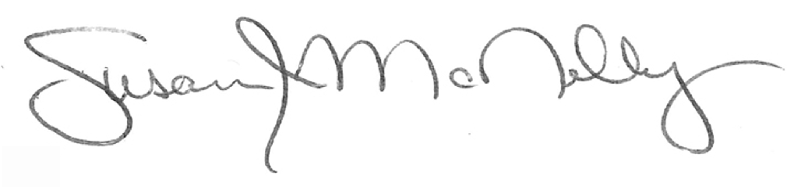

_________________________________ ___________________________________________________

Susan McNelly Instructors: Thomas Champion, Yamille del Valle, and Dean Williams

Committee Chair