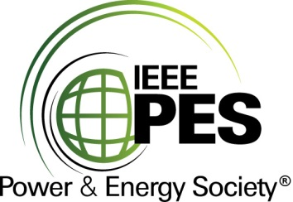

CERTIFICATE OF
EDUCATIONAL ACHIEVEMENT

This certificate is presented to

replace with your name

for attendance at the educational presentation:

"Statistical Methods for Transformer Condition Assessment"

sponsored by the IEEE/PES Transformers Committee

and has earned one (1) Professional Development Hours (PDH) unit.
Spring 2018 Committee Meeting; Thursday, March 29, 2018

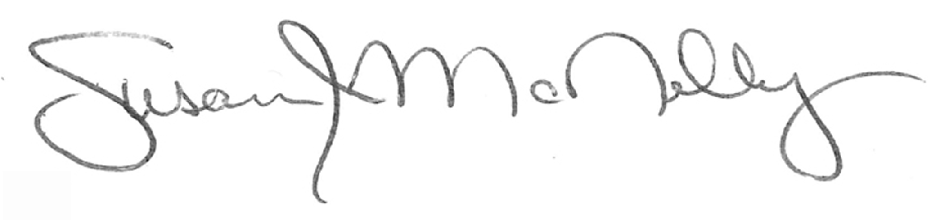

_________________________________ ___________________________________________________
Susan McNelly Instructors: Luiz Cheim, Jim Dukarm, and Tom Rhodes
Committee Chair

