1. Instrument Transformers Subcommittee

**Chair:** Ross McTaggart (unable to attend this meeting)

**Acting Chair for this meeting:** Thomas Sizemore (normally the Secretary)

**Acting Secretary:** David Wallace

# Introductions

The attendees introduced themselves and reported affiliations.

# Quorum

16 of 36 members were present - quorum not attained. 21 guests also attended

# Agenda

An agenda was displayed for this meeting. No objections to the agenda were raised.

No motion to approve the agenda was made as quorum requirements were not met.

# Approval of minutes – Louisville KY meeting

# Could not be approved as quorum requirements were not met.

# Status of C57.13 Standards

Thomas briefly presented the status of the various standards handled by the ITSC:

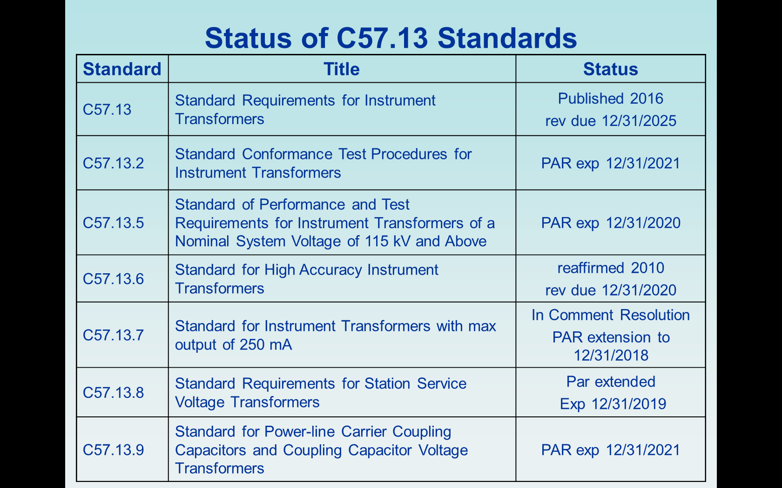

The PAR was approved for the revision of C57.13.2 in December 2017. Work on this standard officially began at this meeting. Thomas Sizemore is the chair for this revision.

# Working Group Reports

**F.6.1 WG on Station Service Voltage Transformers - D Wallace**

The meeting of the C57.13.8 Working Group met at 8:00 AM as convened by Chair David Wallace. Roster sheets were circulated for attendees to sign in.

A total of 34 people were in attendance with 16 members and 18 guests. 16 out of 29 members were present, therefore quorum was met. 3 guest requested membership.

The agenda was presented. Pierre Riffon made a motion to accept the agenda and Rudy Ogajanov seconded the motion. The agenda was accepted with no objection.

The Patent Claims Statement was presented to the workgroup with no claims being identified.

The minutes from the New Orleans meeting were presented. Patrick Rock made a motion to accept the minutes and Igor Ziger seconded the motion. The minutes were accepted by unanimous agreement.

### *In old business:*

Clause 4.4.1.1, 8.3.10, 8.4.3, and 8.4.7.6 were accepted as per the changes requested in the returned comments.

In clause 8.4.5 it was agreed to use NEMA 107-2016 as the reference document replacing NEMA CC-1.

In Clause 8.4.3 It was agreed to use the lightning impulse clause in C57.13.5.

In Clause 8.4.7.6 it was agreed to remove the reference to thermally upgraded paper.

In Clause 8.5.2.1 it was agreed to refer back to Clause 12.2 of C57.13.5

David will send out a survey on clause 7.3 to determine if the clause will reference C57.12.90 and what % impedance will require internal inspection, 2% or 7.5%

David will reword the Short Circuit portion of Table 12 to reference C57.12.00

Time expired before all of the comments could be reviewed. If time is permitting during the Instrument Transformer Sub-committee on Wed 3/28, the WG will reconvene to try and address the remaining comments and the result of the survey.

A motion to adjourn the meeting was offered by Rudy Ogajanov and seconded by Thomas Sizemore.  The motion carried unanimously without discussion.

The C57.13.8 Working Group reconvened during the Instrument Transformer Sub-committee meeting. Attendance was checked and 16 members were present, therefore quorum was met.

The remaining comments from the 3/27/18 meeting were reviewed.

Clause 8.5.3 – it was decided to refer to IEEE 693 in the C57.13.8 standard.

In new business:

The results of the survey on Clause 4.1.7.3 were presented for discussion. The committee agreed to accept the clause from Ross McTaggart with the additions proposed by Pierre Riffon. Discussion was held on the removal of the first sentence from the clause. Zolton Roman made the motion and Patrick Rock seconded it. The vote was 10 for and 1 against with 5 abstaining. The motion carried. It was also decided to change the wording on the voltage classes. David Wallace will reword the clause and insert it into Draft 5 for review and comment.

David Wallace will compile Draft 5 of the standard and send it out to the committee for review and comment. If possible, a web meeting will be held before the next meeting in October to discuss the results of the review.

The next meeting will be at the Fall 2018 Transformers Committee meeting in Jacksonville, Fl.

## F.6.2 WG PD in Bushings & PTs/CTs PC57.160 - Thang Hochanh

This working group did not meet. Invitations to join the ballot pool have been sent out.

## F.6.4 Working Group on Revision of C57.13.5 "Standard of Performance and Test Requirements for Instrument Transformers of a Nominal System Voltage of 115 kV and Above.

The WG met on March 27, 2018, from 9:30 am to 10:45 am. Seventeen (17) members and eighteen (18) guests attended the meeting. Three (3) guests requested membership. The meeting was chaired by Pierre Riffon, WG chair. Mr. David Wallace was the vice-chair.

This was the fifth WG meeting.

Attendance has been recorded in the AM system.

Required quorum was met, presence of at least 16 members was required.

The agenda has been reviewed and was approved unanimously. The motion of approving the agenda was made by Igor Ziger and was seconded by Thomas Sizemore.

Minutes of the Louisville meeting minutes have been approved by all members present. The motion of approving the minutes of Louisville meeting was made by Robert Middleton and was seconded by Thomas Sizemore.

Call for patents has been made and no essential patent claims have been reported.

The first item of business, was related to the survey made on the temperature rise test methodology for current transformers. The results showed that we did not get consensus on the actual edition methodology. A new proposal has been made by the Chair, this proposal is inspired from IEC 61869-1 and IEC 61869-2 wording but an exception has been made to gas-insulated current transformers rated 550 kV and above. In addition, the minimum duration of the temperature rise test has been decreased from 5 times the thermal time constant to 3 times the thermal time constant.

Dry-type current transformers rated 550 kV and above will be added with the same criteria as oil-filled current transformers.

A motion to approve the revised Chair proposal as amended during the meeting was made by Zoltan Roman and was seconded by Igor Ziger. The Chair revised proposal has been approved unanimously. The agreed wording will be part of next Draft 1.6.

The second item of business was related to the comments received on Draft 1.5. Among the subjects discussed, the following additions of modifications will be made to Draft 1.5:

* A reference to IEEE Std. 4 will be made;
* Maximum system voltages will be aligned with C57.13;
* The wording regarding background noise during partial discharge test will be the same as used in C57.13. Moreover, if IEEE C57.160 is adopted before the publication of the new edition of IEEE C57.13.5, then the reference will be changed from IEC 60270 to IEEE C57.160;
* "Pd intensity" will be change for "Pd level";
* TPS class called in Annex D will be deleted.

D1.6 will be issued before the next meeting, this will be the last round of comments within the WG and SC membership. It is planned to request from the Subcommittee an approval for Sponsor Ballot at the upcoming meeting in Jacksonville, Florida.

As a new business, the internal arc test procedure has been discussed. The description of the fuse wire location may need to be improved. Igor Ziger will make a proposal as soon as possible. In addition, an additional rated current for the arc protection classification will be added. This rated arc protection current may equal to or lower than the rated short-circuit withstand current. This rated value will need to be added to the nameplate.

Zoltan Roman made a motion to add informative wording in Annex D in order to recommend the use of polymeric insulators when an arc proof protection class is specified. His motion was seconded by Igor Ziger. The motion was accepted unanimously.

The meeting adjourned at 10:30 am on March 27, 2018. The adjournment motion was made by Robert Middleton and was seconded by Arnaud Martig. The motion was approved unanimously.

The next meeting is planned to be held in Jacksonville, Florida, USA, on October 16, 2018.

## F.6.5 C57.13.9 Working Group for PLC Capacitors and CCVT’s – Zoltan Roman

Zoltan Roman started the meeting as Chair with Mike Craven as Secretary.

Introductions were made.

This is the third meeting as a Working Group. There were 32 attendees including 11 members and one request for membership. 13 members were needed and since there was not a quorum, no business was voted on. Memberships will be re-evaluated after this meeting.

The patent notice was made and there were no patent claims by attendees.

Zoltan reviewed Survey 1 and the 8 responses. An objective is to harmonize with the IEC and CSA as much as possible. There were discussions for and against the offered voltage changes:

-Arnaud Martig explained the Trench opinion that the higher voltages requirements are preferred due to the higher frequency duties of CCVTs.

-Zoltan’s opinion is that the BIL requirement insures that capability.

-A user comment supported the higher voltage because of the uncertainties of aging and capacitor characteristics.

-A user comment that existing standards have worked for 345 and 765 units in service in his experience.

The survey will be transmitted again with additional items.

Zoltan moved on to the next agenda item and his many proposed edits as Draft 3. As before red text in Draft 3 is material not yet reviewed.

-Added Figure 1 schematic diagram to illustrate the definition of the EMU.

-Added section 6.2 capacitance and dissipation factor of the stack and noted the ambient temperature specification is important.

-Table 7 now has corrected pd extinction voltage values per C57.13. Further question whether to use 13.5 or IEC values instead, so the proposed values will be Question 2 added to the next survey.

-Table 8 range of C was changed to 100 nF.

There was a good bit of participation and discussion about Section 6.4 and whether the EMU could be disconnected during test. Considerations were:

-EMU can be tested as a separate physical unit

-12 to 20 kV rating of EMU does not require pd test

-Manufacturer does not want to have to build the whole unit in order to test EMU

-May push the test capabilities of the manufacturers

-And note that it would be a routine test

The issue of disconnecting the EMU for CCVT pd testing is Question 3 of the next Survey.

In Section 6.5 RIV Table 9 was added as no RIV requirements are in 13.5. Some discussion about the need for 72.5 kV and below specification and Igor said not using would harmonize with 13.5 and IEC.

Section 6.6.2 was added with the intent that primary transients are not transmitted to the low voltage side. 6.7.2 is where the review of Draft 2 ended, but needs further review.

Moving on to new items the review of the Draft 3 continued:

-7.1.1 is from the line tuner standard for CCVTs as is the new table just above Table 10.

-Table 10 has burdens Q and T added. Burdens W through ZZ are the same. There were no comments.

Last topic touched was ferroresonance requirements.

Date and place of the next meeting will be the Transformers Committee Meeting in Jacksonville Florida. Adjournment was at 12:15.

**F.6.6 C57.13.2 Working Group for Conformance Test Procedures – Thomas Sizemore**

**Attendees:** 30 people attended and 19 requested membership.

**Rosters:** An initial roster was circulated for members and guests.

**Essential Patent Claims:** Text was displayed and the Chair inquired as to if anyone knew of essential patent claims. None were brought up.

**Minutes:** Initial meeting thus no minutes needed to be approved.

**PAR Approval:** The PAR was approved in December 2017. This was the first official meeting.

**Review of the current version of the standard:**

Based on the meeting that took place in Louisville prior to the PAR being approved the points below were focused on during this meeting. In Louisville the entire standard was reviewed to find the main points of discussion and to identify a number of small technical or editorial issues.

* Section 7.5 was discussed concerning if the section should be removed or not. Zoltan Roman made motion to reference C57.13 Rudy Ogajanov seconded this motion. Unanimous approval was given by those in attendance.
* Section 8 was regarding insulation system acceptance was discussed. Igor Ziger is to review wording and perhaps propose next text. Thomas Sizemore is to review the referenced ANSI/UL 1446 document. Once text changes are worked on between Igor and Thomas as survey will be sent out for comment.
* Section 9 which covers production monitoring was discussed. Huan Dinh suggested the addition of partial discharge as a required test to this section. Igor Ziger made a motion and Arnaud Martig provided a second to add PD in this section. This was unanimously accepted by the attendees.
* Section 9 was also discussed with respect to third party monitoring (by UL, CSA inspectors, etc.) was discussed but no conclusion was reached to make a change to this item. More discussion may take place in the future to clarify this language.

**Motion to adjourn:** A motion was put forth by Rudy Ogajanov and was seconded by Scott McClosky.

**Next Meeting:** This WG will meet to continue work at the Fall 2018 meeting in Jacksonville, Florida.

**Next version of draft:** A new draft is being prepared to update based on comments. It will be issue between meetings with a request for comments.

# New Business

## Survey Results on Group 4B Transformers:

Thomas Sizemore presented the results of the survey on group 4B transformers. This covered three points. First, how to clearly mark the nameplates for these requirements. Second, do accuracy requirement apply at both the 58% and full accuracy voltage level. Finally, is partial discharge test voltage to be defined by the normal operating voltage or the full accuracy voltage level typically seen in fault or emergency conditions.

## Task Force on Accuracy Requirements

If a quorum had been met than discussions and actions to initiate a Task Force to review accuracy requirements would have begun. This topic was not advanced at this time. It may be addressed at the next meeting.

# ITSC Adjournment

The meeting concluded after a motion to adjourn by Scott McClosky and seconding of this motion by Pat Rock.

The next meeting will be at the Fall 2018 Transformers Committee meeting in Jacksonville, FLA