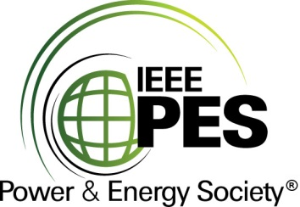

###### 

###### CERTIFICATE OF

**EDUCATIONAL ACHIEVEMENT**

# This certificate is presented to

## replace with your name

for attendance at the educational presentation:

**" Tutorial on Guide for Dielectric Frequency Response"**

*sponsored by the IEEE/PES Transformers Committee*

**and has earned one (1) Professional Development Hours (PDH) unit.**

**Spring 2019 Committee Meeting; Thursday, March 28, 2019**

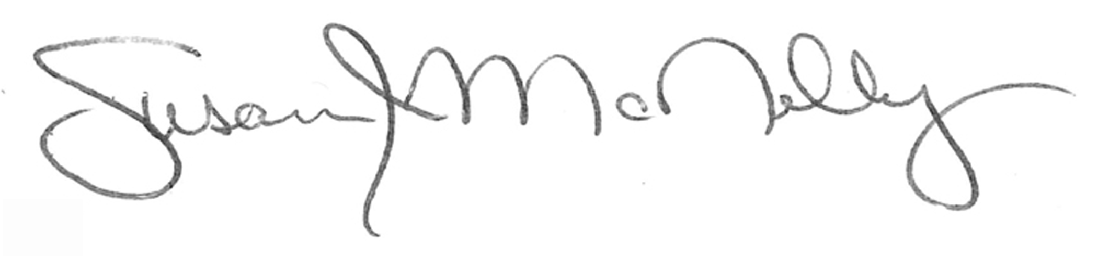

_________________________________ ___________________________________________________

Susan McNelly Instructors: Ali Naderian, Poorvi Patel and Peter Werelius

Committee Chair