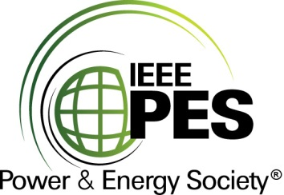

###### 

###### CERTIFICATE OF

**EDUCATIONAL ACHIEVEMENT**

# This certificate is presented to

## replace with your name

for attendance at the educational presentation:

**"A New Dual Nameplate kVA Distribution Transformer – Part 1 & 2"**

*sponsored by the IEEE/PES Transformers Committee*

**and has earned two (2) Professional Development Hours (PDH).**

**Spring 2022 Denver Committee Meeting; Thursday, March 31, 2022**

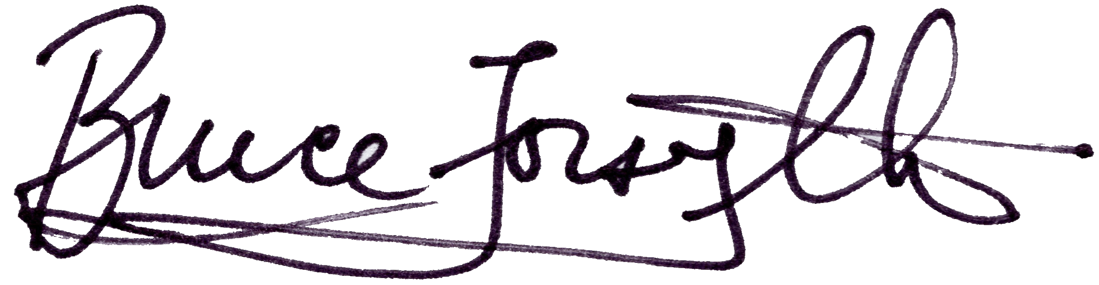

_________________________________ ___________________________________________________

Bruce Forsyth Instructor: Phil Hopkinson

Committee Chair