Recognition and Awards Report – Bruce Forsyth

General
The Transformers Committed appreciates the efforts and contributions made by its many members who volunteer their time to advance the work performed by the Committee. To that end, the Committee dedicates time at each of its meetings to recognize noteworthy events and contributions made by members and participants.

Memorial Tributes
I am pleased to announce that since our last meting there have been no reports of the passing away of past Committee members.

Emeritus members
The Emeritus Member classification is a non-voting member classification for past voting members who have made longstanding and notable contributions to the Committee demonstrated a high level of participation in the past but for extenuating reasons are no longer able to meet the other membership requirements.
The following is a list of the Committee’s current Emeritus Members:
Peter Balma | Thomas Lundquist | Georges Vaillancourt
Richard Dudley | Bipin Patel | Loren Wagennaar
Donald Fallon | Linden Pierce | Kipp Yule
Kenneth Hanus | H. Jin Sim

New Committee Members
Applications for voting membership in the Transformers Committee are review and approved by the Administrative Subcommittee.
Successful applicants can demonstrate active participation in at least three Committee activities for at least two years and are sponsored by at least one Subcommittee Chair (specific details available at www.transformerscommittee.org).
The Transformers Committee welcomes the following new Voting Member whose membership application was reviewed and approved by the Administrative Subcommittee at its March 22, 2022 meeting:
Tim Raymond – Electric Power Research Institute (EPRI)

General Service Awards

Certificate of Appreciation – Meeting Host
The Transformers Committee awards thanks Xcel Energy for serving as the Host Company for the Spring 2022 meeting. In addition, the Comment thanks Jeff Gragert for his dedicated service as Host for the meeting.

Certificate of Appreciation – Outgoing Subcommittee Chair
The Transformers Committee thanks the following individuals for completing a 5-year term as Subcommittee Chair:
Bill Griesacker – Power Transformers Subcommittee
Ajith Varghese – Dielectric Test Subcommittee

Outstanding Service Awards
The Transformers Committee has been fortunate over the years to have had many people willing to volunteer their time to help advance the Committee’s work. At any given time, there are typically dozens of working groups and task forces active. Each of these is composed of volunteers willing to dedicate their personal time and skills to help develop or improve a standard, guide, or recommended practice that helps ensure the best performance and reliability of transformers covered under the Committee’s scope. Subject to the requirements outlined in the Policies and Procedures for Standards Development for the Transformers Committee and the Policies and Procedures for: Transformers Committee’s Working Groups (Individual Method) participants can join as many of the development activities as they desire.
A recent review of recorded participation records indicates that approximately75% of active participants have participated in 10 or fewer development activities. However, 3 people (about 0.3% of active participants) have participated in 36 or more development activities.
The Transformers Committee awards the following individuals an Outstanding Service Award for longstanding commitment and participation in Committee activities:

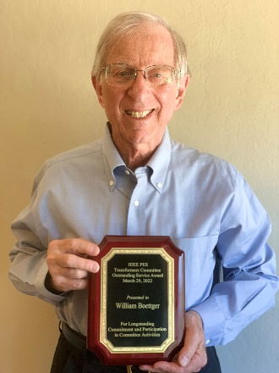 | 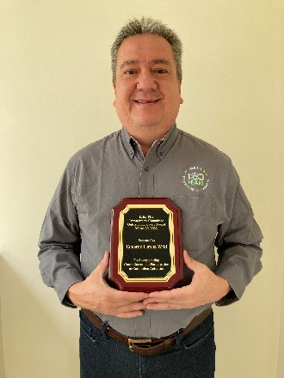 | 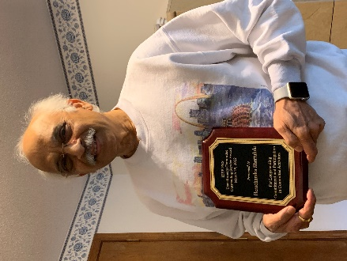
William (Bill) Boettger | Eduardo Garcia Wild | Hemchandra Shertukde

Working Group Awards
The IEEE Standards Association Standards Board (SASB) presents awards to Working Group Chairs upon publication of a new or revised document and offers the Working Group Chair the opportunity to nominate significant contributors for an IEEE SASB Certificate of Appreciation. At this meeting 3 Working Groups were recognized.

IEEE Std C57.12.00™-2021 – IEEE Standard for General Requirements for Liquid-Immersed Distribution, Power, and Regulating Transformers
WG Chair: Steve Snyder
Certificates of Appreciation: Stephen Antosz, Phil Hopkinson, Ajith Varghese, Eric Davis, Bill Griesacker, David Walker, Ramsis Girgis, Steve Shull, Rogerio Verdolin, Tauhid, Ansari

IEEE Std C57.12.90™-2022 – IEEE Standard Test Code for Liquid-Immersed Distribution, Power, and Regulating Transformers
WG Chair: Stephen Antosz
Plaques: Ajith Varghese, Bertrand Poulin, Hakan Sahin, Bill Griesacker
Certificates of Appreciation: Jerry Murphy, Pierre Riffon, Sheldon Kennedy, Vinal Mehrotra, Peter Balma, Ramsis Girgis, Steve Snyder, Tauhid Ansari, Phil Hopkinson, Rogerio Verdolin.

IEEE Std C57.164™-2021 – IEEE Guide for Establishing Short-Circuit Withstand Capabilities of Liquid-Filled Power Transformers, Regulators, and Reactors
WG Chair: Sanjay Patel
WG Vice Chair: Raj Ahuja
WG Secretary: Joe Watson
Certificate of Appreciation: Jane Vernor

Presentation Slides
This report was presented at the Spring 2022 Awards Luncheon in PowerPoint format. The following slides were presented:
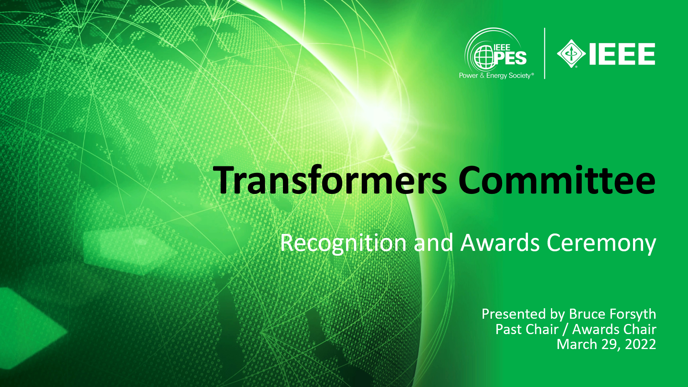 | 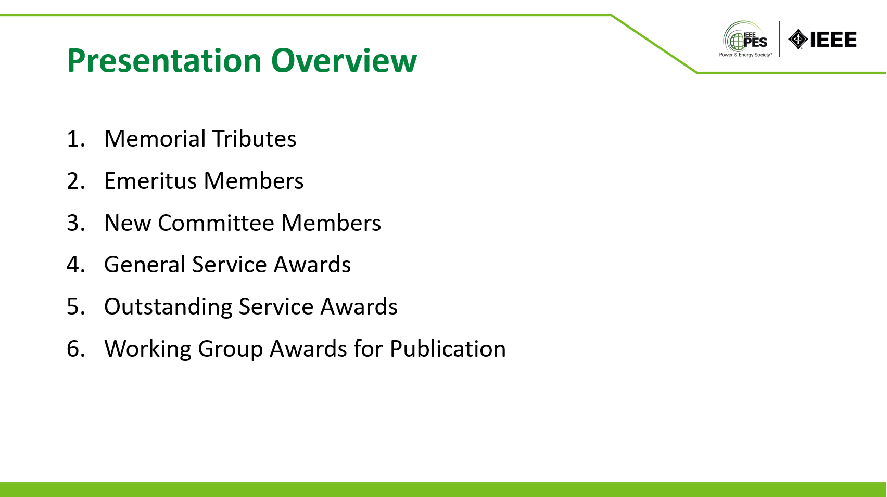
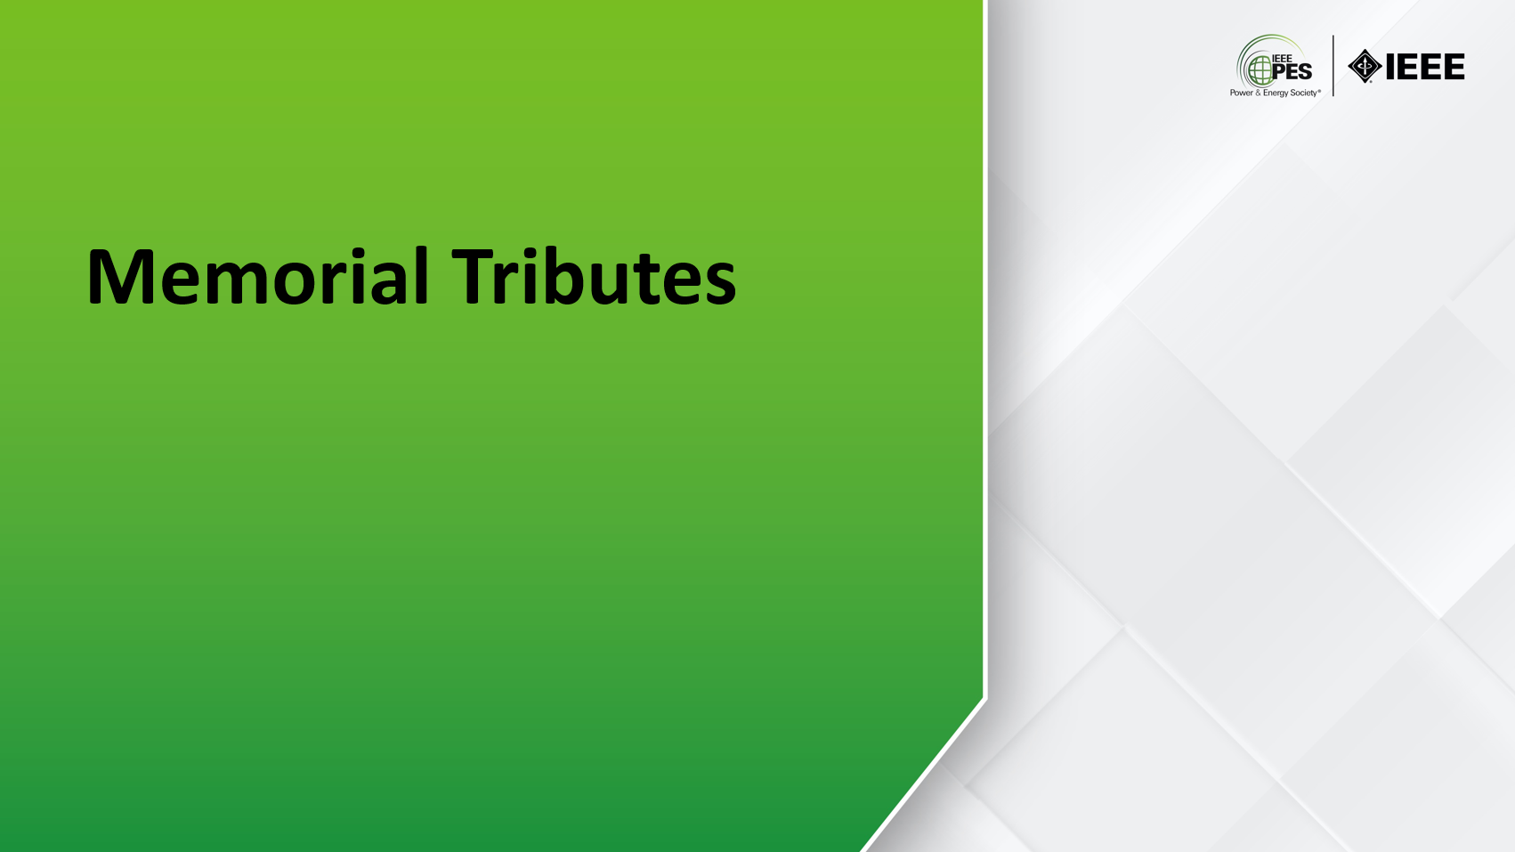 | 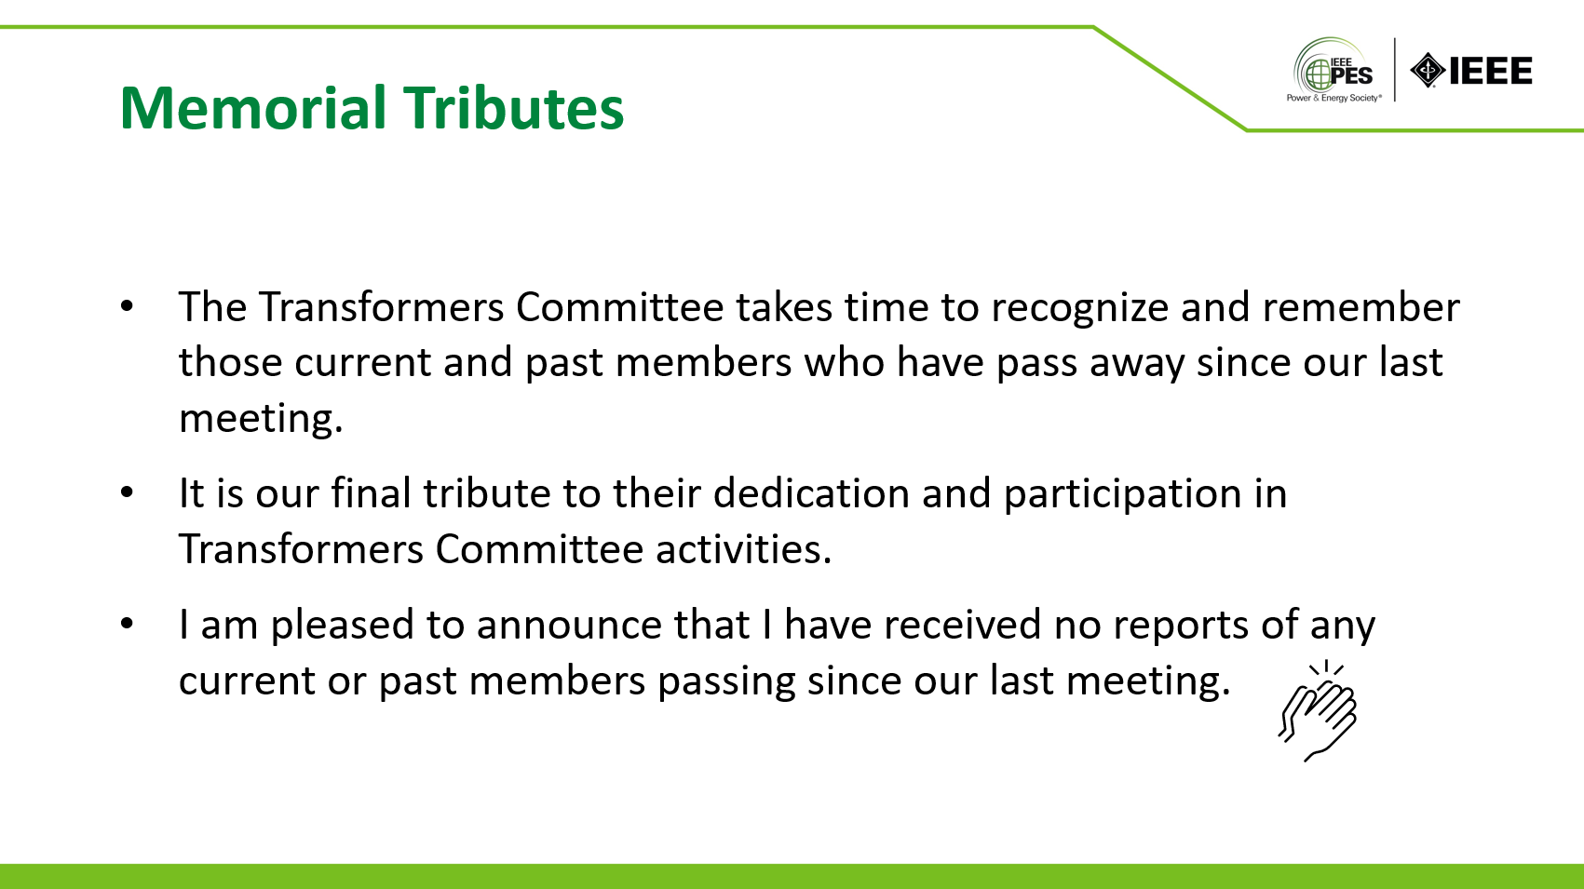
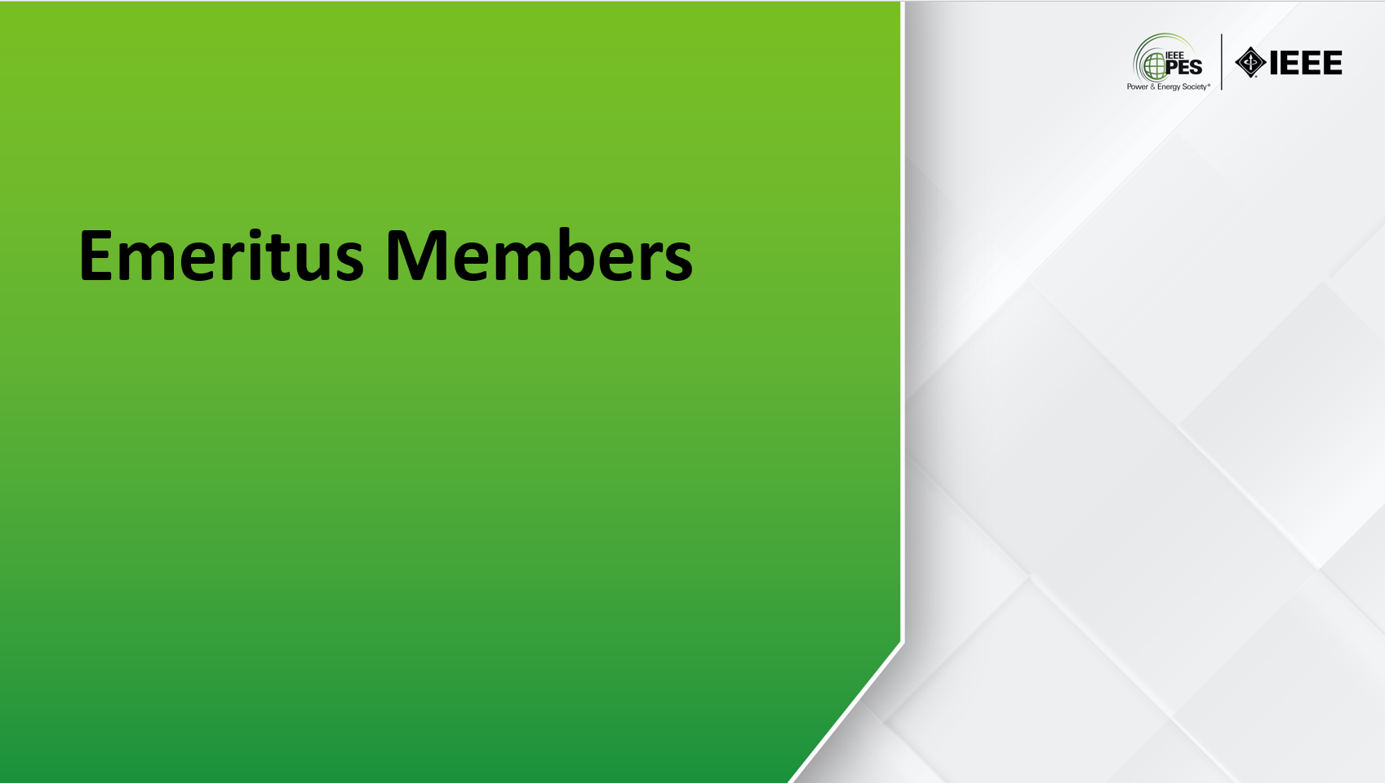 | 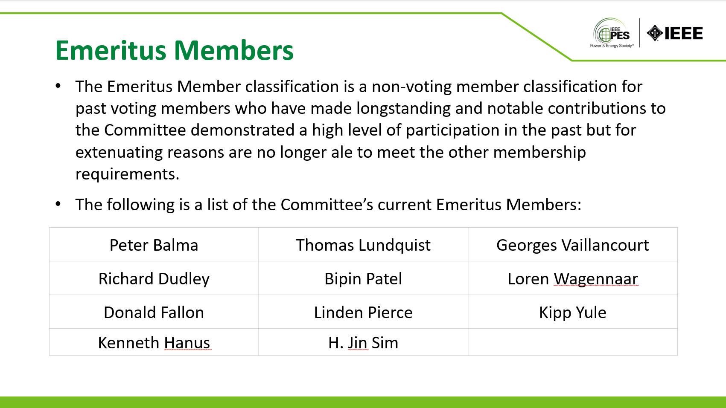
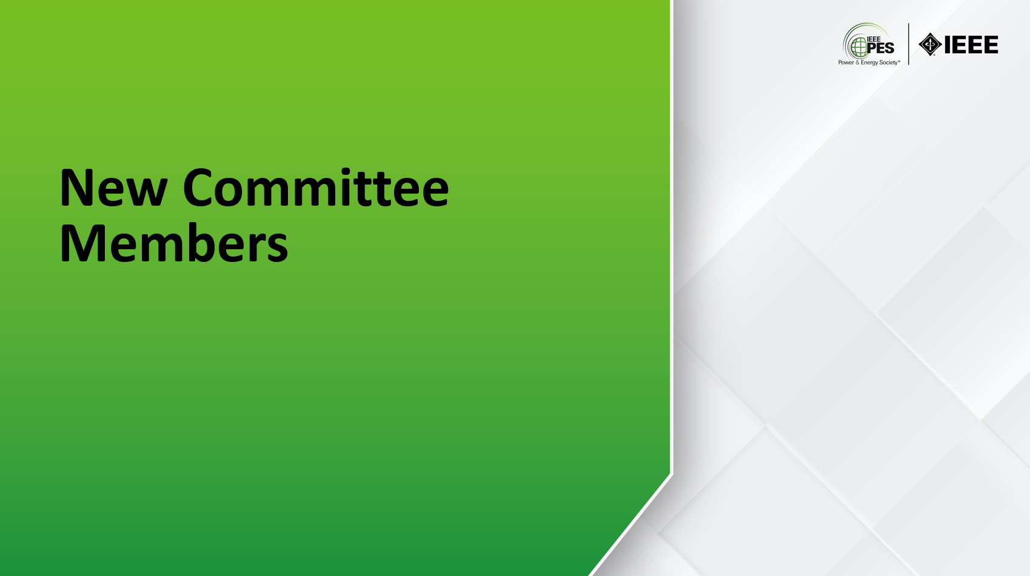 | 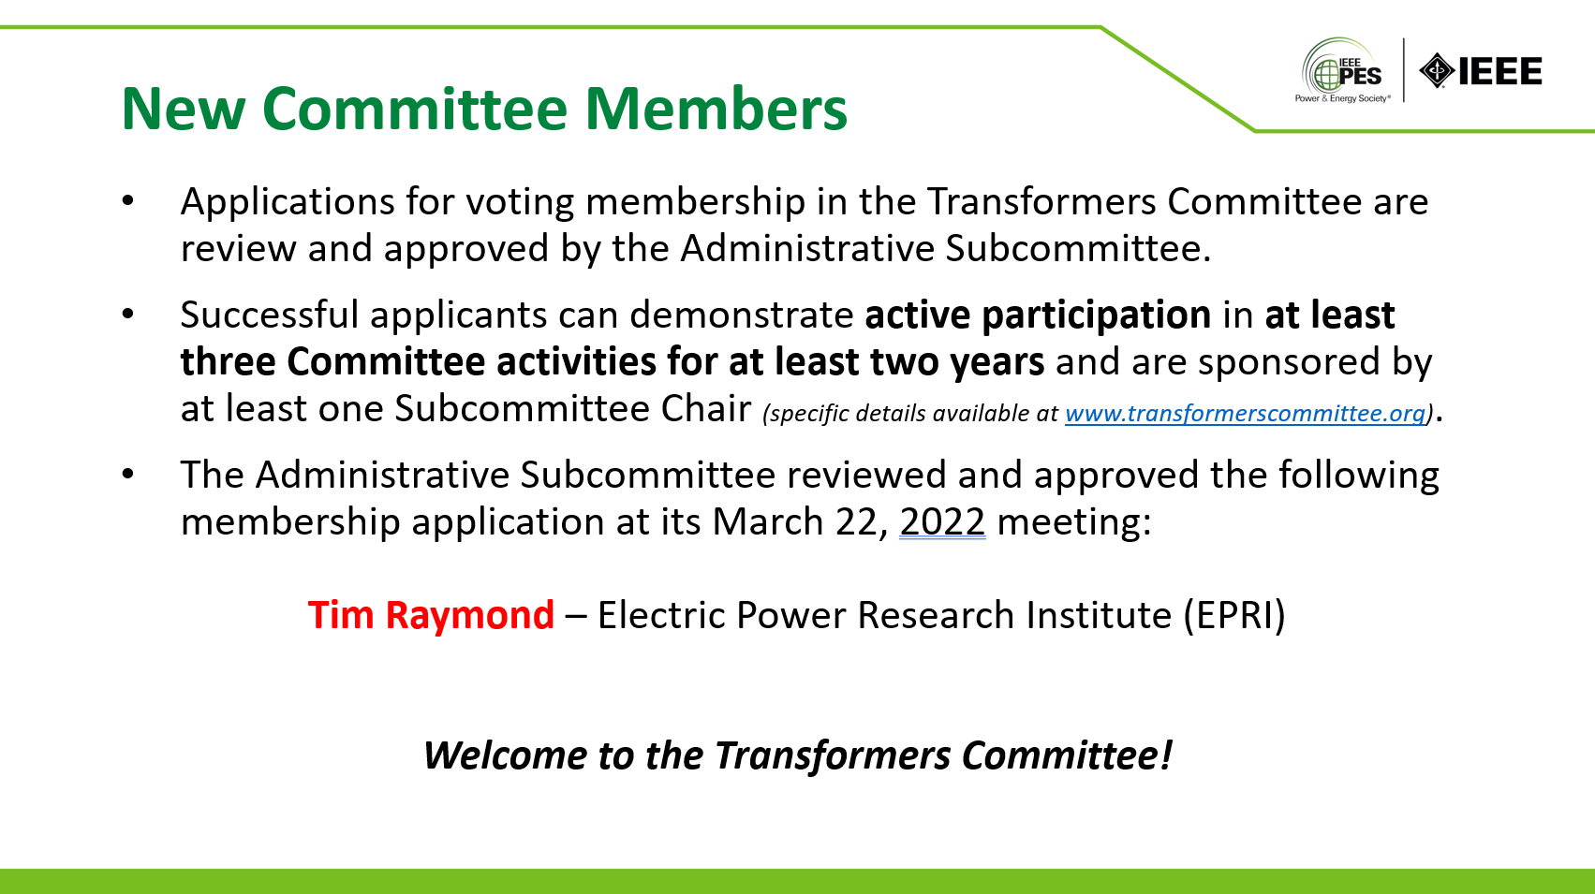
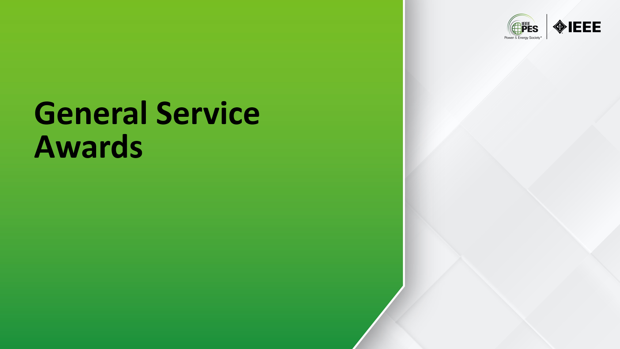 | 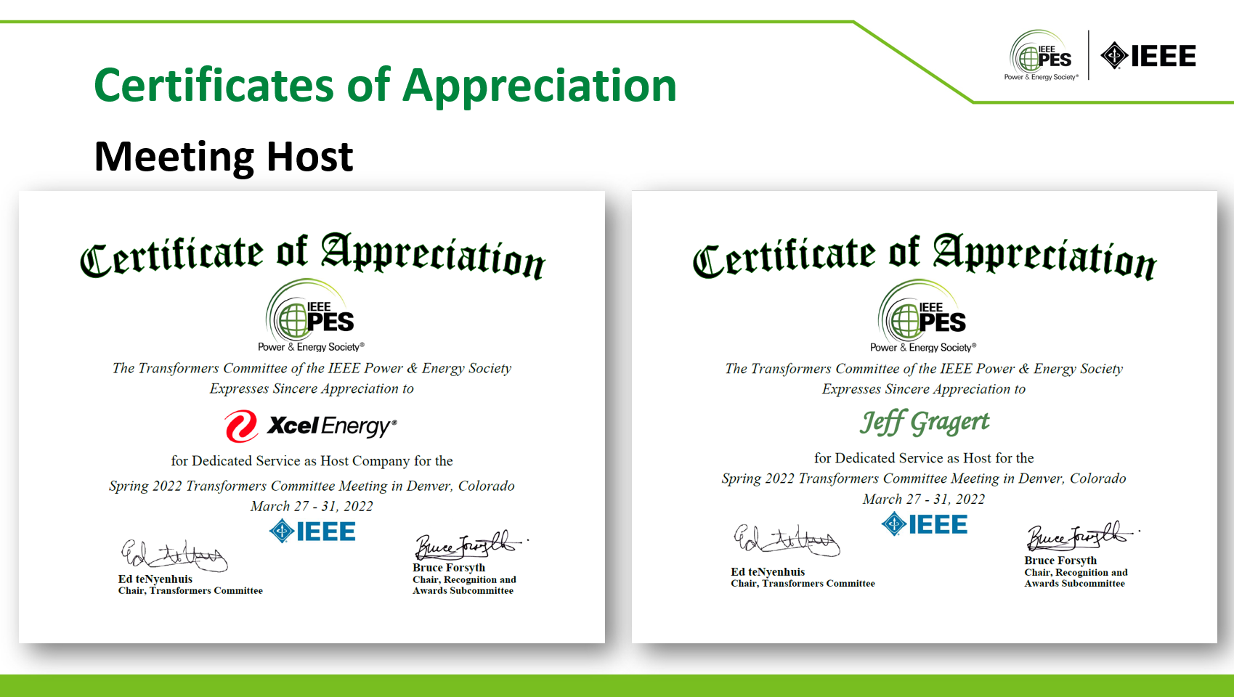
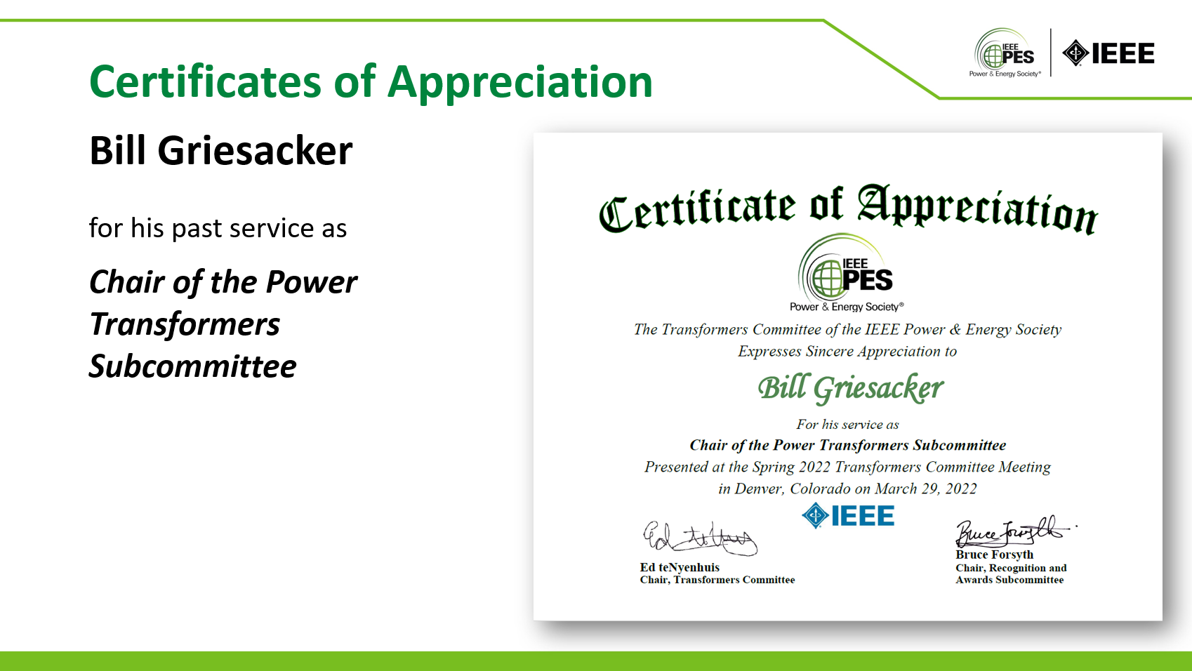 | 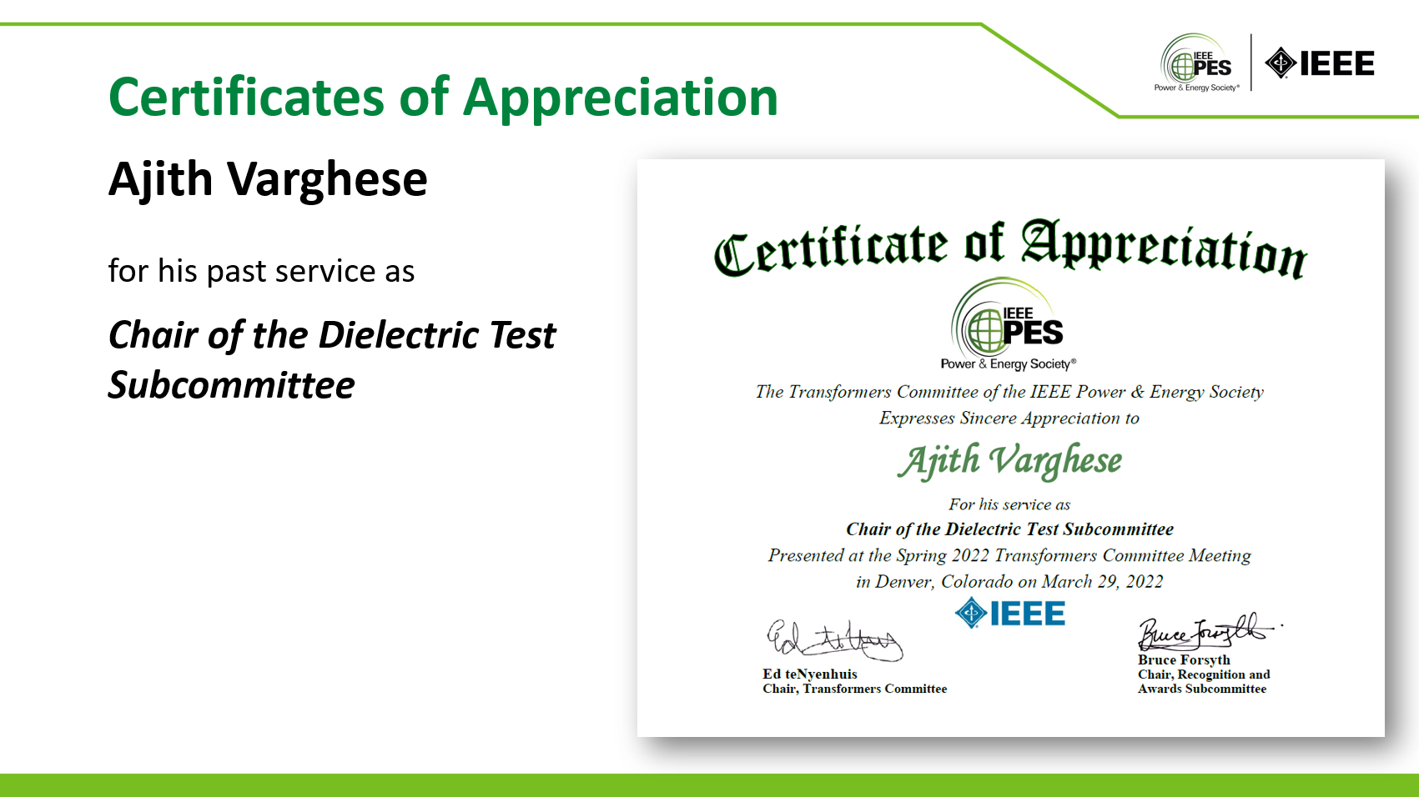
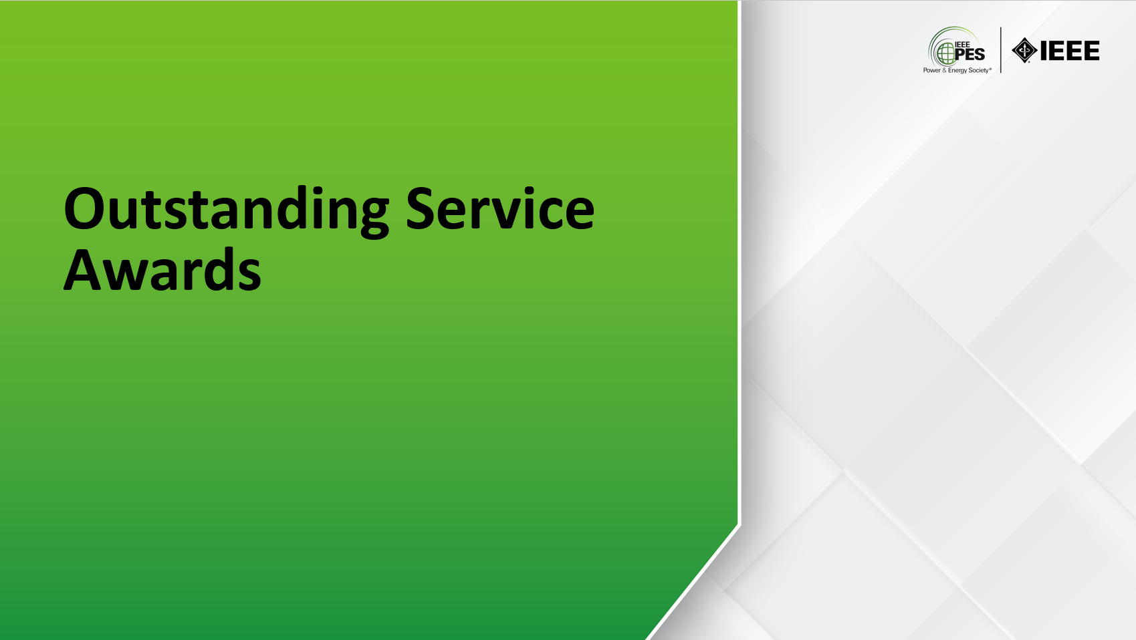 | 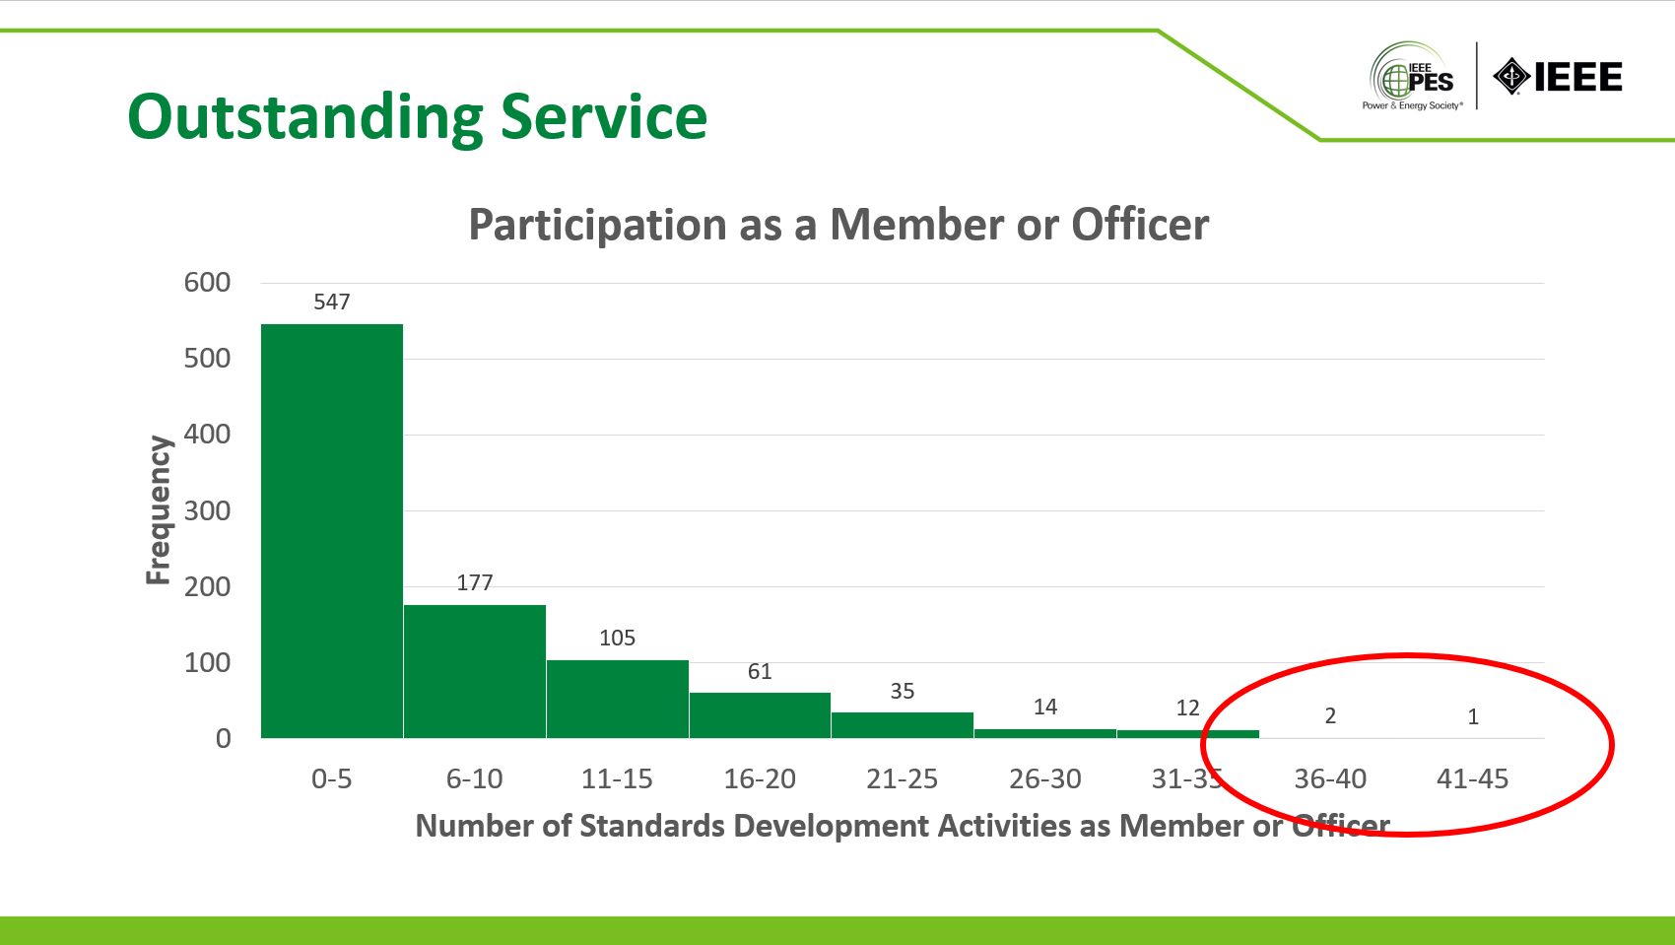
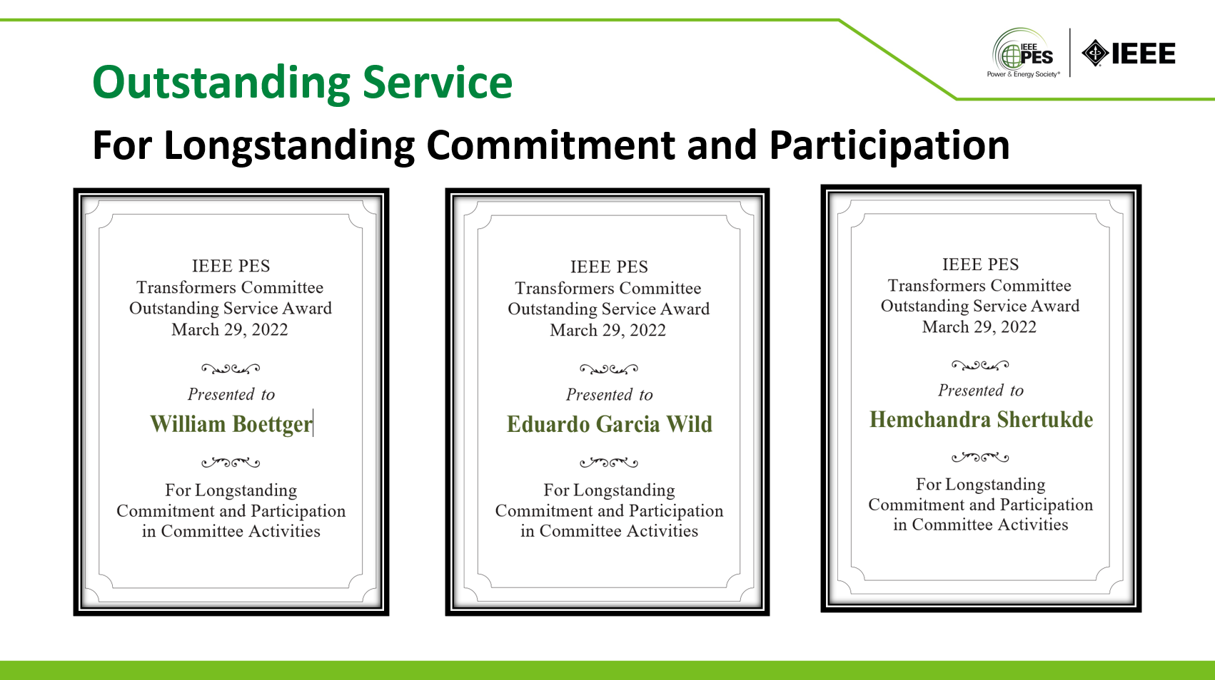 | 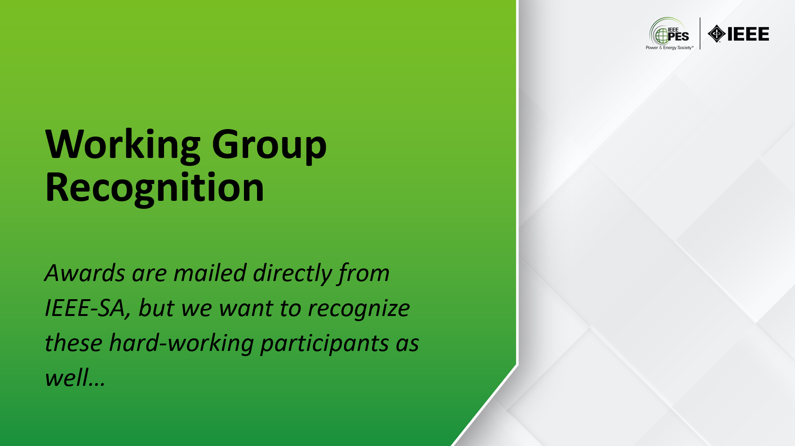
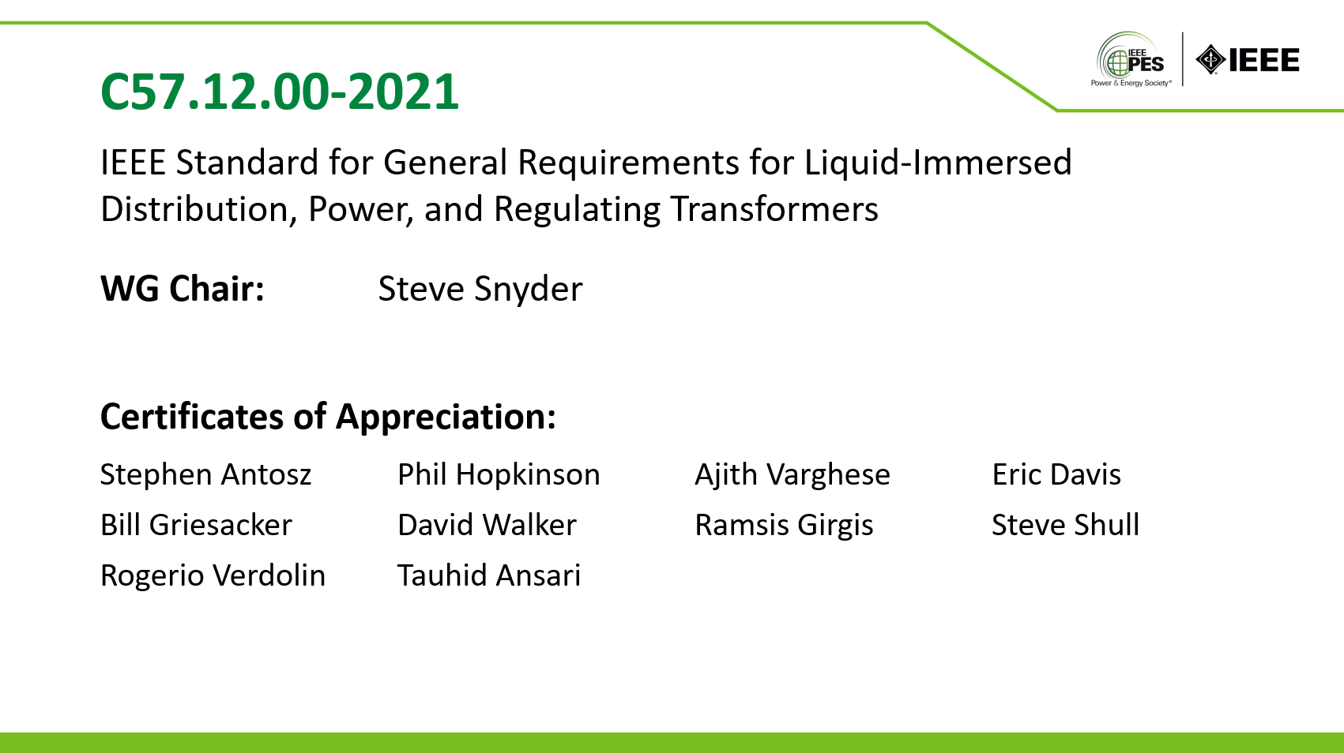 | 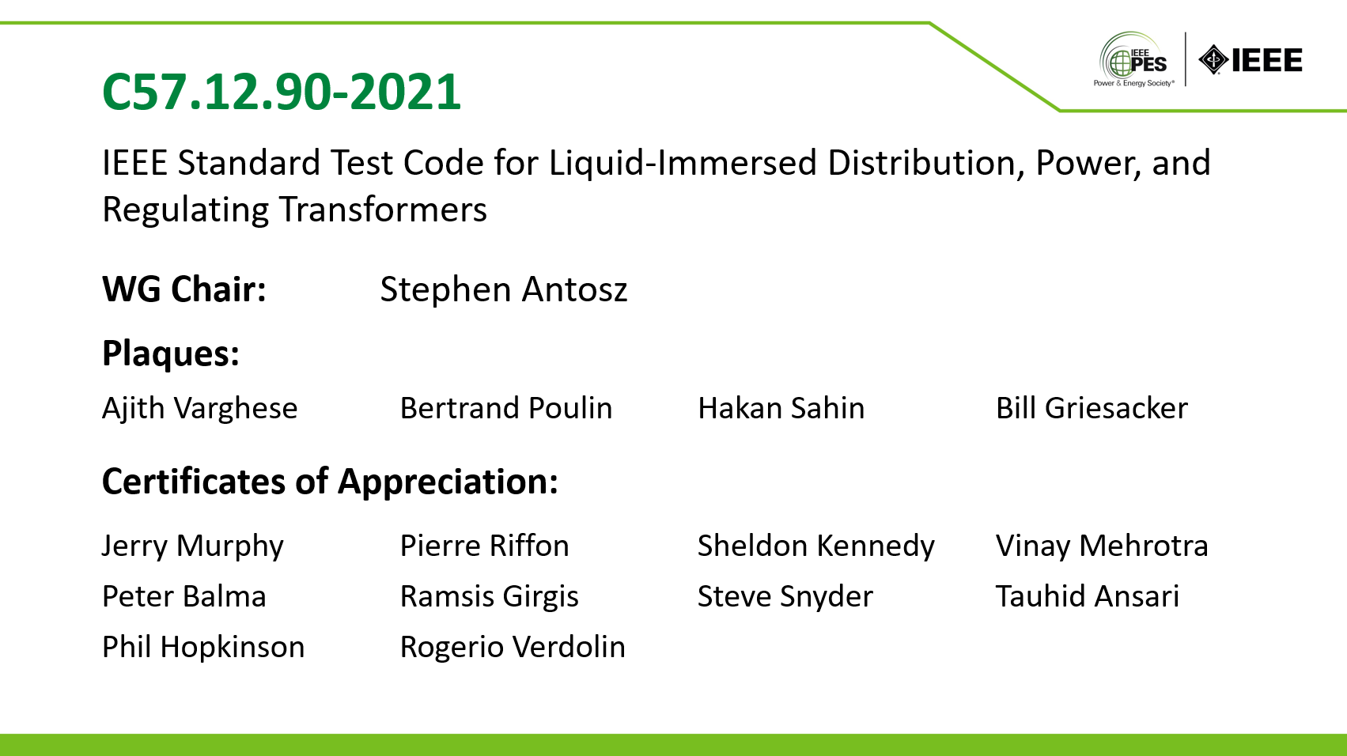
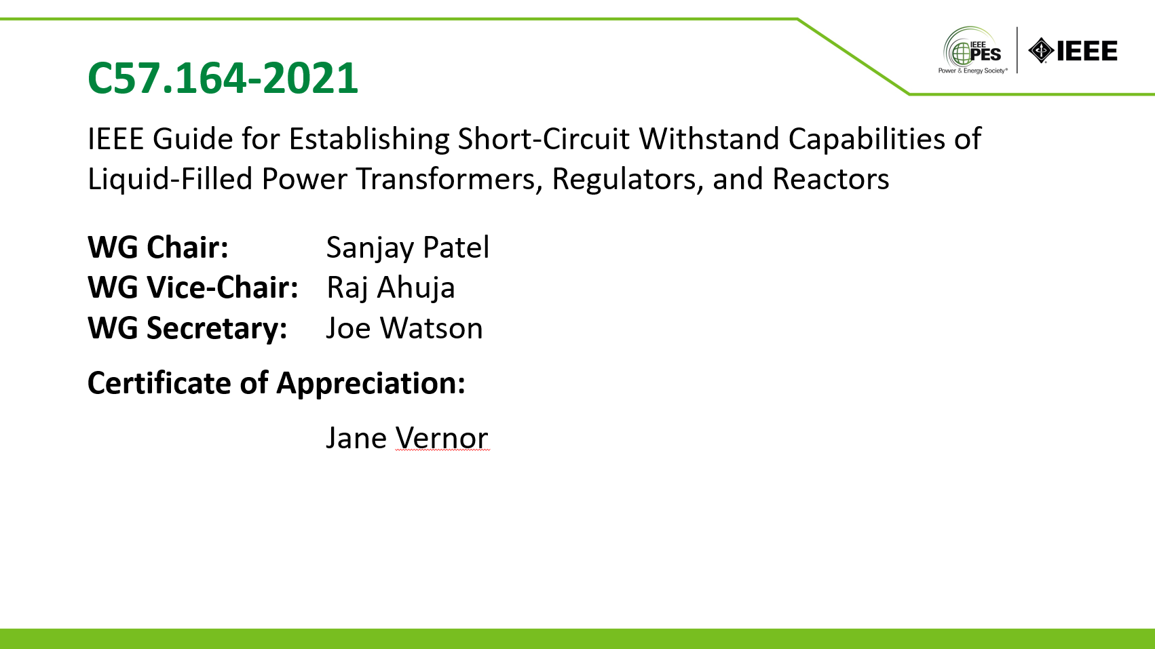 | 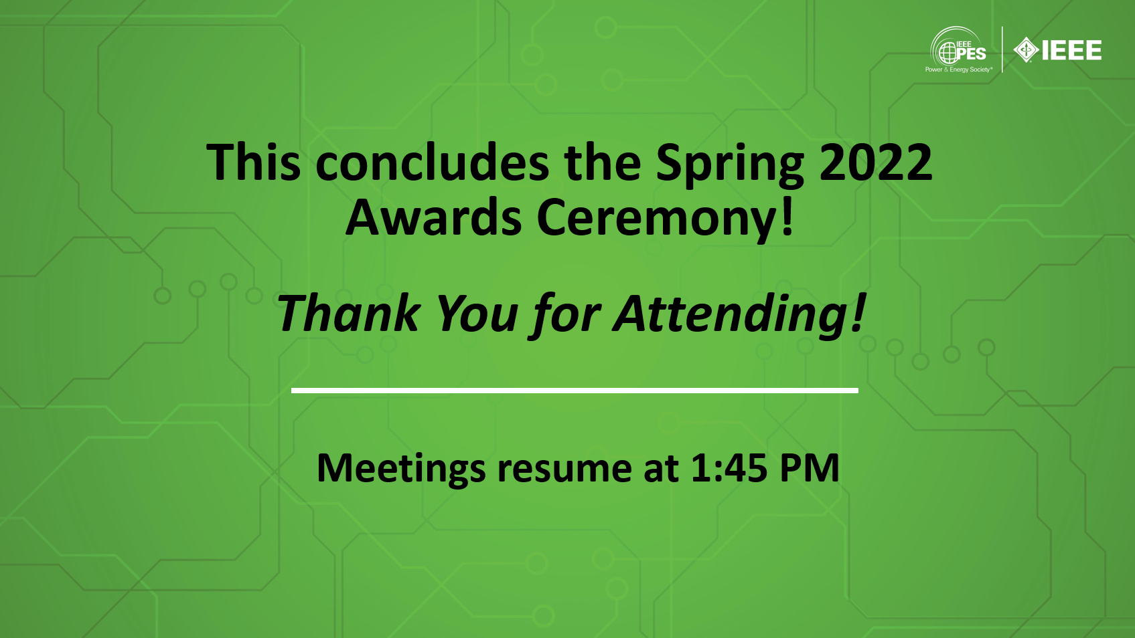

Respectfully submitted,
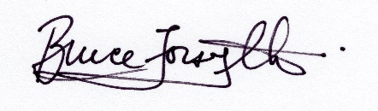
Bruce Forsyth
Past Chair and Awards Chair, IEEE PES Transformers Committee
Rev. 0, August 3, 2022

