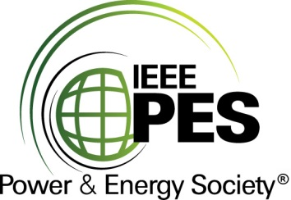

###### 

###### CERTIFICATE OF

**EDUCATIONAL ACHIEVEMENT**

# This certificate is presented to

## replace with your name

for attendance at the educational presentation:

**“U.S. Department of Energy NOPR for Distribution Transformers”**

*sponsored by the IEEE/PES Transformers Committee*

**and has earned one (1) Professional Development Hour (PDH).**

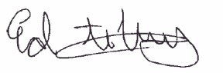**Spring 2023 Milwaukee Committee Meeting; Thursday, March 23, 2023**

_________________________________ ___________________________________________________

Ed teNyenhuis Instructors: Phil Hopkinson, Colby Lovins, Bryan Marquardt,   
Committee Chair Aaron Meyers, Dan Mulkey, Joe Tedesco and Alan Traut