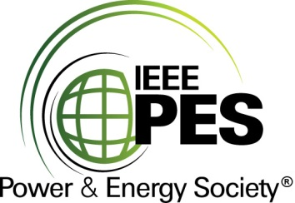

###### 

###### CERTIFICATE OF

**EDUCATIONAL ACHIEVEMENT**

# This certificate is presented to

## replace with your name

for attendance at the educational presentation:

**“Transformer Bushing Overloads: Innovative Solutions to Increase Overload Capability for Oil and Dry Types"**

*sponsored by the IEEE/PES Transformers Committee*

**and has earned one (1) Professional Development Hour (PDH).**

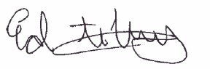**Spring 2023 Milwaukee Committee Meeting; Thursday, March 23, 2023**

_________________________________ ___________________________________________________

Ed teNyenhuis Instructor: Kurt Kaineder, Alfons Schrammel and Esseddik Ferdjallah-Kherkhachi

Committee Chair