ANNEX A Bushings Subcommittee
Milwaukee, Wisconsin, USA
March 22nd, 2023, 09:30AM Eastern

Chair (presiding officer): Eric Weatherbee, PCORE Electric, Inc. / Hubbell Power Systems
Vice-Chair: Scott Digby, Duke Energy
Secretary: Fabien (Durand) Stacy, Hitachi Energy

- Opening of the Meeting
  - Call to Order / Chairman’s Opening Remarks
The Chair presented and reviewed the proposed agenda that was circulated to the SC members by the Chair prior to the meeting. There were no comments concerning the proposed agenda.
The Chair requested that each person use the microphone, state their name and affiliation when addressing the subcommittee.
The Chair reminded the WG chairs and secretaries that their meeting minutes need to be submitted to the Subcommittee officers no later than 15 days after their WG or TF meetings took place.
The Chair noted that the replacement for the AMS system should be ready for use by the Fall-2023 meeting, but for now attendance and attendance records are to continue to be managed manually.
The Chair noted that WG Chair training that had previously been mandatory is now voluntary, however the IEEE-SA Antitrust, Competition, and Commercial Temp Policies training unit is still mandatory, which is required to be completed by SC and WG officers withing 90-days of appointment or by December 31, 2023 (whichever is later).
  - Reminders of IEEE policies
The requisite IEEE-SA information concerning the Call for Patents, the Copyright Policy, and the Individual Participation Guidelines had been transmitted to SG Members and Participants along with the meeting Agenda prior to this meeting.
  - New Members
It was reported that 4 new members had been accepted into the Subcommittee, each of whom were recognized. These new members are Kayland Adams, Sami Debass, Jeffrey Door, and Jerzy Kazmierczak.
  - Attendance
Participant rosters were circulated during the meeting for recording the meeting attendance. The Chair presented a list of the 77 current voting members to perform a quorum check. Quorum was achieved. Per subsequent review of the rosters the meeting had 119 attendees, of which 46 were members and 73 guests, with 12 guests requesting membership. Refer to Appendix A for meeting participants, their affiliation, and voting member status.
Table 1 – Meeting Attendance
Total | 120
Members – Quorum Achieved | 47
Guests | 73
Guests Requesting Membership* | 12
*Review of the historical attendance records indicate that of the 12 guests requesting membership, 6 meet the eligibility requirements (Raymond Frazier, Ronald Hernandez, Daniel Posadas, Zoltan Roman, Eric Schleismann, William Solano) and will be added to the membership roster effective at the next SC meeting.
  - Agenda Approval
As 46 of the 77 members were in attendance a quorum was achieved. There were no comments to the proposed agenda. A motion was made by Sanjib Som and seconded by Hugo Flores to approve the agenda as proposed. This motion carried by unanimous consent.
  - Previous Meeting’s Minutes Approval
There were no comments to the minutes that had been posted. A motion was made by Fabian (Durand) Stacy and seconded by Hugo Flores to approve the minutes as posted. This motion carried by unanimous consent.
  - Status of Bushing Standards
The Chair presented the Standards Status Report for standards and guides under the Bushing SC, see Appendix B.
- Working Group and Taskforce reports
  - WG PC57.19.00-2004 – Peter Zhao, Chair; VACANT, Vice-Chair; Eric Weatherbee, Secretary
No meeting was held due to the status of the balloting process. The WG Chair reported that balloting was complete and was going to RevCom for approval. The work of the WG is complete except for supporting the final editing that will take place with IEEE stall prior to publication.
  - WG C57.19.01-2017 – Dr. Shibao Zhang, Chair; VACANT, Vice-Chair; VACANT, Secretary
No meeting held, with the current document having a 2027 expiration date. The WG Chair reported that after the call for comments made at the last SC meeting that some comments had been received. A motion was made by Sanjib Som and seconded by Kumar Mani to form a Task Force to prepare the PAR documentation to support the next revision cycle. The motion passed by unanimous consent.
  - WG PC57.19.02 Distribution Transformer Bushings – Steven Shull, Chair; Ed Smith, Vice-Chair, Rhett Chrysler, Secretary
The WG Chair was not present and there was not meeting of the WG this week. The document has completed the balloting process and is on the next RevCom agenda for approval. The work of the WG is complete except for supporting the final editing process that takes place with IEEE staff prior to publication.
  - IEC/IEEE 65700-19-03 Bushings for DC Application – Eric Weatherbee (IEEE) and Lars Jonsson (IEC), Co-Chairs; Sami Debass, Vice-Chair; J. Arturo Del Rio, Secretary
See complete WG minutes in Appendix C of this report.
The WG Chair reported that a complete reporting of WG meeting minutes is maintained by IEC, with the most recent IEC WG meeting having taken place February 7-8. It was reported that a third version of the Draft document had been circulated for review. It was reported that there have been three (3) Task Forces under the WG: 1) Voltage source converters (work complete); 2) Altitude correction factors; and 3) Special tests. Editorial work in ongoing. The next IEC WG teleconference was scheduled for April 12-13.
  - WG C57.19.04-2018 – Scott Digby, Chair; VACANT, Vice-Chair; Rich vonGemmingen, Secretary
No meeting held as the latest revision was recently published and is not due for revision again until closer to the document’s 2028 expiration date. The WG Chair noted that no comments regarding the document had been received thus far. The WG Chair requested that any comments regarding the current document be forwarded to him for consideration.
  - WG PC57.19.100-2012 – Tommy Spitzer, Chair; VACANT, Vice-Chair; Fabian (Durand) Stacy, Secretary
See complete WG minutes in Appendix D of this report.
The WG Chair reported that the Draft document was close to completion, and it was planned to solicit a vote of the WG for approving moving the document to Sponsor Ballot with the objective to go to ballot this year. It is expected that a PAR extension requires will be likely, which would be its first PAR extension request.
PAR expires at the end of 2023.
- External Liaison Reports
  - IEC Bushing Standards Activity – Bruno Mansuy, IEEE/IEC Liaison
Mr. Mansuy was not in attendance but did submit a summary report, of which Art Del Rio provided a brief description. This summary report is included in Appendix E of this report. It was noted that the group discussing dimensional standards has reached some consensus, a draft of an application guide is being prepared, the document associated with maintenance is out for review and comment by the respective national committees with possible revision cycle forthcoming, and the document associated with DGA in bushings in the process of being withdrawn and its content transferred to other documents.
  - WG PC57.160 Guide for PD Meas. in Bushings and Inst. Trans. – Thang Hochanh, Chair
The WG Chair reported that the document was currently going through the balloting process and that there were more than 500 ballot comments that the WG was working to resolve.
  - Amendment to IEEE 693, Recommended Practice for the Seismic Design of Substations - Durand Stacy
Mr. Stacy reported that the document was in the Ballot comment resolution stage of the process.
- Unfinished Business
- Venting/PD in OIP Bushings during FAT
This topic currently resides within the TF for Continuous Revision of Low Frequency Tests (under the Dielectric Test SC), with a Study Group having been formed under that TF formed to review the comments from a 2020 survey on the topic and make further recommendations. The Study Group included volunteers that had been solicited from within the Bushing SC. The Study Group facilitator, Ajith Varghese, provided a summary of the group’s activities and status. A more detailed reporting of the Study Group would be included under the minutes of that Task Force so is not reiterated in detail in these minutes. The primary points of the report are as follows:
Text is in development for proposed text for inclusion within C57.12.90.
Egon Kirchenmayer with Siemens repeated a presentation that had been given to the Study Group and again at the Low Frequency TF regarding a bushing test procedure to simulate the cooldown behavior and bubble evolution. The Low Frequency TF Chair, who was present at this SC meeting, indicated that the complete presentation will be posted on the TC website under the Low Frequency TF.
There were some comments and discussion regarding this presentation. It was noted that other bushing manufacturers were reviewing this bushing testing in more detail in order to provide a more complete peer review. It was noted that this test procedure only applies to OIP bushings. It was noted that it would be expected that this would be a “type” dependent test, thus a special or type test and not a routine test. Much additional discussion regarding the test procedure, including its benefit and impact to the industry, is anticipated.
The SC Chair expressed appreciation to Siemens for their work on this bushing test procedure and the testing they had completed.
- New Business
Cihangir John Sen made a presentation proposing two items to be considered during the next revision cycle of the applicable standard documents.
The first was suggesting reviewing the test voltages and PD level limits for Dry Type Condenser Bushings within C57.19.01, mainly to define such voltage levels and PD limits within Table-5 of that standard. The presentation noted that there are newer technologies being used (such as RIS, RIF, RIG, SDC, etc.) today that are not specifically addressed by the document but that his utility was increasing population of these type bushings. It was noted that these bushings behave differently than OIP bushings.
With preparations for the next revision cycle for C57.19.01 in process, the information will be forwarded to the Chair of C57.19.01 for consideration during that process.
The second item was to consider the addition of the word “concentrically” within the definition of “capacitance graded bushing:” within C57.19.00, such that it would read “A bushing in which metallic or nonmetallic conducting layers are concentrically arranged within the insulating material for the purpose of controlling the distribution of the electric field of the bushing, both axially and radially.” The presentation noted that non-concentrically arranged layers creates concentrated stresses within the insulation system that could potentially cause breakdown.
C57.19.00 has just been completed its recent balloting process, so, while the issue is not able to be considered for the current, approved Draft, the information will be forwarded to the WG Chair of that document for consideration during its next revision cycle.
- Adjournment
- After meeting note
Following the meeting Fabien (Durand) Stacy, Hitachi Energy, volunteered to fill the vacant role of Secretary, which was accepted, thank you Durand.
- Next Meeting: Spring 2023, Milwaukee, Wisconsin - March 19 – 23, 2023
First Name | Last Name | Affiliation | Role
Mubarak | Abbas | Siemens Energy | Member
Kayland | Adams | Prolec-GE Waukesha | Member
Barry | Beaster | H-J Family of Companies | Member
William | Boettger | Boettger Transformer Consulting LLC | Member
David | Calitz | Siemens Energy | Member
Juan | Castellanos | Prolec GE | Member
Arup | Chakraborty | Delta Star Inc. | Member
Juan Carlos | Cruz Valdes | Prolec GE | Member
Samson (Sami) | Debass | EPRI | Member
J. Arturo | Del Rio | Siemens Energy | Member
Scott | Digby | Duke Energy | Vice-Chair
Huan | Dinh | Hitachi Energy | Member
Jeffrey | Door | H-J Family of Companies | Member
Evgenii | Ermakov | Hitachi Energy | Member
Marco | Espindola | Hitachi Energy | Member
Eric | Euvrard | RHM International | Member
Hugo | Flores | Hitachi Energy | Member
Jose | Gamboa | H-J Family of Companies | Member
Eduardo | Garcia Wild | Siemens Energy | Member
Bill | Griesacker | W. Griesacker & Associates Inc. | Member
Niklas | Gustavsson | Hitachi Energy | Member
Roger | Hayes | General Electric | Member
Egon | Kirchenmayer | Siemens Energy | Member
Kumar | Mani | Duke Energy | Member
Robert | Middleton | RHM International | Member
Emilio | Morales-Cruz | Qualitrol Company LLC | Member
Poorvi | Patel | Electric Power Research Institute (EPRI) | Member
Ulf | Radbrandt | Hitachi Energy | Member
Scott | Reed | MVA | Member
Diego | Robalino | Megger | Member
Amitabh | Sarkar | Virginia Transformer Corp. | Member
Ewald | Schweiger | Siemens Energy | Member
Cihangir | Sen | Duke Energy | Member
Sanjib | Som | Pennsylvania Transformer | Member
Thomas | Spitzer | City Transformer Service Co. | Member
Fabian | Stacy | Hitachi Energy | Member
Brad | Staley | Leeward Renewable Energy | Member
Troy | Tanaka | Burns & McDonnell | Member
Ajith | Varghese | Prolec-GE Waukesha | Member
Jason | Varnell | Doble Engineering Co. | Member
Dharam | Vir | Prolec GE Waukesha Inc | Member
Hugh | Waldrop | Memphis Light, Gas & Water | Member
David | Wallach | Duke Energy | Member
Eric | Weatherbee | PCORE Electric | Chair
Christopher | Whitten | Hitachi Energy | Member
Shibao | Zhang | PCORE Electric | Member
Peter | Zhao | Hydro One | Member
Alex | Alahmed | Evergy - Wolf Creek | Guest
Stephen | Antosz | Stephen Antosz & Associates, Inc | Guest
Elise | Arnold | SGB | Guest
Kush | Arora | Reinhausen | Guest
Christopher | Baumgartner | We Energies | Guest
EDWIN | BETANCOURT | SIEMENS ENERGY | Guest
Sanket | Bolar | Oncor Electric Delivery | Guest
Susan | Bonfiglio | Western Area Power Admin. | Guest
Jeremiah | Bradshaw | Bureau of Reclamation | Guest
Deniss | Carr | GE Grid Solutions | Guest
Juan Alfredo | Carrizales | Prolec GE | Guest
Nikolaus | Dillon | Dominion Energy | Guest
Jesse | Duffy | Nashville Electric Service | Guest
Sanford | Fong | Georgia Power | Guest
Raymond | Frazier | Ameren | Guest
Ronald | Hernandez | Doble Engineering Co. | Guest
Jean | Hernandez-Mejia | Georgia Tech NEETRAC | Guest
Christopher | Johnson | Oncor | Guest
Akash | Joshi | Black & Veatch | Guest
Nathan | Lange | Siemens Energy, Inc. | Guest
Ryan | Musgrove | Oklahoma Gas & Electric | Guest
Anthony | Natale | HICO America | Guest
Anastasia | O'Malley | Consolidated Edison Co. of NY | Guest
Rakesh | Patel | Hitachi Energy | Guest
Sanjay | Patel | SGB SMIT | Guest
Homero | Portillo | Advanced Power Technologies | Guest
Daniel | Posadas | Prolec St de CV | Guest
Thomas | Prevost | Weidmann Electrical Technology | Guest
Clemens | Reiss IV | Custom Materials, Inc. | Guest
Tim | Rocque | SPX Transformer Solutions, Inc. | Guest
Zoltan | Roman | GE Grid Solutions | Guest
Markus | Schiessl | SGB | Guest
Eric | Schleismann | Southern Company Services | Guest
Salahuddin | Shaikh | Hitachi Energy | Guest
Christopher | Slattery | FirstEnergy Corp. | Guest
Jason | Snyder | FirstEnergy | Guest
William | Solano | Reinhausen Manufacturing | Guest
Brian | Sparling | Dynamic Ratings, Inc. | Guest
Mike | Spurlock | Spurlock Engineering Services, LLC | Guest
Kyle | Stechschulte | American Electric Power | Guest
Charles | Sweetser | OMICRON electronics Corp USA | Guest
Matthew | Sze | OMICRON electronics Canada Corp. | Guest
Richard | vonGemmingen | Dominion Energy | Guest
Barrett | Wimberly | GE Grid Solutions | Guest
Fei | Yang | Hitachi ABB Power Grids | Guest
Kwasi | Yeboah | GE Energy Management | Guest
Malia | Zaman | IEEE | Guest
Christpoh | Kerschenbauer | Siemens Energy | Guest
Michael | Richardson | Ameren | Guest
Daniel | Crockett | Ameren | Guest
Rafal | Kowalski | Hitachi Energy | Guest
Jusuf | Krvavac | Sargent & Lundy | Guest
Oliver | Uhlmann | Reinhausen Canada Inc. | Guest
Mark | Newbill | Hitachi Energy | Guest
Toni | Mellin | Vaisala | Guest
Scott | Thomas | Hitachi Energy | Guest
Kevin | Mazzei | Black & Veatch | Guest
Bertrand | Poulin | Hitachi Energy | Guest
Monil | Patel | PG&E | Guest
Jacob | Thielbar | WAPA | Guest
Jose Luis | Machain | Prolec-GE | Guest
Marta | Munoz | Hitachi Energy | Guest
Vivek | Bhatt | Prole-GE Waukesha | Guest
Tiffany | Lucas | Prolec-GE Waukesha | Guest
Alaor | Scardazzi | Siemens Energy | Guest
Abdulmajid | Shaikh | Delta Star Inc. | Guest
Bernard | LaBean | Consumers Energy | Guest
Chris | Rutledge | Dynamic Ratings | Guest
Mark | Cheatham | GE | Guest
Jeremy | Sewell | Quality Switch | Guest
Alan | Sbravati | Hitachi Energy | Guest
Sam | Sharpless | Rimkus | Guest
Ethan | Steiger | Qualitrol | Guest

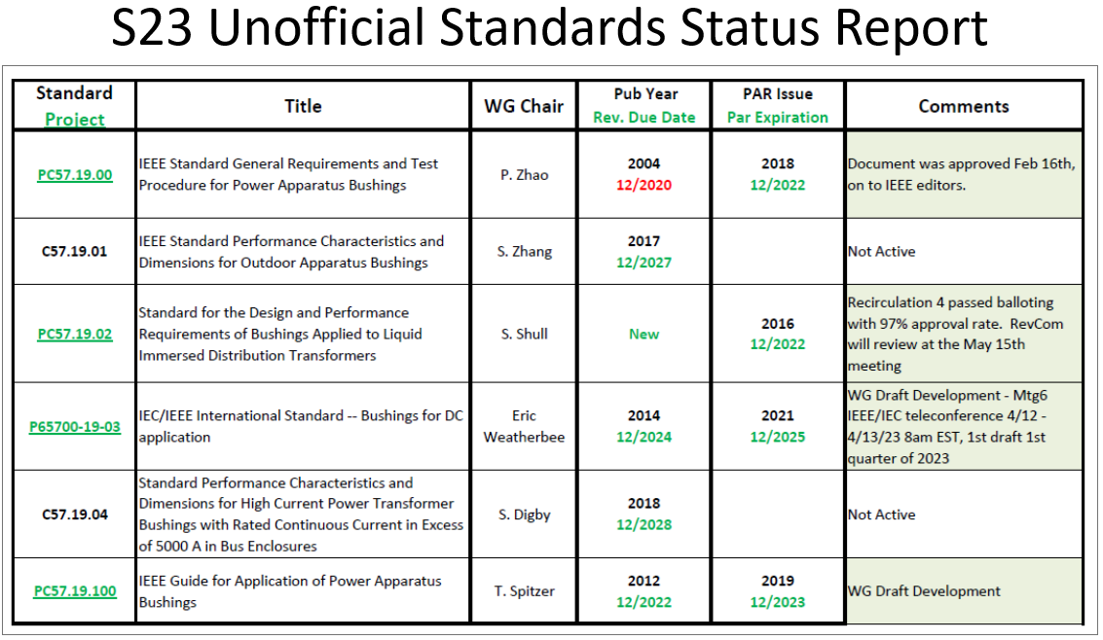
IEC/IEEE 65700_19_03 DC Bushings WG
Minutes of 2023 Spring Meeting
Tuesday, March 21st, 2023- 9:30 – 10:45 AM
HYATT Regency - Milwaukee (2) - Milwaukee, WI.

Eric Weatherbee - Chair
Vacant – Vice Chair J. Arturo Del Rio – Secretary

The WG met on Tuesday, March 21st, 2023, at 9:30 am in the Milwaukee room.

- Welcoming and Call for Patents, Copyrights
- The meeting was called to order at 9:30 AM by the WG Chair.
- The call for potentially essential patents and copyrights issues was made. None were reported.
- Quorum
- Total of 24 participants: 5 members and 19 guests.

- 5 Members of the 10 WG Members were present and quorum was not met. Agenda and previous meeting minutes could not be approved. Membership roster will be updated since 4 members have not attended the last 3 meetings.

- Sammy Debass has volunteered for the role of WG Vice Chair.

- Liaison Update on Join Team activity

Full JMT meeting minutes to be posted in the Transformer Committee website.

Previous meeting: February 7th and 8th, 2023.

3rd Draft in the working group was submitted. Further topics addressed and will be discussed in the upcoming meeting.

TF1; review the draft CD re. Voltage Source Converter (VSC).
- Finished, incorporated in the next CD.

TF2; review updates incl. examples re. altitude corrections and pollution parameters.
- Some minor changes will be prepared for the next meeting.

TF3; review the draft CD re. the special tests section (even and uneven wetting) incl. reference documents.
- Finished, incorporated in the next CD.

Editorial; Review the status of draft 3rd CD including, e.g.:
- Wording for tests.
- Replace oil with liquid.
- Remove the old reference to IEC 62199.

- New business:

4.1 No new business or comments

Meeting was adjourned at 9:45 am

Next JMT JOINT IEC Meeting
Next meeting: April 12th and 13^{th,} 2023, to be held by Zoom teleconference service on two consecutive days @ 14:00 to 16:00 (Central European Time).

Next IEEE WG Meeting
Fall 2023 – Kansas City (Westin at Crown Center), Missouri USA, Oct 22 – 26, 2023.

Respectfully submitted,
Chair: Eric Weatherbee (eweatherbee@ieee.org)
Secretary: Art Del Rio (a.delrio@ieee.org)

Attendance and status:

Status | First Name | Last Name | Affiliation
Guest | Mubarak | Abbas | Siemens Energy
Guest | Kush | Arora | Reinhousen
Guest | Eunyoung | Cho | HICO America
Guest | Samson | Debass | EPRI
Secretary | J. Arturo | Del Rio | Siemens Energy
Guest | Hassan | Elkassem | Siemens Energy
Guest | Eric | Euvrard | RHM International
Guest | Esseddik | Ferdjallah | Siemens Energy
Guest | Marc | Foata | Reinhousen
Guest | Sanford | Fong | GA Power
Guest | Juan Carlos | Hernandez-Mejia | GT-Neetrac
Member | Kurt | Kaineder | Siemens Energy
Guest | Jusuf | Krvavac | Sargent Lundy
Guest | Justin | Minikel | EATON Corporation
Guest | Verena | Pellon | FPL
Guest | Daniel | Posadas | Prolec Celeco
Member | Ulf | Radbrandt | Hitachi Energy
Guest | Brian | Sparling | Dynamic Ratings, Inc.
Member | Fabian | Stacy | Hitachi Energy
Guest | Oliver | Uhlmann | Reinhousen
Chair | Eric | Weatherbee | PCORE Electric
Guest | Elliot | White | SD Myers
Guest | Christopher | Whitten | Hitachi Energy
Guest | Malia | Zaman | IEEE-SA

The following members will be moved to Guest status as they have not attended the last 3 meetings.

First Name | Last Name | Company
Hugo | Flores | Hitachi Energy
Eduardo | Garcia Wild | Siemens Energy
David | Geibel | Retired
Peter | Werelius | Megger

IEEE C57.19.100
Guide for Application of Power Apparatus Bushing WG
Minutes of 2023 Spring Meeting
Monday, March 20th, 2023- 3:15-4:30 PM
HYATT Regency - Regency A (2) - Milwaukee, WI.

Tommy Spitzer– Chair Durand Stacy – Secretary

The WG met on Monday, March 20th, 2023, at 3:15 PM in the Regency A (2) room.

- Welcoming and Call for Patents, Copyrights
- The meeting was called to order at 3:15 PM by the WG Chair.
- The call for potentially essential patents and copyrights issues were made, and none were reported.
- Quorum
- Total of 53 participants: 12 members and 41 guests.

- 12 Members of the 23 WG Members were present, but never more than 11 at one time so a quorum was not met. No official business was conducted.

- Reconsolidation document

Document “Copy of CommentProposalForm Spring 2023 comments from Draft 5 R1.xls” was reviewed Much discueesion was had about the overload ability of bushing Durand Stacy offered to propose language for this. I have included it below for review

- New business:

4.1 No new business or comments

Meeting was adjourned at 4:30 PM

Purpose language for overload of bushings.
“Per standard, bushings are not required to have an inherent overload capability. Any overload capability a bushing might have is individual to that bushings design and is not indicative of all bushing of that type of construction or even of that manufacturer across their product portfolio. Contact the bushing manufacturer with questions about a particular design. “

Next IEEE WG Meeting
Fall 2023 – Kansas City (Westin at Crown Center), Missouri USA, Oct 22 – 26, 2023.

Respectfully submitted,
Chair: Tommy Spitzer (t.spitzer@sbcglobal.net)
Secretary: Durand Stacy (durand.stacy@hitachienergy.com)

Attendance and status:

First Name | Last Name | Company | Status
Murarak | Abbas | Siemens Energy | Guest
Alex | Alahmed | Evergy | Guest
Barry | Beaster | H-J Family of Companies | Guest
Edwin | Betancourt | Siemens Energy | Guest
Vivek | Bhatt | Prolec GE | Guest
Juan Carlos | Cruz Valdes | Prolec GE | Guest
Samson | Debass | EPRI | Guest
Yasiu | Demip | Prolec GE | Guest
J. Arturo | Del Rio | Siemens Energy | Member
Scott | Digby | Duke Energy | Member
Huan | Dinh | Hitachi Energy | Guest
Jeffrey | Door | H-J Family of Companies | Guest
Jesse | Duffy | Nashville Electric | Guest
Salih | Durmus | Siemens Energy | Guest
Hassum | Elkussem | Siemens Energy | Guest
Eric | Euvrard | RHM International | Member
Essedoik | Ferdjallah | Siemens Energy | Guest
Jose | Gamboa | H-J Family of Companies | Guest
Andrew | Gregory | ITEC | Guest
Jean | Hernandez-Mejia | GT-NEETRAC | Guest
Kurt | Kaineder | Siemens Energy | Guest
Chrisloph | Kerschemboer | Siemens Energy | Guest
Nathan | Lange | Siemens Energy | Guest
Junho | Lee | Hyundai | Guest
Soyoung | Lee | Hyundai | Guest
Mario | Locarno | Doble Engineering Co. | Member
Tiffany | LUCAS | Prolec GE | Guest
Robert | Middleton | RHM International | Member
Hugo | Murillo | H-J Family of Companies | Guest
Paul | Mushill | Ameren | Guest
Anthony | Natale | Hico America | Member
Vera | Pellon | Florida Power and Light | Guest
Damian | Podgrski | Sargent & Lundy | Guest
Daniel | Posadas | Prolec Cleco | Guest
Clemons | Reiss IV | Custom Materials Inc | Guest
Eric | Schleismann | Southern Company Services | Guest
Afrons | Schrammel | Siemens | Guest
William | Solano | Reinhausen | Member
Andy | Speegle | Entergy | Guest
Thomas | Spitzer | City Transformer Service Co. | Chair
Fabian | Stacy | Hitachi Energy | Secretary
Troy | Tanaka | Burns & McDonnell | Guest
Dervis | Tekin | Meramec Instrument Transformer Co. | Guest
Jacques | Vanier | Electro Composites (2008) ULC | Guest
Yves | Vermette | Electro Composites ULC | Guest
Loren | Wagenaar | WagenTrans Consulting | Guest
Eric | Weatherbee | PCORE Electric | Member
Christopher | Whitten | Hitachi Energy | Guest
Fei | Yang |  | Guest
Shibao | Zhang | PCORE Electric | Member
Peter | Zhao | Hydro One | Member
Richard | vonGemmingen | Dominion | Guest

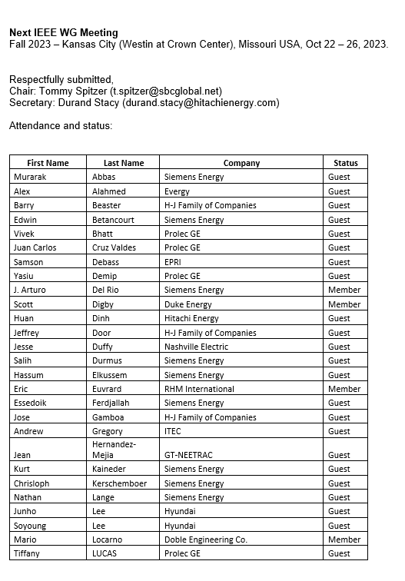
SPRING 2023 MEETING OF IEEE TRANSFORMER BUSHINGS
Location: MILWAUKEE
Date: MARCH 19 – 23, 2023

BUSHINGS SUBCOMMITTEE WORKING GROUP AND TASK FORCE MEETINGS
Liaison Reports - IEC Bushing Standardization Activities

INTERNATIONAL ELECTROTECHNICAL COMMISSION
TECHNICAL COMMITTEE No.36A: Insulated Bushing

Meeting to be held in Milan (Italy), with remote participation, on Thursday June 15, 2023

Potential New Work item  Bushing dimensional standardization  PWI 36A1-ED1 JWG 7 | Update on the first Committee draft (CD) part1: LV and MV bushing and part 2: HV bushings
Potential New Work item  Application guide for Bushings above 1 kV  PWI 36-A2-ED1 JAHG8 | Update on the work done by joint ad hoc group 8 and on the comments received after circulation of the doc 36A/223/DC
Revision of IEC 65700 Bushings for DC application | update about the status of the document revision in dual logo with IEEE
Maintenance Team for revision of IEC 60137 Bushings above 1kV. | The questionnaire 36A/224/Q has been sent to national committees for comments about the revision of the standard IEC 60137  A report on the project of revision will be presented.
Withdrawal of TR 61464 Guide for DGA in bushings | Transfer to IEC 60599 (guidance on the interpretation of dissolved  and free gases analysis) and IEC 60475 (Method of sampling insulating liquids) the corresponding contents of IEC TR 61464  Report on the work done together with TC10

