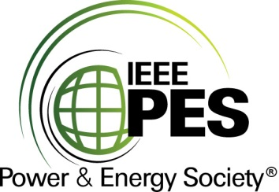

###### 

###### CERTIFICATE OF

**EDUCATIONAL ACHIEVEMENT**

# This certificate is presented to

## replace with your name

for attendance at the educational presentation:

**“Dry‐Type Pole‐Mounted Transformers: Innovative Solution to Increase Safety in Overhead Distribution Networks”**

*sponsored by the IEEE/PES Transformers Committee*

**and has earned one (1) Professional Development Hour (PDH).**

**Spring 2024 Vancouver Transformers Committee Meeting; Thursday, March 14, 2024**



_________________________________ ___________________________________________________

David Wallach Instructors: André Moreno, Tim‐Felix Mai and Cassandra Wadsten  
Committee Chair