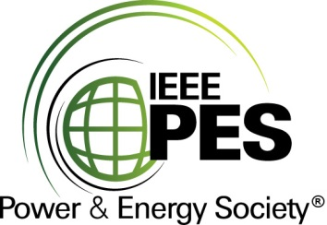

###### 

###### CERTIFICATE OF

**EDUCATIONAL ACHIEVEMENT**

# This certificate is presented to

## replace with your name

for attendance at the educational presentation:

**“Optimizing Transformer Cores to Meet DOE 2029”**

*sponsored by the IEEE/PES Transformers Committee*

**and has earned one (1) Professional Development Hour (PDH).**

**Spring 2025 Denver Transformers Committee Meeting; Thursday, March 27, 2025**

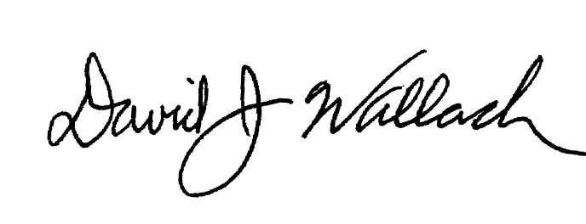

_________________________________ ___________________________________________________

David Wallach Instructors: Ales Bertuzzi for Georg and

Committee Chair Stefan Siebert on behalf of Brockhaus