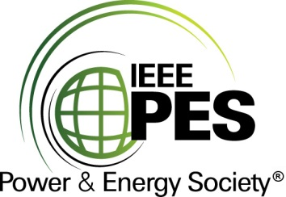

###### 

###### CERTIFICATE OF

**EDUCATIONAL ACHIEVEMENT**

# This certificate is presented to

## replace with your name

for attendance at the educational presentation:

**“Power Transformer Tank Specification for Passive Protection Against Internal Arc and**

**Status of CIGRE TF A2 and IEEE C57.156”**

*sponsored by the IEEE/PES Transformers Committee*

**and has earned one (1) Professional Development Hour (PDH).**

**Spring 2025 Denver Transformers Committee Meeting; Thursday, March 27, 2025**



_________________________________ ___________________________________________________

David Wallach Instructors: Jean-Bernard Dastous, Peter Zhao, Marc Foata &   
Committee Chair Ewald Taschler