10.6 Insulating Fluids Subcommittee – F. J. Gryszkiewicz, Chair; R.K. Ladroga, Vice-Chair

10.6.1 Introduction/Attendance

The Insulating Fluids Subcommittee met in Pittsburgh, Pennsylvania on Wednesday, October 8, 2003 with 21 members and 12 guests present.

10.6.2 Approval of Meeting Minutes

The minutes of the March meeting in Raleigh, North Carolina meeting were approved as printed.

    - Subcommittee Membership

Paul Boman, Hartford Steam Boiler, was welcomed as a new Subcommittee member.

    - Current Subcommittee Business

10.6.4.1C57.106 – IEEE Guide for Acceptance and Maintenance of Insulating Oil in Equipment

This document was approved by the IEEE Standards Board in June of 2002 and was printed in November of 2002. Since that time, a Working Group was formed to review Section 4.5 of the document. This was done as some members felt that this section contained blatant technical errors and was beyond the scope of the guide.

The Working Group met on October 7 with a combination of 50 members and guests in attendance. Jim Thompson and T.V. Oommen are the Co-Chairs of the Working Group. The Working group reviewed the suggested rewrite of Section 4.5. Several additional comments were made. These comments will be incorporated into another revision, which will be discussed at the next meeting in San Diego.

10.6.4.2 C57.104 – IEEE Guide for the Interpretation of Gases Generated in Oil – Immersed Transformers

This Working Group is Co-chaired by Frank Heinrichs and Frank Gryszkiewicz. This document recently completed a Standards Association Ballot. Several negative ballots were received. The negative ballots were resolved and/or rebutted and incorporated into Draft 11C.

A Standards Association Ballot will be conducted on Draft 11C. This will be the first electronic ballot of this document. The Working Group also agreed to participate with IEEE Headquarters in an experimental procedure. Any negative ballots will be resolved or rebutted via a website based and teleconferencing procedure.

10.6.4.3 C57.130 – Trial Use Guide for the Use of Dissolved Gas Analysis During Factory Temperature Rise Tests for the Evaluation of Oil- Immersed Transformers and Reactors

This Working Group is co-chaired by Frank Heinrichs and Frank Gryszkiewicz. This document has been sent to IEEE for a Standards Association Ballot. Frank Gryszkiewicz reported that IEEE sent out the Invitation to Ballot Letter on September 12, 2003.

10.6.4.4 C57.111 – IEEE Guide for Acceptance of Silicone Insulating Fluid and Its Maintenance in Transformers

Kent Haggerty and Jim Goudie are the Working Group Co-Chairs. This document was sent to IEEE for a Standards Association Reaffirmation Ballot. A successful Ballot was completed in September of 2003 and the document has been sent to the Standards Board for approval.

10.6.4.5C57.139 – IEEE Guide for Dissolved Gas Analysis in Load Tap Changers

Rick Ladroga is the Working Group Chair for this project. Rick was unable to attend the Pittsburgh meetings due to work commitments; therefore, an official Working Group meeting was not conducted. Frank Gryszkiewicz served as Acting Working Group Chair and gave a status report on this project to those in attendance.

In the past, the Working Group had a difficult time agreeing on dissolved gas analysis(DGA) limits for the different design type load tap changers. The Working Group Chair formulated a table containing ranges of the combustible gases of interest for the various design types of load tap changers.

As a result of the discussions, the Working Group was advised that this Guide also contain information on the use of ratios of the various combustible gasses in determining whether the DGA data is indicative of a tap changer problem.

The Working Group will prepare a new draft, which will be discussed at the next meeting in San Diego.

10.6.4.6 C57.146 – IEEE Guide for the Interpretation of Gases Generated in Silicone Immersed Transformers

This document previously carried the IEEE designation P1258. This has been changed to the IEEE designation C57.146 to be consistent with the other standards in the C57 collection.

Jim Goudie and Bill Bartley are the Working Group Co-Chairs of the document. A Standards Association Ballot is in the process of being conducted.

10.6.4.7 IEEE STD 637 – IEEE Guide for the Reclamation of Insulating Oil and Criteria for Its Use

A successful Reaffirmation Ballot was recently conducted on this document. The IEEE Standards Board approved this document at their meeting in December of 2002. There are tables in this document that need to be revised to be consistent with tables in C57.106, which is now being revised (Section 4.5). This will be done when the C57.106 revision is approved.

10.6.4.8 C57.XXX – IEEE Guide for the Acceptance and Maintenance of Natural Ester Based Fluids

Patrick McShane is the Task Force Chair. The Task Force met on Tuesday, October 7, with 14 members and 37 guests in attendance. After discussions, it was agreed that this document would be written in the same format as C57.121.

Patrick has applied for a PAR. When the PAR is approved, the Task Force will become a Working Group. The Working Group will prepare Draft 1 for discussion at the next meeting in San Diego.

The Subcommittee Chair was given a letter from Cooper Industries Associate General Counsel. The letter was addressed to the IEEE Standards Board PatCom Administrator and concerned patent issues associated with the Natural Ester Based Fluids. A copy of this letter can be found as Attachment 1 to these minutes. 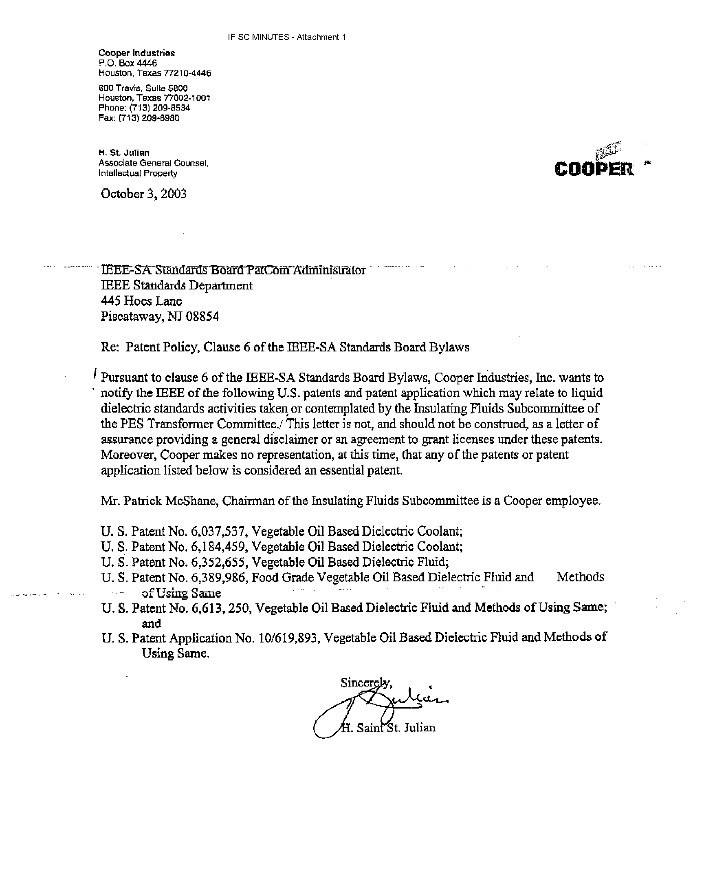

      - C57.121 – IEEE Guide for Acceptance and Maintenance of Less Flammable Hydrocarbon Fluid in Transformers

This Guide is approaching the end of its five-year life and must be reaffirmed or revised. The former Working Group Chair, Patrick McShane reported that this document still contains state of the art information. In view of the foregoing, the Subcommittee voted to send this document to IEEE for a Standards Association Reaffirmation Ballot.

    - Adjournment

There being no new business, the Subcommittee adjourned at 12:20 p.m.

    - Next Meeting

The Insulating Fluids Subcommittee and its Working Groups will next meet in San Diego, California, during the period of March 7-11, 2004.

