10.5 C57.13 Instrument Transformers – J. Smith

9 members and 13 guests attended

    - Chair’s Remarks & Announcements:

The dates and locations for future meetings were announced.

The previous meeting minutes were approved as written

    - Old Business:

Thermal Evaluation
Jim Smith presented a proposal for discussion (see appendix). V Khalin questioned the need and practicality of the proposal as it applies to High-voltage Instrument Transformers. P. Riffon said he would prefer to include continuous PF measurement than PD. He also advised that the 10 ⁰C/hr rate is difficult to achieve and that most Climactic Chambers only go up to 70 ⁰C. He also agreed to investigate IREQ and other labs’ capabilities. The other attendees were invited to send him suggestions. J. Ma pointed out that the CVT endurance test does not translate to magnetic IT’s.

    - New Business

P. Riffon presented a comparison of partial discharge requirements as well as information on terminal temperature rise (see appendix)

    - Working Group Reports:

      - WG C57.13.5 - Working Group on Test Requirements for High Voltage Instrument Transformers 115 kV Nominal System Voltage and above

The WG met on October 7, 2003. Six members and eleven guests attended the meeting.

The meeting was co-chaired by Mr. P. Riffon and Mr. R. McTaggart.

Minutes of the Raleigh meeting were approved as written.

Mr. Joe Ma announced that the Trial-Use Standard 057.13.5 has been approved by IEEE and will be published imminently. A PAR will be requested for modifications to IEEE 57.13.5 as soon as it will be issued in order to be ready in two years time from now.

The impulse test section of the new normative Annex (Annex H) related unbalance current transformers for use as unbalance current protection of capacitor banks have been discussed. This Annex is intended to be added to 057.13.5 when this Trial-Use standard will be due for revision as a full-use standard (in approximately two years from now).

The main topics discussed were:

- A review of actual test data and impulse generator parameters for impulse tests across primary terminals of three different unbalance current transformer designs have been presented;

- Based on that review, the concept of having a minimum impulse generator energy of 25 kJ for impulse tests across primary terminals has been changed for the concept of a minimum capacitance value. A value of 3,0 pF has been suggested;

- Ross McTaggart has presented the results obtained with alternative testing methods such as the use of an inductance in parallel with the front resistor of the impulse generator, impulse tests with the secondary winding in open circuit and impulse tests with a resistive burden applied on the secondary terminal winding.

After discussion, it has been agreed upon that:

- The concept of a minimum capacitance value is much more adequate than the minimum energy level concept. The proposed value of 3,0 pF seems to be an acceptable value;

- Impulse tests across the primary winding with nominal burden applied to secondary terminals seems to be a valuable alternative method and needs be analyzed further.

A revised proposal will be presented at the next meeting considering the use of the alternative method using the rated burden on secondary terminals. Examples of test circuit configurations and oscillograms will be added if necessary.

The second subject on the agenda was related to the allowable temperature rise of terminals of instrument transformers during temperature rise test. Actual standards (057.13 and 057713.5) do not give any temperature limits to be observed on terminals during temperature rise test. A proposal giving the same values as used for switchgear in lEG 60694 and lEG 60943 has been presented. This proposal limits the temperature rise of terminals to 50CC for bare aluminum or copper terminals, 65~G for tin-coated terminals and 7500 for silver or nickel-coated terminals. The WG did not come to any conclusion yet and this subject needs to be discussed further during the Instrument Transformers SubCommittee meeting and upcoming WG meetings.

      - WG C57.13.6 – Working Group on Instrument Transformers for use with Electronic Meters and Relays – Chris TenHaagen
Chair’s remarks & Announcements:
The subcommittee met on October 7,2003 in Pittsburgh, PA with seven members and eight guests present.

Old business
- Par was granted on February 13, 2003, expiring December 31, 2007
- Draft reviewed by Editorial Staff
- With final acceptance of paragraph 6.1.1 re accuracy testing, a survey of the group indicated that there was unanimous agreement that the standard was ready for ballot. The Chair will accomplish this at the earliest possible date
New business
- Agreed changes were made to the draft.
- Draft went for one more review by IEEE editorial staff.
- Draft was uploaded, and request for ballot pool formation initiated. (>71 responded so far).
- Present status: Pool closes October 12, 2003
- Sponsor will review pool for balance.
- Ballot will commence, and chair will respond to any comments or negatives.
- By next meeting, summary of ballots will be presented.

      - Working Group on C57.13 Revision – Tom Nelson

The working group met on October 7, 2003. There were 18 members and guests present.
An application for a PAR to “officially” start working on the draft that we have completed will be submitted to IEEE this month for the December approval meeting. With the PAR approved the draft can go forward to IEEE for balloting after the following items: Attached are the comments that Jim Smith received on the reaffirmation ballot he just completed. The comments that are editorial in nature the working group is asked to review to see if they agree and the draft standard should incorporate these changes before submittal to IEEE for ballot. A few figures need to be modified per IEEE editorial review comments before the draft can be submitted also. It is anticipated that the draft can be submitted for ballot after the March 2004 meeting.
Also attached is the presentation by Chris Tenhaagen discussing the partial discharge testing that is in the draft standard. It is assumed that there will be negative ballots concerning PD testing, and this is one proposal to have in mind when we are addressing the assumed negative ballots.

      - Study Group IEEE Std C57.13.2 – Vladimir Khalin

Working Group met on Tuesday, October 7 at 3:15 PM with 13 members and guests present.
Chair reported: PAR was developed, submitted to IEEE-SA and approved.
Draft of the Standard was sent to the editorial staff for pre-ballot review. The group discussed several editorial and application issues.
Group suggested: Submit the corrected Standard draft for balloting.
Appendix A

Thermal Tests

The preferred method is to test the completely assembled transformer. With the approval of the customer, the manufacturer can test the individual transformer components if there is documentation that verifies the coordination of the individual tests to being equal to the testing of the completed transformer.

1. To demonstrate the ability of instrument transformers to mechanically perform over the entire range of its guaranteed temperature range, the test is to be performed:

- With the HV Terminal(s) loaded to the maximum rated Static Load.

- With the transformer mounted in each of the guaranteed mounting positions.

- For 10 cycles per figure 1.

- To demonstrate the ability of the instrument transformer to electrically perform over the entire range of its guaranteed temperature range, the test is to be performed:

- With the transformer energized at its maximum rated voltage.

- With continuous partial discharge measurements.

- For 10 cycles per figure 1.

3. The following dielectric tests are to be performed with in 12 hours before and after each of the thermal tests.

Dielectric Tests

- Impulse Test per IEEE Standard C57.13-1993
- HV Applied Wet Test per IEEE Standard C57.13-1993
- HV Applied Dry Test per IEEE standard C57.13-1993
- LV Applied Test per IEEE Standard C57.13-1993
- Induced Potential Test per IEEE Standard C57.13-1993
- Partial Discharge Test per IEC 44-1:1996 & 44-2:1997
- Polarity Test and Accuracy Test per IEEE Standard C57.13-1993

Fig 1

The preferred rate of temperature change is 15ºC/hr. The minimum rate of temperature change is 10ºC/hr.
Appendix B

Partial discharge tests; comparison between IEC 60044-1, IEC 270-1981, IEC working document 38/298/NP and IEEE C57.13.5 (Trial-Use Guide)

 | IEC 60044-1, 1996 | IEC 270-1981 | IEC 38/298/NP, 2003 | IEEE C57.13.5, 2003
Scope: | Current transformers  (≥ 1,0 kV) | All electrical equipment without voltage rating | Common clauses to instruments transformers  (≥ 1,0 kV; not approved yet) | Instrument transformers for system voltage ≥115 kV
Method of measuring partial discharge: | Apparent charge | Apparent charge | Apparent charge | Apparent charge

Appendix C

Instrument Transformers

Temperature rise of power terminals

Temperature rise of terminals are not or not clearly defined in IEEE C57.13 nor in IEEE C57.13.5 (Trial-Use guide).

IEEE C57.13 states:

"4.6 Temperature rise

The limits of observable temperature rise in instrument transformers when tested in accordance with their ratings shall be as given in table 4, and the transformers shall be designed so that the hottest-spot winding temperature rise above ambient will not exceed the values given in table 4."

Table 4—
Limits of temperature rise*

 | 30°C |  | 55°C
Type of instrument transformer | Average winding temperature rise determined by resistance method  (°C) | Hottest-spot winding temperature rise  (°C)† | Average winding temperature rise determined by resistance method  (°C) | Hottest-spot winding temperature rise  (°C)
55°C rise‡ | 55 | 65 | 30 | 40
65°C rise‡ | 65 | 80 | 40 | 55
80°C rise dry-type | 80 | 110 | 55 | 85

*Temperature rise of current transformers that are a part of high-voltage power circuit breakers or power transformers shall
be in accord with IEEE Std C37.04-1979 or IEEE Std C57.12.00-1993, respectively.
†Temperature rise of other metallic parts shall not exceed these values.
‡Temperature rise at the top of the oil in sealed transformers shall not exceed these values."

"6.9 Terminals

Primary terminals of wound-type and bar-type current transformers shall be suitable for use with either aluminum or copper conductors. Secondary terminals and voltage terminals, where provided, shall be suitable for use with copper conductors."

IEEE C57.13.5 (Trial-use Guide) states:

"4.5 Thermal performance requirements

All instrument transformers shall be capable of operating under the most onerous load conditions without exceeding the limits of temperature rise provided in Table 4 of IEEE Std C57.13-1993."

Based on these wordings, possible interpretations could be:

1- Temperature rise of power terminals shall not exceed the hottest-spot temperature rise limits (see note † of table 4 of IEEE C57.13).

2- Temperature rise of power terminals are not defined if they are not in direct contact with insulation material.

Current Transformers

- Temperature rise limits of power terminals should be defined according to the material used (copper, aluminum. silver, tin or nickel plating, etc…).

- When exceeding certain temperature limits, contact oxidation starts which can cause further thermal runaway of terminals and produces major damages to the instrument transformers.

Power Terminals

- IEC 60943 "Guide for specification of permissible temperature and temperature rise for parts of electrical equipment, in particular for terminals" and IEC 60694 specify different temperature rises for different type of terminal materials in different type of medium (oil, air, SF₆). These standards specify:

- For bare aluminum or copper bolted contacts (in air):

- Maximum temperature rise: 50°C;
- Maximum working temperature: 90°C

- For silver-coated or nickel-coated bolted contacts (in air):

- Maximum temperature rise: 75°C;
- Maximum working temperature: 115°C

- For tin-coated bolted contacts (in air):

- Maximum temperature rise: 65°C;
- Maximum working temperature: 105°C

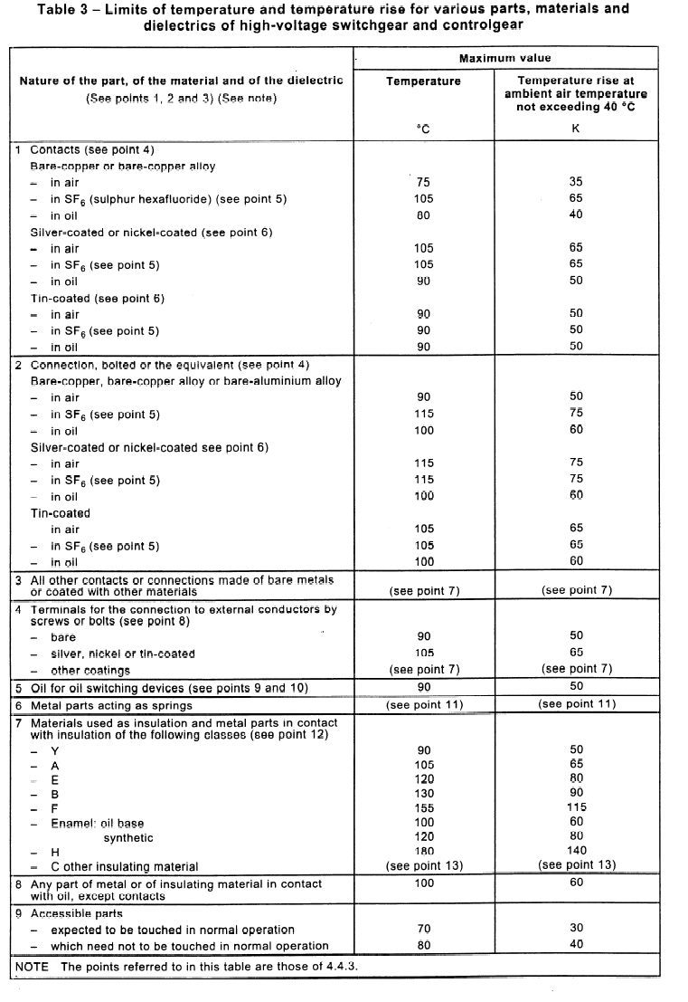

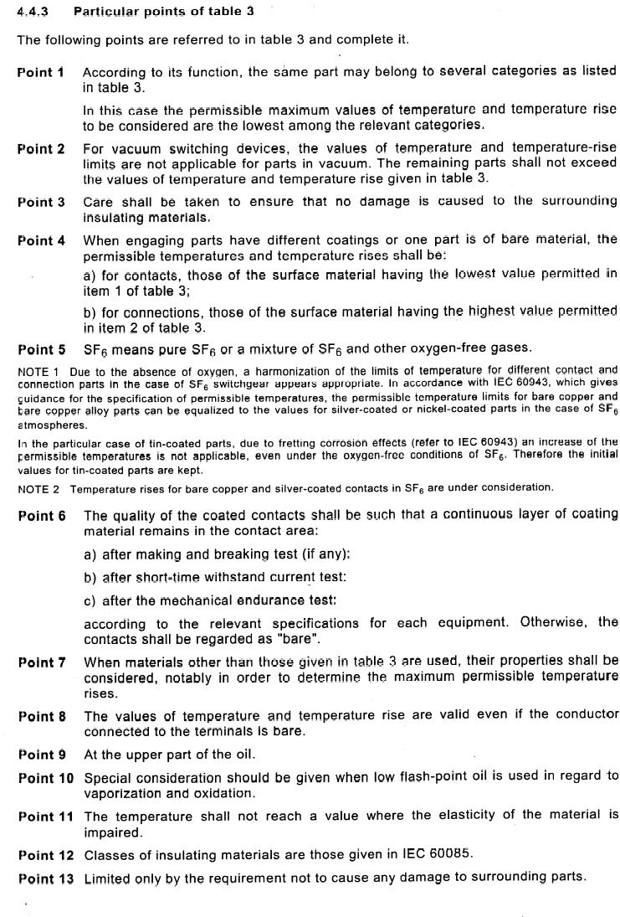

Power Terminals

If IEEE C57.13 and IEEE C57.13.5 permit temperature rises of 55°C, 65°C and up to 80°C for dry type, it is obvious that the 50°C maximum temperature rise for bare aluminum or copper terminals can be easily exceeded. Thus, some rules should be given for a proper choice of contact material and coating and associated temperature rise limits.

It is suggested to modify the clause 4.6 of C57.13 and to add a similar clause in C57.13.5:

"Temperature rise

The limits of observable temperature rise in instrument transformers when tested in accordance with their ratings shall be as given in table 4 of IEEE C57.13, and the transformers shall be designed so that the hottest-spot winding temperature rise above ambient will not exceed the values given in table 4 of IEEE C57.13.

Terminals shall be designed so that their temperature rise and maximum working temperature when tested with their ratings are not exceeding the following values:

- For bare aluminum or copper bolted contacts:

- Maximum temperature rise: 50°C;
- Maximum working temperature: 90°C

- For silver-coated or nickel-coated bolted contacts:

- Maximum temperature rise: 75°C;
- Maximum working temperature: 115°C

- For tin-coated bolted contacts:

- Maximum temperature rise: 65°C;
- Maximum working temperature: 105°C"

