Cigré liaison

Highlights
In 2007 activities were related to the problem of oil corrosivity, fire behavior, maintenance and experience with new insulating fluids.

Main technical directions pursued
The two strategic directions of SC A2 are:
• To continue on transformer technology issues and to consider new information technologies (data, communication, web services)
•To provide services to CIGRE customers (reliability and availability including impact of accessories, life management, economical issues, tutorials, etc).

Bruges Meeting 8-10 october 07
The last colloquium was held conjointly with subcommittee D1 ( Materials and emerging technologies) in Bruges (Belgium) and presentation on the three following preferential subjects were given:

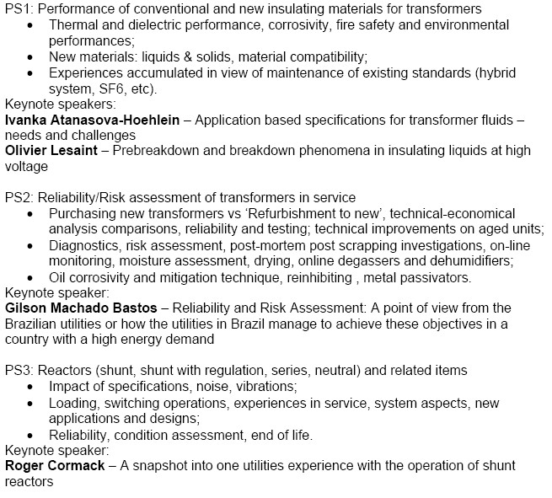
The following Cigre Tutorials were given.
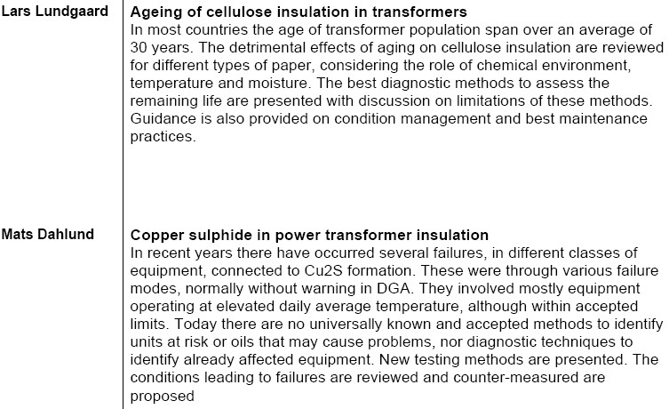
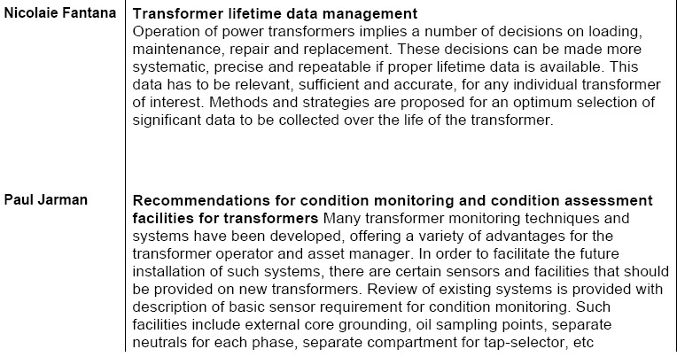

Cigré can provide a set of tutorials on different subjects related to transformers. Those tutorials are a state of the art reflecting the work done by working groups They present in n easily accessible way the work done there.

There aim is to:
- Capture the knowledge and know-how developed by CIGRE SC A2 and other related SC and disseminate
- Add value to this knowledge and information by synthesizing state-of-the-art documents
- Improve visibility of recent development in transformer related topics
- Identify the research that appear most promising
- Disseminate at the regional level to reach a larger audience

It exists tutorials on :
Transformer overload performances
Transformer short circuit performances
Economics of transformer management
Partial discharge in transformers

Working group and task force reports
Full progress report, scope and membership of the different groups are on the WEB site of A2

WG A2-24 - Thermal performances (J. Declerq) created in 2003.
The WG is considering: fundamentals of thermal ageing of insulation system, thermal modeling of transformers (for monitoring system) and thermal testing of transformers (contribution to measuring uncertainties at heat run tests).

Recent adding were on gas turbine transformer sizing and thermal modeling
We expect a closing of this group in 2008.

WG A2-26 - Mechanical condition assessment of windings (P. Picher) created in 2004.
The CIGRE Working Group A2.26 main objective is to develop a guide on the mechanical condition assessment of transformer windings using the Frequency Response Analysis (FRA) method.
The working group is divided in three task forces: 1-Guidance and introduction to FRA, 2-Techniques and 3-Interpretation.
The WG should deliver a final report soon.

WG A2-27 - Recommendations for condition monitoring facilities (P. Jarman)
created as TF in 2003 and as WG in 2005.
A definite pattern and commonality to the requirements of the diverse monitoring systems has emerged. Communication protocols were not be considered, but the WG output may help to guide transformer data requirements for example for IEC 61850 application.
The final report has been circulated within the SC and comments are being taken care of
A final brochure will be issued during the first part of 2008.

WG A2-33 - Fire Safety (A. Petersen/AU)
The aim is to prepare recommendations for transformer fire safety practices that will help transformer designers and users to define and apply best practices in the domain of transformer fire. The scope shall cover different parts, mainly: a) Avoidance of tank rupture, b) Precaution to fire victim and c) Precautions to fire origin
This Working had its first meeting in Bruges.

WG A2-34 Guide for Transformer Maintenance (C. Rajotte/CA)
The aim is to prepare a guide for transformer maintenance that will help transformer users to define and apply best practices for transformer maintenance. The Scope shall: a) define a best practices list of periodic actions applied on line or off line, b) address condition based maintenance and c) human and material aspects of transformer maintenance, with maintenance planning, maintenance tasks tracking, maintenance resources, cost references, level of competences required for different tasks, training, on-site repair, etc.

WG A2-35 Experiences in service with new liquids (R. Martin/UK)
The aim is to collate and review the in-service experience of using the new fluids in a way which is relevant and beneficial to the electrical industry. Domains to be covered are : a) Basic properties like physical and chemical and electrical differences between the new fluids and mineral oil, fire safety, toxicity, etc. b) Design considerations, c) Maintenance, Retro filling practice, Handling, experiences of these new fluids with cellulose, d) Standards: Review what standards exist for these fluids, highlight deficiencies, propose remedies and e) Further work: identify the knowledge gaps/concerns and propose solutions, or work for other groups.

JWG A2/B4-28 - HVDC Converter Transformers (M. Saravolac) created in 2004.
The design review guide will address specific aspects of HVDC transformers and their application. Concerning test specification, some new recommendations for test requirements and procedures covered will be issued in order to ensure higher reliability in service.
One of the areas under consideration is the duration of the Polarity Reversal test.

Last Publications
All publication are available from the site : http://www.e-cigre.org

N°323 Ageing of cellulose in mineral-oil insulated transformers
The guide describes the normal ageing processes in the cellulose of oil impregnated insulation systems for transformers. The various cellulose materials and their properties are described. New knowledge on oxidation and hydrolysis and the influence of the chemical condition of oil and of paper together with thermal stresses are described. Also possibilities for diagnostics and for maintenance of the cellulose are discussed.

International Symposium on International standards for Ultra High Voltage
The CD includes the papers presented during the Symposium organized jointly by CIGRE and IEC, in Beijing, 18-21 July 20007. Part of the papers presented at Poster Sessions are also included. The 47 main papers are ordered as they were discussed in the 11sessions, dedicated respectively to: - Needs and plans for UHV infrastucture (1000kV AC and 800kV DC) - System issues - Lines, Substations, Equipment, Transformers - DC - Testing - Standardization

next meetings
In 2008, the SC meeting will be part of the Paris session. The preferential subjects are the same as those of the colloquium.

