10.5 C57.13 Instrument Transformers – J. Smith

5 members and 9 guests attended
Jim Smith was unable to attend so the meeting was chaired by Ross McTaggart

    - Chair’s Remarks & Announcements:

A brief summary of the Website development meeting was presented

The previous meeting minutes were approved as written

    - Old Business:

Thermal Evaluation

The general feeling was that although the proposed test procedure is very comprehensive, it is not possible for voltage ratings over 145 kV and very costly even up to that level. The total test costs could be as high as $200K.

The most important aspects of the tests were identified as:
- To verify that the IT can mechanically survive thermal cycling – eg no cracking occurs (mainly for cast resin units) and additionally for oil and gas units that no leakage occurs
- At low temperature, the partial discharge extinction voltage remains at a safe level, and
- At low temperature, the accuracy performance remains within acceptable limits

The consensus of the group was that these could be verified using simplified test methods, basically as follows:

- Thermal cycling to be done separately, with no continuous monitoring, only routine tests before and after
- PD and accuracy tests to be done by putting the test sample in a freezer and then removing it and quickly doing the test (note - there is some concern that the inevitable frost on the porcelain surface will interfere with PD measurements – R. McTaggart will try to schedule a test on a Cap section to investigate)

It was agreed that someone would write up an alternative procedure based on this before the next meeting.

    - New Business

We were advised by Aaron Snyder that any new definitions that are added to Standards should be sent to the WG on Standard Terminology for inclusion in C57.12A.

    - Working Group Reports:

      - WG C57.13.5 - Working Group on Test Requirements for High Voltage Instrument Transformers 115 kV Nominal System Voltage and above

The WG met on March 9, 2004. Five members and thirteen guests attended the meeting. Four guests requested membership. The meeting was co-chaired by Mr. P. Riffon and Mr. R. McTaggart.

Minutes of the Pittsburgh meeting were approved as written.

The Trial-Use Standard C57.13.5 has been published by IEEE on August 2003. None of the members has received a complimentary copy. The SubCommittee Chairman will be asked to contact IEEE for getting the complimentary copies to the WG membership. Its validity is two years and will expire in August 2005. The WG shall prepare a revision as soon as possible in due time for balloting. Members are invited to provide feedback regarding the application of C57.13.5.

The impulse test section of the new normative Annex (Annex H) related to unbalance current transformers for use as unbalance current protection of capacitor banks have been discussed once more and has been modified according to Pittsburgh meeting decisions. The use of a resistive burden on secondary windings for improving the tail time of the impulse waveshape when applied across the primary winding is now incorporated. No further comments have been received. This draft will be circulated to the WG membership for survey prior to the next meeting. Typical oscillograms of a lightning impulse waveshape across primary winding will be added as additional information.

The second subject on the agenda was related to the allowable temperature rise of terminals of instrument transformers during temperature rise test. This subject has been also presented during the previous WG and SubCommittee meetings in Pittsburgh. No further comments were received concerning the proposal. The same values as used for switchgear in IEC 60694 and IEC 60943 has been proposed. This proposal limits the temperature rise of terminals to 50°C for bare aluminum or copper terminals, 65°C for tin-coated terminals and 75°C for silver or nickel-coated terminals. This draft will be circulated to the WG membership for survey prior to the next meeting.

An informative Annex related to TPY cores seems to be necessary for US manufacturers dealing on export markets. Such current transformer class is not generally in use in North America. Only few utilities are requesting such a performance.. A first draft will be issue prior to the next meeting. This informative Annex will be mainly based on Annex D of IEC 60044-6. The testing section will refer to IEC 60044-6.

As New Business, a discussion took place on the definition of standardized burdens to be used when applied to 1A windings. After the discussion, the WG is to the opinion that the concept of limiting voltage for relaying application CTs or the burden value in ohm for metering CTs shall be kept. This subject is not under the task of this WG and shall be bring to the WG responsible of the revision of C57.13 (T. Nelson).

The meeting adjourned at 8:45 on March 9, 2004.

      - WG C57.13.6 – Working Group on Instrument Transformers for use with Electronic Meters and Relays – Chris TenHaagen

The subcommittee met on March 9, 2004 in San Diego, CA, with three members and ten guests present.

Old business-
Ballot results:
Pool closed October 12, 2003
Ballot met 75% retuned requirement (85% returned)
Eligible people in-group
63 affirmative
3 negative with comments
4 abstention votes
The 75% affirmation requirement was met (95% affirmative)

New business
1) Review and discussed ballot editorial comments. . A marked up Std was circulated.
Chair Comments: WG Group accepted all balloter editorial comments.
2) Review and discuss negative ballot comments.
- TW Olsen, Siemens Power T&D
  - Missing Abstract.
    - Chair Comments: (Not required for std, per IEEE staff).
  - Removal of “and Relays” from 5.1 title and footnote #2, pg 7.
    - Chair Comments: WG member was concerned that removal was in fact technical, because it suggests these burdens be excluded for relay ratings (which is not true). Balloter comment not accepted; this section will be re-circulated

- Daniel Slomovitz, UTE
  - Requested lower VA burden for VT’s (not accepted)
    - Chair Comments: Retracted by Balloter by E-mail before meeting.

- Jeffrey Nelson, TVA
  - Document Title should read “Trial Use Standard for High Accuracy Instrument Transformers” based on phrase “trial use” in introduction.
    - WG concurred to recirculate as a Full Standard.
  - Misc reference corrections style and grammatical (all accepted)
  - Request WG take under consideration CT accuracy testing at RF.
    - WG rejected. Chair Comments: Balloter will accept WG consensus.
  - Request WG take under consideration VT accuracy testing 90%&110%Vp.
    - WG rejected. Chair Comments: Balloter will accept WG consensus.
  - Section 6.1.1 (basis of negative Ballot) Delete “A current transformer may be certified to this standard when demonstrated to inherently meet the stated accuracy class using the following tow test points: at 100 % of rated current using burden E0.04, and at 5% of rated current using the maximum burden for which it is rated” Balloter found this confusing and requested reconsideration by WG.
    - Chair comment
      - Chair re-wrote section 6.1.1 to improve clarity, but not procedure.
      - WG discussed and edited rewrite and new format
      - WG agreed to revisions, which will be re-circulated.

Summary.
. Chair will recirculate Standard for three items:
Acceptance as full standard (remove trial guide from introduction).
Clarified format of section 6.1.1
Keeping reference to “relays” in section 5.1, along with footnote.

Chair comment: Consensus of group anxiously awaits publication of this standard.

Presentation: Proposed revisions to C57.13/D03 Section 8.10: Partial Discharge Measurement

Partial Discharge Connections- Two Bushing Voltage Transformers

Connection 1 accurately determines extinction of partial discharge in the primary bushings and primary major insulation. The purpose of Connection 2 and 3 is to measure extinction of partial discharge in the primary winding. A shortcoming of Connection 2 and 3 is that it puts excessive stress on the bushings in order to achieve moderate primary over-voltage. Partial discharge from the over stressed bushings masks the ability to measure partial discharge originating from turn to turn voltage stress in the primary winding. Passing this test increases product cost because it requires manufacture of bushing quality to the next higher voltage class.
The Cross Winding test (Connection 4) can substitute for or referee for the connection 2 and 3 connections. The stress to ground on the floating H1 and H2 bushings is one half of the induced primary excitation. If the bushing partial discharge extinction voltage is established appropriately above in-service levels using the Connection 1 test, one can conclude any discharge observed during the Cross winding test must originate within the primary winding.
The cross winding test can also be performed using a applied polyphase source. This duplicates in service conditions for a two bushing voltage transformer, and a complete evaluation of the product for partial discharge can be performed in one test setup.

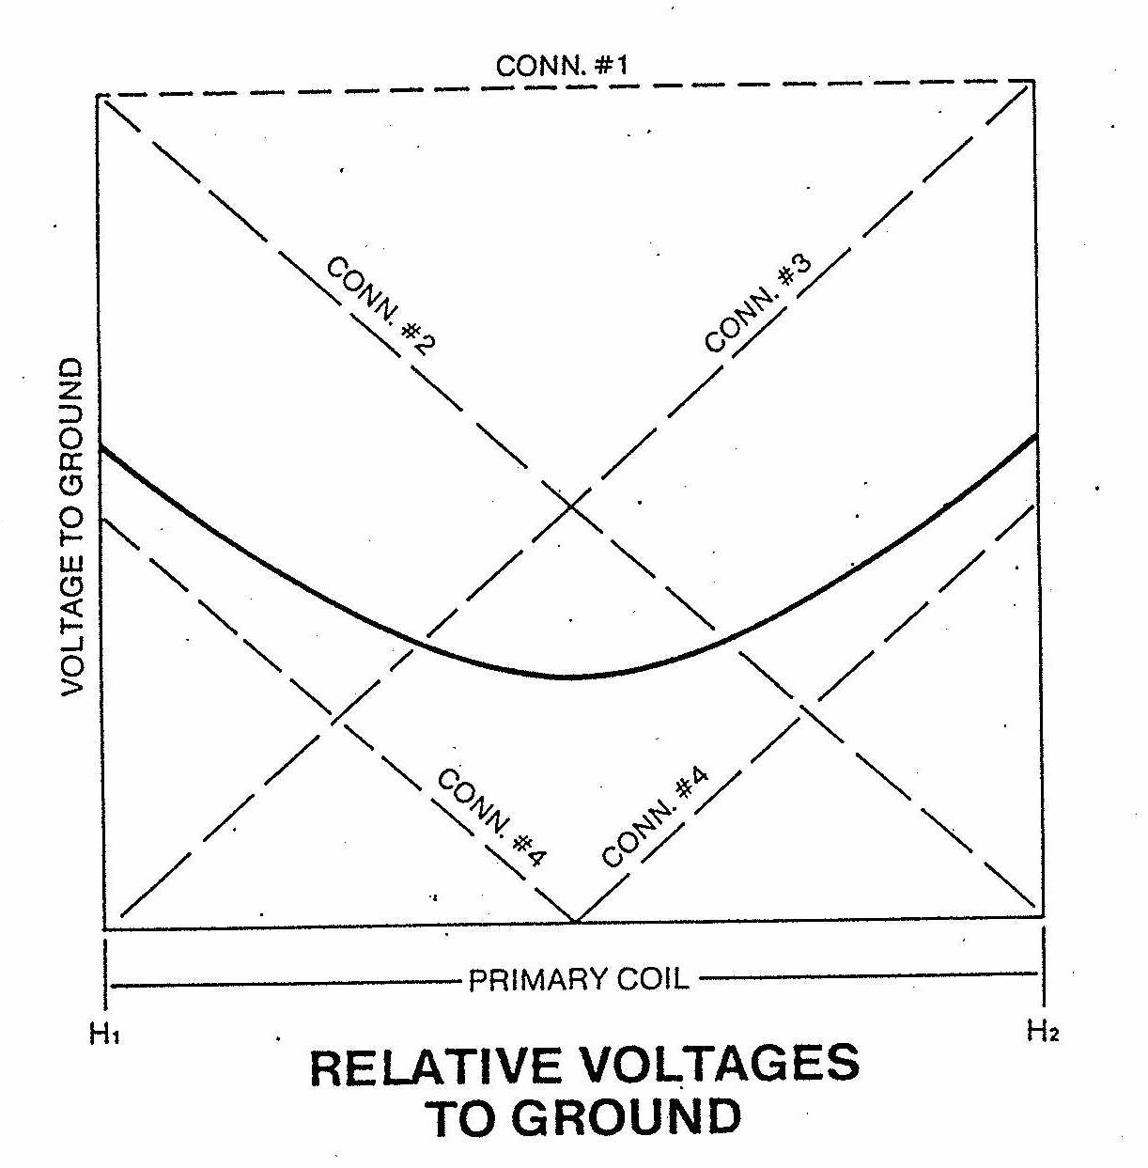

[Purpose of this chart was to emphasize each connection is limited in its ability to pinpoint location of partial discharge. Use of various test connections to isolate the source of partial discharge in a dry type voltage transformer will result in better interpretation of test results.]
Conceptual Location of Partial Discharge in
Instrument Transformers

[Purpose of this chart is to provide a conceptual framework to support use of various test connections.]

Proposed Partial Discharge
Test Levels for Various Connections

      - Working Group on C57.13 Revision – Tom Nelson

The working group met on March 9, 2004. There were 6 members and 10 guests present. Tom Nelson was unable to attend so Ross McTaggart took his place. The minutes of the Pittsburgh meeting were approved with 1 exception: the Partial Discharge presentation by C. TenHaagen was not attached. An updated version will be attached to the minutes from this meeting.

Status report on the reaffirmation of C57.13 and revised draft C57.13D4

The Standard has now been re-affirmed. It was noted that this re-affirmation was necessary to ensure that it would not be withdrawn, even though a revised draft has passed through the WG and is ready for balloting. Fifty-five comments were received on the re-affirmation ballot. RM will confirm that the new PAR has been issued after the re-affirmation.

Discussion of Comments from Re-affirmation Ballot

The comments from the re-affirmation ballot were reviewed and compared with the new draft (D04). Most of the technical comments have already been addressed in D04, the main exception being the references to 50 hz. Although some South American Utilities may be using IEEE Standards for 50 hz, this is the exception to the rule. We will try to incorporate the ones that were not addressed in the Draft(where agreed upon) as well as the editorial comments in the new document before balloting. If this is not possible, the authors of the comments may have to re-submit. The problems with figure 6 are being addressed by Tom Nelson. List of comments attached

De-magnetization Procedure

Vladimir Khalin pointed out that the procedure in clause 8.2 c) method 3 does not work and should be removed. If the membership agrees after reviewing this, it should be taken out of the draft standard

      - Study Group IEEE Std C57.13.2 – Vladimir Khalin

Working Group met on Tuesday, March 9 at 3:15 PM with 12 members and guests present.
Minutes from the Pittsburgh meeting were approved.
Chair reported:
- PAR was approved.
- Draft D3 was uploaded and request for ballot pool formation was initiated.
- Invitations for the pool creation were distributed.
- Balance of participants was approved.
- Standard was MIA ( It was not distributed for balloting by SA?)
The meeting adjourned at 4:00 PM.

10.5.4.5 Joint PSIM/Transformer Working Group - PAR P1601 Optical Current and Voltage Sensing Systems

Session was chaired by: Harley Gilleland (PSIM) and Farnoosh Rahmatian (TC/ITSC)
Attendees: K. Yule (G), V. Khalin (M), V. Nguyen (G), G. Morehart (G), L. Davis (M), M. Haas (G), C. Ten Haagen (G), D. Wagner (G), R. McTaggart (M), P. Canova (G), L. Recksiedler (G), V. Moreno (G), R. Gomez (G), D. Satpathi (M), A. Snyder (G), D. Makinson (G).

Minutes

- Opening comments were delivered by F. Rahmatian.
- Minutes of previous meeting, Oct 6, 2003, Pittsburgh, were reviewed.
- Update on other standards activities were given by F. Rahmatian and H. Gilleland:
  - IEC 61850-9-2 and IEEE/UCA Guide for digital interface to instrument transformers
  - PSRC ITF4 Working Group for Optical Sensor System Guide for Relaying
  - CSA series (Canadian Standards)
- The format and table of content for the first draft of the Par P1601 were presented by F. Rahmatian:
  - The format of IEEE C57.13.5 was used for the first draft.
  - Various sections of the first draft were reviewed.

Actions:
  - F. Rahmatian to publish the first draft (Rev. 1) of P1601 for comments by March 31, 2004.
  - Reviewers, including corresponding working group members, to provide feedback on the first draft to F. Rahmatian by April 30, 2004.
  - F. Rahmatian to publish a revised draft (Rev. 2) by May 30, 2004.
  - Working group will meet at the IEEE/PES General Meeting in June 6-10, 2004 in Denver to review and address comments received
  - H. Gilleland to check PAR expiry date.
  - D. Satpathi to review medium voltage dielectric test levels.

- Next Scheduled Working Group Meeting

- IEEE/PES General Meeting, June 2004, Denver, CO (see Denver 2004 IEEE General Meeting)

