DATE: March 7, 2004

TO: Members of IEEE Transformers Committee

FROM: Bill Chiu, Standards Subcommittee Chair
IEEE /PES Transformers Committee

SUBJECT: Standards Activities since the October, 2003 Meeting
_________________________________________________________________________________________

TRANSFORMERS STANDARDS STATUS

The transformers standards status is given with one attachment entitled IEEE/PES Transformers Committee Status Report of Standards, Dated 3/6/2004.

The report is a list of all the C57 standards, including ANSI C57 standards, sorted by Subcommittee names. It contains a listing of the projects for which a Subcommittee is responsible. The standards that are not assigned to a subcommittee yet are temporarily listed under the Standards Subcommittee.

NEMA/ANSI DOCUMENTS TRANSFERRED TO IEEE

The following standards were transferred to IEEE as of December 2, 2002. Currently there is no process for reaffirmation for these standards as these were not prepared under IEEE. The date of transfer (December 2, 2002) will be considered as the start of life. These standards will need a PAR for revision. We will have 5 years from the date of transfer to revise these standards. Given that these are special circumstances, it is likely we could obtain some extension from RevCom.

At this point IEEE SA indicated they can only provide PDF document for our revision work.

C57.12.10-1997
C57.12.20-1997
C57.12.21-2002
C57.12.22-1993
C57.12.24-2000
C57.12.25-1990
C57.12.26-1992
C57.12.28-1999
C57.12.29-1991
C57.12.31-2002
C57.12.32-2002
C57.12.40-2000
C57.12.50-1981
C57.12.51-1998
C57.12.52-1981
C57.12.55-1987
C57.12.57-1987

DOCUMENTS SUBMITTED TO THE IEEE STANDARDS BOARD

NEW STANDARDS COMMITTEE (NesCom)
Recommendations - 22 October 2003

PC37.91 (PE/PSR) Guide for Protecting Power Transformers
Recommendation: Approve PAR for the revision of a standard until December 2007.

Recommendations - 9 December 2003

PC57.12.01 (PE/TR) Standard General Requirements for Dry-Type Distribution and Power Transformers Including Those with Solid Cast and/or Resin Encapsulated Windings
Recommendation: Approve target extension request until December 2005.

PC57.130 (PE/TR) Trial-Use Guide for the Use of Dissolved Gas Analysis During Factory Temperature Rise Tests for the Evaluation of Oil-Immersed Transformers and Reactors
Recommendation: Approve target extension request until December 2005 (8 approve, 0 disapprove, 1 abstain-Paul Nikolich).

PARS TO BE ADMINISTRATIVELY WITHDRAWN
PC57.141 (PE/TR) Guide for the Application of Load Tap ChangersGuide for the Application of Load Tap Changers
Recommendation: Approve administrative withdrawal.

NEW PARS
PC57.147 (PE/TR) Guide for Acceptance and Maintenance of Natural Ester Fluids in Transformers
Recommendation: Approve new PAR until December 2007.

PARS FOR REVISIONS OF STANDARDS
PC57.13 (PE/TR) Standard Requirements for Instrument Transformers
Recommendation: Approve PAR for the revision of a standard until December 2007.

NEW STANDARDS COMMITTEE (NesCom)
Recommendations - 19 February 2004

NEW PARS
PC57.19.03-1996/Cor 1-20xx (PE/TR) Standard Requirements, Terminology, and Test Code for Bushings for DC Applications - Corrigendum 1
Recommendation: Approve new PAR until December 2008.

PC57.148 (PE/TR) Standard for Control Cabinets for Power Transformers
Recommendation: Approve new PAR until December 2008.

STANDARDS REVIEW COMMITTEE (RevCom)
RECOMMENDATION – 9 December, 2003

C57.13-1993 (PE/TR) IEEE Standard Requirements for Instrument Transformers
Recommendation: APPROVE

C57.18.10-1998 (PE/TR) IEEE Standard Practices and Requirements for Semiconductor Power Rectifier Transformers
Recommendation: APPROVE [Vote: Yes=9; No=0; Abstain=2 (Aggarwal, Klerer)]

C57.19.100-1995 (PE/TR) IEEE Guide for Application of Power Apparatus Bushings
Recommendation: APPROVE

C57.111-1989 (R1995) (PE/TR) IEEE Guide for Acceptance of Silicone Insulating Fluid and Its Maintenance in Transformers
Recommendation: APPROVE

STANDARDS REVIEW COMMITTEE (RevCom)
5-Year Review Cycle – December, 2003

62-1995 IEEE Guide for Diagnostic Field Testing of Electric Power Apparatus - Part 1: Oil Filled Power Transformers, Regulators, and Reactors
Sponsor states that a reaffirmation ballot is in progress.
Recommendation: Extend until December 2004.

1276-1997 IEEE Guide for the Application of High-Temperature Insulation Materials in Liquid-Immersed Power Transformers
Sponsor states that a reaffirmation ballot is in progress.
Recommendation: Extend until December 2004.

C57.12.01-1998 IEEE Standard General Requirements for Dry-Type Distribution and Power Transformers Including Those with Solid Cast and/or Resin Encapsulated Windings
Sponsor has submitted a PAR extension request to NesCom for revision project PC57.12.01.
Recommendation: Extend until the expiration of the PAR for PC57.12.01 {December 2005}.

C57.12.35-1996 IEEE Standard for Bar Coding for Distribution Transformers
Sponsor requests an extension to determine whether to revise or reaffirm the standard.
Recommendation: Extend until December 2004.

C57.12.56-1986 (R1998) IEEE Standard Test Procedure for Thermal Evaluation of Insulation Systems for Ventilated Dry-Type Power and Distribution Transformers
Sponsor has submitted a PAR for revision to NesCom.
Recommendation: Extend until the expiration of the PAR for PC57.12.60 {December 2007}.

C57.12.60-1998 IEEE Guide for Test Procedures for Thermal Evaluation of Insulation Systems for Solid Cast and Resin-Encapsulated Power and Distribution Transformers
Sponsor has submitted a PAR for revision to NesCom.
Recommendation: Extend until the expiration of the PAR for PC57.12.60 {December 2007}.

C57.110-1998 IEEE Recommended Practice for Establishing Transformer Capability When Supplying Nonsinusoidal Load Currents
Sponsor states that a reaffirmation ballot is in progress.
Recommendation: Extend until December 2004.

C57.117-1986 (R1998) IEEE Guide for Reporting Failure Data for Power Transformers and Shunt Reactors on Electric Utility Power Systems
Sponsor states that a reaffirmation ballot is in progress.
Recommendation: Extend until December 2004.

C57.121-1998 IEEE Guide for Acceptance and Maintenance of Less-Flammable Hydrocarbon Fluid in Transformers
Sponsor states that a reaffirmation ballot will be initiated shortly.
Recommendation: Extend until December 2004

C57.125-1991 (R1998) IEEE Guide for Failure Investigation, Documentation, and Analysis for Power Transformers and Shunt Reactors
Sponsor states that a reaffirmation ballot is in progress.
Recommendation: Extend until December 2004.

C57.138-1998 IEEE Recommended Practice for Routine Impulse Test for Distribution Transformers
Sponsor states that a reaffirmation ballot is in progress.
Recommendation: Extend until December 2004.

PARS DUE TO EXPIRE AT THE END OF 2004
(from IEEE SA/J. Haas)

PC57.12.25 Standard for Pad-Mounted, Compartmental-Type,Self-Cooled, Single-Phase Distribution Transformers with Separable Insulated High-Voltage Connectors; High Voltage, 34500 GrdY/19920 Volts and Below, Low Voltage, 240/120 Volts; 167 kVA and Smaller – Requirements

PC57.12.33 Guide for Distribution Transformer Loss Evaluation

PC57.12.34 Requirements for Pad-Mounted, Compartmental-Type, Self-Cooled, Three-Phase Distribution Transformers, 2500 kVA and Smaller: High-Voltage, 34 500GrdY/19 920 Volts and Below; Low Voltage, 480 Volts and Below

PC57.15 Standard Requirements, Terminology, and Test Code for Step-Voltage Regulators

PC57.19.00 Standard General Requirements and Test Procedure for Power Apparatus Bushings

PC57.104 Guide for the Interpretation of Gases Generated in Oil-Immersed Transformers

PC57.119 Recommended Practice for Performing Temperature Rise Tests on Oil Immersed Power Transformers at Loads Beyond Nameplate Rating

PC57.142 A Guide To Describe The Occurrence And Mitigation Of Switching Transients Induced By Transformer-Breaker Interaction

PC57.145 Guide for the Definition of Thermal Duplicate Liquid-Immersed Distribution, Power, and Regulating Transformers

If the projects will not be submitted to RevCom in time for the December 2004 meeting, you have the following options:
1. Request an extension for the projects. The Target Extension Request Form can be found at http://standards.ieee.org/guides/par/extension.rtf. Please note that this extension request can now be from one to four years.
2. Request withdrawal of the projects.

If there is no response by 19 October 2004, the projects will be recommended for administrative withdrawal at the 8 December 2004 IEEE-SA Standards Board meeting.

INVITAION TO BALLOT STATUS -- 2003-2004 , SORTED BY INVITATION NUMBER (As of 3/5/2004)

Invitation Number | Sponsor (Soc/Com) | Working Group Chair | Invitation Open Date | Invitation Close Date | Invitations Sent Out | Type of Invitation
PC57.12.20 | PE/TR | Alan Wilks | 2/3/2004 | 3/4/2004 | 673 | Electronic Invitation
PC57.12.37 | PE/TR | Richard Hollingsworth | 11/13/2003 | 12/13/2003 | 658 | Electronic Invitation
PC57.13.2 | PE/TR | Vladimir Khalin | 10/17/2003 | 11/16/2003 | 658 | Electronic Invitation
PC57.13.6 | PE/TR | Chris Ten-Haagen | 9/12/2003 | 10/12/2003 | 653 | Electronic Invitation
PC57.130 | PE/TR | Frank J Gryszkiewicz | 9/8/2003 | 10/8/2003 | 653 | Electronic Invitation
PC57.144 | PE/TR | Dudley L Galloway | 7/7/2003 | 8/6/2003 | 651 | Electronic Invitation
PC57.146 | PE/TR | William H Bartley | 2/19/2004 | 3/20/2004 | 675 | Electronic Invitation
Std.259 REAFF | PE/TR | Robert Simpson | 11/7/2003 | 12/7/2003 | 664 | Electronic Invitation
Std.C57.110 REAFF | PE/TR | Richard P Marek | 1/23/2003 | 2/22/2003 | 844 | Electronic Invitation
Std.C57.111 REAFF | PE/TR | N Kent Haggerty | 3/31/2003 | 4/30/2003 | 642 | Electronic Invitation
Std.C57.117 REAFF | PE/TR | Wallace B Binder | 9/12/2003 | 10/12/2003 | 653 | Electronic Invitation
Std.C57.121 REAFF | PE/TR | Charles Patrick McShane | 10/23/2003 | 11/22/2003 | 658 | Electronic Invitation
Std.C57.125 REAFF | PE/TR | Wallace B Binder | 9/12/2003 | 10/12/2003 | 653 | Electronic Invitation
Std.C57.13 REAFF | PE/TR | James Smith | 4/1/2003 | 5/1/2003 | 642 | Electronic Invitation
Std.C57.138 REAFF | PE/TR | John R Rossetti | 9/4/2003 | 10/4/2003 | 653 | Electronic Invitation
Std.C57.18.10 REAFF | PE/TR | Sheldon P Kennedy | 6/5/2003 | 7/5/2003 | 650 | Electronic Invitation
Std.C57.91 REAFF | PE/TR | Timothy Raymond | 7/15/2003 | 8/14/2003 | 651 | Electronic Invitation
Std.C57.96 REAFF | PE/TR | Michael E Haas | 11/21/2003 | 12/21/2003 | 663 | Electronic Invitation

BALLOT STATUS - 2003-2004, SORTED BY BALLOT NUMBER (As of 3/5/2004)

Ballot Number | Sponsor (Soc/Com) | Type of Ballot | Ballot Opened | Sched. Close Date | # Ballots | Balloting Results |  |  | Type of Ballot
 |  |  |  |  |  | Affirm | Neg | Abstain | Type of Ballot
PC 57.13.6/D1 | PE/TR | New | 20-Nov-03 | 20-Dec-03 | 82 | 95% | 5% | 5% | Electronic
PC57.12.34/D10 | PE/TR | Reballot | 3-Feb-04 | 4-Mar-04 | 90 |  |  |  | Electronic
PC57.12.34/D9 | PE/TR | Recirc | 7-Feb-03 | 9-Mar-03 | 90 | 79% | 21% | 3% | Electronic
PC57.144/D4 | PE/TR | New | 11-Nov-03 | 11-Dec-03 | 120 | 98% | 2% | 3% | Electronic
Std. 259-1999 | PE/TR | Reaff | 12-Dec-03 | 11-Jan-04 | 56 | 100% | 0% | 2% | Electronic
Std. 62-1995 | PE/TR | Reaff | 17-Mar-03 | 16-Apr-03 | 122 | 95% | 5% | 3% | Electronic
Std. 62-1995 | PE/TR | Reaff Recirc | 26-Sep-03 | 26-Oct-03 | 122 | 99% | 1% | 3% | Electronic
Std. C57.110-1998 | PE/TR | Reaff | 27-Feb-03 | 30-Mar-03 | 132 | 99% | 1% | 1% | Electronic
Std. C57.111-1989 (R1995) | PE/TR | Reaff | 9-May-03 | 8-Jun-03 | 73 | 100% | 0% | 0% | Electronic
Std. C57.117-1986 | PE/TR | Reaff | 16-Oct-03 | 15-Nov-03 | 98 | 100% | 0% | 3% | Electronic
Std. C57.121-1998 | PE/TR | Reaff | 21-Jan-04 | 20-Feb-04 | 73 | 100% | 0% | 1% | Electronic
Std. C57.125-1991 | PE/TR | Reaff | 16-Oct-03 | 15-Nov-03 | 137 | 99% | 1% | 4% | Electronic
Std. C57.13-1993 | PE/TR | Reaff | 9-May-03 | 8-Jun-03 | 92 | 94% | 6% | 5% | Electronic
Std. C57.13-1993 | PE/TR | Reaff Recirc | 5-Aug-03 | 4-Sep-03 | 92 | 98% | 2% | 3% | Electronic
Std. C57.138-1998 | PE/TR | Reaff | 10-Oct-03 | 9-Nov-03 | 83 | 100% | 0% | 1% | Electronic
Std. C57.18.10-1998 | PE/TR | Reaff | 10-Jul-03 | 9-Aug-03 | 52 | 95% | 5% | 2% | Electronic
Std. C57.21-1990 | PE/TR | Reaff Recirc | 12-Sep-03 | 27-Oct-03 | 78 | 93% | 7% | 3% | Paper
Std. C57.91-1995 | PE/TR | Reaff | 11-Sep-03 | 11-Oct-03 | 155 | 98% | 2% | 3% | Electronic
Std. C57.96-1999 | PE/TR | Reaff | 5-Jan-04 | 4-Feb-04 | 70 | 100% | 0% | 1% | Electronic

2004 STANDARDS BOARD MEETINGS SCHEDULE AND SUBMITTAL DEADLINES

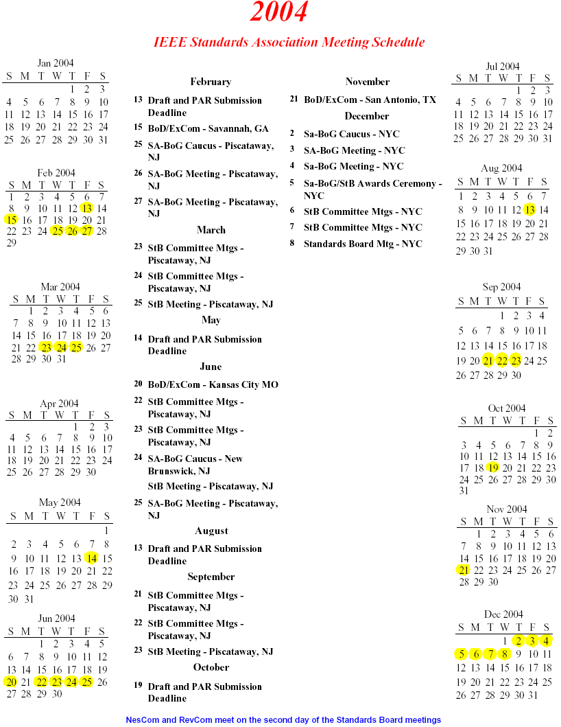
Meeting Dates Deadline for Submittal of PAR ⁽¹⁾ or Draft Standard ⁽²⁾
March 23, 2004 February 13, 2004
June 22, 2004 May 14, 2004
September 21, 2004 August 13, 2004
December 6, 2004 October 19, 2004

- A PAR must be sent to the Standards Subcommittee Chair before the stated deadline.
- Standards must be submitted directly to the IEEE Standards Department by the Working Group Chair before the stated deadline to be considered at the next Standards board Meeting.
For current PAR form: http://standards.ieee.org/guides/par/index.html.
Target Extension Request form: http://standards.ieee.org/guides/par/extension.html.
CURRENT LIST OF ALL OPEN STANDARDS PROJECT (FROM IEEE WEB SITE MARCH 5, 2004)
http://standards.ieee.org/board/nes/C2-C136.html
Only PARs submitted electronically and approved since the December 1998 Standards Board meeting are listed

PC57.12.00 (PE/TR) Standard General Requirements for Liquid-Immersed Distribution, Power, and Regulating Transformers
PC57.12.01 (PE/TR) Standard General Requirements for Dry-Type Distribution and Power Transformers Including Those with Solid Cast and/or Resin Encapsulated Windings
PC57.12.10 (PE/TR) Standard Requirements for Liquid-Immersed Power Transformers
PC57.12.20 (PE/TR) Standard for Overhead Type Distribution Transformers, 500 kVA and Smaller: High Voltage, 34500 Volts and Below; Low Voltage, 7970/13800Y Volts and Below
PC57.12.25 (PE/TR) Standard for Pad-Mounted, Compartmental-Type, Self-Cooled, Single-Phase Distribution Transformers with Separable Insulated High-Voltage Connectors; High Voltage, 34500 GrdY/19920 Volts and Below, Low Voltage, 240/120 Volts; 167 kVA and Smaller - Requirements
PC57.12.28 (PE/TR) Standard for Pad Mounted Equipment - Enclosure Integrity
PC57.12.29 (PE/TR) Standard for Pad Mounted Equipment - Enclosure Integrity for Coastal Environments
PC57.12.33 (PE/TR) Guide for Distribution Transformer Loss Evaluation
PC57.12.34 (PE/TR) Requirements for Pad-Mounted, Compartmental-Type, Self Cooled, Three-Phase Distribution Transformers, 2500 kVA and Smaller: High-Voltage, 34 500 GrdY/19 920 Volts and Below; Low Voltage, 480 Volts and Below
PC57.12.36 (PE/TR) Standard Requirements for Liquid-Immersed Distribution Substation Transformers
PC57.12.37 (PE/TR) Standard for the Electronic Reporting of Distribution Transformer Test Data
PC57.12.40 (PE/TR) Requirements for Secondary Network Transformers, Subway and Vault Types (Liquid-Immersed)
PC57.12.44 (PE/TR) Standard Requirements for Secondary Network Protectors
PC57.12.60 (PE/TR) Standard Test Procedure for Thermal Evaluation of Insulation Systems for Dry Type Power and Distribution Transformers, Including Ventilated, Solid-Cast and Resin Encapsulated Transformers
PC57.12.80 (PE/TR) Standard Terminology for Power and Distribution Transformers
PC57.12.90 (PE/TR) Standard Test Code for Liquid-Immersed Distribution, Power, and Regulating Transformers
PC57.13 (PE/TR) Standard Requirements for Instrument Transformers
PC57.13.1 (PE/PSR) Guide for Field Testing of Relaying Current Transformers
PC57.13.2 (PE/TR) Conformance Test Procedure for Instrument Transformers
PC57.13.3 (PE/PSR) Guide for Grounding of Instrument Transformer Secondary Circuits and Cases
PC57.13.6 (PE/TR) Standard for High Accuracy Instrument Transformers
PC57.15 (PE/TR) Standard Requirements, Terminology, and Test Code for Step-Voltage Regulators
PC57.19.00 (PE/TR) General Requirements and Test Procedures for Power Apparatus Bushings
PC57.19.03-1996/Cor 1-20xx (PE/TR) Standard Requirements, Terminology, and Test Code for Bushings for DC Applications - Corrigendum 1
PC57.21 (PE/TR) Standard Requirements, Terminology, and Test Code for Shunt Reactors Rated Over 500 kVA
PC57.32 (PE/TR) Standard Requirements, Terminology and Test Procedures for Neutral Grounding Devices
PC57.93 (PE/TR) Guide for Installation of Liquid-Immersed Power Transformers
PC57.98 (PE/TR) Guide for Transformer Impulse Tests
PC57.104 (PE/TR) Guide for the Interpretation of Gases Generated in Oil-Immersed Transformers
PC57.106 (PE/TR) Guide for Acceptance and Maintenance of Insulating Oil in Equipment
PC57.119 (PE/TR) Recommended Practice for Performing Temperature Rise Tests on Oil Immersed Power Transformers at Loads Beyond Nameplate Rating
PC57.127 (PE/TR) Guide for the Detection and Location of Acoustic Emissions from Partial Discharges in Oil-Immersed Power Transformers and Reactors
PC57.130 (PE/TR) IEEE Trial-Use Guide for the Use of Dissolved Gas Analysis During Factory Temperature Rise Tests for the Evaluation of Oil-Immersed Transformers and Reactors
PC57.131 (PE/TR) Standard Requirements for Tap Changers
PC57.139 (PE/TR) Guide for Dissolved Gas Analysis in Transformer Load Tap Changers
PC57.140 (PE/TR) Evaluation and Reconditioning of Liquid Immersed Power Transformers
PC57.142 (PE/TR) A Guide To Describe The Occurrence And Mitigation Of Switching Transients Induced By Transformer-Breaker Interaction
PC57.143 (PE/TR) Guide for Application of Monitoring to Liquid-Immersed Transformers and Components
PC57.144 (PE/TR) Guide to Metric Conversion of Transformer Standards
PC57.145 (PE/TR) Guide for the Definition of Thermal Duplicate Liquid-Immersed Distribution, Power, and Regulating Transformers
PC57.146 (PE/TR) Guide for Interpretation of Gasses Generated in Silicone-Immersed Transformers
PC57.147 (PE/TR) Guide for Acceptance and Maintenance of Natural Ester Fluids in Transformers
PC57.148 (PE/TR) Standard for Control Cabinets for Power Transformers

