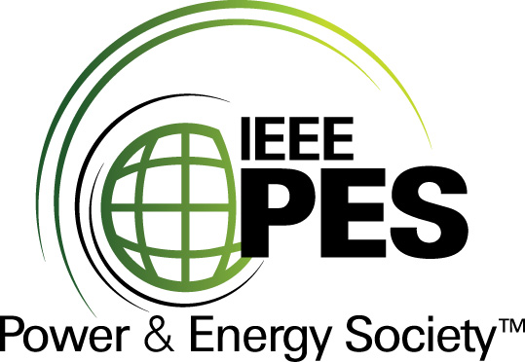
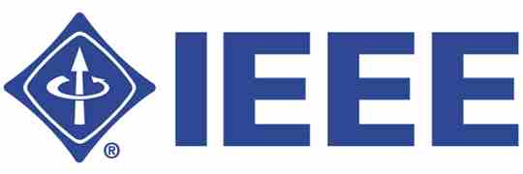

CERTIFICATE OF
EDUCATIONAL ACHIEVEMENT

This certificate is presented to

replace with your name

for attendance at the educational presentation:

“Frequency Response Analysis (FRA)
Diagnostic Method"

sponsored by the IEEE/PES Transformers Committee

and has earned one (1) Professional Development Hour (PDH) unit.
Spring 2009 Committee Meeting -- Monday, 22 April 2009
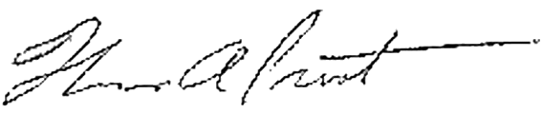

Tom Prevost Instructors: L. Coffeen, A. Kraetge, A. McGrail,
Chair, IEEE/PES Transformers Committee M. Perkins, C. Sweetser, P. Werelius

