UNAPPROVED MINUTES
SC Insulating Fluids Meeting
March 10, 2010
Houston, Texas

Insulating Fluids Subcommittee
Susan McNelly, Chair, Jerry Murphy Vice-Chair, C. Patrick McShane, Secretary

Introduction/Attendance
The Insulating Fluids Subcommittee meeting in Houston was called to order by the Chair at 3 PM on Wednesday, March 10, 2010. All the officers of the SC were present. There were 20 members and 54 guests present. The quorum requirement was met. The following 2 guests requested membership: Edwardo Garcia W. (Manufacturer) and John Crotty (Manufacturer).

Introduction/Attendance, F08 Minutes Approval, & Patent Disclosure Request
As required the IEEE patent disclosure requirements were discussed and a request was made for disclosure of any patents that may be related to the work of the subcommittee. No new disclosures were forthcoming. Question was asked if there were any ABB patents that should disclosed. ABB attendees did not respond that there were any patents that needed to be disclosed.
The Minutes of the Fall 2009 Lombard, IL meeting were approved as written.

WG & TF Reports Presented at the SC Meeting:

C57.104 – IEEE Guide for the Interpretation of Gases Generated in Oil – Immersed Transformers
WG Chair: Rick Ladroga, Vice-Chair: Claude Beauchemin

The WG Report Given at the Sub-Committee Meeting:
The WG report was presented by Claude Beauchemin. The WG met on Tuesday with 35 of 94 members present, therefore a quorum was not achieved. Claude Beauchemin has agreed to step in as Vice-Chair of the WG.
PAR for revision of the Guide was submitted and approved at the December NESCOM meeting. The PAR will expire Dec of 2014
There is an extensive Bibliography in the present version of the Guide. There was discussion on whether the Bibliography should be kept. General consensus was that the Bibliography should be kept. A new TF was developed to determine whether the present documents are still appropriate or if there are new references that should be added. Jerry Murphy agreed to chair this TF.
An aggressive schedule has been developed with the expectation that a draft document will be available for review before the Fall 2010 WG meeting in Toronto.
Michel Duval gave a presentation on a diagnostic methods questionnaire which resulted in considerable discussion regarding the Table 1 concentration values and the Table 2 rate of generation values. A poll was taken on whether the concentration values or the generation rates should be listed first. The consensus was that the present order should be kept.
There was also a discussion regarding concentration values versus volume of oil. Submittal of data has been requested in order for this issue to be investigated.
No questions were asked.

The Minutes (unapproved) of WG Meeting as Submitted:
The meeting was called to order by Chair Rick Ladroga at 1:50pm. Secretary Susan McNelly and Claude Beauchemin, who has agreed to be Vice-Chair of the WG, were also present.
There were 35 of 94 members present, 48 guests, and 10 guests requesting membership. A membership quorum was not achieved. The membership roster will be pared down before the next meeting based on attendance and participation.
Guests requesting membership were:
John Crotty Pierre Feghali
Shawn Luo Libin Mao
Terence Martin Hali Moleski
Arturo Nunez Robert Rasor
Andy Speegle Peter Zhao
Agenda
- Welcome & Roll Call
- Introduction
Approval of Minutes from Fall 2009 Lombard, Illinois meeting
- Patent Disclosure
- Revised PAR
- Task Force Reports:
      - DGA in Arc Furnace Transformers - Tom Lundquist
      - Framework Structure - Jim Dukarm
      - Data - Norman Field
      - Case Studies (Q – Existing – SDM, ABB, DOBLE, WEIDMANN, etc) - Brian Sparling
      - Diagnostic Studies – open
- New Business
Approval of minutes from the Fall 2009 Lombard, Illinois meeting was requested. Since a quorum was not present, approval of the minutes will be deferred to the next meeting.
The IEEE Patent disclosure requirements were discussed and a request was made for disclosure of any patents that may be related to the work of the WG. There were no responses to the request for disclosure.
Rick announced that the request for the PAR for the revision of C57.104 was approved by NESCOM in December. The PAR will expire in December of 2014.
Task Forces:
Rick went through the TFs that are in place and the present chairs for each. He then indicated a desire to have vice-chairs assigned to most of the task forces to ensure that the work keeps progressing. Dave Hanson was asked to be vice-chair of the Framework TF. Paul Boman has agreed to chair the Case Studies TF.
He also indicated that anyone wishing to participate in the TFs should contact the Chairs of each.
- Arc Furnace – Chair Tom Lundquist
- Framework – Chair Jim Dukarm, Vice-Chair Dave Hanson
- Data – Chair Norman Field, Vice-Chair Pierre Feghali
- Case Studies – Chair – Paul Boman, Vice-Chair Arturo Nunez
- Diagnostic Methods – Chair Michel Duval, Vice-Chair Dave Wallach
- Bibliography – Chair Jerry Murphy
There is an extensive Bibliography in the present Guide. The question was asked if there is anyone that feels we do or don’t need the Bibliography. A comment was made that if there is something that is no longer valid, it should probably be removed, but otherwise they should stay. Jerry Murphy agreed to Chair a TF on review of the Bibliography
Schedule:
Rick indicated a need to keep the revision process moving. The following are the planned dates for information to be provided:
- Diagnostic Methods – final input by Friday, April 30, 2010
- Statistical analysis - Friday, May 28, 2010
- Issue compiled draft for TF Review by Friday, June 25, 2010
- Continue meeting bi-weekly, editing and refining the document in preparation for the Fall 2010 WG meeting in Toronto.
- Provide draft to entire WG for review and comment – Monday, Sept 13
Task Force reports:
Presentation on Diagnostic Methods Questionnaire – Michel Duval
A copy of Michel’s presentation is included at the end of the minutes.
There was much discussion on whether the concentration or rate information should be the primary focus. There seemed to be much consensus that relying on a single sample and result would not be advisable and that the rate of gas increase is the primary tool for determining whether there is a problem.
Rick asked for a poll on whether people would prefer to see the Concentration values 1st and the rates second in the Guide or vice versa. The consensus was that the Concentration limits should be listed first with the generation rates as second.
Other issues:
A question was raised for concentration values for distribution units based on volume of oil. There are differing opinions on this topic and Rick requested data be submitted so that this can be actively investigated.
The meeting was adjourned at 3:00 pm.
Rick Ladroga
WG Chair
Susan McNelly
WG Vice-Chair and Secretary

C57.104 Presentation by Michel Duval:
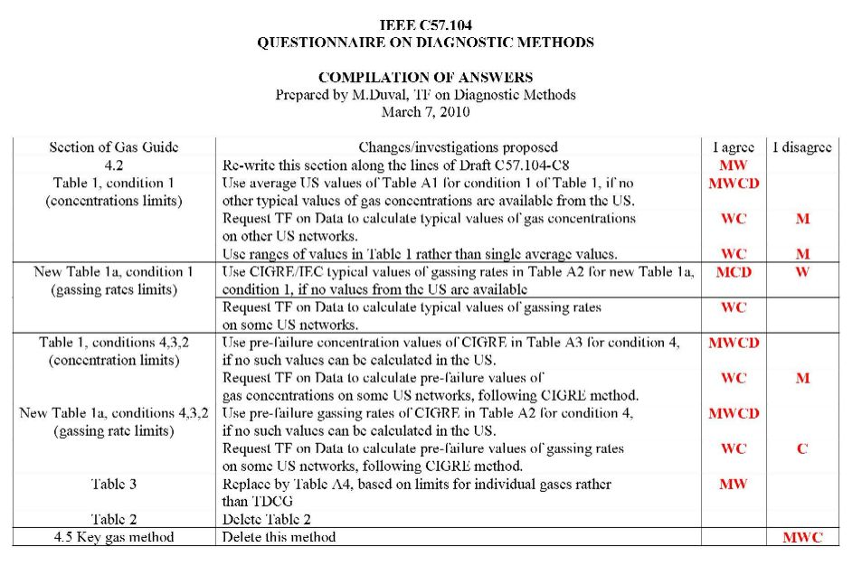
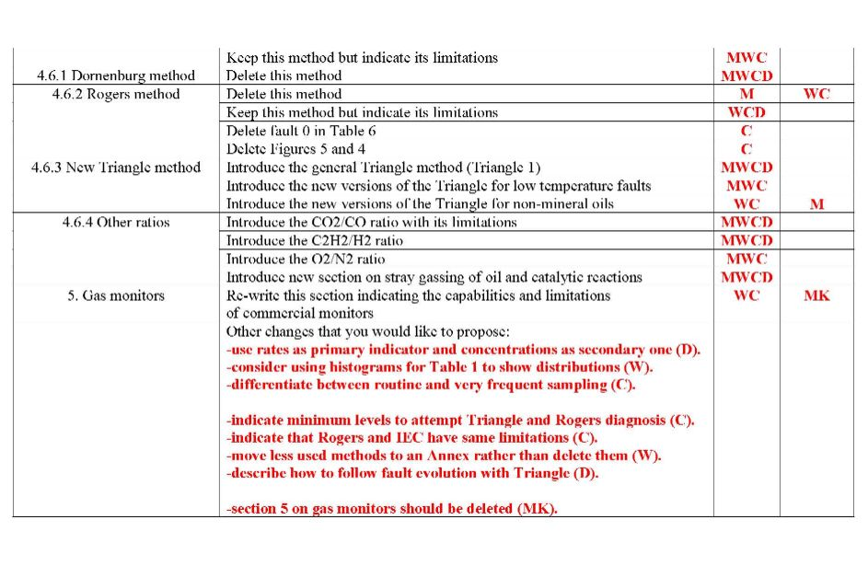
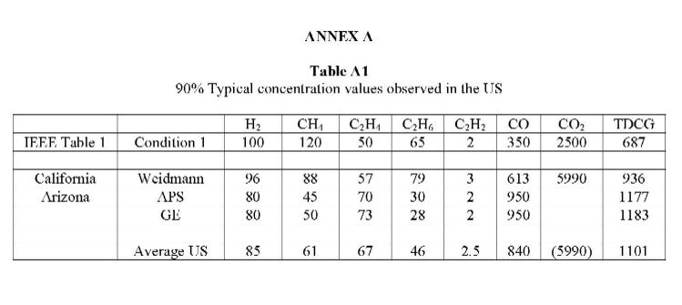
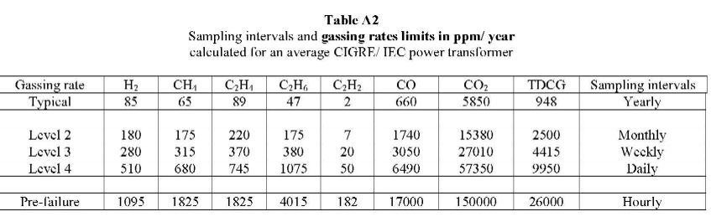
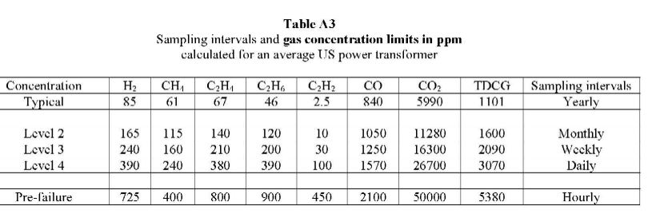
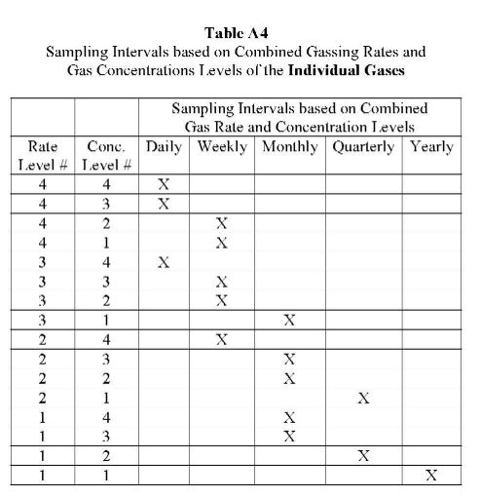

IEEE C57.121 Guide for the Acceptance and Maintenance of Less Flammable Hydrocarbon Fluids in Transformers
WG Chair: David Sundin

The Report Given at the Sub-Committee Meeting:
David Sundin presented. No meeting was held. The standard was reaffirmed and valid through 2014.

IEEE C57.130 IEEE Trial-Use Guide for Dissolved Gas Analysis During Factory Temperature Rise Tests for the Evaluation of Oil-Immersed Transformers and Reactors
WG Chair: Fredi Jacob

The WG Report Given at the Sub-Committee Meeting:
The presentation was made by Jim Thompson, No meeting was held. Draft 18 from the previous WG will be the starting point for the new WG.
The PAR for this Guide expired at the end of 2009 and the document was withdrawn. A new PAR was submitted this week and Bill Bartley had forwarded this on for the next REVCOM meeting. The WG for this Guide intends to meet at the Fall meeting in Toronto.

IEEE C57.139 IEEE Dissolved Gas Analysis in Load Tap Changers
WG Chair: Fredi Jacob, Vice-Chair: David Wallach

The WG Report Given at the Sub-Committee Meeting:
Dave Wallach presented. The WG met Tuesday, a quorum was not achieved. Draft 12 of the Guide with an example spread sheet went to ballot after the Fall 2009 meeting. A PAR extension to the end of 2010 was received in December.
There were many comments and some negative ballots received. As a result, the ballot resolution group has made some revisions to the Guide. Annex C has been completely revised and Annex D removed. Further refinement of the example spreadsheet has also been made thanks to Mick Bayer.
The document will be sent for recirculation ballot within the next few weeks. A PAR modification was submitted this week for modification of the purpose as required as a result of the IEEE legal review.

The WG Minutes (unapproved) of WG Meeting as Submitted:
Fredi Jakob called the WG meeting to order at 11:00am. WG Vice-Chair Dave Wallach and Secretary Susan McNelly were also present. There were 16 of 35 members (Quorum requirement not met) and 26 guests present with 5 guests requesting membership.
New members are not being accepted at this time as the document has already been balloted.
Agenda:
- Welcome and Member Roll Call
- Patent Disclosure Request
- Approval of Minutes from Fall 2009 Lombard, Illinois meeting
- Review of WG Ballot Resolution Group - Comments/Actions - Presentation by Dave Wallach
- Automated Data Analysis – Jim Dukarm
- Safety Issue - Claude Beauchemin
- Submittal for Recirculation Ballot
- Adjourn
The IEEE Patent disclosure requirements were discussed and a request was made for disclosure of any patents that may be related to the work of the WG. There were no responses to the request for disclosure.
Approval of minutes from the Fall 2009 Lombard, Illinois meeting was requested. Since there was not a quorum present, the minutes were not approved.
The PAR was set to expire 12/31/2009, since the ballot process would not be completed prior to the PAR expiration. A PAR extension request was submitted for NESCOM review at their December 8, 2009 meeting. A one year PAR extension was granted.
Review of WG Ballot Resolution Group - Comments/Actions - Presentation by Dave Wallach:
Rowland James, Claude Beauchemin, Norman Field, Fredi Jacob, Dave Wallach, Jim Dukarm, Shuzhen Xu, and Mick Bayer worked on comment resolutions for the ballot.
Dave reviewed the changes that were made to the Scope and Purpose for which a PAR modification request will be submitted in parallel to the recirculation ballot effort.
Automated Data Analysis – Jim Dukarm
- Jim discussed the work that was done on the example spreadsheet and the improvements done by Mick Bayer. Jim demonstrated the revised spreadsheet. .
Safety Issue - Claude Beauchemin:
- Claude made a presentation on how the number that was used in the warning statement was determined. A task force made up of Jack Harley, Paul Griffin, and Claude Beauchemin met to determine a worst case value of DGA that could create a flammable mixture when at equilibrium with air. Claude’s presentation will be posted on the WG web page.
- Tom Prevost indicated that if limits are to be provided, then technical basis needs to be provided as a reference for how these values were determined. A reference to the Baker paper will be added, which he indicated would satisfy his negative ballot.
Submittal for Recirculation Ballot
There was discussion on submitting a new PAR request for continuing work on future versions. A comment was made that this can’t be done until the present PAR is completed. A PAR modification will need to be submitted as soon as possible. The document will be sent for recirculation ballot in parallel with the PAR modification request.
Documents to be included in the Recirculation Ballot:
- C57.139 Draft 14
- Example Spreadsheet
- The Ballot will be sent out within the next month or so to be able to meet the year end deadline.
- Plans for Fall 2010 Toronto Meeting:
- Review Recirculation Ballot comments/results
The meeting was adjourned at 12:00pm.
Fredi Jakob
Chair
Dave Wallach
Vice-Chair
Susan McNelly
Secretary

WG PC57.637 Guide for the Reclamation of Insulating Oil and Criteria for Its Use Chair: Jim Thomson; Co-Chair: TV Oommen

The WG Report given at the Sub-Committee Meeting:
The report was presented by Jim Thompson. The WG met Tuesday and did achieve a quorum. The work on the Guide is progressing. There were no questions or comments from participants.

The Minutes (unapproved) of the WG Meeting as Submitted:
The working group meeting was conducted at 8 am on April 9, 2010 with 28 people in attendance with 16 of the 20 working group members present. This document was reaffirmed in 2007 and the PAR for revision was approved December 10, 2008. Working Group members Jim Thompson (chair) and TV Oommen (co chair) conducted the meeting. There was a request for patent declarations regarding the PC57.637 document and none given.
There was a motion to approve the October 27, 2009 Working Group minutes by Don Cherry and a second by Derek Baronowski. The approval of the minutes was unanimous. The discussion of the meeting included a. Juan Castenellos’ revision language on the introduction regarding the recommendation of new oil, rather than used reclaimed oil, in new electrical apparatus, and b. Claude Beauchemin’s text on the sulfuric compound testing and Polychlorinated Biphenyl testing per ASTM methods, to be inserted as footnotes of Table 2, and c. Dave Sundin’s text on the sections for definitions and askeral tradenames.

Ray Bartnikas asked if the life of the used oil was discussed in the guide. Currently the guide does not address that issue.

The current working group membership is:
Baranowski | Derek
Bartnikas | Ray
Beauchemin | Claude
Boman | Paul
Castellenos | Juan
Cherry | Don
Claiborne | Claire
Garza | Joe
Hernden | Rodney
McNally | Mark
Moleski | Hali
Oommen | TV
Pellon | Verena
Peterson | Alan
Rasor | Bob
Stiegemeier | Craig
Sundin | David
Tenyenhuis | Ed
Thompson | Jim
Thompson | Ryan

Respectfully submitted,

Chair Jim Allen Thompson
Co Chair TV Oommen

TF Natural Based Ester Fluids DGA Guide Development
Chair: Paul Boman, Secretary: John Luksich, 9:30 am Tuesday, October 27, 2009 4th meeting of the group.

The TF Report given at the Sub-Committee Meeting:
The WG met Tuesday with 18 of 45 members were present, so there was not a quorum. The PAR is going before NESCOM at the next meeting, however there is a correction to the scope that is required which may require withdrawing it until the next NESCOM meeting.
No patent issues were raised at the meeting, however there are patent issues with the natural ester fluids, that may need to be addressed. A letter of assurance may be required for any applicable patents. More research into this is required.
A subset of the TF has been very active between meetings collecting data. They are obtaining samples from the natural and synthetic ester manufacturers of the fluids and are getting analysis done from 3 separate labs, focusing on repeatability of testing, such as for spray gassing ASTM 7150.
The group has settled on three different methods of interpretation of gases: The Duval Triangle, rate of change, and key gases. They are still looking for NE or Synthetic esters case studies.
The group would like to determine if trade names of the oils can be used in place of calling them high oleic or soybean oil to avoid confusion by users who may not know the difference in what they have other than by the trade name.

Minutes (unapproved) of the TF meeting as submitted:
Attendance: 18 members out of 45 members were in attendance, total attendance was 72 and 8 people requested membership.
The meeting was called to order at 9:30AM. Attendance rosters where circulated and we did introductions. The following agenda was followed:
The IEEE Patent Disclosure policy was reviewed. No patents were disclosed.
Status Update:
NESCOM to meet soon to consider upgrading status to WG
6 webinars since last meeting with task force subset group.
Soybean based fluid already tested, stray gas ASTM7150 with High Oleic fluid and synthetic (UK) samples being sent.
Looking at 3 interpretation methods, Duval Triangle, Rates of Change, and Key Gases.
Goal before next meeting draft one issued for straw ballot.
Claude Beauchemin cautions on moisture monitors and how they calculate relative saturations. The gas readings are ok.
Michel Duval: Need failure information to make more refined analysis for triangle method.
ABB Presentation: George Frimpong
High Energy Arcing Tests for the high oleic natural ester fluid 8,000A 3 cycles 1” gap. Very difficult to control energy input. Combustible gas produced by mineral oil generated violent explosion but mild reaction from high oleic natural ester fluid for similar conditions.
Film did not work so stated presentation. Bolted cover went into air followed by burning gases and oil spray however the remaining oil self extinguished after a few minutes, fluid sprayed into large area, most of the energy occurs in first instants, but checking gases of both oils after DGA fit for D2 area of Duval triangle. Some test almost the same, but others much less. Presentation not available until published submittal expect in 2010.
Question: Any impact on viscosity.
Ray Bartnikas, Hydro Quebec IREQ researched partial discharges in several types of dielectric fluids like synthetic and natural esters. Measuring is quite different at of fluid vs. equipment. Cavities are under tremendous pressure above 50 MPa then cavities collapse, disappear, 2 to 10 micro meters in diameter, all fluids seem to behave similarly. Discharge inception voltages are roughly the same, some differences but do not know how significant they are. Series of papers on power delivery
Chair reminded members to provide feedback on ballets to maintain workgroup membership.
The meeting was adjourned at 10:15AM.

TF Guide for Field Application of Natural Esters
Jim Graham – Chair, Jerry Murphy Vice-Chair

The TF Report Given at the Sub-Committee Meeting:
Jim Graham presented the TF meeting summary. The meeting met Tuesday, March 9. and had a quorum with 11 members and 38 guests. 4 guests requested membership. The TF is working on Draft 1, dated March 2008. The Chair spoke of the TF discussion regarding the option including all field related issues in one standard guide even if they directly or indirectly cross-link with other standards. The consensus was to have a single document and provide cross references as needed.
PAR title, scope, and purpose were approved and a motion made to request approval from the SC to establish a WG. The motion passed.
The TF meeting minutes (unapproved) as received:
The meeting was called to order at 3:15 PM. Introductions were skipped, and an attendance roster was circulated. Membership attendance was checked, and we did have a quorum. The chair asked if there were any patent disclosures, and none were disclosed. The fall 2009 task force minutes were sent out prior to the meeting for comments and no corrections were submitted. A motion to approve the Fall 2009 minutes was approved.
Membership requirements for the task force were reviewed. Members are required to attend two of the past four meetings and actively participate to gain and maintain membership. Corresponding members are exempt from the attendance requirement.
The list of topics developed in previous meetings was reviewed. After some discussion, a topic covering revised nameplates and/or adding informational labels to alert users of the presence of an alternative fluid was added. A question was raised re the use NE fluids in LTC's.
The chair asked the task force for opinions of creating a single, centralized guide covering the application of NE fluids as opposed to modifying any applicable existing guides. Steve Moore expressed strong support of creating a single guide document. A poll of the members present supported this approach. No support was offered to modify existing standards documents.
Derek Baranowski volunteered to create a draft covering NE fluid handling/processing:
Sanjib Som volunteered to create a draft covering NE fluid filling of new units.
The task force recommends keeping the word "Field" in the document title.
A draft of the PAR application based on previously approved task force recommendation of scope and purpose was presented and reviewed. No substantial changes were proposed (see below). A consensus among the task force members was reached to present the current PAR draft to the fluids subcommittee and ask for approval to submit a PAR.
There was no new business.
The meeting adjourned at 4:30 PM.

PROPOSED TOPICS TO BE ADDRESSED BY FIELD GUIDE TASK FORCE:
- Types of Equipment Covered by Task Force (Should NE Fluid be used in LTC's?)
- Applications Needing Guidance on “Do’s & Don’t’s”
- NE Fluid Handling vs. Mineral Oil - (Derek Baranowski volunteered)
- Transportation and Storage Requirements for NE Fluids vs. Mineral Oil
- Short, Medium, & Long Term Storage of NE Fluid-Filled Equipment
- Condition Assessment of Existing Equipment (How will NE fluid react with heat exchangers, pumps, insulation materials?)
- Retro-Filling Existing Equipment
  - NE Fluid Filling Procedures (Be wary of reusing gaskets for retrofills.)
  - Post Fill Procedures – Recommended Tests (May need to bring in relevant transformer subcommittees.)
  - Start-Up Procedures
  - Expected Key Properties Change of NE fluid as it ages (should key property changes of equipment using NE fluids also be address, and if so is this within the task force scope?)
- Filling New Equipment – (Sanjib Som)
  - NE Fluid Filling Procedures
  - Post Fill Procedures - Recommended Tests (May need to bring in relevant transformer subcommittees.)
  - Start-Up Procedures
  - Expected Key Properties Change. (should key property changes of equipment using NE fluidsalso be address, and if so is this within the task force scope?)
- Cold Start Operations
- Recommended Monitoring
- Proper NE Fluid Disposal Procedures
- Nameplate changes and/or informational labels
Draft PAR for Guide for Field Application of Natural Esters
Submittal Email: jimgraham@ieee.org
Type of Project: PAR for a New Guide
1.1 Project Number: P
1.2 Type of Document: Guide for
1.3 Life Cycle: Trial
1.4 Is this project in ballot now? No
1.5 Is the balloting group aware of the PAR modification?

2.1 Title of Standard: Guide for ???

3.1 Name of Working Group: ()
Contact information for Working Group Chair
Jim Graham
jimgraham#ieee.org
412-251-2928
3.2 Sponsoring Society and Committee:IEEE Power Engineering Society/Transformers(PE/TR)
Contact information for Sponsor Chair:
Tom Prevost
379 Sadie Roberts Rd.
St. Johnsbury, VT 05819
US
tprevost@ehv-weidmann.com
Contact information for Standards Representative:
William Bartley
One State St.
Hartford, CT 06102
US
william_bartley@hsb.com
4.1 Type of Ballot: Individual
4.2 Expected Date of Submission for Initial Sponsor Ballot:
4.3 Projected Completion Date for Submittal to RevCom:
5.1 Approximate number of people expected to work on this project:

5.2 Scope of Proposed Standard: This guide recommends procedures for the field use of natural ester fluids (NE) used as dielectric coolant in liquid-immersed transformers and other electrical apparatus. This guide is not intended to determine the suitability of these fluids in specific equipment.

5.3 Is the completion of this standard is dependent upon the completion of another standard: No
If yes, please explain:

5.4 Purpose of Proposed Standard: The purpose of this guide is to provide information for the application of natural ester fluids for insulating and cooling. This will include field procedures for filling new equipment, retro-filling and handling natural ester fluids in existing equipment.

5.5 Need for the Project: The use of natural ester fluids as an insulating medium in liquid-immersed equipment is increasing. Detailed knowledge of the handling and testing of natural ester fluids is not widespread among users.
5.6 Stakeholders for the Standard: Stakeholders in this project include utilities, industrial, government agencies & commercial users, transformer & component manufacturers, field service organizations, repair facilities, re-manufacturers, and suppliers of natural ester fluids.
Intellectual Property
6.1.a. Has the IEEE-SA policy on intellectual property been presented to those responsible for preparing/submitting this PAR prior to the PAR submittal to the IEEE-SA Standards Board? Yes
If yes, state date: 2007-10-15
If no, please explain:
6.1.b. Is the Sponsor aware of any copyright permissions needed for this project? No
If yes, please explain:
6.1.c. Is the Sponsor aware of possible registration activity related to this project? No
If yes, please explain:
7.1 Are there other standards or projects with a similar scope? No
If yes, please explain:
and answer the following: Sponsor Organization:
Project/Standard Number:
Project/Standard Date: 0000-00-00
Project/Standard Title:
7.2 Future Adoptions
Is there potential for this standard (in part or in whole) to be adopted by another national, regional, or international organization? Do not know at this time
If Yes, the following questions must be answered:
Technical Committee Name and Number:
Other Organization Contact Information:
Contact person:
Contact Email address:
7.3 Will this project result in any health, safety, security, or environmental guidance that affects or applies to human health or safety? No
If yes, please explain:
7.4 Additional Explanatory Notes: (Item Number and Explanation)

TF on Particle Count Limits in Mineral Oil - Chair: Mark Scarborough

The Report given at the Sub-Committee Meeting:
The TF report was presented by Mark Scarborough. The TF members met 5 times via web conference between the F09 and S10 meetings. The TF drafted a web ready survey to gather information on the current industry practices. The invitation with the web link to take the survey will be sent to all names on the current TC master list.
Some recommendations for the survey topics were suggested by attendees including: New oil vs. aged oil samples, metallic vs. cellulosic particles, noting the sample port flush volume, and indication of where sample was taken (top or bottom of the transformer).
The TF Meeting Minutes (unapproved) as Received:
Mark Scarborough – Chair, T.V. Oommen – Vice-chair, Paul Boman - Secretary
Meeting Date: 3/8/2010 Time: 8:00 – 9:15 AM
Attendance: 10 members out of 20 members (2-members are oil refiners and rarely attend the IEEE conference) were in attendance, total attendance was 73, 14 requesting membership. See the list below:
John Crouse, Jaun Castellanos, Don Platts, Ajith Varghese, Andy Steineman, Eduardo Garcia, Bill Boettger, Paul Boman, Dave Hanson, Don Cherry, Rugen Huyes, Bill Daronvny, Saurasbh Ghosh, Baitum Yang
The meeting was called to order at 8:05AM. Attendance rosters where circulated and we did introductions. The following agenda was followed:
- Introductions & Roster
- Patent Disclosure
- Purpose
- Activities to Date
- Particle Basics
- Standards / Calibration
- Available Guidance
- Test Results of New Oil
- Survey
- Open Discussion
- Invitation to Participate
- Adjournment
The IEEE Patent Disclosure policy was reviewed. No patents were disclosed. Mark Scarborough presented a MS Power Point presentation per the agenda above. The main purpose of the presentation was to provide a general background on particle count to meeting attendees.
The purpose of the TF is to investigate particle counts in new transformer oil and to see if limits need / can be established. The TF has had five (5) teleconference / web meetings on the subject, gathered information on industry standard methods for counting particles and calibration standards, and reviewed known IEC and IEEE conference paper guidance on particle counts in transformers. The TF had the particles counted in samples taken directly from a transformer mineral oil refiner’s bulk storage after passed through a 0.5 micron filter. The results of the testing were presented. The test showed that there was about 60 particles / mL >5 um in the sample tested per ASTM D 6786.
The TF developed a web based survey on particle count limits in new transformer insulating fluid. The purpose of the survey is to gather information in the transformer community about particle count testing methods, filtering, and manufacturer/owner established limits in new transformer insulating fluid. The web link for the survey was presented and a business style card containing the survey link was circulated. In addition, the survey link will be circulated via e-mail through the IEEE Transformers Committee e-mail list. Per request of the IEEE Transformers Committee, entry of contact information / company is optional in the survey. The only required field is “Country.”
During the open discussion portion of the meeting, the following topics / concerns were raised:
- There was a discussion on dielectric strength and what we want in an insulating fluid is high dielectric strength. Particle count alone should not determine the health of the insulating fluid or transformer.
- A discussion was held about how the shape and type of particles (i.e. cellulose, metals, etc) effect dielectric strength.
- The chair was asked if a written TF scope had been developed. A scope has not been fully defined. The main purpose of the TF was to first become educated and gather data on what has been occurring in the industry. Most of the TF members had very limited knowledge of particle counts. Once the results from the survey are gathered, then a scope statement will be formulated. It was decided during our first TF meeting that the focus of the TF would be on particle limits on new mineral oil in new transformers. This may still be the scope, but it depends on the results of the survey. Some of the TF members have particle count limits in their purchase specifications for new transformers. Typically, when particle count limits are in a specification, samples may be taken before and after heat runs. The main reason for particle counting at the manufacturing stage is to determine the cleanliness of the transformer and not a diagnostic tool.
- There was a discussion on using particle count in insulating fluid as a diagnostic tool for in-service transformers. To use particle count in this way, the types of particles would need to be defined and then the source could be identified based on the material type. There are several documents / papers that discuss this subject, but using particle counts as a diagnostic tool was not something that the TF was originally chartered to study. It could be added at a later date.
- Paul Boman volunteered to be TF Secretary.
- A suggestion was made to add a question about how sample bottles are prepared for particle testing. Mark Scarborough is not sure if the survey can be changed if people have taken the survey. Mark to investigate.
- The meeting presentation has been sent to the Insulating Fluids Subcommittee chair for posting on the IEEE Transformers Committee / Insulating Fluids Subcommittee web site.
The meeting was adjourned at 9:15AM.

TF on Moisture in Oil - Chair: Bob Rasor

The TF Report given at the Sub-Committee Meeting:
SD Meyer ran data on 600,000 moisture samples since 2003. From this data, ~4700 transformers were found to have experienced swings above and below 35ppm for the <69kV class indicating a need for guidance in addition to ppm levels. An evaluation of the data based on various ranges of % saturation, transformer average age, average ppm of moisture, average sample temperature, and average total furans in ppb. A word of advice was given regarding the mining of data is that variations of sampling methods and temperatures can cause a large variation in results.
The TF has met via conference calls since the Fall meeting and has developed a scope.
The TF is very interested in obtaining on-line monitoring data.
A question was asked if there was any resolution to the original negatives expressed to forming the TF, the response was that the meeting went well and the concerns with how the data is mined are understood.

The TF Meeting Minutes (unapproved) as Received:

TF on Moisture in Oil, Monday, March 8, 2010 3:15 pm, Houston, Texas
The meeting was called to order by Chair Bob Rasor at 3:20 pm. There were approximately 70-80 attendees. The roster indicates 65 attendees signed in. 12 of the 25 members were present. And 9 requested membership.
Members attending were:
Bob Rasor Claude Beauchemin
Hali Moleski Juan Castellanos
Tony Pink Jim Thompson
Subhas Sarkar Paul Boman
Dave Hanson Dinesh Chhajer
Oleg Roizman Jin Sim
Attendees requesting membership were:
Valery Darydou
Shuzhen Xu
Mark Scarborough
T.V. Oommen
James Gardner
Mark Tostrud
Terry Martin
Zan Kiparizoski
Libin Mao
Agenda
- Meeting called to order at 3:20pm
- Roster
- Introductions
- Reviewed minutes from Fall 2009 meeting
- Reviewed minutes from Feb 2010 conference call
- Reviewed scope
- Comments were given
- SDMI presented 2 data examples
- Comments were given
- Action items for TF members are to provide data
- Meeting was adjourned at 4:14pm
Comments provided throughout the meeting include the following:
After the scope was read, it was asked if dielectric test D877 was still widely used. It was stated that labs still offer the test. And although many manufactures do not use it, that others still do.
Bob explained the data examples in the agenda. He explained that some may look at data two different ways. Acute aging such as bubble evolution is a major concern. However, some also look at longer term aging factors that can be indicated by moisture and furan trends. It was also mentioned that IEC currently corrects their relative saturation and uses 20 C as a baseline. It was stated that the current revision will likely not keep the current way of calculating back to 20C. The current IEC 296 draft only provides ppm. IEC 60422 provides different equations to calculate relative saturation if temperatures are below 20C.
It was also stated the IEEE C57.106 gives warning and equations for cold start up of transformers.
It was suggested that the relative saturation presented should be adjusted to include used transformer oil and take IFT, color and acid into consideration when using a relative saturation equation, as coefficients will vary.
Additional comments that followed:
- Data collection performed by one guest indicated a very large standard deviation even though conditions were very similar. He looked at why there was such a difference, and it was very difficult to get accurate results from data mining.
- Another member commented that a difference of 10-50% can be common. But agreed that data mining will be difficult because if there is any error in temperature or ppm measurement, it will largely affect the results.
- Data from new transformers can be expected to be very different than used transformers due to the relative saturation of used oil vs. new.
- Relative saturation is desired over ppm, but issues have been seen with using relative saturation. It is not desired to return to the old guidance documents that looked at relative saturation, because manufacturer had new transformers not pass the standard. It was stated that when temperatures are low, the error in calculating relative saturation can be huge. It was restated that the relative saturation equation should be corrected for each oil. Temperature used in the equations should also carefully be evaluated.

Old Business:
- None

New Business:
- Field Guide for natural and synthetic ester fluids: Jim Graham recommended the TF be elevated to WG status. A PAR is ready for submittal. The requested WG scope and purpose were read and a motion was made to approve the formation of the WG.
A question was asked whether this Guide will provide any different information than can be obtained from the fluid manufacturers; the answer was yes.
The motion passed unanimously. The next step will be for the request for WG to be presented to the Administrative Committee.
- A note was sent to the SC Chair from Jimmy Rascoe Chair of ASTM D1, and Chair of ASTM D27 SC looking for IEEE guidance for sub-zero viscosity to be applied to transformer oil. There are no specific references to viscosity at low temperatures in the IEEE guides that attendees to the SC meeting were aware of. C57.637 and C57.106 will be reviewed and any references found will be forwarded to Mr. Rascoe.
SC IF Adjournment 4:15PM
Respectfully Submitted:
Susan McNelly, Fluids SC Chair
Jerry Murphy, Fluids SC Vice-Chair
Patrick McShane, Fluids SC Secretary

