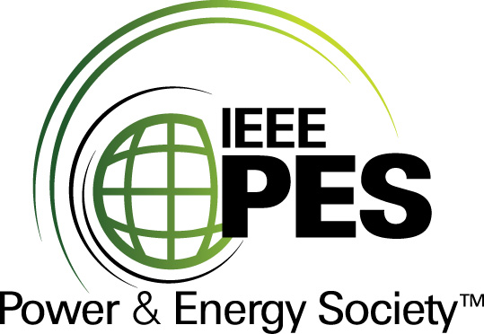
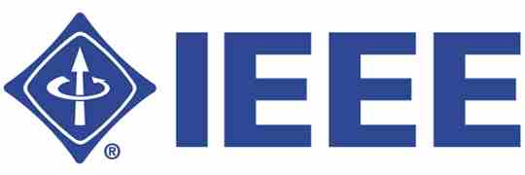

CERTIFICATE OF
EDUCATIONAL ACHIEVEMENT

This certificate is presented to

replace with your name

for attendance at the educational presentation:

“Geo-magnetically Induced Currents (GIC)
and the Effects on Power Transformers”

sponsored by the IEEE/PES Transformers Committee

and has earned one (1) Professional Development Hour (PDH) unit.
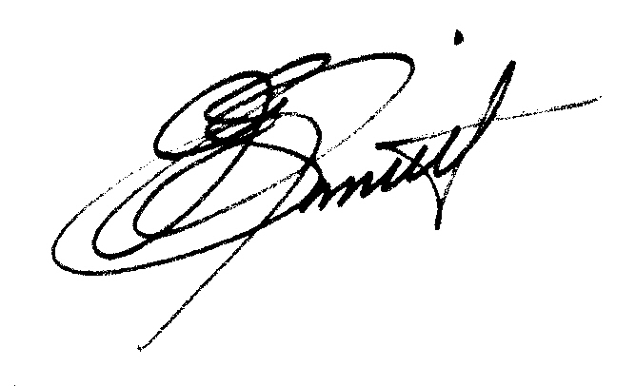
Spring 2010 Committee Meeting; Monday, March 8, 2010

J. Edward Smith Instructors: Peter Balma, Leonard Bolduc, Ramsis Girgis,
Chair, IEEE/PES Transformers Committee and Hasse Nordman

