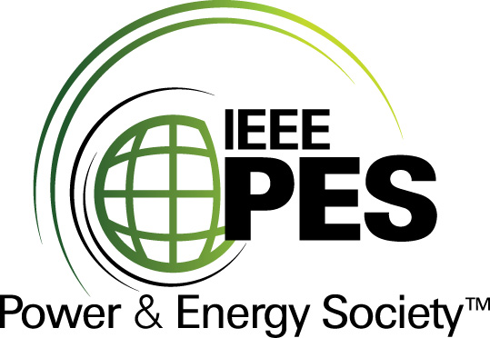
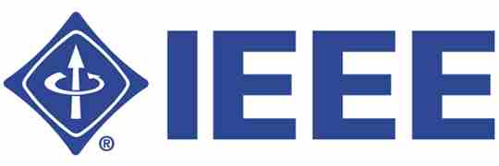

CERTIFICATE OF
EDUCATIONAL ACHIEVEMENT

This certificate is presented to

replace with your name

for attendance at the educational presentation:

“Transformer Tank Rupture and Mitigation”

sponsored by the IEEE/PES Transformers Committee

and has earned one (1) Professional Development Hour (PDH) unit.
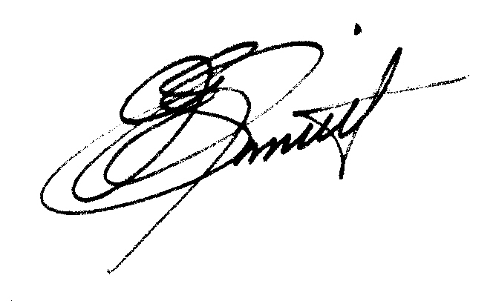
Spring 2010 Committee Meeting; Tuesday, March 9, 2010

J. Edward Smith Instructors: Nick Abi-Samra, Bill Darovny, Marc Foata,
Chair, IEEE/PES Transformers Committee Joshua Herz, Craig Swinderman, Peter Zhao

