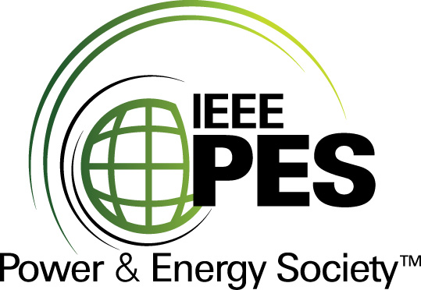


CERTIFICATE OF
EDUCATIONAL ACHIEVEMENT

This certificate is presented to

replace with your name

for attendance at the educational presentation:

“Transformers Used with Alternative Energy
Sources - Wind & Solar”

sponsored by the IEEE/PES Transformers Committee

and has earned one (1) Professional Development Hour (PDH) unit.
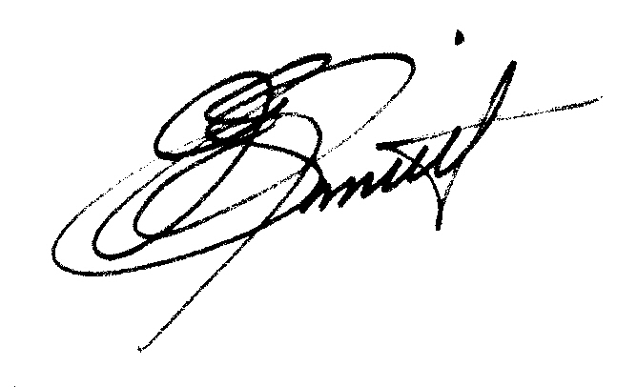
Spring 2011 Committee Meeting; Monday, 11 April 2011

J. Edward Smith Instructors: D. Buckmaster, P. Hopkinson, H. Shertukde
Chair, IEEE/PES Transformers Committee

